**+91-7842514524**

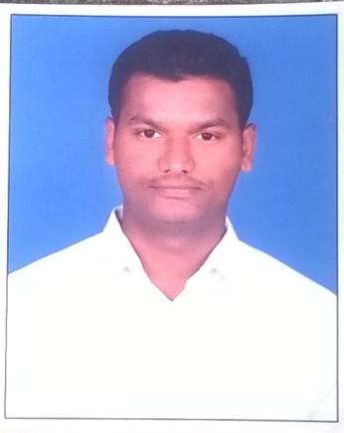

**KOTHAKONDA REVANTH KUMAR**

H. NO: 3-1-36, OPP IB GUEST HOUSE,

KARIMNAGAR -505001

Mobile: +91-8897427807

Email ID: [revanth.kothakonda@gmail.com](mailto:revanth.kothakonda@gmail.com)

Git Hub ID: revanthkothakonda

**OBJECTIVE**

To provide my honest efforts to your esteemed organization and goals, where in turn enhance my knowledge and performance to put up my career.

**EDUCATIONAL QUALIFICATION**

* **Bachelor of Technology** in **Computer Science and Engineering,** Sree Chaitanya college of Engineering, affiliated to Jawaharlal Nehru Technological University (JNTUH), Hyderabad, 2016. **63%**
* **Higher Secondary**, Alphores junior college, Karimnagar, 2010-2012.

Aggregate. **68.8%**

* **Secondary School**, Vidyadhari High school , Karimnagar, 2009-2010.

Aggregate. **89.5%**

**TECHNICAL SKILLS**

* Operating Systems : Windows XP, windows 7 and 8
* Languages : C, C++, JAVA
* Database : MYSQL
* Web Technologies : HTML, JAVA SCRIPT,SERVLETS,JSP
* Software : Microsoft office, Turbo C, Net Beans, XAMPP, Eclipse,

Android Studio

**AREAS OF INTEREST**

* JAVA Programming.
* Web designing with PHP,HTML, JAVA SCRIPT,SERVLETS.
* Data Base Management Systems(DBMS).

**CERTIFICATIONS**

* Trainee on JAVA and Android.
* ANDROID APPLICATION DEVELOPMENT from I3india.
* WEB DEVELOPMENT from SWETCHA.
* ETHICAL HACKING from INDIANSERVERS.

**ACHIEVEMENTS**

* Developed two web applications.
* Won 2nd prize in Aptitude Reasoning workshop.
* Active participation in all events since schooling to college
* Sports In-charge at ASCII ASSOCIATION.

**INTERPERSONAL SKILLS& STRENGTHS**

* Quick learner, adaptability and hard worker.
* Confident and determinant.

**PROJECTS UNDERTAKEN**

**Mini project**:Employ management.

Description: This web application was developed using JAVA Technology.This exhibits employees with their details performs addition, deletion, search activities.

URL:https://github.com/revanthkothakonda/javaWebApp.git

**Other:** Web application developed using Php. This application consits of a registration, login, profile, reporting pages.

URL: https://github.com/revanthkothakonda/Registration-Web-app

**PERSONAL DETAILS**

|  |  |
| --- | --- |
| * Father Name : | K. Srinivas |
| * Date Of Birth : | 7th may 1994 |
| * Marital status : | Single |
| * Languages known: | English, Telugu, Hindi |
| * Nationality: | INDIAN |
| * Hobbies : | Work out, Dance, Playing Volley ball. |

**DECLARATION**

I hereby declare that the above furnished information is truth and best of my knowledge.

Place:

Date: (KOTHAKONDA REVANTH KUMAR)