M.Santha Ganesh

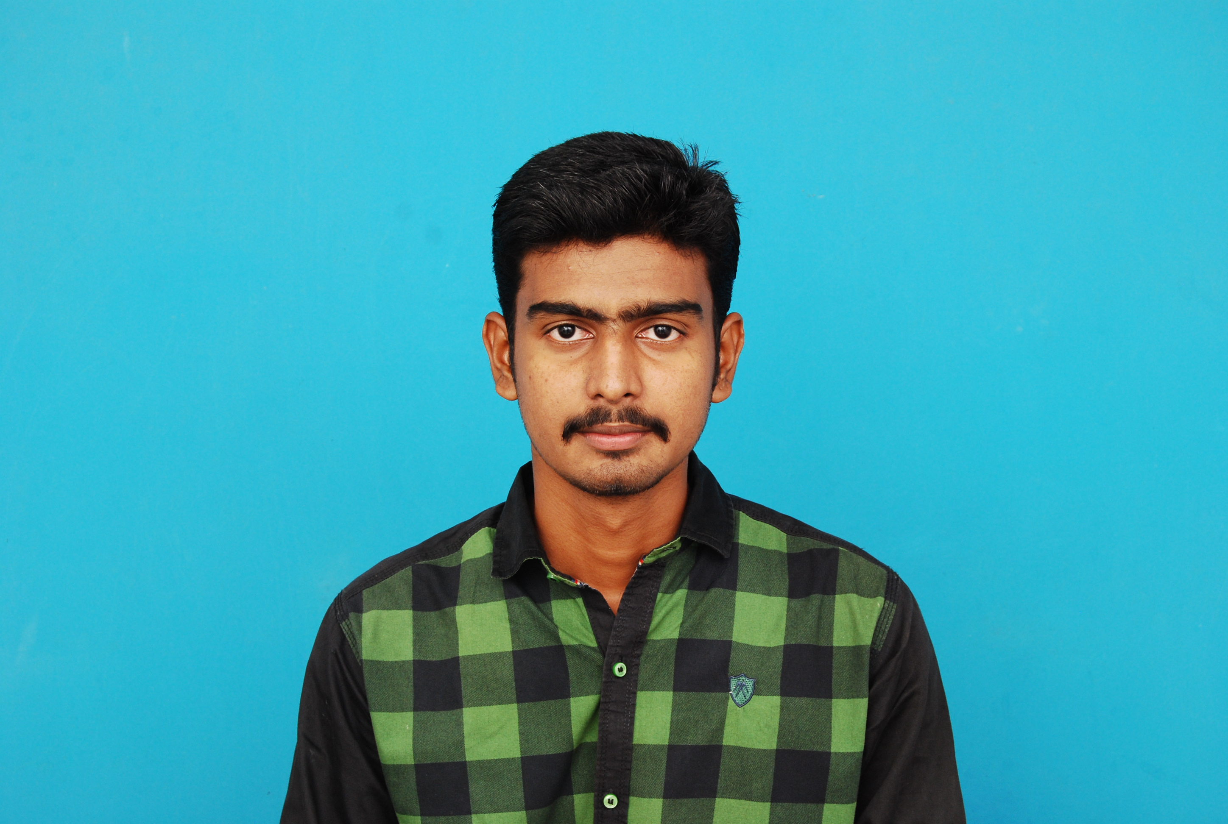

santhaganesh1995@gmail.com

Contact : +9003321541

--------------------------------------------------------------------------------------------------------------------------

**Career Objective**

Looking for a job and want to associate with an organization to provide my skills.Hardworking and eager to get opportunities to improve myself professionally and contribute to the growth of the organization with quality services.

**Academic Qualification**

-BE - Civil Engineering in 2017 with 69% marks from SCAD Engineering College

-HSC from Emmanuel Matric Hr.sec.school in 2013 with 72% marks

-SSC from RamaswamypillaiHr.Sec.school in 2011 with 80% marks

**Technical Skills Set**

|  |  |
| --- | --- |
| SOFTWARES | SKILLS IN |
| Autocad | * 2D & 3D model preparation, * Block creation and parameters in block with implement the actions * Sheets creation, annotation, Manage and edit attributes |
| Revit Architecture &  Structure | * Grids & level creation, * Design model preparation * Knowledge in central file creation,work sharing process, filters and design option * Family creation, sheet creation |

**Professional Experience**

|  |  |  |
| --- | --- | --- |
| **Organization** | **Designation** | **Duration** |
|  |  |  |
| Roycie Construction | Supervisor | 4 months |

**Non Technical Skills**

Got FIRST class in Type writing English (Junior Grade)

**Academic Projects Undertaken**

**Minor Project :**

Project Description : “ **DESIGN OF APARTMENT BULIDING WITH PRESTRESS ELEVATED**

**CIRCULAR WATER TANK”**

This includes the entire planning, which consist the comfort of the residents i.e. parking area, swimming pool, canteen, shopping complex etc. After planning, we analyzed the building.

The circular prestressed concrete tanks. low water to cement ratio has greater corrosion inhibition, impermeability, and strength than conventional concrete. It can use for storing the liquids in high seimic region.

**Major project :**

Project Description :**“GEOPOLYMER CONCRETE BASED ON MICRO KAOLIN”**

Taking Coarse & fine aggregate ,Micro kaolin ,Sodium silicate ,Sodium Hydroxide,and prepare the concrete taking out then put steam curing for 24 hrs at 90◦c.It will cure more quickly than Portland concrete and attain high strength within 24 hrs.

**Personal Qualities**

-Dedicated,

-Ability to quickly grasp new concepts

-Hard working

-Good Communication Skills

**Core competencies**

-Designing skills.

-Creative and innovative mind.

-Team Work.

**Personal Details**

Date of birth : 09-08-1995

Gender : Male

Nationality : Indian

Father’s name : K.Mariappan

Languages known : English, Tamil

Passport Number : 0991695

Address : 125 Middle Street,

Melagaram,

Tenkasi (tk)

Tirunelveli (Dist)

Pin - 627818

**Declaration**

I hereby declare that the above written particulars are true and correct to the best of my knowledge and belief.

Date :

Place : M.Santha Ganesh