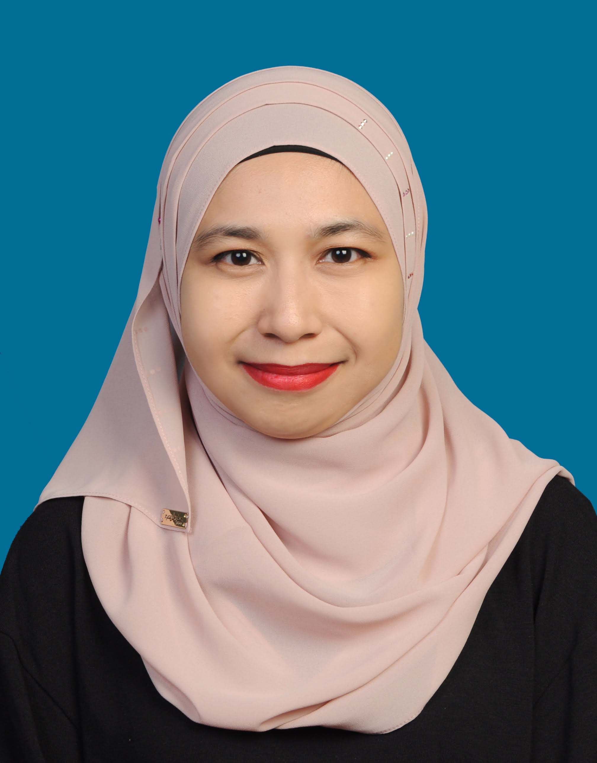

NURUL FATEHAH ABD MANAN

No 12 Jalan Suasana 4/5, Bandar Tun Hussein Onn,

43200 Cheras, Selangor

019-366 5617

[supernurul2102@gmail.com](mailto:supernurul2102@gmail.com)

# profile

* Date of Birth: 21st February 1989
* Marital Status: Single

# Education

Selangor International Islamic University College Bandar Seri Putra, Bangi, Serlangor

Diploma in Human Resource Management 2007-2010

*Degree in Human Resource Management 2013 - 2016*

Sekolah Menengah Teknik Klang Klang, Selangor

Art Stream (Business Management) 2005-2006

# Experience

Internship at Ministry of Tourism & Culture (degree internship) Putrajaya

April 2015 – October 2015

* Placement in Human Resource Department, under training and development unit. Be a part of Islam Hadhari Sub Unit (3 months)
* Learning about how conduct the courses for the officers.
* Learn about the process for staffs’ carrier development e.g. examination.
* Learn and also helping the colleague in preparing the budget for the courses that will be conduct.

Tourism Malaysia (LPPM) Putrajaya

Daily Temporary-worker (PSH E29) Dec 2015-present

* Helping in handling inbound and outbound calls
* Helping in managing the guests of director general while their visit
* Helping in the affairs of Director General’s office
* Updating data and incoming mails
* Helping in the arrangement of business appointment for Director General
* Handling any ad-hoc

# CO-Curricular activity

Selangor International Islamic University College

**2011-2012**

Club/Committee: Kelab Kembara Kuis

Position: Committee member

**2008-2009**

Club/Committee: Pengajian Tajwid

Position: Committee member

**2007-2008**

Club/Committee: Persatuan Silat Lincah

Position: Committee member

Sekolah Menengah Teknik Klang

**2005-2006**

Club/Committee: Puteri Islam

Position: Committee member

Club/Committee: English Society Club

Position: 2005 – Committee Member

2006 – Vice President

# Personal Interest

* Reading
* Hiking
* Wall Climbing
* Marathon

# Language Ability

|  |  |  |
| --- | --- | --- |
| **Language** | **Spoken** | **Written** |
| Malay | Excellent | Excellent |
| English | Good | Good |

# Computer Ability

* Microsoft Word : Fair/Good/**Exellent**
* Microsoft Powerpoint : Fair/**Good**/Excellent

# reference

Name : En. Sharulnazri bin Shahruddin

Company : Lembaga Penggalakan Pelancongan Malaysia (LPPM)

Position : Senior Travel Officer

Relationship : Supervisor

E-mail : shahrulnazri@tourism.gov.my