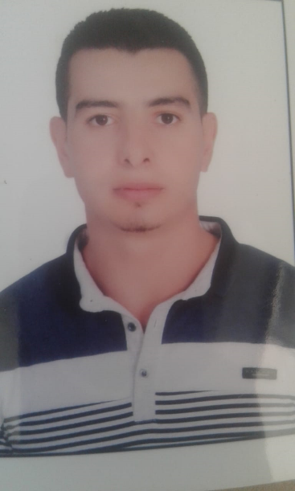

**Ibrahim El Sayed Amin Mahmoud**

**E-mail : *01011047679.in@gmail.com***

## Mobile :0551882401

# Objective :

**A job opportunity in a well know institution where my academic background and work field expertise would be effectively used and further developed and enhanced.**

## 

# Personal information:

## ****Date of Birth : 26 / 9 / 1993****

## ****Nationality: Egyptian****

## ****Religion: Muslim****

## ****Gender: Male****

## ****Marital status: Single****

## ****Military status: finished****

# Education:

## ****B.S.C of Commerce ( Accounting Department ).****

## ****ZagazigeUniversity.****

## ****May 2016****

## ****Overall Gradeof ( Acceptable ) 63.8%..****

# :Work experiences

## ****Consulting Group for accounting and auditing.****

## ****International Office of Accounting and Tax Consulting****

## ****(Mr. Stayed Esmail Hadeya) (Part Time)****

# Personal skills :

## ****Attend good public relationships, Excellent communication skills, Hard worker, Honest belief in the work – group approach and fast learner.****

## Courses&Certificates:

* + ***Professional Financial Accountant (P F A)***
  + ***Advanced Excel***
  + ***The Electronic Accounting in Quick Books***
  + ***International Computer Driving License (I C D L)***
  + ***English***
  + ***Certificate of the Consulting Group for accounting and auditing***
  + ***Certificate of International Office Of Accounting and Tax Consulting***

# Computer skills :

## Excellent Knowledge of:

***(windows – office – internet – fast typing – word – excel – research* )**

# Hobbies

* + ***Reading***
  + ***Foot ball and Swimming***
  + ***Computer and Internet***

# Language skills:

## Arabic language (mother tongue)

## English language ( Good )

