**LEENA RAJPUT**

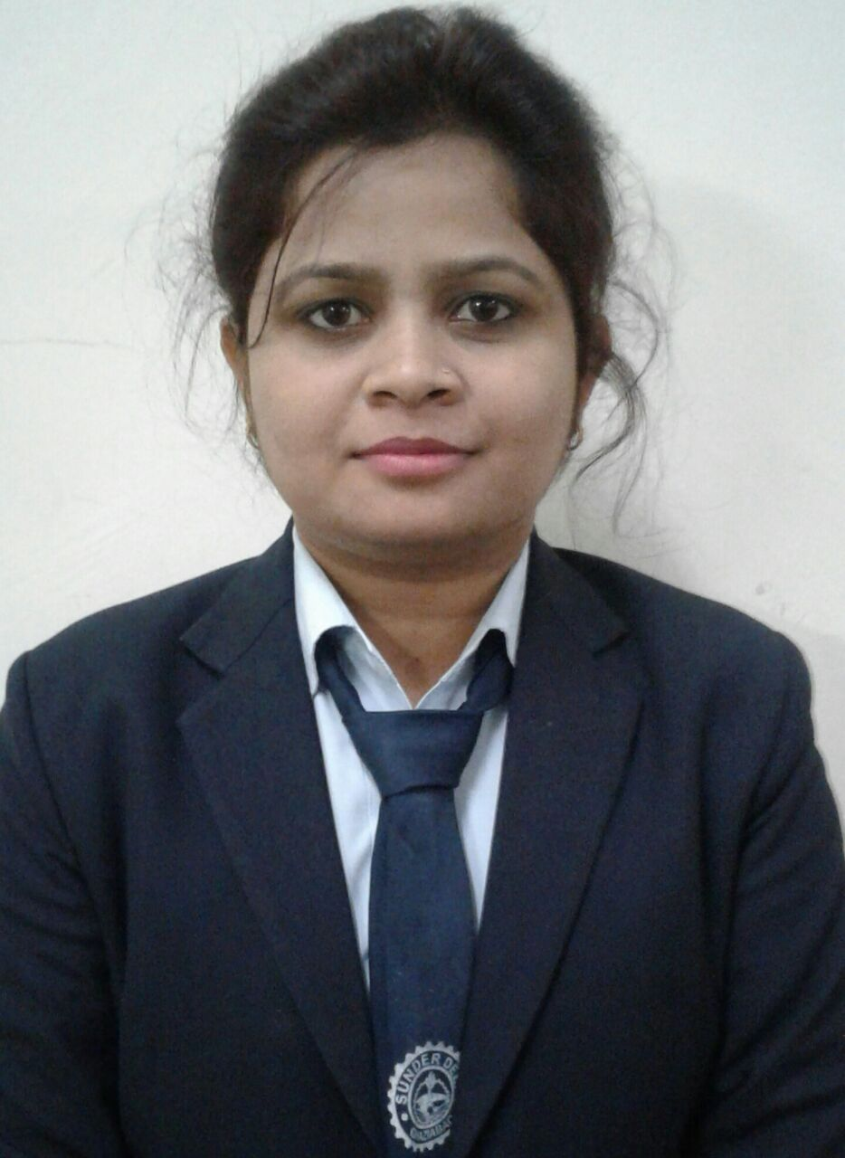

© 9458648237

Email: [leenarajput94@gmail.com](mailto:leenarajput94@gmail.com)

Address: KA-57 kavi nagar ,Ghaziabad

U.P. - 201002

**OBJECTIVE**

Seeking to be a part of a professionally driven esteemed organization which offers continuous challenges and excellent growth prospects and provides valuable insight into a particular field to get an advanced start to my career.

**CURRENT POSITION**

Working as a Software Engineer in Agile Softech Private Limited, Ghaziabad from 02-01-18 to till now in .**NET**.

**EDUCATIONAL QUALIFICATIONS**

|  |  |  |  |  |
| --- | --- | --- | --- | --- |
| **QUALIFICATION** | **UNIVERSITY/BOARD** | **INSTITUTION** | **AGGREGATE/**  **CGPA** | **YEAR OF PASSING** |
| MCA | A.K.T.U. | Sunderdeep Engineering College, Ghaziabad | 73.4% | 2018 |
| BCA | M.J.P.R.U. | SGD College Chandpur,Bijnor(U.P) | 64.30% | 2016 |
| 12th | U.P(Board) | Vivekanand Inter College Chandpur(Bijnor) | 50% | 2012 |
| 10th | U.P(Board) | Vivekanand Inter College Chandpur(Bijnor) | 56% | 2010 |

**PROJECTS**

* **Course Bazaar** as Major Project

Technology:- .Net (Visual Studio 2017)

Database:- SQL SERVER 2014

Team Size:- 5

Details:- Course Bazaar is a Educational Portal through which the student can search for the desired Colleges, Courses and the details related to that College & Course. Students can also see the Fee Structure and ranking of the Colleges.

Role and Responsibility:- Worked as developer, designer and also handled database.

* **Job Portal** as Major Project

Technology:- .Net ( Visual studio2017)

Database:- SQL SERVER 2014

Team Size:- 5

Details:- Job Portal is a job searching portal through which the Candidate can search for the desired Jobs in desired Location. Candidates can apply for the job.

Role and Responsibility:- Worked as developer, designer and also handled database.

**AREA OF INTEREST**

* Sql Server.
* Database(Oracle,Mysql).
* C#, ASP.NET, VB.NET, ADO.NET.
* MVC, LINQ, Entity Framework.
* Webapi
* Web Designing (Html5,Css3).
* Proficiency in entire MS-Office and good understanding of internet tools.

**COMPUTER SKILLS**

* Programming Languages: C#
* Platforms: Windows.
* Database:Sql Server, Oracle, SQLite ,MySQL.

**INTREST AND HOBBIES**

* Travelling
* Singing
* Socializing with friend

**PERSONAL DETAILS**

|  |  |  |  |
| --- | --- | --- | --- |
| **Nationality** | Indian | **Place of Birth** | Bijnor(U.P) |
| **Date of Birth** | 18/04/1994 | **Gender** | Female |
| **Father’s Name** | Mr. Vinay Kumar | **Mother’s Name** | Mrs. Kusum devi |
| **Permanent Address** | D/O:Vinay Kumar, Kakrala, Darbara, Bijnor, Chandpur, Uttar Pradesh,246725 | **Permanent Contact No.** | 9458648237 |

I do hereby confirm that the above information given in the resume is true and correct to the best of knowledge.

**LEENA RAJPUT**