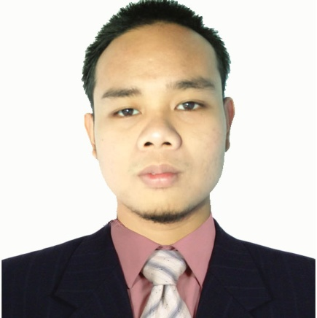**Gerald D. Doctolero**

**Bachelor of Science in Information Technology**

Ph 8 Blk 18 Lot 32 Parklane Subd.

General Trias Cavite

0955 – 8953 – 447

Email Add : [doctolero.gerald@gmail.com](mailto:doctolero.gerald@gmail.com)



**CAREER OBJECTIVE**

To work for an organization which provides me the opportunity to improve my skills and knowledge to growth along with the organization objectives.



**TECHNICAL SKILLS**

* Oriented in Microsoft Office application such as:

Microsoft Word

Microsoft PowerPoint

Microsoft Excel

* Hardware and Software Troubleshooting
* Web Development(knowledgeable in PHP, HTML, CSS)
* Adobe Photoshop



**PERSONAL SKILLS**

* Good communication skills
* Work well under the pressure
* Time Management



**EDUCATIONAL BACKGROUND**

TERTIARY : STI College Dasmariñas Cavite S.Y 2013 – 2018

SECONDARY : Fiat Lux Academe S.Y 2009 – 2013

PRIMARY : Shineridge School Annex of Dasmariñas S.Y 2003 - 2009

**Work Experience**

**On The Job Training**

IT Staff

Dasmrinas City Hall

Don Placido Campos Avenue, Zone 4, Dasmariñas, 4114 Cavite

Nov 2017 – April 2018

**Duties and Responsibilities**

* Hardware and Software Troubleshooting
* Lan Cabling
* Encoding

**CHARACTER REFERENCES**

**Mr. John Bastian Dinglasan**

Creatives Pad(Silang Cavite)

Web Developer

+639979258165

**Mr. Job De Leon**

Marketing Manager

Paperline Paper Product

+639258871053

**Mr. Felix B. Laconse**

Sales Coordinator

Paperline Paper Product

+63966526996