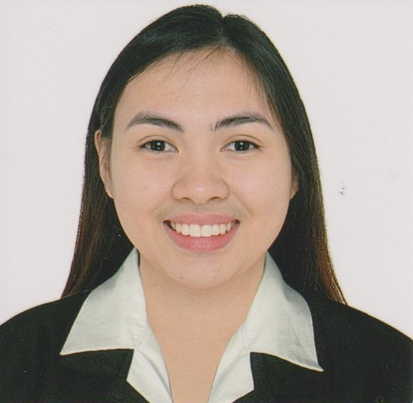**REANN M. DAVID**

Zone 2 San Felipe,City of San Fernando, Pampanga

0905-461-9319

rmdavid.822@gmail.com

**CAREER OBJECTIVE**

* Seeking a position to your company that can broaden my managerial skills and professionalism.
* To learn and grow with the institution as a unique and productive individual.
* To enhance and nurture more my capacities, skills and efficiency.

**EDUCATIONAL BACKGROUND**

* **College:**

*Bachelor of Science in Business Administration*

*Major in Operations Management*

*University of the Assumption*

*2011-2015*

*Unisite Subdivision Del Pilar, City of San Fernando Pampamga*

**ON- THE- JOB TRAINING:**

* **Ben & Jerry’s**

2510 Atlantic Avenue, Virginia Beach, Virginia, 23451 USA

Assistant Manager, Cashier

March, 2014 – June,2014

**WORK EXPERIENCE**

* **CITY OF SAN FERNANDO WATER DISTRICT**

**Job Order Personnel**

**Administrative Aide – (August 1, 2018 – present)**

Duties and Responsibilities

* Assist in filling retrieving of documents and receiving of internal and external communications.
* Assist in conducting inventory, appraisal, disposition and disposal of water district. records.
* Maintain an orderly, updated and systemic filing of records and other water district documents.
* Assist in the preparation of reports of the Technical Officers.

**Job Order Personnel**

**Office of the General Manager Aide – (August 25, 2017 – July 31, 2018)**

Duties and Responsibilities

* Attends regular meeting of the board of directors
* Assists in preparing management/board agenda, minutes of the meeting, resolutions and other board related tasks.
* Perform other duties/tasks as may be required by the management from time to time.
* **TOYOTA SAN FERNANDO PAMP. INC**

**Sales Admin (LTO staff) - (May 25 2016 – July 15, 2017)**

Duties and Responsibilities

* Responsible for all the LTO Transactions of new purchase vehicle.

**Customer Relations Staff - (November 17, 2015 – May 25, 2016)**

Duties and Responsibilities

* Getting feedback about the services given by the company to recent customers.

**SKILLS**

* Computer Literate ( knowledgeable in Ms Word, Ms Excel, Ms Power Point )

**REFERENCES**

Kevinn S. Usman, REE

Key Account Manager

Meralco Energy Inc.

0949-9942453

Jay M. Francisco

Corporate Assistant A

City of San Fernando Water District

0933-860-7943

*I hereby certify that above information is true and correct to the best of myknowledge and belief.*

**Reann M. David**

Applicant’s Name