1. Variables
Task: Create a small program where you set up a nickname for yourself and then make the computer greet you by that nickname.
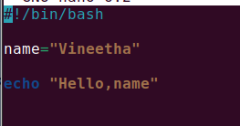
Output:
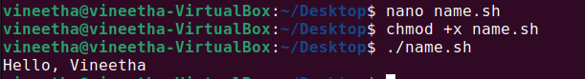

2. Conditional Statements (if-else)
Task: Make a program that decides if a number (you can choose any number) is odd or even.
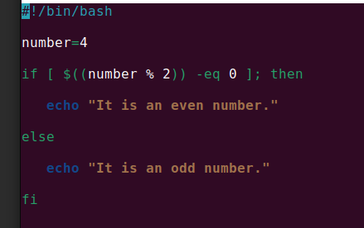
Output:
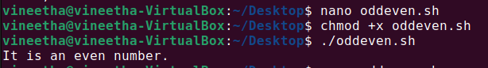

3. For Loop
Task: Create a script using a for loop that prints the numbers 1 to 5.
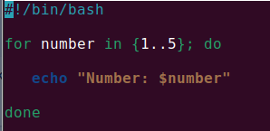
output:
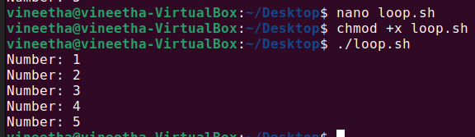
4. While Loop
Task: Write a script that uses a while loop to count down from 5 to 1.
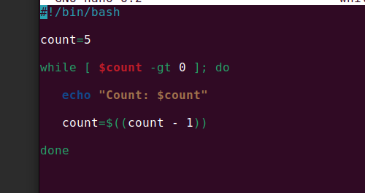
output:
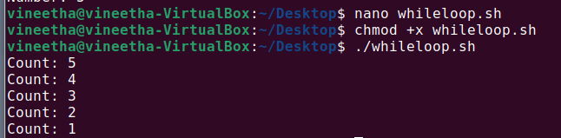

5. Reading User Input
Task: Create a script that asks the user for their favorite color and then echoes it back.
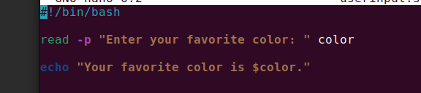
Output:

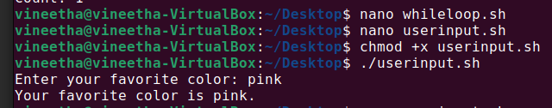

Combined Topic Tasks

1. Variables and Conditional Statements
Task: Write a program where you set your age, and the program tells you if you are considered an adult or not.
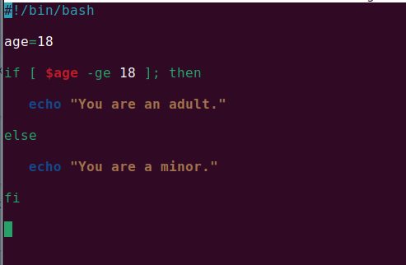

Output:
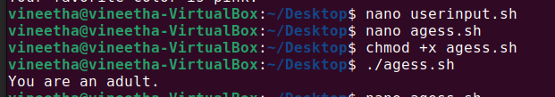
2. Loops and Conditional Statements
Task: Create a script using a for loop that prints whether each number from 1 to 5 is odd or even.
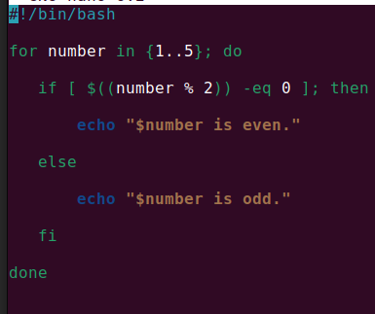
Output:
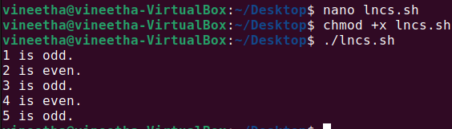

3. User Input and Conditional Statements
Task: Write a script that asks the user to enter a number and then prints if the number is positive, negative, or zero.
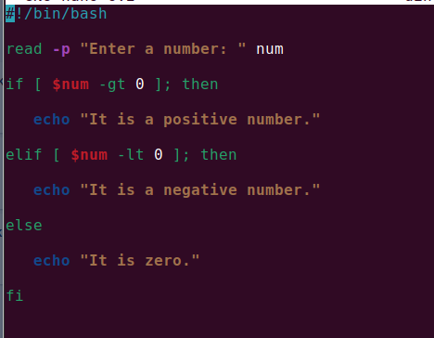
output:

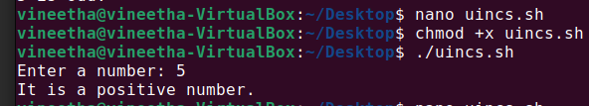
4. While Loop and User Input
Task: Create a script that uses a while loop to keep asking the user for input until they type 'quit'.
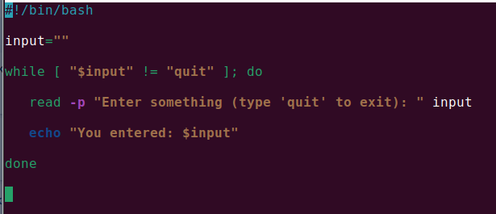
Output:
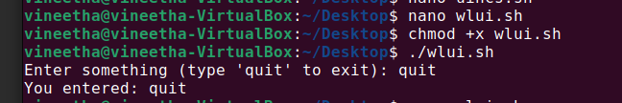
5. For Loop and Arithmetic
Task: Write a script that uses a for loop to calculate the factorial of 5.
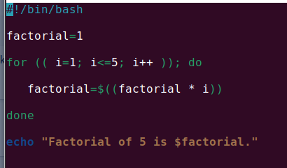
output:
