Program 2: Write a shell script that accepts a file name,starting and ending line numbers as arguments and display all the lines between the given line numbers.

echo "enter file name"

read f

echo 'enter starting position'

read st

echo 'enter ending position'

read end

echo 'The lines between' $st 'and' $end 'from' $f

if [ $st -lt $end ]

then

n1=`expr $st + 1`

n2=`expr $end - 1`

sed -n "$n1,$n2 p" $f

elif [ $st -gt $end ]

then

n3=`expr $st - 1`

n4=`expr $end + 1`

sed -n "$n4,$n3 p" $f

fi

Output:

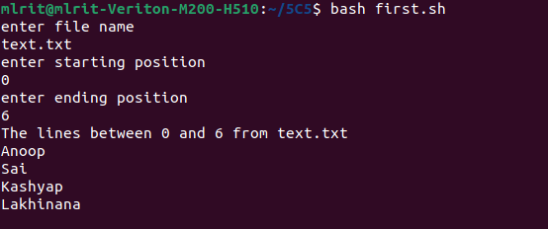

Program 3: Write a shell script that deletes all lines containing a specified word in one or more files supplied as arguments to it.

echo 'enter a word to be deleted'
read word
echo 'enter file name'
read fname

echo 'lines in' $fname 'after deleting the word' $word ':' sed "/$word/d" $fname

Output:

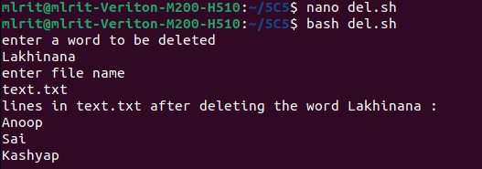

Program 4: Write a shell script that displays a list of all the files in the current directory to which the user has read,write and execute permissions.

for i in *
do
if [ -r $i -a -w $i -a -x $i ]
then
echo $i
fi

done

Output:

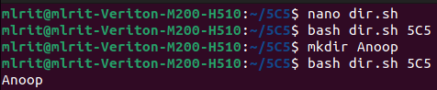

Program 5: Write a shell script that receives any number of file names as arguments checks if every argument supplied is a file or directory and reports accordingly.whenever the argument is a file,the number of lines on it is also reported.
for fname in $*

do
if [ -f $fname ]
then
echo $fname 'is a file'

echo 'no.of lines in' $fname ':'
wc -l $fname
elif [ -d $fname ]
then
echo $fname 'is a directory'

else
echo 'Does not exist'
fi
done

Output:

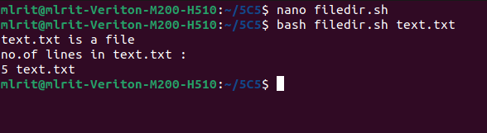

Program 6: Write a shell script that accepts a file names as its arguments,counts and reports the occurrence of each word that is present in the file argument file in other argument files.

if [ $# -eq 0 ]
then
echo "no arguments"
else
tr " " "\n" < $1 > temp
shift

for i in $*
do
tr " " "\n" < $i > temp1
y=`wc -l < temp`

j=1
while [ $j -le $y ]
do
x=`head -n $j temp | tail -1`
c=`grep -c "$x" temp1`
echo $x $c
j=`expr $j + 1`

done
done
fi

Output:

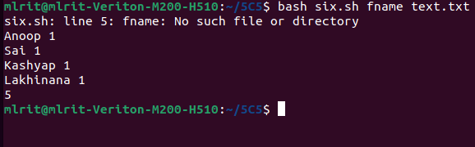

Program 7: Write a shell script to all of the directory files in a directory.

echo 'enter a directory name'

read dname

echo 'The list of directory files in the directory' $dname 'are'

cd $dname

ls -l | grep '^d'

Output:

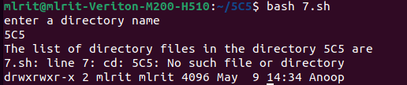

Program 8: Write a awk script to count the number of lines in a file that do not contain vowels.

echo 'enter a file name'
read fn
awk '$0 !~/[aeiou]/ { c=c+1 }
END { print("The no.of lines that do not contain vowels:",c) }' $fn

Output:

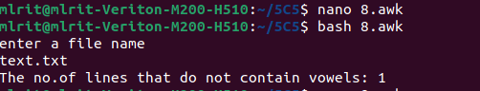

Program 9 : Write a awk script to find the number of characters,words and lines in a file.

echo "enter a file name"
read fn
awk '{ w=w+NF
c=c+length($0)
}
END { print("No.of lines:",NR)
print("No.of words:",w)

print("No.of characters:",c)
}' $fn

Output:

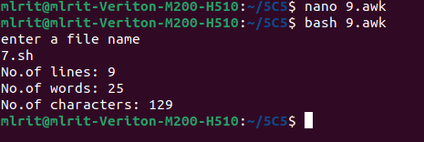

Program 10: Write a C program that makes a copy of a file using standard I/O and system calls.

#include<stdio.h>
#include<unistd.h>
#include<fcntl.h>

#define MAX_SIZE 1000

void main()

{
int fd1,fd2,r1,w1;

char buffer[MAX_SIZE];

char sourceName[100],destName[100]; printf("enter the source file\n"); scanf("%s",sourceName); printf("enter a new file name"); scanf("%s",destName); fd1=open(sourceName,O_RDONLY);

r1=read(fd1,buffer,MAX_SIZE);

fd2=open(destName,O_CREAT|O_RDWR,0600);

w1=write(fd2,buffer,r1);

}

Output:

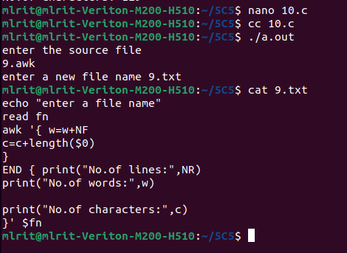

Program 11:.Implement in C the following Unix commands using system calls.

- cat command #include<fcntl.h> #define MAX_SIZE 500 main()

{
int fd1,n;

char buf[MAX_SIZE],fname[20]; printf("enter a file name\n"); scanf("%s",fname); fd1=open(fname,O_RDONLY); if(fd1==-1)
printf("the file does not exist");
else
{

printf("The contents of file %s are:\n",fname); n=read(fd1,buf,MAX_SIZE); write(1,buf,n);

}
}

Output:

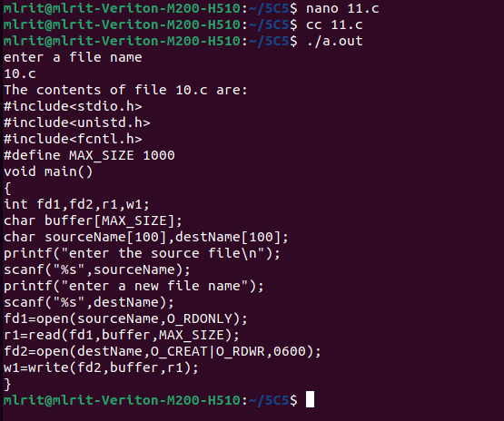

11b)mv command

#include<fcntl.h>
#include<sys/stat.h>

int main(int argc,char *argv[])
{
open(argv[1],O_RDONLY);
creat(argv[2],S_IWUSR);
rename(argv[1],argv[2]);
unlink(argv[1]);
}

Output:

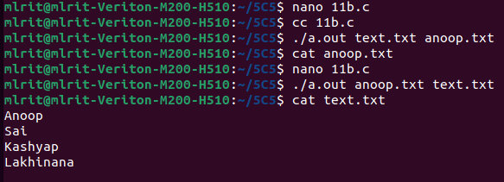

Program 12: Write a C program to list for every file in a directory,its inode number in a given directory

#include<stdlib.h>
#include<stdio.h>
#include<string.h>
int main(int argc,char *argv[])
{
char d[50];
if(argc==2)
{
bzero(d,sizeof(d));
strcat(d,"ls ");
strcat(d,"-i ");
strcat(d,argv[1]);
system(d);
}
else
printf("\nInvalid no.of inputs");
}

Output:

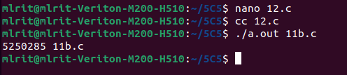

Program 13: Write a C program to create a child process and allow the parent to display “parent” and the child to display “child ” on the screen.

#include<stdio.h>
#include<stdlib.h>
#include<unistd.h>
#include<fcntl.h>
main()
{
pid_t pid;
pid=fork();

if(pid==-1)
printf("failed to fork");

else if(pid==0)
printf("child process:%d\n",getpid());
else
printf("parent process:%d",getpid());
}

Output:

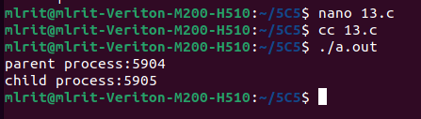

Program 14: Write a C program to create a Zombie process

#include<stdio.h>
#include<stdlib.h>
#include<unistd.h>
#include<fcntl.h>
void main()
{
int pid;
pid=fork();
if(0==pid)
{

printf("child process %d \n",getpid());
exit(0);
}
else

{
wait(0);
sleep(10);
printf("parent process %d \n", getppid());
}
}

Output:

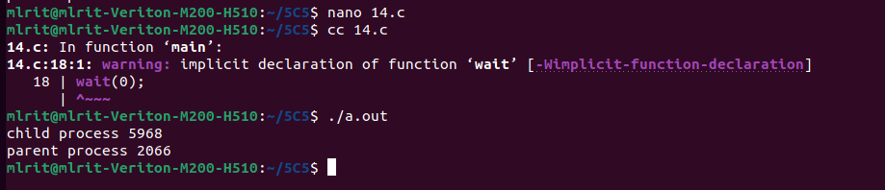

Program 15: Write a C program that illustrates how an orphan is created.

- Orphan process #include<stdio.h>
#include<stdlib.h>
#include<unistd.h>
#include<fcntl.h> void main()
{

int pid; pid=fork(); if(pid==0)
{

printf("I am the child process with PID:%d and my parent id is:%d\n\n",getpid(),getppid());

sleep(15);
printf("I am the child process with PID:%d and my parent id:%d\n",getpid(),getppid());
}
else
{

printf("I am the parent process with PID:%d\n \n",getpid()); printf("My child's PID is:%d\n\n",pid); sleep(1);

}
printf("PID %d terminates \n",getpid()); /*Both processes execute this*/}

Output:

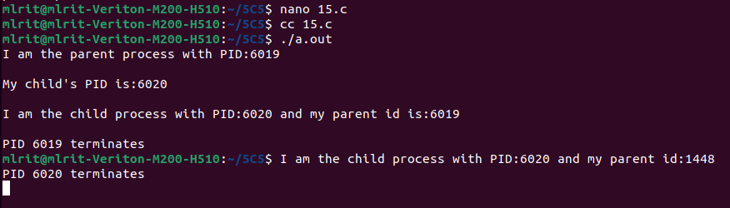

ii)Orphan process #include<stdio.h>
#include<stdlib.h>
#include<unistd.h>
#include<fcntl.h>
void main()
{

int pid; pid=fork(); if(0==pid)
{
printf("%d\n",getpid());
sleep(5);
printf("%d\n",getpid());
}
else
{
printf("%d\n",getpid());
printf("bye from parent\n");
exit(0);

}
}

Output:

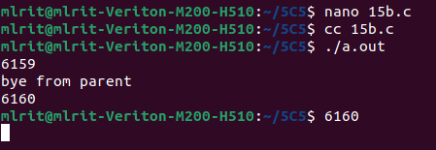

Program 16: Write a C program that illustrates communication between two unrelated process using named pipe(FIFO).

//read write
#include <stdio.h>
#include <string.h>
#include <fcntl.h>
#include <sys/stat.h>
#include <sys/types.h>
#include <unistd.h>

int main()
{
int fd1;

// FIFO file path
char * myfifo = "/tmp/myfifo";

// Creating the named file(FIFO)
// mkfifo(<pathname>,<permission>)
mkfifo(myfifo, 0666);

char str1[80], str2[80];
while (1)
{
// First open in read only and read
fd1 = open(myfifo,O_RDONLY);
read(fd1, str1, 80);

// Print the read string and close
printf("User1: %s\n", str1);
close(fd1);

// Now open in write mode and write
// string taken from user.
fd1 = open(myfifo,O_WRONLY);
fgets(str2, 80, stdin);
write(fd1, str2, strlen(str2)+1);
close(fd1);
}
return 0;
}

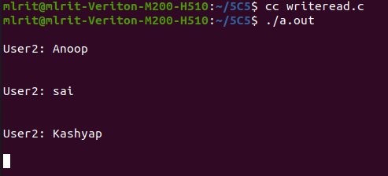
output

//fifo write read// C program to implement one side of FIFO
// This side writes first, then reads
#include <stdio.h>
#include <string.h>
#include <fcntl.h>
#include <sys/stat.h>
#include <sys/types.h>
#include <unistd.h>

int main()
{
int fd;

// FIFO file path
char * myfifo = "/tmp/myfifo";

// Creating the named file(FIFO)
// mkfifo(<pathname>, <permission>)
mkfifo(myfifo, 0666);

char arr1[80], arr2[80];
while (1)
{
// Open FIFO for write only
fd = open(myfifo, O_WRONLY);

// Take an input arr2ing from user.
// 80 is maximum length
fgets(arr2, 80, stdin);

// Write the input arr2ing on FIFO
// and close it
write(fd, arr2, strlen(arr2)+1);
close(fd);

// Open FIFO for Read only
fd = open(myfifo, O_RDONLY);

// Read from FIFO
read(fd, arr1, sizeof(arr1));

// Print the read message
printf("User2: %s\n", arr1);
close(fd);
}
return 0;
}
Output:

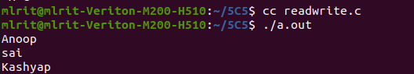

Program 17:write a C program(sender.c) to create a message queue with read and write permissions to wrte 3 messages to it with different priority numbers.

#include<sys/types.h>
#include<sys/ipc.h>
#include<sys/msg.h>
#include<stdio.h>
#include<string.h>
#include<stdlib.h>
int main(){
int qid, len,i;
char s[15];
struct
{
long mtype;
char mtext[15];
} message,buff;
qid = msgget(1000,IPC_CREAT|0666);
if(qid==-1)
{
perror("message queue create failed");
exit(1);
}
for(i=1;i<=3;i++){
printf("enter the msg to send \n");
scanf("%s",s);
strcpy(message.mtext,s);
message.mtype=i;
len=strlen(message.mtext);
if(msgsnd(qid,&message,len+1,0)==-1)
{
perror("message failed\n");
exit(1);
}
}

}

output
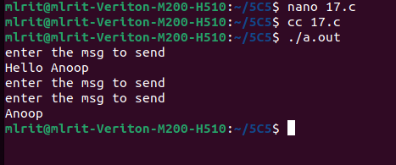

Program 18:write a C program(receiver.c) that receives the messages from sender and displays them.

#include<sys/types.h>
#include<sys/ipc.h>
#include<sys/msg.h>
#include<stdio.h>
#include<string.h>
#include<stdlib.h>
int main(){
int qid, len,i;
char s[15];
struct
{
long mtype;
char mtext[15];
} buff;
qid = msgget(1000,IPC_CREAT|0666);
if(qid==-1)
{
perror("message queue create failed");
exit(1);
}
for(i=1;i<=3;i++){
if(msgrcv(qid,&buff,15,i,0)==-1)
{
perror("message failed\n");
exit(1);
}
printf("message received from sender is %s\n",buff.mtext);
}
}

Output

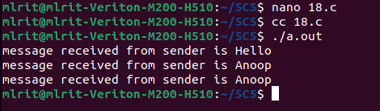

Program 19:write client and server programs(using c) for interaction between server and client processes using Unix Domain Sockets.

a)unix domain sockets(interaction between server and client)
(server)
#include <sys/types.h>
#include <sys/socket.h>
#include <sys/un.h>
#include <stdio.h>
#define NSTRS 3
#define ADDRESS "mysocket"
/* no. of strings */
//"mysocket" /* addr to connect */
/*

• Strings we send to the client. */

char *strs[NSTRS] = {
"This is the first string from the server.\n",
"This is the second string from the server.\n",
"This is the third string from the server.\n"
};

main()
{
char c;
FILE *fp;
int fromlen;
register int i, s, ns, len;
struct sockaddr_un saun, fsaun;

/*
• Get a socket to work with. This socket will
• be in the UNIX domain, and will be a
• stream socket.
*/

if ((s = socket(AF_UNIX, SOCK_STREAM, 0)) < 0) { perror("server: socket");

exit(1);
}

/*

• Create the address we will be binding to. */

saun.sun_family = AF_UNIX;
strcpy(saun.sun_path, ADDRESS);

/*
* Try to bind the address to the socket. We
• unlink the name first so that the bind won't
• fail.
*
• The third argument indicates the "length" of
• the structure, not just the length of the
• socket name.
*/
unlink(ADDRESS);

len = sizeof(saun.sun_family) + strlen(saun.sun_path);

if (bind(s, &saun, len) < 0) {
perror("server: bind");
exit(1);

}

/*

• Listen on the socket. */

if (listen(s, 5) < 0) {
perror("server: listen");
exit(1);
}

/*
• Accept connections. When we accept one, ns
• will be connected to the client. fsaun will
• contain the address of the client.
*/
if ((ns = accept(s, &fsaun, &fromlen)) < 0) {
perror("server: accept");
exit(1);
}

/*

• We'll use stdio for reading the socket. */

fp = fdopen(ns, "r");

/*

• First we send some strings to the client. */

for (i = 0; i < NSTRS; i++)
send(ns, strs[i], strlen(strs[i]), 0);

/*
* Then we read some strings from the client and
• print them out. */

for (i = 0; i < NSTRS; i++) {
while ((c = fgetc(fp)) != EOF) {
putchar(c);

if (c == '\n')
break;

}
}

/*
• We can simply use close() to terminate the

• connection, since we're done with both sides. */

close(s);

exit(0);
}
Output:

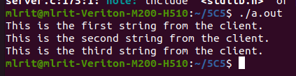

20 unix domain sockets(interaction between server and client)
Client.c
#include <sys/types.h>
#include <sys/socket.h>
#include <sys/un.h>
#include <stdio.h>

#define NSTRS 3
#define ADDRESS "mysocket"

/* no. of strings */
/* addr to connect */

/*

• Strings we send to the server. */

char *strs[NSTRS] = {
"This is the first string from the client.\n",
"This is the second string from the client.\n",
"This is the third string from the client.\n"
};

void main(){
char c;
FILE *fp;
register int i, s, len;
struct sockaddr_un saun;

/*
• Get a socket to work with. This socket will
• be in the UNIX domain, and will be a
• stream socket.

*/

if ((s = socket(AF_UNIX, SOCK_STREAM, 0)) < 0) { perror("client: socket");

exit(1);
}

/*

• Create the address we will be connecting to. */

saun.sun_family = AF_UNIX;
strcpy(saun.sun_path, ADDRESS);

/*
• Try to connect to the address. For this to
• succeed, the server must already have bound
• this address, and must have issued a listen()
• request.
*
• The third argument indicates the "length" of
• the structure, not just the length of the
• socket name.
*/
len = sizeof(saun.sun_family) + strlen(saun.sun_path);

if (connect(s, &saun, len) < 0) {
perror("client: connect");
exit(1);

}

/*
• We'll use stdio for reading
• the socket.
*/
fp = fdopen(s, "r");

/*

• First we read some strings from the server
• and print them out.
*/
for (i = 0; i < NSTRS; i++) {
while ((c = fgetc(fp)) != EOF) {
putchar(c);

if (c == '\n')

break;
}
}

/*

• Now we send some strings to the server. */

for (i = 0; i < NSTRS; i++)
send(s, strs[i], strlen(strs[i]), 0);

/*
• We can simply use close() to terminate the

• connection, since we're done with both sides. */

close(s);
exit(0);
}

Output:

21. internet sockets

a) server1.c
#include<netinet/in.h> //structure for storing address information
#include<stdio.h>
#include<stdlib.h>
#include<sys/socket.h> //for socket APIs
#include<sys/types.h>
int main(int argc, char const* argv[])
{

// create server socket similar to what was done in
// client program
int servSockD = socket(AF_INET, SOCK_STREAM, 0);

// string store data to send to client
char serMsg[255] = "Message from the server to the client";

// define server address
struct sockaddr_in servAddr;

servAddr.sin_family = AF_INET;
servAddr.sin_port = htons(9001);
servAddr.sin_addr.s_addr = INADDR_ANY;

// bind socket to the specified IP and port
bind(servSockD, (struct sockaddr*)&servAddr,
sizeof(servAddr));

// listen for connections
listen(servSockD, 1);
// integer to hold client socket.
int clientSocket = accept(servSockD, NULL, NULL);

// send's messages to client socket
send(clientSocket, serMsg, sizeof(serMsg), 0);

return 0;
}

output:-

b)client.c
#include<netinet/in.h> //structure for storing address information
#include<stdio.h>
#include<stdlib.h>
#include<sys/socket.h> //for socket APIs
#include<sys/types.h>

int main(int argc, char const* argv[])
{
int sockD = socket(AF_INET, SOCK_STREAM, 0);

struct sockaddr_in servAddr;

servAddr.sin_family = AF_INET;
servAddr.sin_port = htons(9001); // use some unused port number
servAddr.sin_addr.s_addr = INADDR_ANY;
int connectStatus = connect(sockD, (struct sockaddr*)&servAddr, sizeof(servAddr));

if (connectStatus == -1) {
printf("Error...\n");
}

else {
char strData[255];

recv(sockD, strData, sizeof(strData), 0);

printf("Message: %s\n", strData);
}

return 0;
}

output:-
