* Start Minikube on windows.

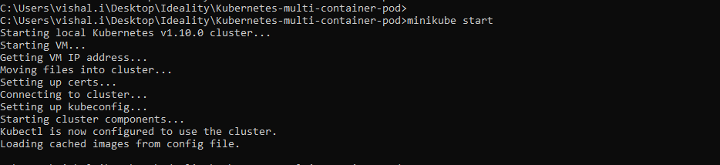

* Check for minikube nodes.

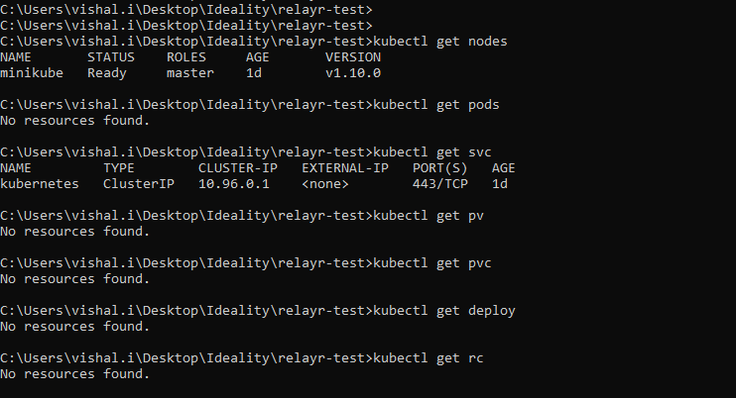

* git clone <https://github.com/vinga2805/relayr-test.git>

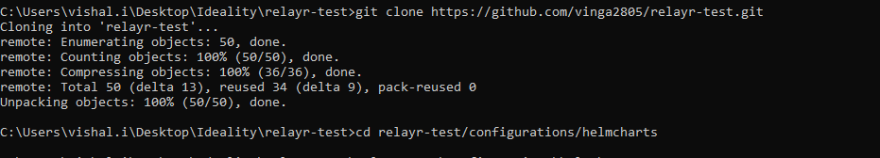

* helm install --name mysql mysql

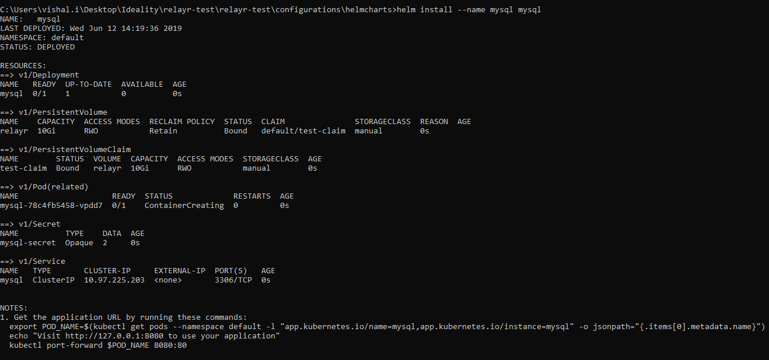

* helm install --name webapp webapp

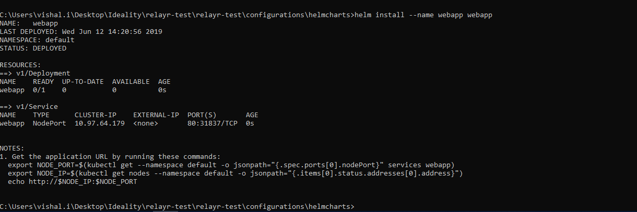

* check all resources created.

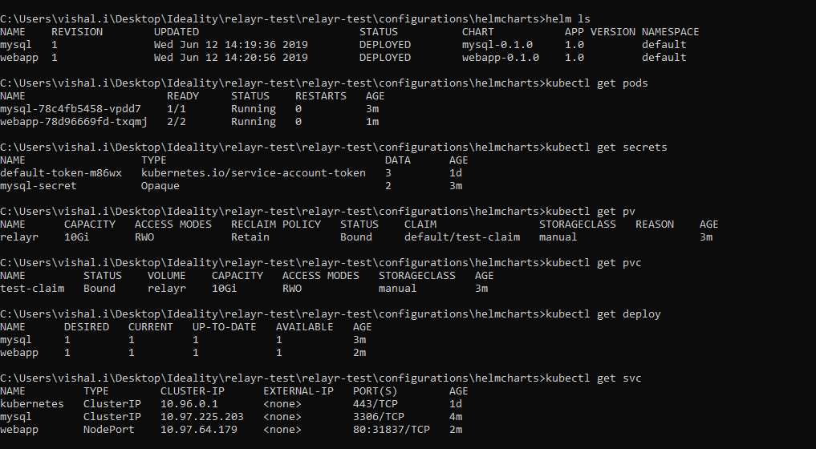

* minikune service webapp --url



* Check if app is running or not.
* <http://10.120.120.132:31837/init>

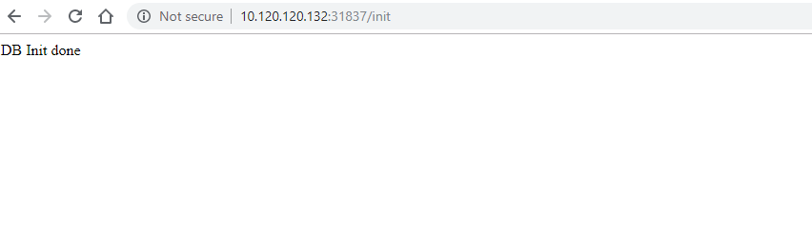

* Add the records via postman with POST method.

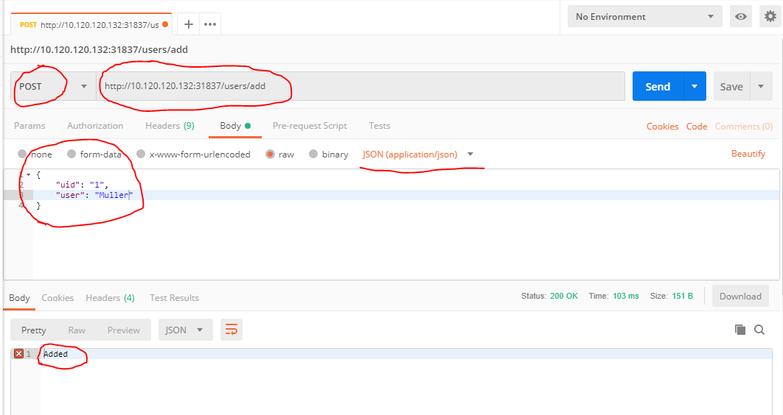

* Verify the record being added.

