**GREEN ACADEMY VIETNAM**

---

**GRADUATION PROJECT**

WEB DESIGN

**FAST FOOD SHOP**

**Students: Đặng Lê Quang Vinh**

**Class: WEB-D007**

**Guide teacher: Huynh Ngoc Duy**

**MỤC LỤC**

**Overviews** **2**

**APPLICATION FEATURES** **3**

**TECHNICAL CONSTRUCTION** **4**

**CONSEQUENCE** **5**

**REFERENCES** **6**

# Overviews

* Thể hiện thông tin ngắn gọn về dự án, mục tiêu

Fast food is a professional website website offers fast food such as hamburgers, drink, toast ,cake, cream ...

# The goal of the site is continuing to develop new functionality for Web sites such as orders, customer feedback, chat with the staff, admin page ...

# APPLICATION FEATURES

* update information up to api or edit the information

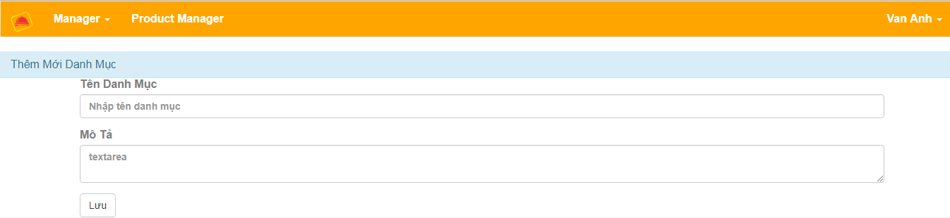

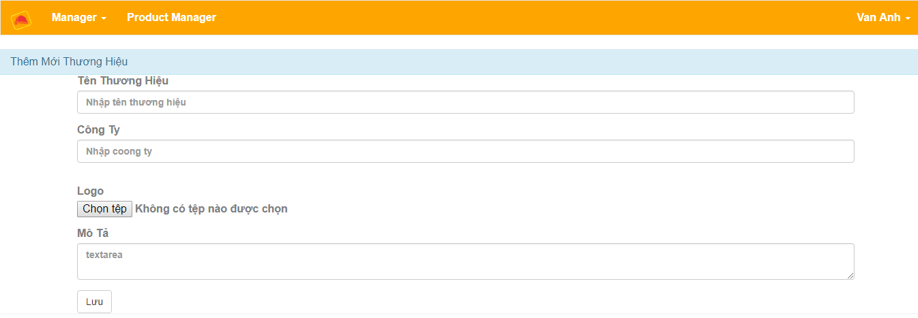

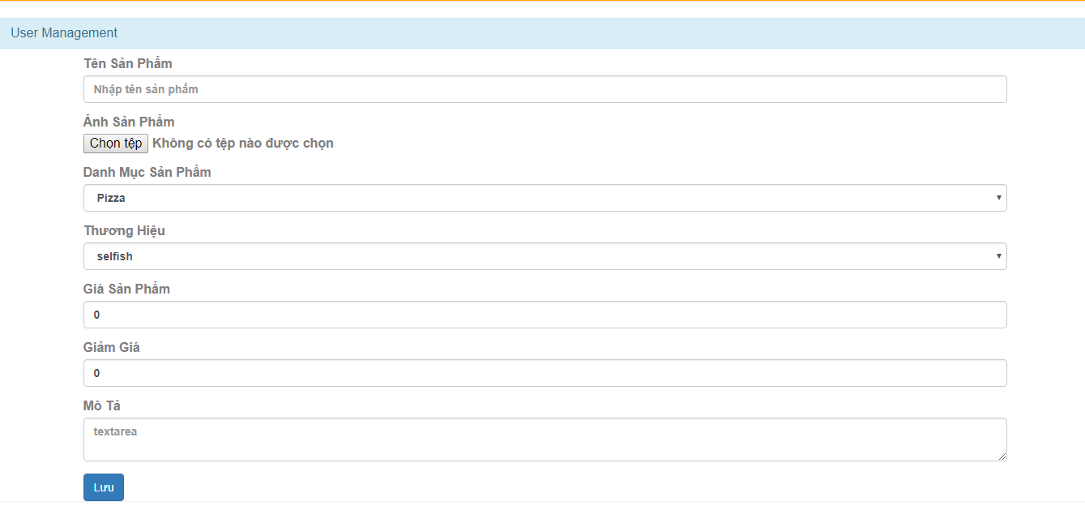

* obtain information from the api and show off the screen

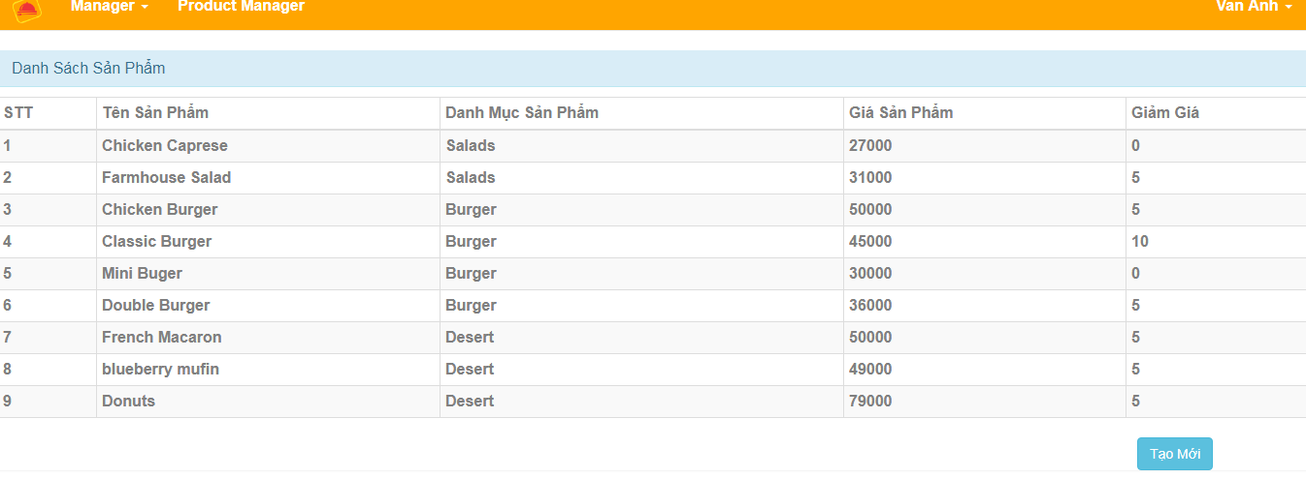

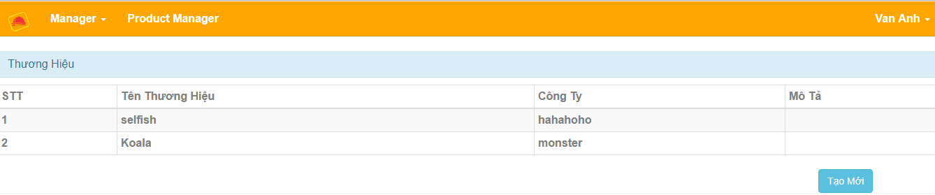

* you need to log in when visiting the website

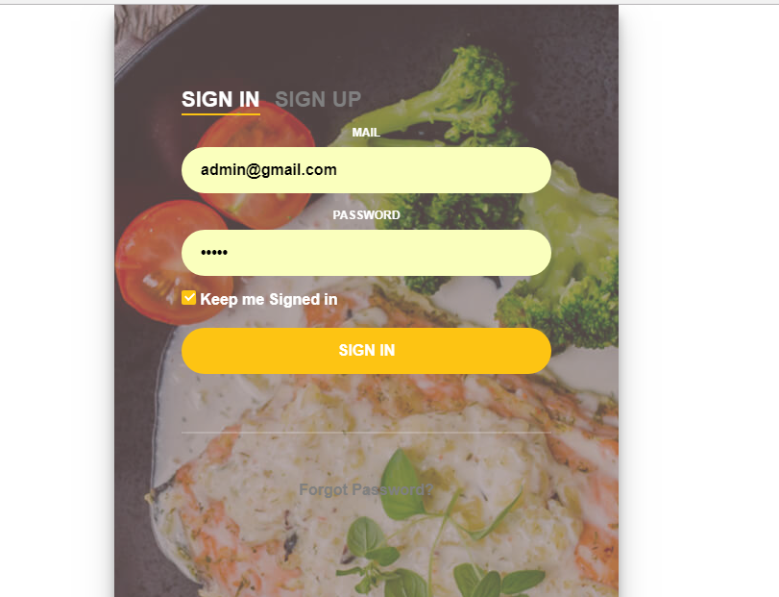

* User Case

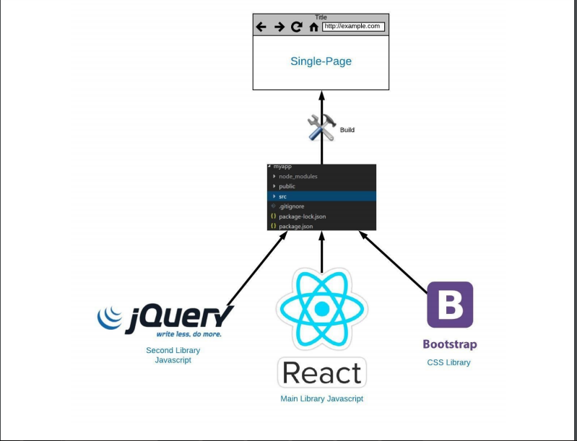

# TECHNICAL CONSTRUCTION

* Workflow mô tả những công nghệ/nền tảng đã sử dụng.
* the technology/platform is used as (ReactJS, JQuery…)
* -Database entity model:

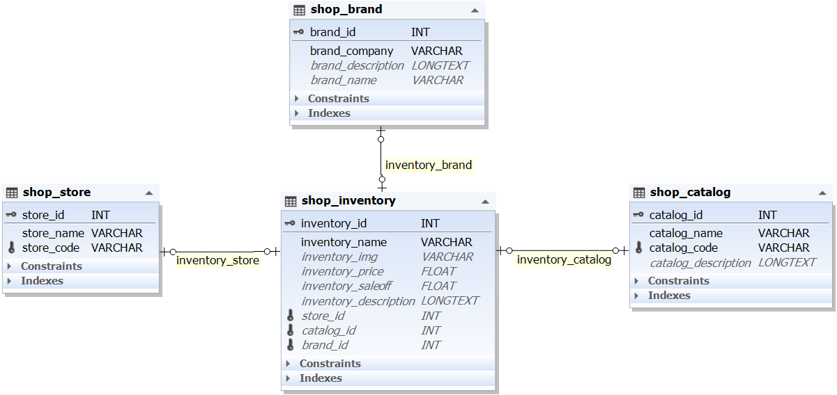

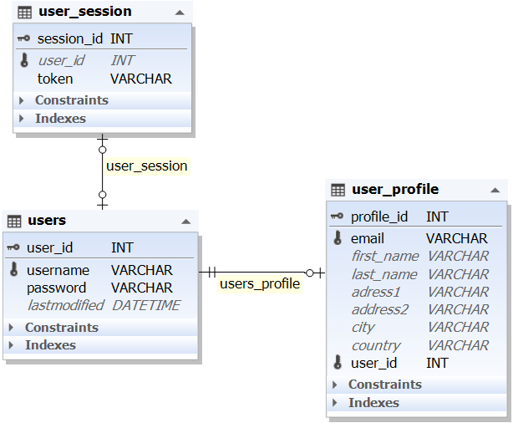

* Workflow

React js : makes it painless to create interactive UIs. Design simple views for each state in your application, and React will efficiently update and render just the right components when your data changes

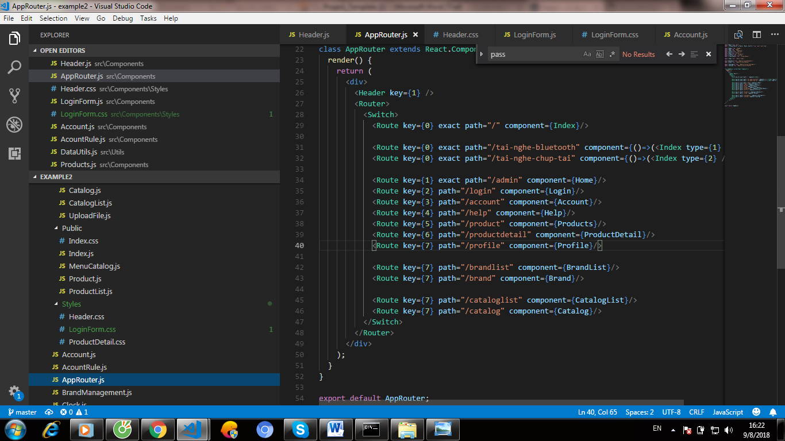

# 

# CONSEQUENCE

* update information up to api or edit the information ,

obtain information from the api and show off the screen and you need to log in when visiting the website

**REFERENCES**

* <https://react-bootstrap.github.io/>
* <https://reactjs.org/>
* <https://reacttraining.com/react-router/>
* <http://www.elevateweb.co.uk/image-zoom/examples>
* <https://www.w3schools.com>
* <https://www.scnsoft.com/blog/web-application-architecture>
* https://vi.wikipedia.org/wiki/Giao_thức_truyền_thông