**Subject: PRF192 - Programming Fundamental with C**

**Workshop 2**

**Objectives:**

* The primary goal of this program is to simulate a salary calculation system for a company using C programming language.
* The system requires **modular design**, **advanced control structures**, and **function-based** computation to calculate salaries, allowances, and generate company statistics.
* This task is designed to enhance their understanding of modular programming, parameter passing, and control flow.

**Problem Description:**

The company needs a program to calculate employee salaries based on the following rules:

* Each employee has a basic salary. Based on this, allowances and total income are calculated.
* The program must also:
* Validate inputs.
* Provide aggregated statistics about the company.
* Demonstrate modular programming through user-defined functions.

**Situation Description:**

The company has employees with varying levels of salaries, and a new HR system is required to:

1. **Input Details**:

* The number of employees.
* The basic salary of each employee.

1. **Perform the following calculations**:

* **Allowance Calculation**:
* If the basic salary is below 6,000,000, the allowance is 25% of the basic salary.
* If the basic salary is between 6,000,000 and 15,000,000 (inclusive), the allowance is 15%.
* If the basic salary exceeds 15,000,000, the allowance is 10%.
* **Income Tax Deduction**:
* Income tax is applied to the total income after adding the allowance:
* If total income <= 8,000,000, no tax is applied.
* If total income > 8,000,000, a 10% tax is applied on the amount exceeding 8,000,000.
* **Total Net Income**:
* Net income is calculated as:

**Net Income = Basic Salary + Allowance − Tax Deduction**

1. **Generate Statistics**:

* The total salary cost (sum of all employees' net incomes).
* The number of employees in each allowance category.

**Syntax Use in the Problem:**

The program must incorporate the following syntax elements effectively:

1. **if and else if**:

* To determine the allowance percentage based on the basic salary range.
* To apply the income tax conditionally.

1. **for loop**:

* To process the salary calculations for multiple employees iteratively.

1. **while loop**:

* To ensure valid input (e.g., the number of employees and basic salary must be non-negative).

1. **User-Defined Functions**:

* Separate the logic into functions for:
* Input validation.
* Allowance calculation.
* Tax deduction.
* Net income calculation.

1. **Parameter Passing by Value**:

* All data between functions is passed by value to ensure simplicity.

**Specific Requirements:**

* **Input**:
* Read the number of employees.
* For each employee, input the basic salary (ensure it is non-negative).
* **Calculations:**
* Compute allowance based on the salary range.
* Deduct income tax if applicable.
* Calculate total net income.
* **Statistics:**
* Compute the total salary cost.
* Count the number of employees in each allowance category.
* **Output:**
* Display detailed salary breakdown for each employee.
* Provide aggregated statistics for the company.

**Hint: Code Design**

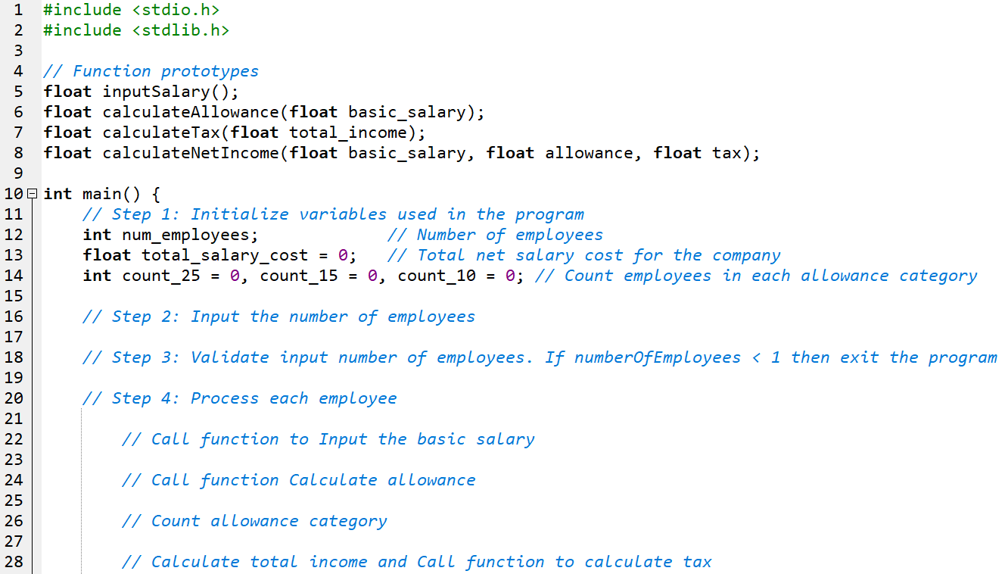

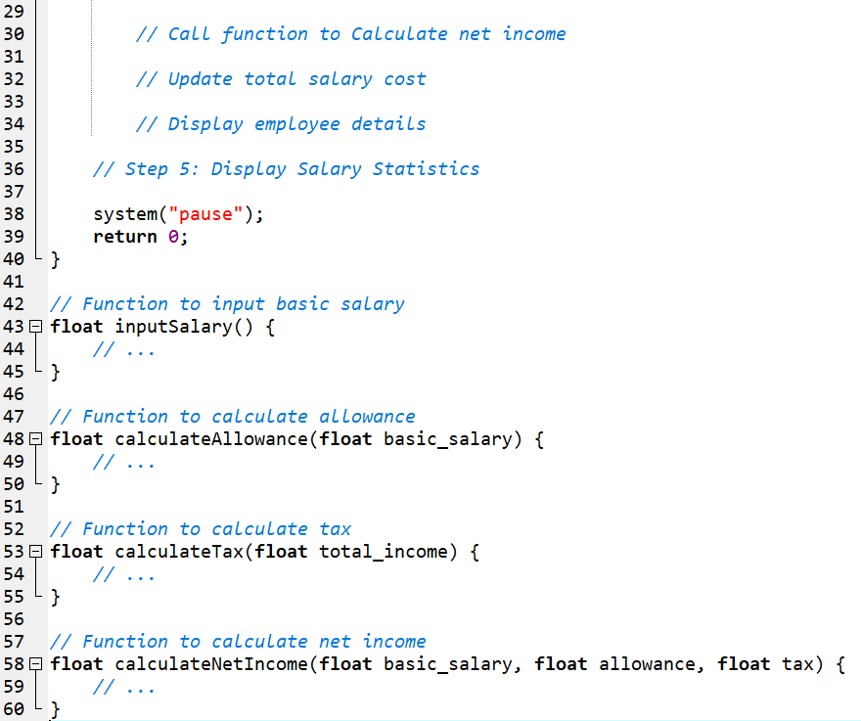

**Output Sample:**

