**Subject: PRF192 - Programming Fundamental with C**

**Workshop 5**

**Objectives:**

In this workshop, you will:

* To understand how to manipulate files in C programming.
* To learn how to read numerical data from a text file into an array.
* To apply concepts of arrays, loops, and file I/O operations in solving real-world problems.
* To enhance problem-solving skills by processing and analyzing data stored in external files.

**Problem Overview:**

Design a program that reads numerical data from a text file into an array. The program will perform the following tasks:

1. Read data from a text file into an array.
2. Display the data stored in the array.
3. Calculate and display the sum, average, maximum, and minimum values of the array elements.
4. Write the results (sum, average, max, and min) to another text file.

**Situation Description:**

In real-world scenarios, numerical data is often stored in external files, such as logs, datasets, or reports. For example:

* A financial system may store daily sales in a file that needs to be analyzed for trends.
* A weather monitoring system may save temperature readings in a file for later statistical analysis.

This program simulates such a scenario by working with a text file containing numerical data. The program processes this data to generate meaningful insights.

**Syntax Use in the Problem:**

1. **File Handling**:

* Use fopen to open a file for reading and writing.
* Use fscanf to read numbers from the file.
* Use fprintf to write results to another file.

1. **Loops**:

* A while loop reads the file data into the array until the end of the file.
* A for loop processes the array to calculate the required statistics.

1. **Conditional Statements**:

* Use if conditions to find the maximum and minimum values in the array.

**Specific Requirements:**

1. **Input:**

The input text file (**data.txt**) contains one number per line.

1. **Output:**

* Display the numbers stored in the array.
* Print the sum, average, maximum, and minimum values to the console.
* Write the results to an output file (**results.txt**).

1. **File Handling:**

* Validate file opening; if a file cannot be opened, display an error message and terminate the program.

**Sample Input File (“data.txt”):**

|  |
| --- |
| 25  30  45  10  60  5 |

**Expected Console Output:**

|  |
| --- |
| Data in the array:  25 30 45 10 60 5  Statistics:  Sum: 175  Average: 29.17  Maximum: 60  Minimum: 5  Results written to results.txt |

**Sample Output File (“results.txt”):**

|  |
| --- |
| Sum: 175  Average: 29.17  Maximum: 60  Minimum: 5 |

**Hint: Code Design**

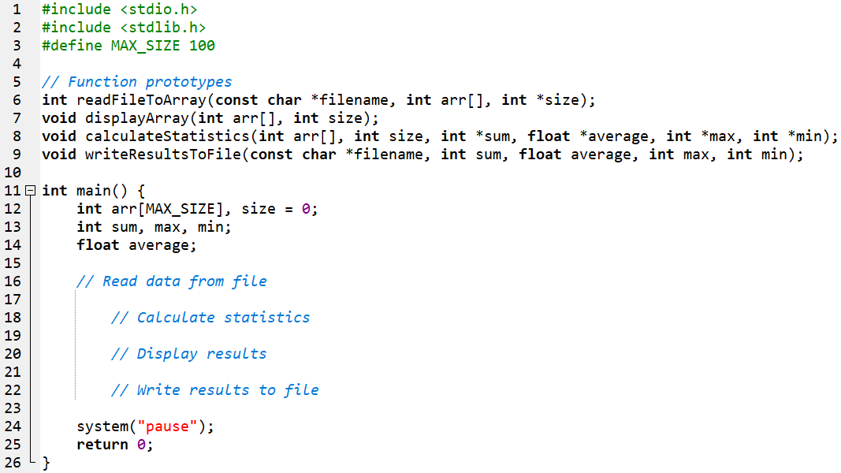

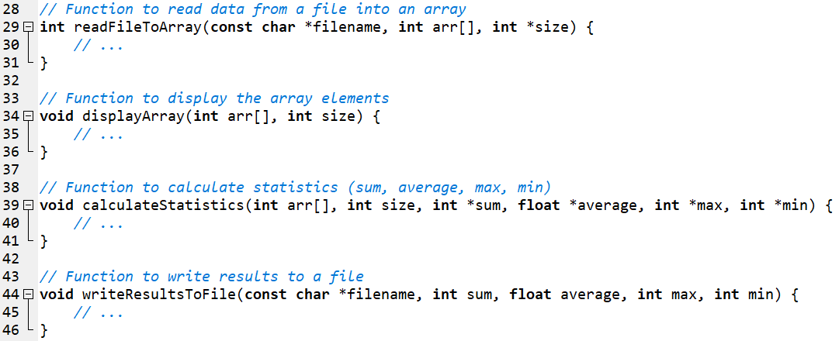

**Output Sample:**

