**Subject: PRF192 - Programming Fundamental with C**

**Workshop 1**

**Objectives:**

In this workshop, you will:

* Understand how to analyze problems and propose appropriate implementation methods.
* Proficient in techniques for declaring and using variables effectively in programs.
* Perform basic input and output operations efficiently.
* Understand and apply fundamental arithmetic operations to process data.
* Know how to use logical control structures (e.g., if-else, switch-case, loops) to handle program requirements.

**Problem: Class Score Management and Statistics**

**Situation Description:**

1. A teacher wants to input and manage the scores of students in a class.
2. The teacher needs to calculate and display:
   * The total score of the class.
   * The average score of the class.
   * The number of students who passed and failed (passing score is >= 5).
3. The program must validate the input to ensure that scores are within the range of 0 to 10.
4. Data should be processed by iterating through the list of students.

**Syntax Use in the Problem:**

1. **if and else**:
   * To check if the scores are valid (in the range 0–10).
   * To classify students as “passed” or “failed” based on their scores.
2. **for**:
   * To loop through the list of students and input their scores.
3. **while**:
   * To handle repetitive actions, such as input validation for the number of students and their scores.

**Specific Requirements:**

1. **Requirement 1: Input Data**
   * Input the number of students.
   * Input each student's score, validating the input using **if-else**.
2. **Requirement 2: Calculation**
   * Use **for** to calculate the total score and count the number of students who passed or failed.
3. **Requirement 3: Statistics**
   * Display:
     + The total score of the class.
     + The average score of the class.
     + The number of students who passed and failed.
4. **Requirement 4: Validation**
   * Ensure that the input is an integer and scores are in the valid range (0–10).

**Hint: Code Design**

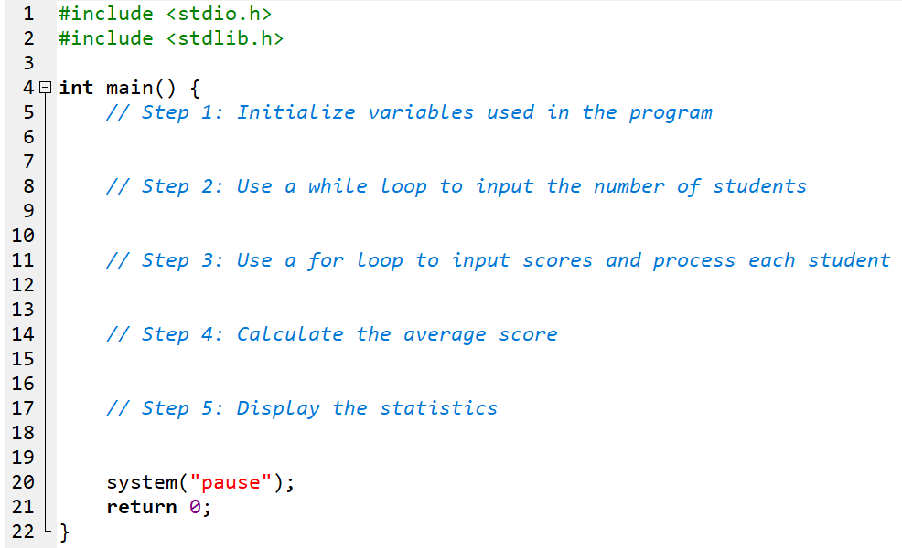

**Output Sample:**

