# TechWiz4

# Installation Guilde SoccerVerse Website Design and Development SRS

**Batch No: *T5.2306.E1***

**Mentor:*****Lê Tuấn Xuyên***

**Group Name: FireAlarm**

|  |  |  |
| --- | --- | --- |
| **Order:** | **Full name** | **Roll No.** |
| *1.* | Lê Vinh Chí | Student1477477 |
| *2.* | Tạ Quốc Thạnh | Student1470287 |
| *3.* | Trần Minh Quang | Student1477192 |
| *4.* | Nguyễn Thanh Hậu | Student1477167 |
| *5.* | Lê Trọng Nghĩa | Student1477172 |
| *6.* | Nguyễn Hoàng Anh Tú | Student1470285 |

***Month****: 08* ***Year****: 2023*

Table of Content

TechWiz4 1

Installation Guilde SoccerVerse Website Design and Development SRS 1

1. **Step 1:**

* Use Winrar to extract file TechWiz4_FireAlarm_Website_Development_SoccerVerse.rar.



* Extracted folder will have 01_Document and Fooball-Website_V5 folders.

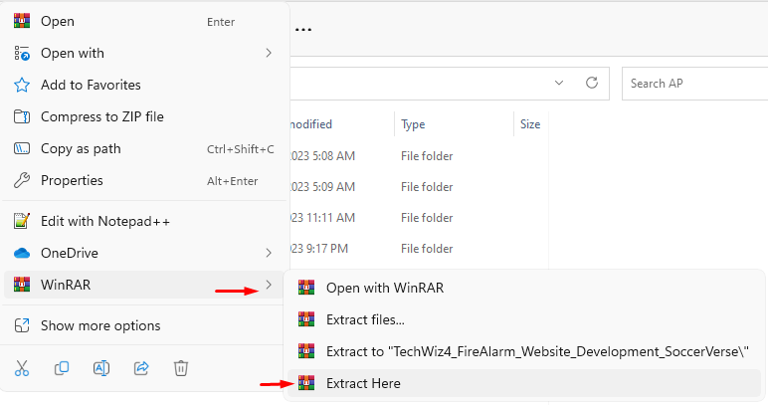

Extract Result:

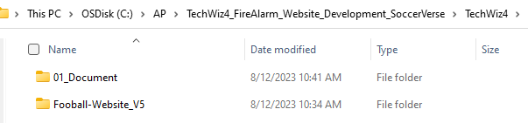

1. **Step 2:**

* Install Visual Code Studio and newest version of Extension “Live Server”.

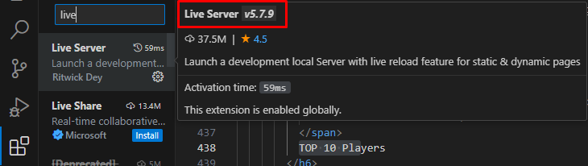

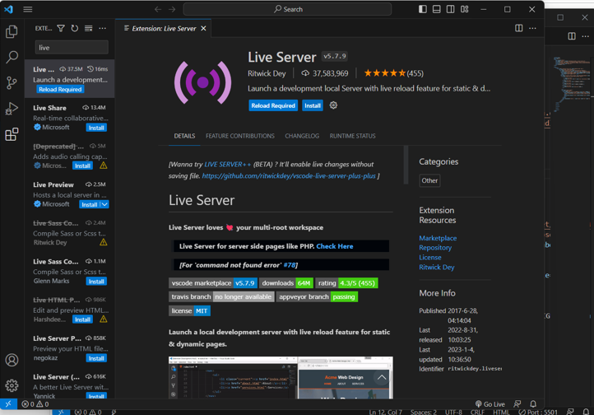

1. **Step 3:**

* In Visual Code Studio: Menu => File => Open Folder => Access to Fooball-Website_V5 folder.

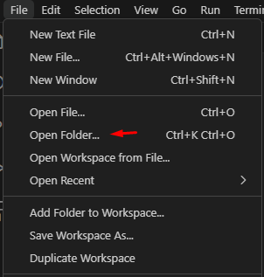

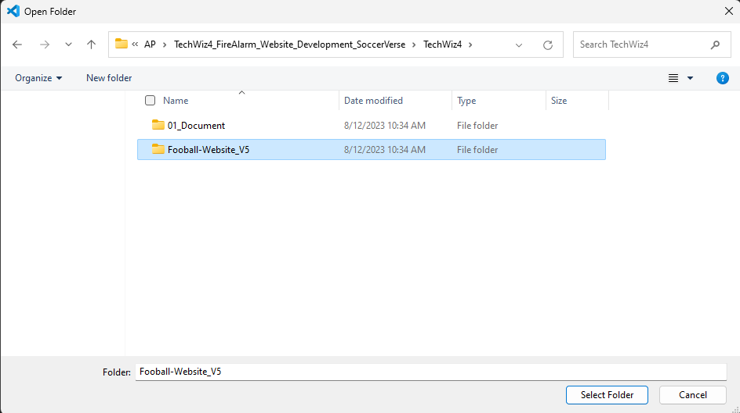

1. **Step 4:**

* In Explorer windows, select “Home.html” in ‘src’ folder.

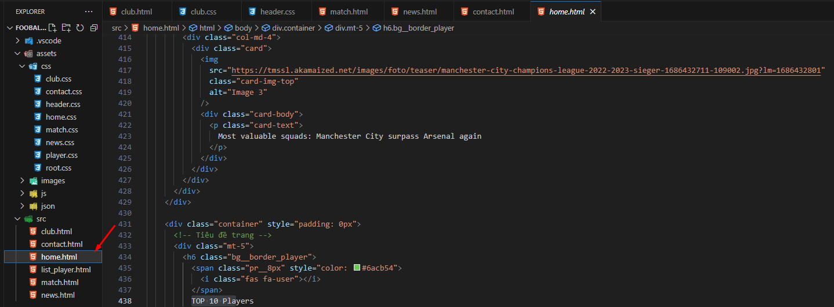

1. **Step 5:**

* At bottom right coner, click “Go Live” to open browser and view the website.

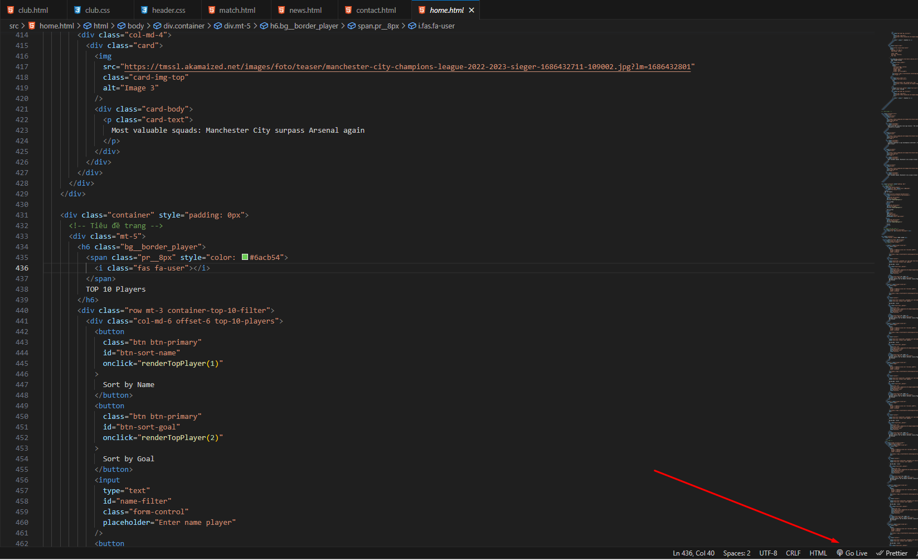

1. **Step 6:**

* Continue to access the website function on browser. Completed.

