2.2.1:

2.2.2:

2.2.3:

2.2.4:

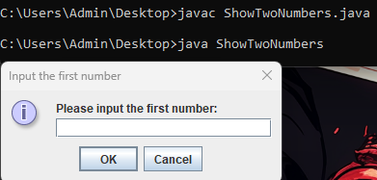

2.2.5:

2.2.6:

Phương trình bậc nhất:

Hệ phương trình bậc nhất:

Phương trình bậc 2:

6.1:

6.2:

6.3:

6.4:

6.5:

6.6:

