

SOFTWARE REQUIREMENT SPECIFICATION
Online Recruitment Management System (Code)

– Hanoi, Jan 2024 –
Table of Contents
I. Record of Changes 3
II. Software Requirement Specification 4
1. Overall Requirements 4
1.1 Context Diagram 4
1.2 Main Business Processes 5
1.3 User Requirements 5
1.4 System Functionalities 7
1.5 Entity Relationship Diagram 7
2. Use Case Specifications 8
2.1 <<Feature Name1>> 8
2.2 Xyz Feature 10
3. Functional Requirements 11
3.1 Feature Name1 11
3.2 User Authentication 11
3.3 System Administration 12
4. Non-Functional Requirements 13
3.1 External Interfaces 13
3.2 Quality Attributes 13
5. Requirement Appendix 14
5.1 Business Rules 14
5.2 System Messages 14
5.3 Other Requirements… 15

I. Record of Changes
Date | A*  M, D | In charge | Change Description
13/09 | M | Hoang Lai | Update Recruiter Use Case
13/09 | A | Hoang Lai | Add Filter Candidates with AI use case
*A - Added M - Modified D - Deleted

II. Software Requirement Specification

1. Overall Requirements

1.1 Context Diagram
[Gives the overall description about the product with some introduction and the context diagram. The context diagram presents the boundary and connections between the system you’re developing and everything else in the universe. This identifies external entities (or terminators – software, hardware, human components, and other systems) outside the system that interface to it in some way, as well as data, control, and material flows between the terminators and the system.]
<<Sample: The Cafeteria Ordering System is a new software system that replaces the current manual and telephone processes for ordering and picking up meals in the Process Impact cafeteria. The context diagram below illustrates the external entities and system interfaces for release 1.0. The system is expected to evolve over several releases, ultimately connecting to the Internet ordering services for several local restaurants and to credit and debit card authorization services.
The Online Recruitment and Job Search System is a new web-based platform that replaces traditional recruitment and job search processes. The context diagram below illustrates the external entities and system interfaces. The system is expected to evolve through multiple versions to become a comprehensive and efficient recruitment platform, providing advanced features such as AI-powered job matching, online interviews, and recruitment analytics.

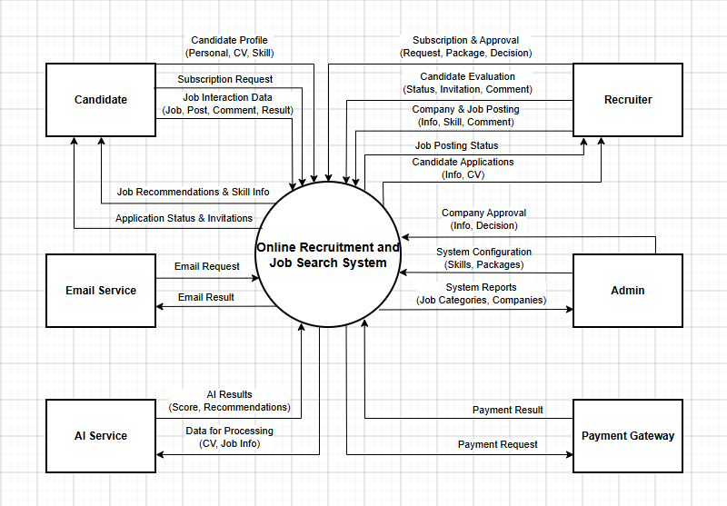

1.2 Main Business Processes
Job Application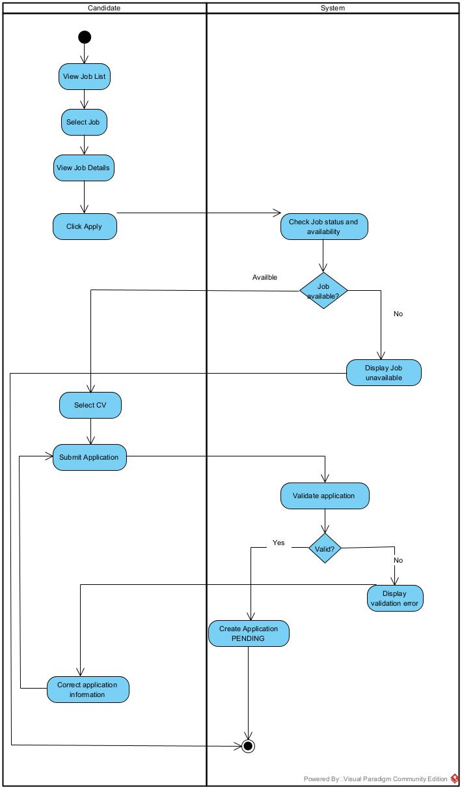
Review Job Application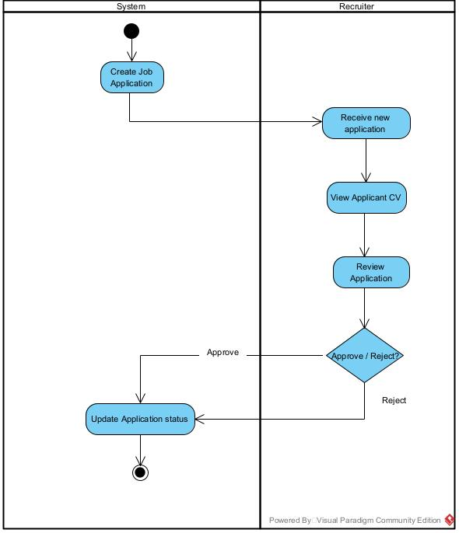

Job Posting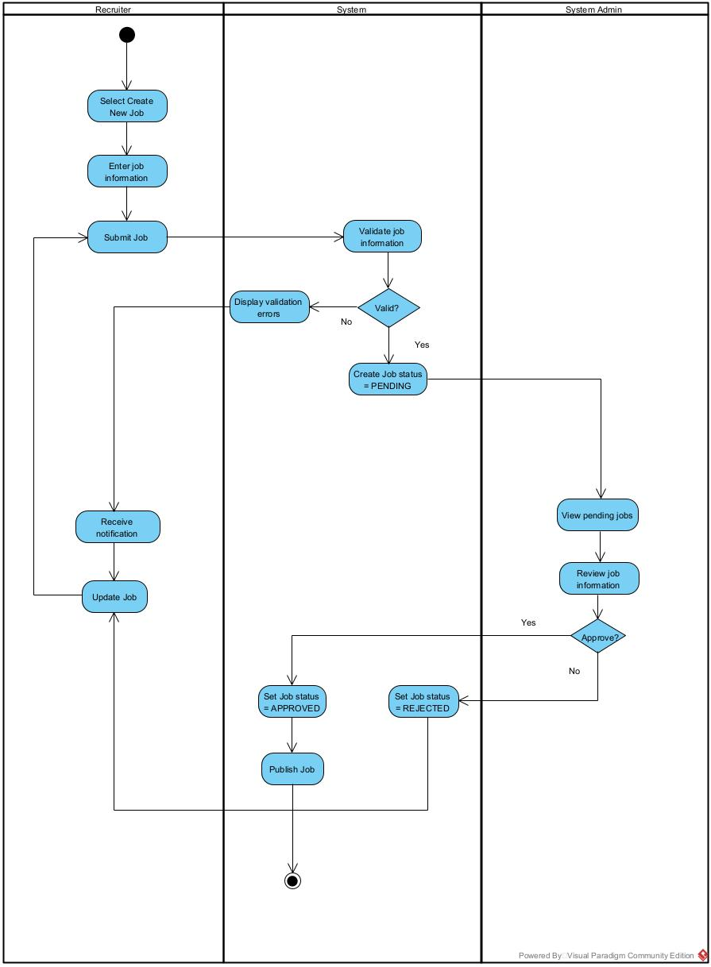
Recruiter onboarding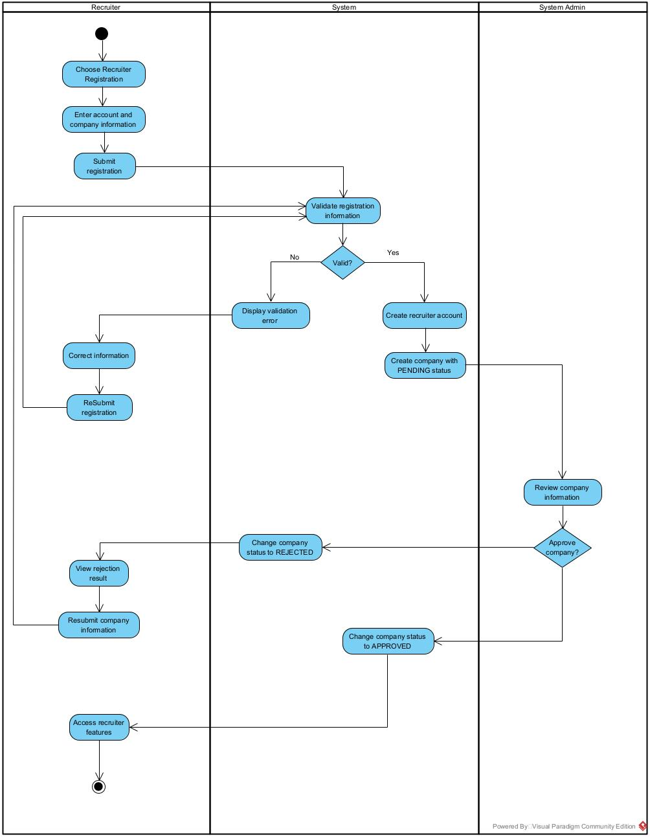

1.3 User Requirements

1.3.1 Actors
[An actor is someone/something that interacts with the system.
- The only external entities that interact with the system
- ﻿Actors are outside the system and not part of it
- ﻿A user is an individual, whereas an actor represents the role played by all users of the same type
- There are other types of actors in addition to or in place of human actors: external systems, I/O devices, or timers
Following are some questions you might ask to help user representatives identify actors
- Who (or what) is notified when something occurs within the system?
- Who (or what) provides information or services to the system?
- Who (or what) helps the system respond to and complete a task?
This part gives the description of system actors, you can follow the table form as below]
# | Actor | Description
1 | Administrator | Actor description here..
2 | Menu Manager | ..
3 | …

1.3.2 Use Cases (UC)
[A use case (UC) describes a sequence of interactions between a system and an external actor that results in the actor being able to achieve some outcome of value. The names of use cases are always written in the form of a verb followed by an object. Select strong, descriptive names to make it evident from the name that the use case will deliver something valuable for some user.
Following are some questions you might ask to help user representatives identify use cases
- What will the actor use the system for?
- Will the actor create, store, change, remove, or read data in the system?
- Will the actor need to inform the system about external events or changes?
- Will the actor need to be informed about certain occurrences in the system?
This part describes the use cases you could define, you can follow the table form as below]
ID | Use Case | Feature | Use Case Description
01 | Register Account | Account | Candidate creates an account using email, phone number, and password.
02 | Login | Account | Candidate logs into the system using their account credentials.
03 | Logout | Account | Candidate logs out and ends the current session.
05 | Forgot Password | Account | Candidate requests assistance to recover a forgotten password.
06 | Change Password | Account | Candidate changes their account password.
07 | Create Personal Profile | Account | Candidate creates a profile containing personal information, contact details, skills, education, and experience.
08 | View Personal Profile | Account | Candidate views their personal profile information.
09 | Candidate edits and updates their personal profile. | Account | Candidate edits and updates their personal profile.
10 | Upload CV | CV Management | Candidate uploads a CV file to the system.
11 | View CV | CV Management | Candidate views a CV stored in the system.
12 | Update CV | CV Management | Candidate replaces or updates an existing CV.
13 | Delete CV | CV Management | Candidate deletes a CV that is no longer needed.
14 | View Job Listings | CV Management | Candidate views currently available job postings.
15 | Search for Jobs | CV Management | Candidate searches for jobs using keywords.
16 | Filter Jobs | Job Application | Candidate filters jobs by industry, location, salary, and experience.
17 | View Job Details | Job Application | Candidate views job description, requirements, benefits, salary, and location.
18 | View Company Information | Job Application | Candidate views company profile and recruiter information.
19 | View Application History | Job Application | Candidate views their previous job applications.
20 | Track Application Status | Job Application | Candidate tracks application status such as submitted, under review, interview, hired, or rejected.
21 | Create Company Profile | Company Management | Recruiter creates company information and introduction.
22 | View Company Profile | Company Management | Recruiter views the company profile.
23 | Update Company Profile | Company Management | Recruiter edits and updates company information.
24 | Create Job Posting | Recruitment | Recruiter creates a job posting including position, description, requirements, salary, and location.
25 | Edit Job Posting | Recruitment | Recruiter edits the content of an existing job posting.
26 | Delete Job Posting | Recruitment | Recruiter deletes a job posting that is no longer needed.
27 | Submit Job Posting for Approval | Recruitment | Recruiter submits a job posting to the Admin for approval.
28 | View Job Postings | Recruitment | Recruiter views the company's job postings.
29 | Close Job Posting | Recruitment | Recruiter closes a job posting when recruitment is no longer needed.
30 | Extend Job Posting | Recruitment | Recruiter extends the posting period of a job.
31 | View Candidate List | Candidate Management | Recruiter views candidates who have applied for jobs.
32 | Search Candidates | Candidate Management | Recruiter searches for candidates using keywords and profile information.
33 | Filter Candidates | Candidate Management | Recruiter filters candidates by skills, experience, position, and other criteria.
34 | View Candidate Profile | Candidate Management | Recruiter views detailed information about a candidate.
35 | View/Download Candidate CV | Candidate Management | Recruiter views or downloads a candidate's CV for evaluation.
36 | Save Candidate | Candidate Management | Recruiter saves potential candidates for future consideration.
37 | Update Candidate Status | Candidate Management | Recruiter changes a candidate's status during the recruitment process.
38 | Schedule Interview | Interview | Recruiter creates an interview schedule for a candidate.
3 | Send Interview Invitation | Interview | Recruiter sends interview information and an invitation to a candidate.
40 | Send Recruitment Result | Recruitment | Recruiter notifies the candidate of the recruitment result or sends a job offer.
41 | Manage Users | User Management | Admin views, searches, and manages user accounts in the system.
42 | Manage Candidates | User Management | Admin manages candidate accounts and their status.
43 | Manage Recruiters | User Management | Admin manages recruiter accounts.
44 | Approve Job Posting | Job Posting Management | Admin reviews and approves job postings before publication.
45 | Reject Job Posting | Job Posting Management | Admin rejects job postings that do not meet requirements.
46 | Manage Job Postings | Job Posting Management | Admin views, hides, or deletes violating job postings.
47 | Handle Violation Reports | Report Management | Admin receives and handles reports submitted by users.
48 | View System Statistics | Report Management | Admin views statistics about users, job postings, candidates, and recruitment activities.
49 | Manage Permissions | Security Management | Admin manages access permissions for different user groups.
…

1.3.2 Use Case Diagrams
In this section, you need to provide the UC diagram(s) to show the actor-UCs and UC-UC relationships like the sample below. You can have multiple UC diagrams for the system, each diagram is for one actor or one workflow]

1.3.2.1 UCs for User
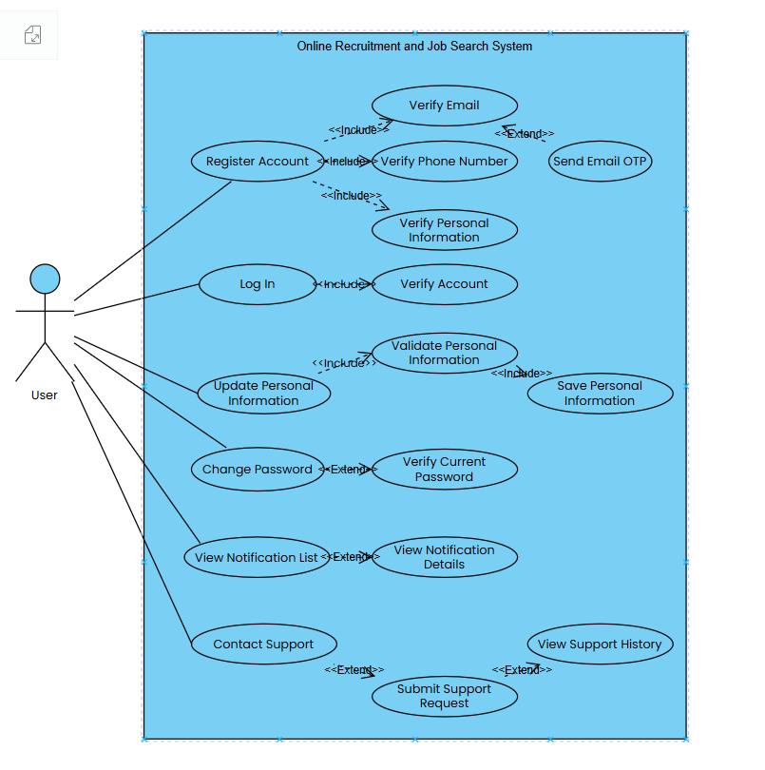

1.3.2.2 UCs for Candidate
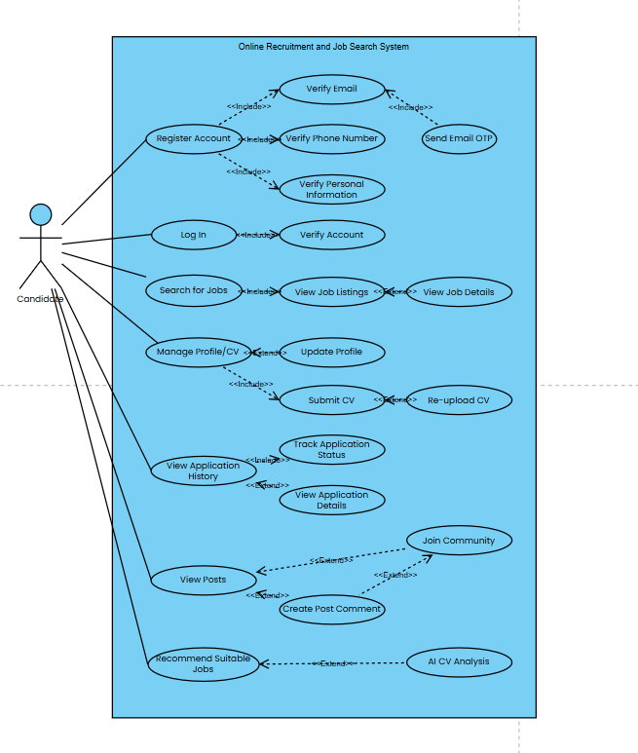

1.3.2.3 UCs for Recruiter
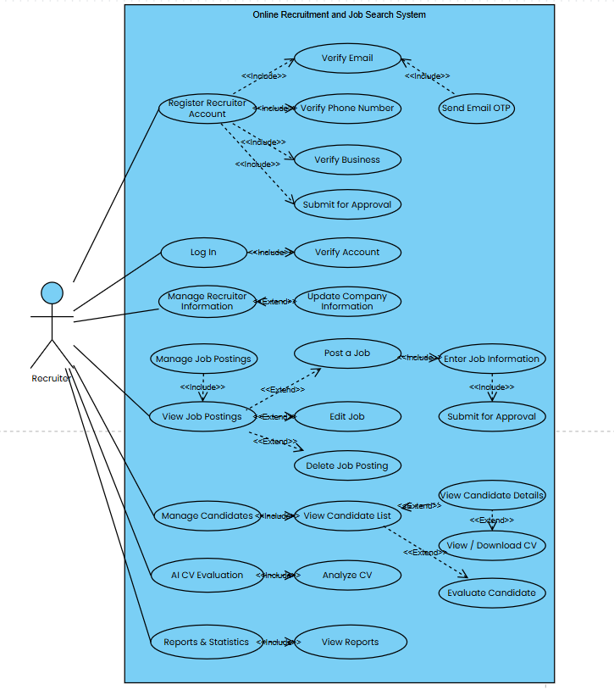

1.3.2.4 UCs for System Admin
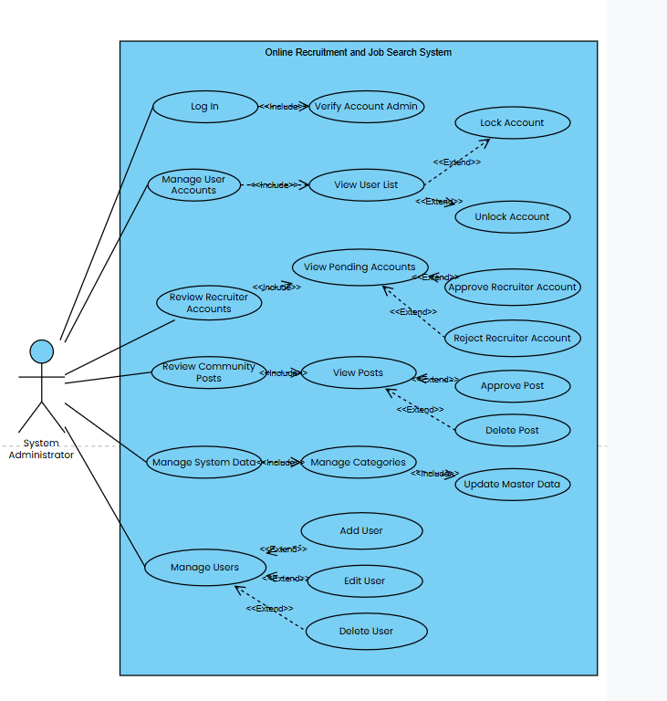

1.4 System Functionalities

1.4.1 Screens Flow

1.4.1.1 Screens Flow for Guest

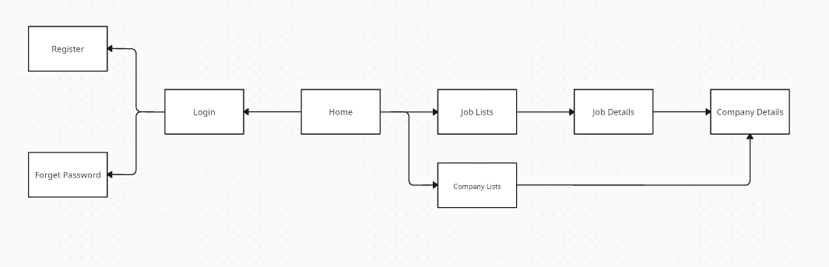

1.4.1.2 Screens Flow for Candidate
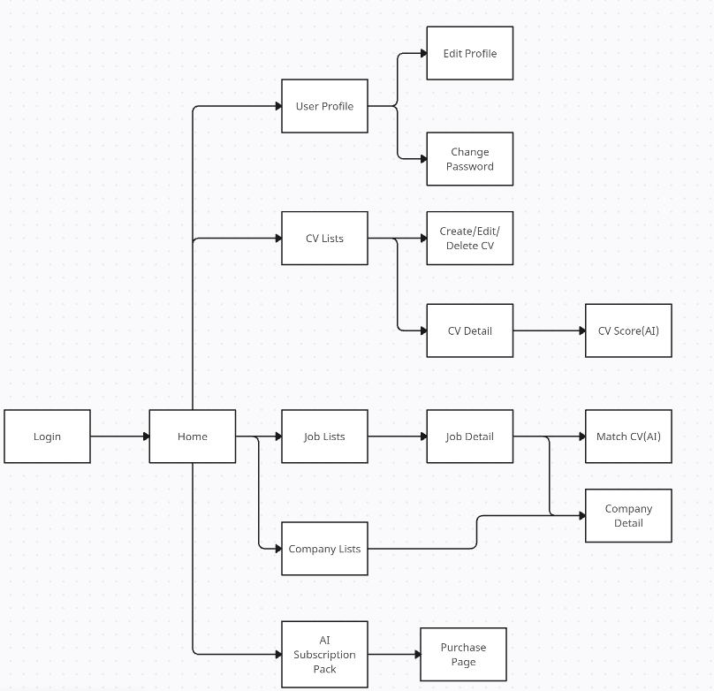

1.4.1.3 Screens Flow for Recruiterx
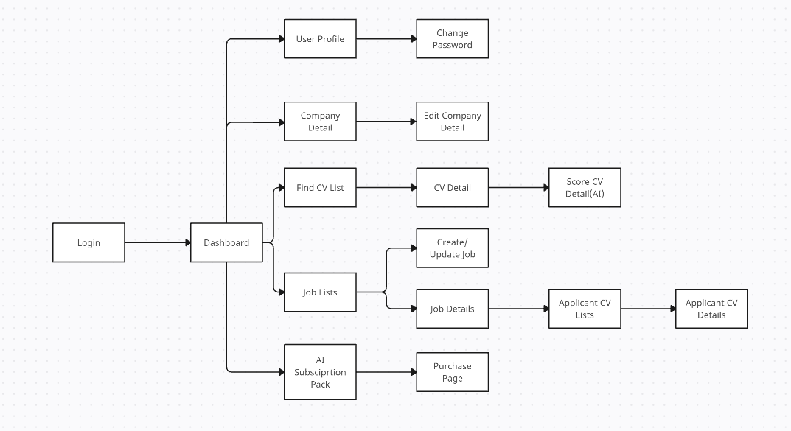

1.4.1.4 Screens Flow Admin
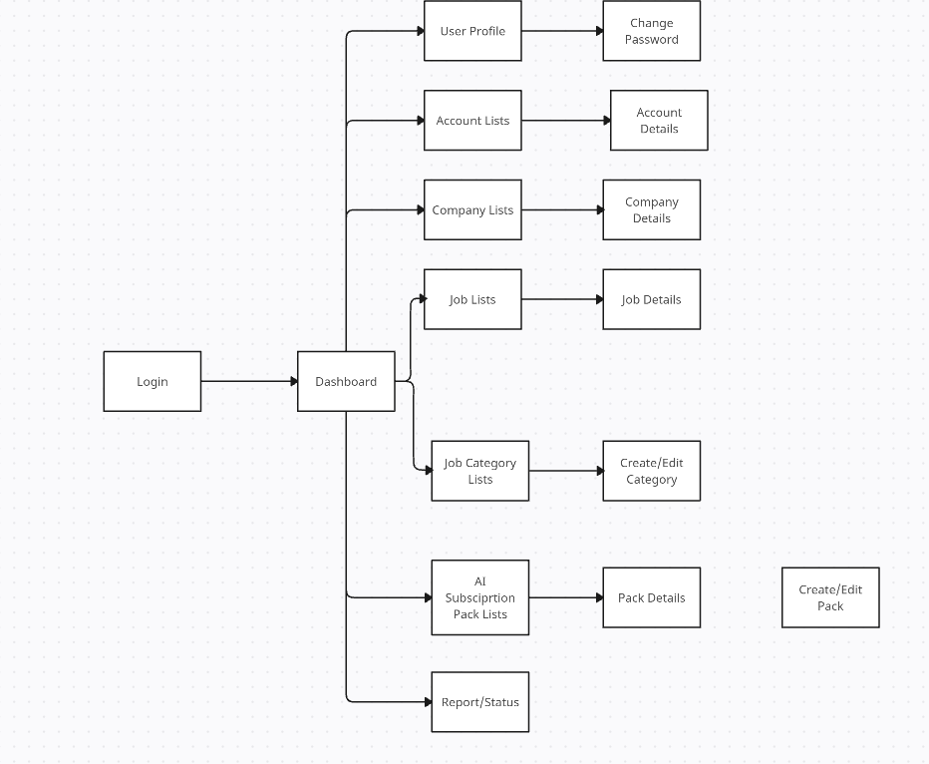

1.4.2 Screen Authorization

Screen | Guest | Candidate | Employer | Admin
Register | X
Forget Password | X
Login | X | X | X | X
Home | X | X | X | X
Dashboard |  |  | X | X
User Profile |  | X | X | X
Edit Profile |  | X | X
Change Password |  | X | X | X
CV Lists |  | X
Create/Edit/Delete CV |  | X
CV Detail |  | X | X
CV Score(AI) |  | X | X
Match CV(AI) |  | X
Find CV List |  |  | X
Job Lists | X | X | X | X
Job Details | X | X | X | X
Create/Update Job |  |  | X
Applicant CV Lists |  |  | X
Applicant CV Details |  |  | X
Company Lists | X | X |  | X
Company Details | X | X | X | X
Edit Company Detail |  |  | X
AI Subscription Pack / Lists |  | X | X | X
Purchase Page |  | X | X
Pack Details / Create/Edit Pack |  |  |  | X
Account Lists |  |  |  | X
Account Details |  |  |  | X
Job Category Lists |  |  |  | X
Create/Edit Category |  |  |  | X
Report/Status |  |  |  | X

1.4.3 Non-UI Functions
[Provide the descriptions for the non-screen system functions, i.e batch/cron job, service, API, etc.]
# | Feature | System Function | Description
1 | AI Scoring | eval_cv_scoring_service | Automatically analyze CV content, calculate metrics, and return the number of suitable or high-quality CVs
2 | Authentication & Security | auth_token_service | Handle login, issue tokens (JWT/Session), authenticate access rights, and encrypt passwords
3 | Password Reset | send_reset_password_mail | Generate a verification code or password recovery link and email it to the user when they use the "Forgot Password" function
4 | Payment Processing | payment_gateway_api | Integrate with a third-party payment gateway to process transactions when users purchase AI service packages ("Purchase Page")
5 | Subscription Renewal & Status | check_subscription_cron | Run a periodic background job (cron job) to check the expiration date of users' AI subscription plans and automatically update their status to expired
6 | AI Matching | match_cv_job_service | Compare CV data against job requirements to determine the compatibility percentage
7 | Reporting & Analytics | aggregate_system_metrics | Compile and aggregate data on job applications, AI package revenue, and account counts to populate the "Report/Status" screen

1.5 Entity Relationship Diagram
[Provide the ERD using the Crow-Foot notation and the entity descriptions as below]

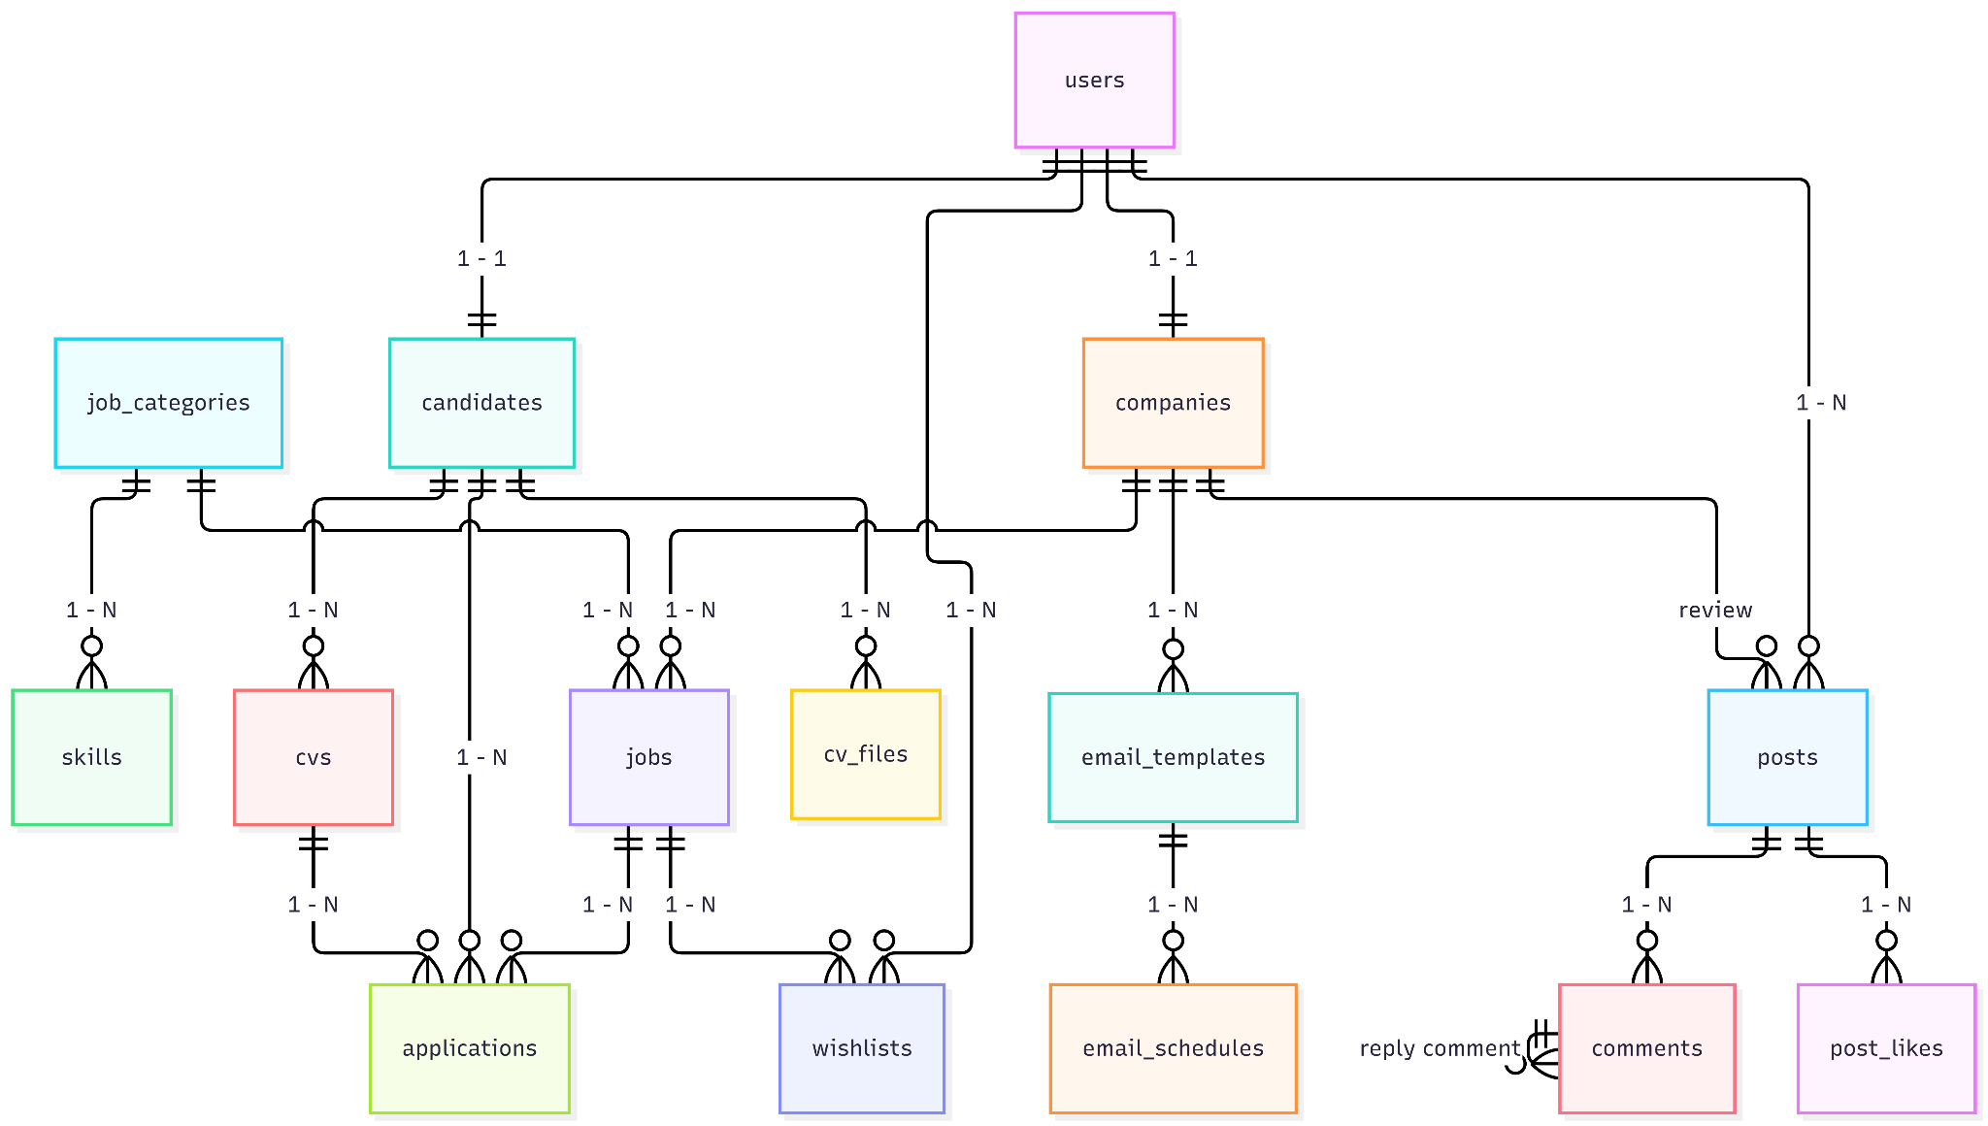

Entities Description
# | Entity | Description
1 | tb_users | Stores account credentials, personal details, roles (candidate, recruiter, admin), and authentication status across the system
2 | tb_tokens | Manages authentication tokens and password recovery/verification tokens for users and companies
3 | tb_companies | Contains business profiles, tax registration details, approval status, and verification assets for employers
4 | tb_candidates | Holds high-level professional profiles for candidates linked to their system accounts (desired title, total experience, bio)
5 | tb_cv | Serves as the editable master CV record containing personal objectives and basic candidate information
6 | tb_cv_attachments | Stores historical employment background, job titles, and responsibilities linked to a master CV
7 | tb_educations | Tracks academic records, degrees, and institutions linked to a master CV
8 | tb_projects | Details specific portfolio projects, roles, and accomplishments linked to a master CV
9 | tb_certificates | Holds professional certification records and issue dates linked to a master CV
10 | tb_awards | Records honors, achievements, and recognition linked to a master CV
11 | tb_activities | Logs extracurricular activities, volunteer work, and social organizations linked to a master CV
12 | tb_references | Stores contact information for professional reference persons linked to a master CV
13 | tb_job_categories | System lookup table defining industries and specialized career fields
14 | tb_skills | Categorized technical and soft skills mapped to specific job industries
15 | tb_jobs | Recruitment listings posted by employers, including requirements, location, compensation, and approval status
16 | tb_wishlist | Bookmark mapping between users and saved job postings for later review
17 | tb_cv_apply | Main application tracking table recording job applications; acts as an immutable snapshot of candidate data at submission time
18 | tb_work_experiences_apply | Immutable snapshot of work experience data at the exact time of job application
19 | tb_educations_apply | Immutable snapshot of educational history at the exact time of job application
20 | tb_projects_apply | Immutable snapshot of candidate project details at the exact time of job application
21 | tb_certificates_apply | Immutable snapshot of candidate certificates at the exact time of job application
22 | tb_certificates_apply | Immutable snapshot of candidate certificates at the exact time of job application
23 | tb_awards_apply | Immutable snapshot of candidate awards at the exact time of job application
24 | tb_activities_apply | Immutable snapshot of candidate volunteer/extracurricular activities at submission
25 | tb_references_apply | Immutable snapshot of reference contacts submitted with a specific application
26 | tb_ai_packages | Defines available subscription tiers and paid AI feature packages for platform users
27 | tb_candidate_ai_usage | Logs transactional history of AI services consumed by candidates
28 | tb_notifications | System-wide broadcast and transactional notification records

2. Use Case Specifications
[Provide specifications for the use cases (UCs) those are covered in the system. The UCs are grouped by the system features and even sub features. You just need to provide UC specifications for complex UCs involving in the main workflows (business processes). Other UCs (i.e CRUD or data-viewing UCs) are simple, and you just need to refer the descriptions in the Functional Requirement (part 3) below)]

2.1 <<Feature Name1>>

2.1.1 UC Name1
Primary Actors |  | Secondary Actors
Description
Preconditions
Postconditions
Normal Sequence/Flow
Alternative Sequences/Flows

Primary and Secondary Actors
An actor is a person or other entity external to the software system being specified who interacts with the system and performs use cases to accomplish tasks. Name the primary actor that will be initiating this UC and any other secondary actors who will participate in completing execution of the UC.
Description
Provide a brief description of the reason for and outcome of this use case, or a high-level description of the sequence of actions and the outcome of executing the use case. The description can be in the form of a user story (As a <type of user>, I want <some goal> so that <some reasons>)
Preconditions
List any activities that must take place, or any conditions that must be true, before the use case can be started.
Postconditions
Describe the state of the system at the successful conclusion of the use case execution.
Normal Flow
Provide a description of the user actions and corresponding system responses that will take place during execution of the use case under normal, expected conditions.
Alternative Flows
Describe below two information if any:
- Other successful usage scenarios that can take place within this use case. State the alternative flow, and describe any differences in the sequence of steps that take place.
- Any anticipated error conditions that could occur during execution of the use case and how the system is to respond to those conditions.

2.1.2 Login System
Primary Actors | Customer | Secondary Actors | None
Description | As a user, I want to be able to log into the system so that I can use the system’s authenticated features and access my personalized account.
Preconditions | User account has been created & authorized
Postconditions | - User logs in the system successfully  - The system tracked successful login into the Activity Log
Normal Sequence/Flow | Login System  - User clicks Login button from the page header or accesses an authenticated feature (from a link or type the page URL directly into the address bar)  - System show the User Login screen  - User types in the login details (email, password)  - User clicks the Login button  - System validates the login details (BR-01, BR-02)  - System allows user to access  - System tracks user’s success login to the Activity Log  - System directs user to the Home Page (or the previous calling page if any)
Alternative Sequences/Flows | Step 2.1_Google Login  - User clicks Google Login button to login system using Google account  - System redirects the user to the Google’s Login screen  - User types in the Google account details and chooses to login  - Google validates user’s login information successfully and redirect him/her back to the system  - Return to step 5 of normal flow.  Step 4_System can’t authenticate the user  User can’t be authenticated & get relevant error message in one of below cases  - He/she leaves the Email and/or Password field blank (MSG10)  - Input Email or Password are incorrect (MSG09)  - Input Email/Password are correct but email has not been verified (MSG11)  - The user account is blocked / inactive (MSG12)  If user inputs wrong logging-in details 5 times continuously, system will lock his/her account in 30 minutes (with relevant warning message - MSG13)

2.1.3 UC Name2
…

2.2 Xyz Feature
…

3. Functional Requirements
[Provide descriptions about the system’s functions/screens. The functions/screens are grouped by the system features, and even sub-features if needed. For the screens, you need to provide the screen layouts (mock-up screens) and relevant specifications if needed]

3.1 Job Management

3.1.1 Job Posting Management

3.1.1.1 Create job
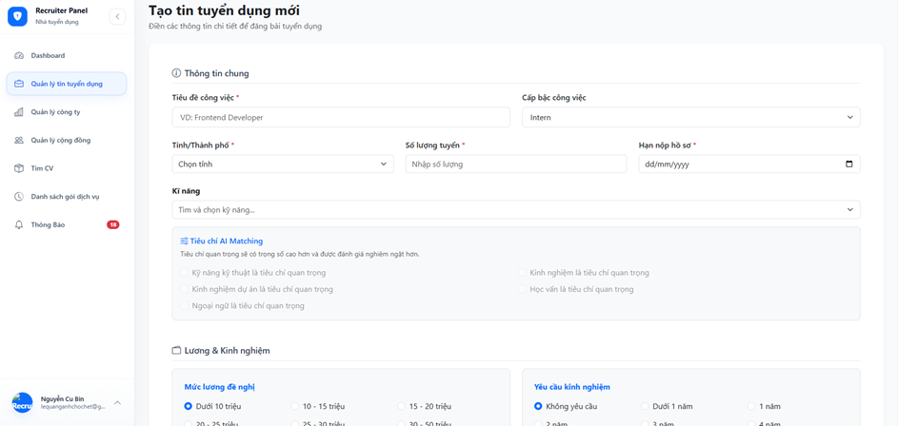

Field Name | Description
Job Title | The title of the position being recruited. This is a required field. Example: Frontend Developer.
Job Level | The level of the position, such as Intern, Fresher, Junior, Senior, or Manager.
Province/City | The province or city where the employee will work. This is a required field.
Number of Vacancies | The number of candidates the company needs to recruit for the position. The value must be a positive integer.
Application Deadline | The final date on which candidates can submit their applications. This is a required field.
Skills | A list of skills required for the position. The recruiter can search for and select multiple skills.
Technical Skill Priority | Indicates that technical skills are an important criterion and will receive a higher weight during AI-based CV matching.
Project Experience Priority | Indicates that project experience is an important criterion when the AI Matching feature evaluates candidates.
Language Priority | Indicates that foreign-language proficiency is an important criterion in the candidate evaluation process.
Work Experience Priority | Indicates that work experience is an important criterion and will receive a higher evaluation weight.
Education Priority | Indicates that the candidate’s educational background is an important criterion when the AI Matching feature scores CVs.
Proposed Salary | The salary range offered by the company for the position.
Required Experience | The minimum amount of work experience required, such as no experience, less than one year, or one year.
Job Description | A detailed description of the duties, responsibilities, and tasks associated with the position.
Candidate Requirements | The knowledge, skills, experience, attitude, and personal qualities required from candidates.
Benefits | The benefits provided to employees, such as bonuses, insurance, allowances, paid leave, or training opportunities.
Contact Phone Number | The phone number used by candidates or the system to contact the recruiter.
Cancel | Cancels the job-creation process and returns the user to the previous page or the job list.
Reset | Clears all entered data and restores the form to its initial state.
Submit for Approval | Submits the job posting to the system for storage and sends it to the administrator for review and approval.

3.1.1.2 Update job
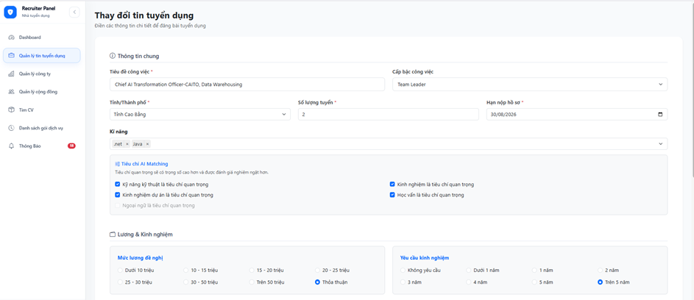
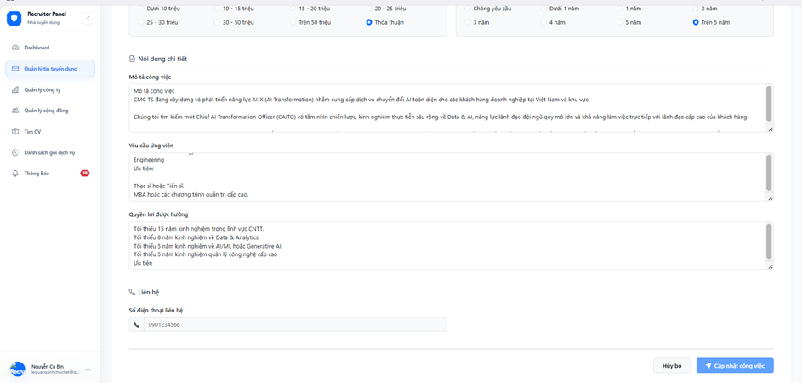

Field Name | Description
Job Title | Displays the current title of the job posting and allows the recruiter to modify it. This is a required field.
Job Level | Allows the recruiter to update the level of the position, such as Intern, Junior, Senior, Team Leader, or Manager.
Province/City | Specifies the working location of the job. The recruiter can select another province or city. This is a required field.
Number of Vacancies | Specifies the number of employees required for the position. The value must be a positive integer.
Application Deadline | Specifies the final date on which candidates can submit their applications. This is a required field.
Skills | Displays the currently selected skills and allows the recruiter to add or remove skills required for the job.
Technical Skill Priority | Indicates that technical skills are an important AI Matching criterion and should receive a higher evaluation weight.
Project Experience Priority | Indicates that project experience is an important criterion when the system evaluates candidate CVs.
Language Priority | Indicates that foreign-language proficiency is an important AI Matching criterion.
Work Experience Priority | Indicates that work experience is an important criterion and should receive a higher matching weight.
Education Priority | Indicates that the candidate’s educational background is an important AI Matching criterion.
Proposed Salary | Allows the recruiter to update the salary range offered for the position, such as under 10 million, 10–15 million, or negotiable.
Required Experience | Allows the recruiter to specify the minimum experience required, such as no experience, under one year, or more than five years.
Job Description | Contains detailed information about the position, including its responsibilities, duties, and main activities.
Candidate Requirements | Contains the qualifications, education, professional experience, skills, and personal qualities required from applicants.
Benefits | Contains information about the benefits offered to successful candidates, such as salary, bonuses, insurance, allowances, and training opportunities.
Contact Phone Number | Displays the phone number used by candidates or the system to contact the recruiter.
Cancel | Cancels the editing process without saving the changes and returns the recruiter to the previous page or job list.
Update Job | Validates and saves the modified job information. The updated job posting may be submitted for administrator review depending on the system workflow.

[Content #1: UI layout (Mockup screen prototype)]
[Content #2: brief descriptions of the screen/function, mapped to the relevant use cases]
[Content #3: provide further descriptions for the screen’s components/fields using table format below]
Field Name | Description
Field Name1 | Field description: data type min/max length or value, initial data, etc.
Field Name2 | …
Field Group-Name1
Field Name3 | …
Field Name4 | …
Field Group-Name2
… | …
3.1.1.2 Screen/Function Name2S
…

3.1.2 SubFeature Name1.2
…

3.2 User Authentication

3.2.1 User Login
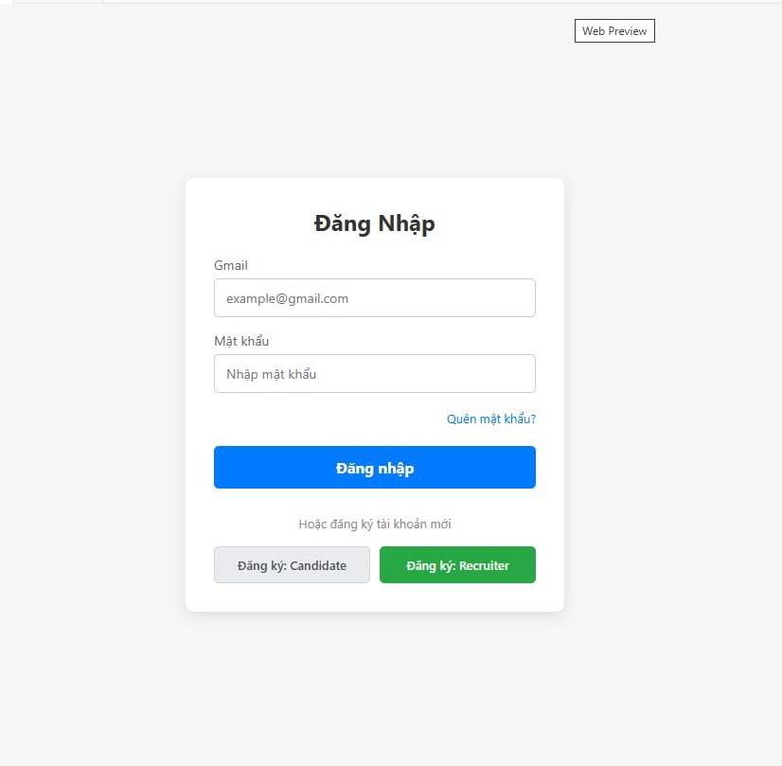

Field Name | Description
Email | Textbox, Email format, mandatory. Validates user input against registered accounts
Password | Textbox (masked ***), mandatory
Forgot Password | Link/Button, redirects user to the password recovery screen
Login | Button, submits credentials for authentication
Register as Candidate | Button/Link, redirects user to the Candidate Registration screen
Register as Recruiter | Button/Link, redirects user to the Recruiter Registration screen

3.2.2 Candidate Register
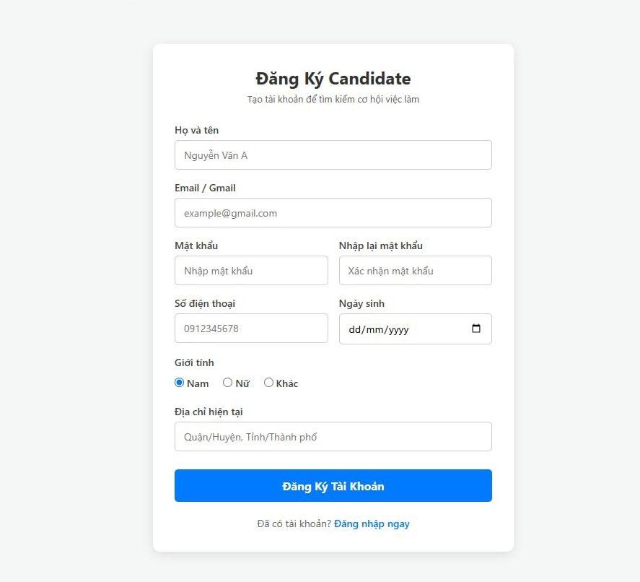

Field Name | Description
Full Name | Textbox, string, mandatory, max length 100 characters
Email | Textbox, Email format, mandatory, must be unique in the system
Password | Textbox (masked ***), minimum 8 characters, mandatory
Confirm Password | Textbox (masked ***), mandatory, must match Password
Phone Number | Textbox, numeric format (10 digits), mandatory
Date of Birth | Datepicker, format DD/MM/YYYY, mandatory
Gender | Radio button, options: Male / Female / Other (Default: Male)
Current Address | Textbox, string, mandatory, max length 255 characters
Register Account | Button, validates form constraints and saves new candidate data into DB
Login Now | Link, redirects user back to the Login Screen

3.2.3 Recruiter Register
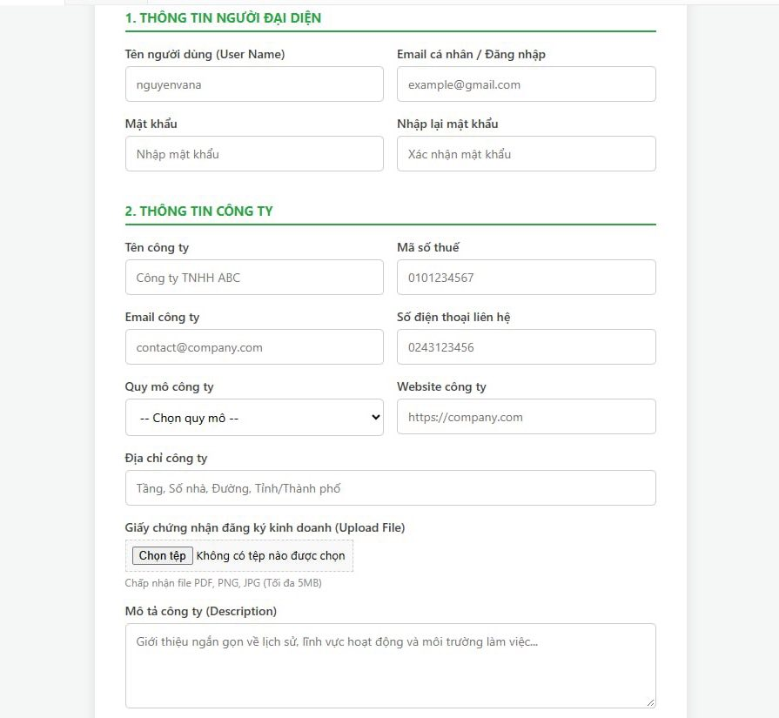

Field Name | Description
Username | Textbox, string (no spaces/special characters), mandatory, unique
Personal Email | Textbox, Email format, mandatory, used for login credentials
Password | Textbox (masked ***), minimum 8 characters, mandatory
Confirm Password | Textbox (masked ***), mandatory, must match Password
Company Name | Textbox, string, mandatory, max length 200 characters
Tax Code | Textbox, alphanumeric business tax ID format, mandatory
Gender | Radio button, options: Male / Female / Other (Default: Male)
Company Email | Textbox, corporate Email format, mandatory
Contact Phone Number | Textbox, numeric format (10-11 digits), mandatory
Company Scale | Dropdown list, options: 1-10, 10-50, 50-100, 100-500, 500+ employees, mandatory
Company Website | Textbox, URL format, optional
Company Address | Textbox, string, mandatory, max length 255 characters
Business Certificate | File upload, accepts .pdf, .png, .jpg, .jpeg, mandatory
Company Description | Textarea, multiline string describing company background and culture, optional
Register Recruiter | Button, validates form data & uploaded file, submits request for Admin approval
Login Now | Link, redirects user back to the Login Screen

3.2.4 Password Reset

3.3 System Administration

3.3.1 Admin Dashboard
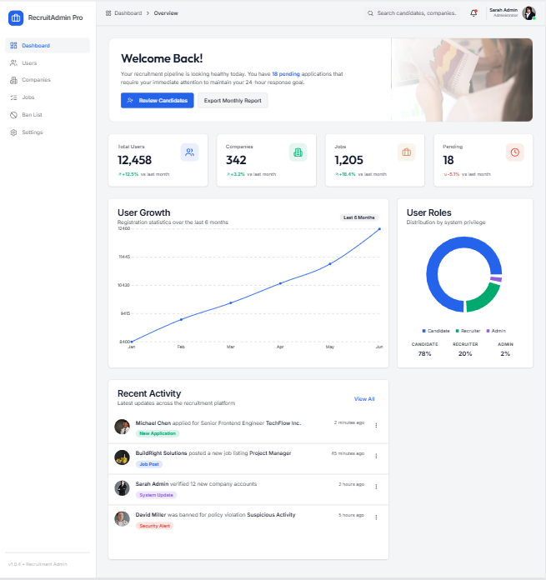
This screen allows the Administrator to:
- View Welcome Banner: view a personalized greeting with the current number of pending applications that need attention.
- View Overview Statistics: view summary KPIs of the whole system (Total Users, Companies, Jobs, Pending).
- View User Growth Chart: view a line chart showing user registration statistics over the last 6 months.
- View User Roles Chart: view a donut chart showing the distribution of users by system privilege.
- View Recent Activity: view a list of the latest actions across the recruitment platform.
- Navigate to Related Screens: click on a KPI card or activity item to navigate to the corresponding list screen.
- Navigate to Pending Applications: click Review Dashboard to go to the pending applications queue.
- Export Monthly Report: export the current dashboard statistics to a report file.
- Search globally: enter keyword(s) to search candidates, companies, or jobs from the top bar.
- Manage Account: access profile, settings, or sign out via the account dropdown.
Field Description
Field Name | Description
Global Search box | Initial value: blank. Placeholder: "Search candidates, companies...". Hover the mouse to show the field name: "Global Search". Max length: 100 characters.
Welcome Banner | Displays greeting message: "Welcome Back!". Subtitle shows the number of pending applications, e.g., "Your recruitment pipeline is looking healthy today. You have 18 pending applications that require your immediate attention...".
Review Dashboard button | Primary CTA. Navigates to the Pending Applications queue.
Export Monthly Report button | Secondary CTA. Exports the current dashboard statistics to PDF/Excel.
Total Users card | Displays total number of records in tb_users (e.g., 12,458). Shows trend vs. last month (↑/↓ %). Clickable → navigates to Account Management.
Companies card | Displays total number of records in tb_companies (e.g., 342). Shows trend vs. last month. Clickable → navigates to Company Management.
Jobs card | Displays total number of records in tb_jobs (e.g., 1,205). Shows trend vs. last month. Clickable → navigates to Job Management.
Pending card | Displays total pending approvals (e.g., 18). Highlighted with red icon. Shows trend vs. last month. Clickable → navigates to Pending List.
User Growth Chart | Line chart. Title: "User Growth – Registration statistics over the last 6 months". X-axis: month (Jan → Jun). Y-axis: number of users (0 → 1.75K). Legend: "Last 6 Months".
User Roles Chart | Donut chart. Title: "User Roles – Distribution by system privilege". Segments: Candidate (78%), Recruiter (20%), Admin (2%). Legend displayed below with color dots.
Recent Activity list | Read-only feed. Title: "Recent Activity – Latest updates across the recruitment platform". Displays the 5 most recent items, each with: avatar, actor name + action description, timestamp (e.g., "2 minutes ago"), and a status tag (e.g., New Application, Job Alert, System Update, Suspicious Activity).
View All link | Navigates to the full Activity Log screen.

3.3.2 Account Management

3.3.2.1 Account List
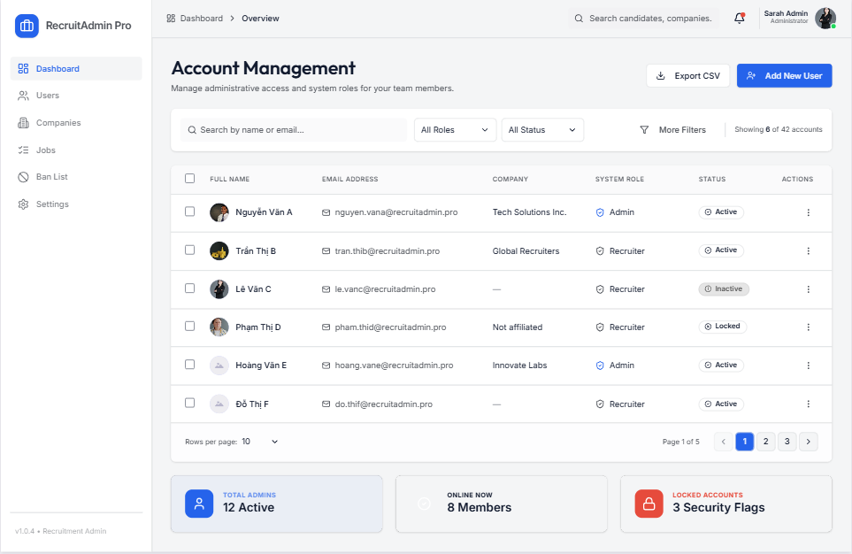
This screen allows the Administrator to:
- View Account List: view list of all accounts (Candidate, Recruiter, Admin, Hiring Manager) in the system.
- Filter Account List: filter accounts by System Role and Status.
- Search Accounts: enter keyword(s) to search accounts by their name or email address.
- Sort Account List: sort account list (ascending, descending) by clicking column headers.
- View Account Details: click on an account row or the ⋮ action to navigate to the Account Details screen.
- Export Account List: export the current filtered list to CSV.
- Add New User: navigate to the Account Details screen to create a new account.
On the screen, s/he can also:
- Activate/Deactivate Account: change status of a specific inactive/active account.
- Ban/Unban Account: lock or unlock a specific account.
- View pagination: choose page size and navigate between pages.

Field Name | Description
Search box | Initial value: blank. Placeholder: "Search by name or email...". Hover the mouse to show the field name: "Search Account". Max length: 100 characters.
Role filter | Initial values: All Roles, Candidate, Recruiter, Admin, Hiring Manager (default value "All Roles"). Hover the mouse to show the field name: "System Role".
Status filter | Initial values: All Status, Active, Inactive, Locked (default value "All Status"). Hover the mouse to show the field name: "Account Status".
More Filters link | Expands additional filter options (e.g., Created Date, Last Login).
Account counter | Displays total filtered records, e.g., "Showing 6 of 63 accounts".
Full Name column | Displays tb_users.full_name with avatar thumbnail. Clickable → opens Account Details.
Email Address column | Displays tb_users.email.
Company Column | Displays tb_companies.company_name for accounts with role = Recruiter.
System Role column | Displays tb_users.role as a badge with icon: Admin / Recruiter / Candidate.
Status column | Displays tb_users.status: ● Active (green dot) / ○ Inactive (gray) / ⛔ Locked (red).
Actions column | Contains a ⋮ menu with: View Details, Edit, Activate/Deactivate.
Export CSV button | Exports the current filtered list to .csv.
Add New User button | Primary CTA. Navigates to Account Details screen in Add New mode.
Pagination | Shows "Rows per page: 10" dropdown and page navigation (e.g., "Page 1 of 5" with ◀ 1 2 3 ▶).

3.3.2.2 Account Details
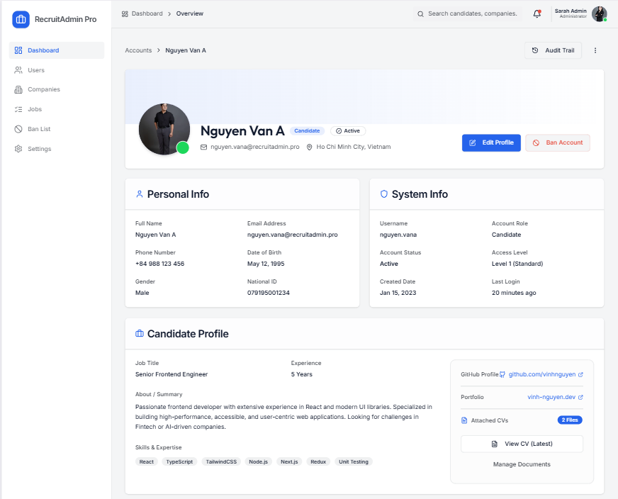
This screen allows the Administrator to:
- View Account Details: view full information of a specific account.
- Update Account Details: update editable fields of a specific account.
- Add New Account: create a new account (in Add New mode).
- Ban / Unban Account: change status of the account directly from this screen.
- Edit Profile: navigate to the full profile editor.
- View Related Information: view candidate profile, skills, experience, and attached documents.
- View Audit Trail: navigate to the audit trail for this account.

Field Name | Description
Breadcrumb | Displays navigation path: "Accounts > Nguyen Van A". Clickable to return to Account List.
Audit Trail button | Navigates to the Audit Trail screen filtered by this account.
Avatar | Displays tb_users.avatar_url. Shows online status dot (green = online).
Full Name | Displays tb_users.full_name (e.g., "Nguyen Van A").
Role badge | Displays tb_users.role (e.g., Candidate).
Status badge | Displays tb_users.status (e.g., ● Active).
Contact line | Displays email and location, e.g., "nguyen.van.a@recruitadmin.pro · Ho Chi Minh City, Vietnam".
Edit Profile button | Navigates to the full profile editor.
Ban Account button | Opens the Ban confirmation modal. Label is Ban Account when Active, Unban Account when Locked.

4. Non-Functional Requirements

3.1 External Interfaces
[This section provides information to ensure that the system will communicate properly with users and with external hardware or software/system elements.]

3.2 Quality Attributes
[List all the required system characteristics (quality attributes) specification. Some of the possible attributes are provided with the guide/descriptions are mentioned here]

3.2.1 Usability
[This section includes all those requirements that affect usability. For example, specify the required training time for a normal user and a power user to become productive at particular operations specify measurable task times for typical tasks or base the new system’s usability requirements on other systems that the users know and like specify requirement to conform to common usability standards, such as IBM’s CUA standards Microsoft’s GUI standards]

3.2.2 Performance
[The system’s performance characteristics are outlined in this section. Include specific response times. Where applicable, reference related Use Cases by name.
Response time for a transaction (average, maximum)
Throughput, for example, transactions per second
Capacity, for example, the number of customers or transactions the system can accommodate
Resource utilization, such as memory, disk, communications, and so forth.]

3.2.3 …

5. Requirement Appendix
[Provide business rules, common requirements, or other extra requirements information here]

5.1 Business Rules
[Provide common business rules that you must follow. The information can be provided in the table format as the sample below]
ID | Rule Definition
BR-01 | Delivery time windows are 15 minutes, beginning on each quarter hour.
BR-02 | Deliveries must be completed between 10:00 A.M. and 2:00 P.M. local time, inclusive.
BR-03 | All meals in a single order must be delivered to the same location.
BR-04 | All meals in a single order must be paid for by using the same payment method.
BR-11 | If an order is to be delivered, the patron must pay by payroll deduction.
BR-12 | Order price is calculated as the sum of each food item price times the quantity of that food item ordered, plus applicable sales tax, plus a delivery charge if a meal is delivered outside the free delivery zone.
BR-24 | Only cafeteria employees who are designated as Menu Managers by the Cafeteria Manager can create, modify, or delete cafeteria menus.
BR-33 | Network transmissions that involve financial information or personally identifiable information require 256-bit encryption.
BR-86 | Only regular employees can register for payroll deduction for any company purchase.
BR-88 | An employee can register for payroll deduction payment of cafeteria meals if no more than 40 percent of his gross pay is currently being deducted for other reasons.

5.2 System Messages
# | Message code | Message Type | Context | Content
1 | MSG01 | In line | There is not any search result | No search results.
2 | MSG02 | In red, under the text box | Input-required fields are empty | The * field is required.
3 | MSG03 | Toast message | Updating asset(s) information successfully | Update asset(s) successfully.
4 | MSG04 | Toast message | Adding new asset successfully | Add asset successfully.
5 | MSG05 | Toast message | Confirming email of asset hand-over is sent successfully | A confirmation email has been sent to {email_address}.
6 | MSG06 | Toast message | Resetting asset information successfully | Return asset(s) successfully.
7 | MSG07 | Toast message | Deleting asset information successfully | Delete asset(s) successfully.
8 | MSG08 | In red, under the text box | Input value length > max length | Exceed max length of {max_length}.
9 | MSG09 | In line | Username or password is not correct when clicking sign-in | Incorrrect user name or password. Please check again.
10 | ..

5.3 Other Requirements…

