**Your Project Title**

**Your Name: VINH PHI StudentID: GCS18309**

**Supervisor: Van Ho**

**Initial Contextual Report**

**COMP1682 Final Year Project**

**Programme Title, e.g. BSc Computer Science or BSc Computing**

**Due date: 29/01/2021**

**Word count:**

**Abstract**

Project is an eCommerce website made to connect businesses with customers, help businesses reach, and sell products to their customers. We will build and design websites based on the Scrum model to work and operate. The code editor used is Visual Studio Code, PHP is used as the main language along with the Laravel Framework. Using the editor Visual Studio Code is an advantage because it is both cost-effective but highly effective. At the same time, the Laravel Framework is currently the most powerful library available today, which will help a lot on the three main elements of the project: time, manpower and money. The database used is MySQL at the same time for easy manipulation and management we will use the MySQL Workbench database design tool. When the project ends as well as the product completion, the biggest concern we need is the performance and security of this website product. The end result that will delight your business with a website with good performance, not too many functional or interface bugs, and good security control will be an expected project outcome.

# 1 Table of Content

1 Introduction 3

1.1 Background 3

1.2 Aims and objectives 3

1.3 Approach 3

2 Literature Review 3

2.1 Approach to literature searching 3

2.2 Identifying the problem 3

2.3 Another Section 3

2.4 Yet Another Section 3

2.5 Conclusions 4

3 Product Research 4

4 Legal, Social, Ethical and Professional Issues and Considerations 4

5 Requirements 4

5.1 Analysis of requirements 4

5.2 Comparison of systems 4

5.3 Requirements elicitation 4

5.4 Functional requirements 4

5.5 Non-functional requirements 5

6 Design 5

7 Prototype 5

7.1 Review of technology 5

8 Reflection 5

9 Bibliography 5

10 Appendices 5

***\*optional chapters***

# 2 Introduction

## 2.1 Background

Vietnam is an emerging phenomenon around the world because achievements that even the big guys cannot do have changed the situation of the country. One of these is Vietnam's victory over epidemics and natural disasters, along with the number of internet users ranked 8th in the world and 3rd in the region. Vietnam is also ranked 48 out of 157 countries in the human capital index (HCI), second only to Singapore in the ASEAN region. Therefore, Vietnamese businesses have been changing and expanding rapidly in business forms, not to mention e-commerce. E-commerce makes buying and selling more convenient than ever when only one device connected to the internet can interact with each other. Payment is also easier than ever when in Vietnam there are many supporting banking systems along with electronic wallets. There is a reputable organization selling electronic accessories looking to make e-commerce for them by setting up a website.

The goal of this project is to develop a general purpose e-commerce store where any product (such as gear, graphics card, mouse, keyboard, etc.) can be purchased from the home. over the Internet. An online store is an Internet virtual store where customers can browse the catalog and select products of interest. Selected items can be collected in a shopping cart. At the time of checkout, the items in the shopping cart will be displayed as orders. Then, more information will be needed to complete the transaction. Typically, customers will be asked to enter or select a billing address, shipping address, shipping options, and billing information such as credit card numbers. A notification email is sent to the customer as soon as an order is placed.

## 2.2. Aims and objectives

### 2.2.1 Aims

Businesses that bring their products to their customers through e-commerce are websites. Deliver fast, convenient and extremely secure transactions between website business owners and their customers.

### 2.2.2 Objectives

The project will have many main goals to complete and we will break it down in an appropriate, recognizable order.

- Create a request set for the site CM: The requisition is that the administrator's implementations mistakenly control the website with specific changes to display to users, some functions such as adding, modifying, deleting accounts, categories, brand, product, ... The elements that make up the website to display to the users and customers of the business when they visit the website. This admin page will be secure and strictly authorized, only accounts belonging to Role Admin can access and execute functions on this Admin page.

- Build and test prototype of website CMS: Designing and using the entire CMS system for the Admin site, then applying it to reality is another story. We need to ensure that when operating a large number of products, handling requests from thousands of users, a small error will also cause a very high risk so the actual running test will also be one of the Great goals are set.

- Control of customers' shopping cart: Developing an e-commerce website is most important not only selling products, but also knowing your potential customers. There are some customers who like the product but cannot afford it and maybe they add it to the basket or favorites list. The control of these data will help businesses have correct investment orientation and good business choices.

- Organize effective product classification: An effective search and arrangement network for customers is indispensable. The fact that customers can find and choose the right conditions for products that are suitable for themselves is a great thing and helps them to approach the business more easily. This is one of the factors of direct competition between e-commerce sites.

- Many product payment methods: Completing the payment gateway for customers by the tradition, what is decisive for another website is online payment. Online payments can have many things such as banks, e-wallets in many forms such as wire transfer, direct payment, scanning QR code, ... etc. The diversification of these forms and their application to the website will be a pretty important goal to help the website to be competitive in the market.

- Simple navigation: From home page to ordering information and links for specific products. The link from the homepage until the checkout, the information and the interface must be consistent for the user to easily use. In addition to displaying products, product information must be described in the fastest and most specific way to customers.

- Flexible product reviews: Create a bond between non-connected customers by allowing them to rate and comment on the products they use. This helps users who intend to buy the product know the experience of the users who have bought and used the product will be a great experience. At the same time, these reviews and comments will help businesses manage their products and understand their customers much better.

- Customer care system: The quicker they are to solve the problems or questions of our customers, the more they will remember our website. This will be resolved by having a live chat frame of the customer with the website administrator. In addition, links for customer communication will also become more convenient. For complex issues, we will also design an interface, optimize user functions, and facilitate the most convenient way for website customers to present their problems quickly.

## 2.3 Approach

Again, you have already discussed this in your proposal but you may wish to restate this now that you are older and wiser. The key here is to realistically describe your approach and avoid regurgitating tedious guff about DSDM or some other branded ‘methodology’ when your approach is truthfully just making it up as you go along and keeping your fingers crossed.

## 2.4 Types of eCommerce

There are many types of e-commerce, but the most common are as follows:

- B2B (Business-to-Business): B2B involves trade dealings between businesses where sale of merchandise is made to an interim purchaser (Pandey and Agarwal, 2014). B2B e-commerce deals with interactions between and among businesses. About 80% of e-commerce is in this category (Gupta, 2014). One example of B2B is a business transaction between a manufacturer and a wholesaler, or between a wholesaler and a retailer.

- B2C (Business-to-Consumer): In this model the trade is conducted directly between company and consumers via a website (Dan, 2014). In the B2C model, businesses or organizations trade goods or services to customers over the Internet for consumers’ own use.

- C2C (Consumer-to-Consumer): This is the fastest-growing type of e-commerce. Businesses simply provide a platform (i.e., www.ebay.com) to advertise the product, and buyers can buy the product directly from the seller (Pandey and Agarwal, 2014). In the C2C model, businesses facilitate the setting where consumers buy and sell goods and services directly to each other.

There are also many other types of e-commerce but we have also determined that our project will follow the **B2C** model, so the research will focus on this model, this type of website and competitors. present ours on the market.

# 3 Literature Review

## 3.1 Approach to literature searching

## 3.2 Identifying the problem

Making an e-Commerce website is a new thing for me, I can say too much. Therefore, the search for materials for construction and development is an extremely necessary thing. I will search for documents on the internet about building a website by searching through the Google search toolbar. As a result, I have found 3 ways to build and develop a website that best suits myself through the reviews of many people about these searches.

- The first method of guiding us to build and develop a website is very clear and specific with WordPress.

- The second method guides us to build and develop website using Asp.Net Framework, C # language.

- The third method guides us to build and develop website using Laravel Framework, PHP language.

### 3.2.1 Analyze them one by one

The first method of guiding us to build and develop a website is very clear and specific with WordPress. After analyzing, I can understand that WordPress is a very popular and widely used Content Management System not only in Vietnam but all over the world. The number of websites using WordPress accounts for about 34% of the total number of websites worldwide. It uses Themes / Plugins, drag and drop and creates a useful website very quickly and conveniently even when you do not need to know anything about programming.

WordPress is widely used by many people, supported by its ease of use and many useful features. Designing a basic e-Commerce website is extremely easy with Wordpress because there are so many platforms available.

We will talk about the strengths of WordPress such as not having to know too much about programming and easy to use user interface. When using there are many blogs, templates and themes for us to choose from. WordPress also offers many SEO advantages through plugins, helping your content to rank better on the search results boards of tools like Google. HTML, CSS, PHP elements can easily extend your WordPress site with lots of useful features. Finally, WordPress supports many languages for us to choose from.

Along with its advantages, WordPress also has its downsides, as the first issue that is often mentioned is security. WordPress is open source and very popular. Also because of that popularity is an advantage for hackers to easily deploy their intentions. Since WordPress is open source, it's easy for hackers to find security loopholes and vulnerabilities, making these websites more vulnerable to hacking. Hacked WordPress sites keep happening. Because of being under constant attack and always improving, WordPress requires constant updates. This doesn't take long but can become frustrating when you just want to install and forget about them to focus on other things. WordPress memory is reported to have very low data processing performance if it is too large or multiple pages. Any website built by WordPress consumes a lot of resources on the server. WordPress themes are difficult to edit, unless you understand what you're doing. Even for programmers who are unfamiliar with the theme structure of WordPress, it can take a long time to edit. Many themes and plugins in the free version are not updated and supported, making it difficult for everything to work smoothly while the WordPress platform is always up to date.

#### The Second method

The second way guides us to build and develop website using Asp.Net Framework, C # language. After studying the documentation, I can understand that Asp.Net for designing some basic websites. ASP.NET is preferred by many users and is used a lot today. .Net has advantages such as possessing a series of outstanding and convincing advantages, especially high security that has helped .NET gain more points from users. As a programming language with an extremely diverse and rich library repository, powered by Net Framewrork, it has many outstanding advantages. Not to mention this programming language is also very well supported in XML and database access via ADO.Net.

- The next advantage of .Net is the ability to work well on many applications to ensure the best and highest performance for the website. We can separate the code and the interface into two completely separate parts to make the most interesting features for the web. The ability to upgrade and maintain the system will be relatively easy. Web sites programmed by .NET often operate stably, smoother, have better page load speed than some other languages, create a sense of comfort and trust for users, reduce bounce rate and increase muscle mass. The customer association will come back to the website next time. The loading speed of .NET is even more appreciated by experts than both PHP and JS. In addition, .NET also automatically generates HTML code for the servers to make the website work well in all browsers.

The downside of .Net is quite critical because it does not support Linux devices, does not support Visual studio during coding. Besides, because there are many attractive advantages like that, ASP.NET has a quite high usage fee, which is not suitable for use by small businesses or individuals.

#### The third way

The third way guides us to build and develop website using Laravel Framework, PHP language. After learning, I can come up with analysis that Laravel is one of the most popular PHP web frameworks following the MVC (Model-View- Controller) pattern. The Laravel framework is free and open source to help us make high quality products. The code will be minimized, but still meet industry standards, saving us hundreds of hours in development. It uses the PHP language, which is trusted by a lot of programmers around the world and is almost dominating the market. One of the features that makes the PHP Lararel framework stand out from all is that it uses all of the new features of PHP. Currently on the market there are very few frameworks that can do this, which is always updating the best functions for the language of that library. There are many CMS libraries out of PHP, perhaps this useful language helped a lot in creating websites.

Let's take a look at the advantages of the library, the most popular website making language on the market today. First, - All updated versions of Laravel we can view the documents related to that update such as functions, classes. Laravel also supports popular caching backends, supports cached backends like Memcached and Redis out-of-the-box, can customize a lot of caches, and is very convenient. Command line integration - Artisan, exactly like the name Artisan created by the developer. All command lines are created to easily support the system's MVC. Laravel packages and resources that are always available will benefit from the npm and bower packages by combining the framework with Gulp and elixir, which helps with resource modification. This integration will resolve dependencies and is the most reliable package source in the PHP world. The IoC container, also known as Inversion of Control, is a method to create new objects without having to start any external libraries against Laravel. In other words, we can access these objects from wherever we are coding, we should no longer have trouble with inflexible monolithic structures. Reverse Routing is a very useful feature in the framework where we can create links to named routes. So when we create the links, we just need to use the name of the router, the framework will automatically insert the correct URL. If we need to change routes in the future, the changes will automatically be made everywhere. Finally, Eloquent ORM is one of the best features of Laravel, providing simple and efficient ActiveRecord implementation, working with databases. The models we create in MVC will have a corresponding table in the database. ORM has relationships, if we manipulate a table in the database, we will also manage the related data. These relationships are: one-to-one, one-many, many-many, have-to-many, polymorphic, and many-many-polymorphism.

However, the language or the library also has disadvantages. Lack of continuity between versions without a seamless transition from Laravel 4 to 5. If we try to update the code, we can end the system crash entirely. This is the most troublesome and annoying for those who use Laravel. Some upgrades can be problematic, not only for Laravel, but also for PHP frameworks. Therefore, we should take us away before upgrading the mobile app / website, or we may keep the version as it is. Usually not providing mobile application richness, it seems that PHP and laravel language developers are not targeting mobile users so it is imperative that our products are designed by themselves. next. for phone users the array is a lot.

## 3.3 Conclusions

About the website building methods, we will have many things to prepare such as ideas, images, content, budget, then to mention is the construction and development of a website using language methods. language, library, etc. It would be nice if we could customize and build the website ourselves, however it is not that simple and it will take a lot of our time. Choosing interface templates or using drag-and-drop tools can suit those who need a fast and cost-effective website solution like analysis and comparison but risk, protection factors. project. , flexible in changing, requires quite a bit of manual code. Designing eCommerce website with manual code will bring us higher efficiency in the present time, in the present case. The method of using the library for fast paced and easy deployment with a lot of support is optimal and Laravel is the first choice for someone who does not have much experience like me. In short, the method of building a third e-commerce website using Laravel Framework with PHP language will be the optimal and most suitable choice.

# Product Research

On the market today, there are many products about e-commerce websites like the ones we will do, but having goals, products and scale, we will take a look at some excellent names that already exist. standing position on the market.

Beginning is the product of a commercial company GEARVN with the domain name of GearVN.com. GearVN has been too big and has increasingly gained market confidence with its very high website rating indexes.

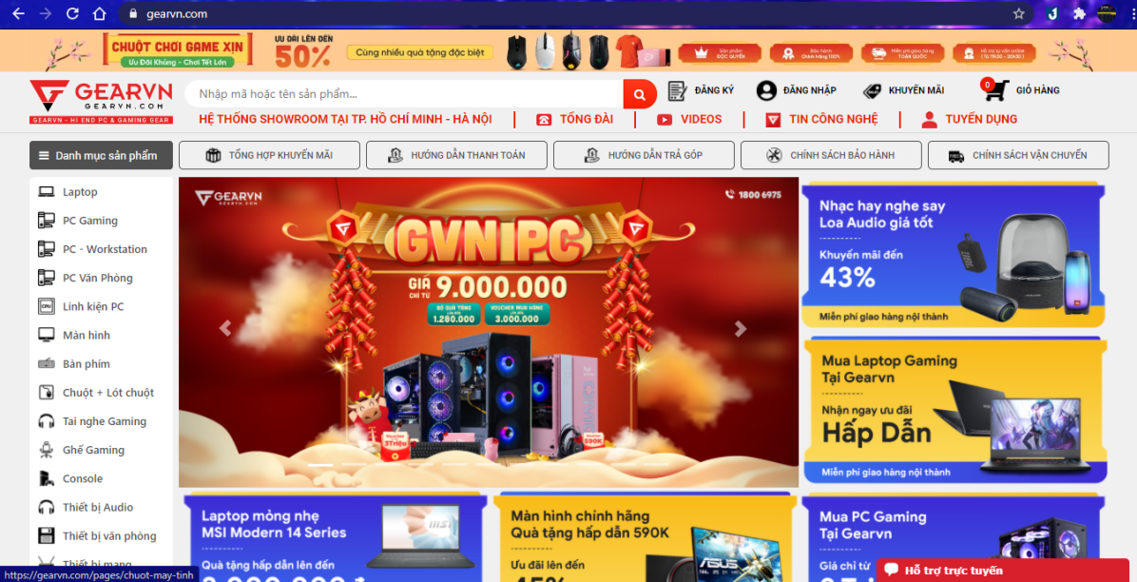

Figure 12-1: Website GearVN

But we only consider the aspect of making a website for users, the criteria of the website we have given will also have all the basic functions of GearVN, which means relatively us. will be able to keep pace with their website system.

The next influential in the e-commerce market for electronic component products is the product of XGEAR trading company with the domain name Xgear.vn. To talk about XGear's website is probably somewhat simpler than GearVN. The function and operation of XGear, we can certainly catch up and improve.

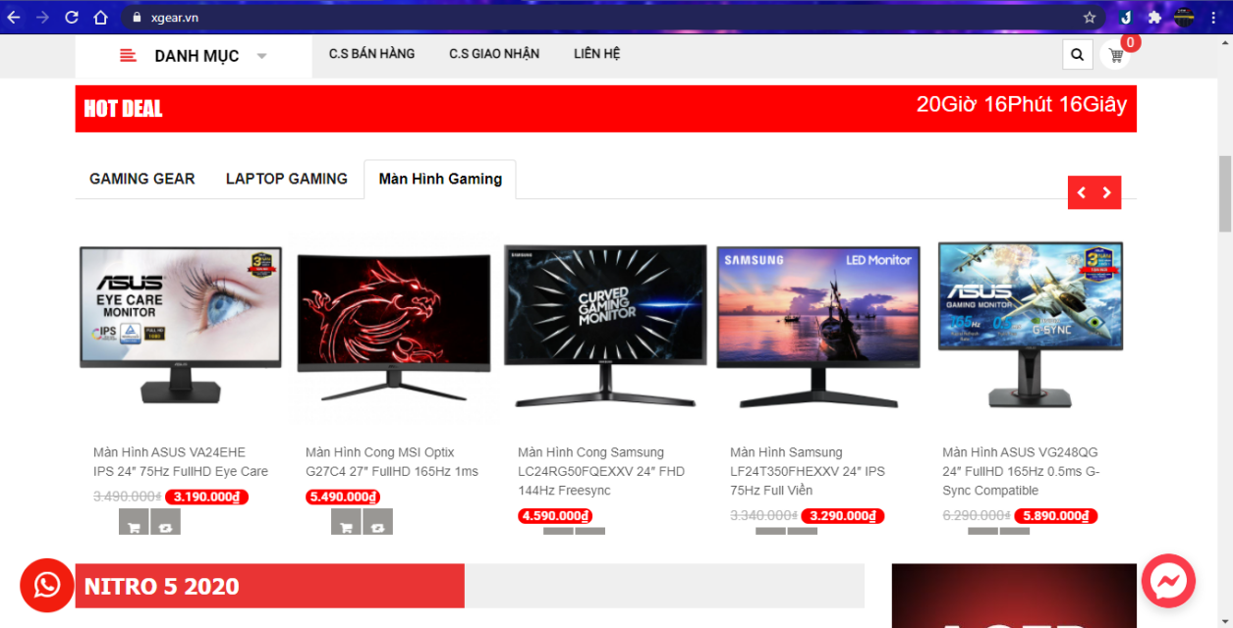

Figure 12-1: Website XGear

# 5 Legal, Social, Ethical and Professional Issues and Considerations

E-commerce has been popular in every corner of Vietnam from urban to rural areas, to the fact that a certain farmer uncle goes online to order online from e-commerce sites or applications. normal. It is followed by technological innovation that regularly incorporates ethical standards into legislation. New forms of e-commerce allowing to conduct new business have many advantages but also bring many risks. We will discuss ethical and legal issues related to e-commerce business to take the right direction.

## 5.1 Ethical issue

In general, many of the ethical and global issues of Information Technology apply to e-business. According to the Vietnamese Ministry of Industry and Trade, Only in the first July of 2020, the authorities checked 2,403 cases, discovered and handled 2,213 violations, sanctioned 16.3 billion dong, the infringing goods more than 40 billion. Most infringing goods in e-commerce business are goods without invoices, vouchers, counterfeit goods, goods of unknown origin, goods infringing intellectual property. We can see that morally before, individuals and organizations must be ethically conscious that what they do will affect others quite a lot. Just like the owner of that E-Commerce business is responsible for protecting its customers.

## 5.2

# 6 Requirements

## 6.1 Analysis of requirements

In this project there are of….

## 6.2 Comparison of systems

For some projects there may be similar existing systems. This would be a good place to identify these, compare them and elicit requirements from them.

## 6.3 Requirements elicitation

Perhaps you have conducted some actual research with questionnaires and interviews and such like (having obtained research ethics clearance of course). This would be a good place to discuss this.

## 6.4 Functional requirements

A clear statement of functional requirements is the starting point for your design. Without this you will look foolish.

## 6.5 Non-functional requirements

Clear statement of non-functional requirements. It may be an idea here to refer back to your earlier LSEPi section as compliance is likely to (and should) be an important aspect here.

# 7 Design

Describe your approach to design. If perhaps you are using UML use-case notation then the line between requirements and design starts to blur (Šilingas & Butleris, 2015). Other UML notation is however part of the design process, but perhaps overlaps with testing.

# 8 Prototype

Describe your approach to creating your first (and second and third) prototype(s).

## 8.1 Review of technology

If you need to review technologies this is perhaps the place to do it. Perhaps you need a data base, in which case state what database engines have you considered, which have you decided to use and for what reason. Perhaps you need an app, in which case you could, for example, state which development frameworks are available, compare and contrast all, select 3 for detailed comparison, choose one and state why you have made this choice.

# 9 Reflection

Wrap the whole thing up with some conclusions. A reflective approach is increasingly popular but many students struggle with introducing a critical personal perspective (Day, 2013).

# 10 **Bibliography**

Day, T. (2013). *Success in Academic Writing.* Palgrave.

Portocarrero, J. M., Delicato, F. C., Pires, P. F., Gámez, N., Fuentes, L., Ludovino, D., & Ferreira, P. (2014). Autonomic Wireless Sensor Networks: A Systematic Literature Review. *Journal of Sensors*.

Rudestam, K. E., & Newton, R. R. (2007). *Surviving Your Dissertation: A Comprehensive Guide to Content and Process* (3rd ed.). SAGE.

Šilingas, D., & Butleris, R. (2015). Towards implementing a framework for modeling software requirements in MagicDraw UML. *Information Technology and Control, 38*(2).

# 11 Appendices

# 12 Reference

1. Reliablesoft.net. 2021. How to SEO an eCommerce Site Structure. [online] Available at: <https://www.reliablesoft.net/ecommerce-site-structure/> [Accessed 24 February 2021].
2. Smith, D., 2021. 3 Clicks Deep: The Best Website Structure for Ecommerce SEO - Cazbah. [online] Cazbah. Available at: <https://www.cazbah.net/seo-website-structure/> [Accessed 24 February 2021].
3. Smart Insights. 2021. A Guide to Effective SEO Tactics to Improve Ranking. [online] Available at: <https://www.smartinsights.com/search-engine-optimisation-seo/seo-strategy/guide-effective-seo-tactics-improve-ranking/> [Accessed 25 February 2021].
4. Cowell Asia. 2021. E-COMMERCE WEBSITE DEVELOPMENT: STEP BY STEP!. [online] Available at: <https://co-well.vn/en/tech-blog/e-commerce-website-development-step-by-step/> [Accessed 26 February 2021].
5. Lofgren, L., 2021. How to Create an Ecommerce Website in 5 Easy Steps. [online] Quicksprout.com. Available at: <https://www.quicksprout.com/create-ecommerce-website/> [Accessed 27 February 2021].
6. Hicks, K., 2021. Build an eCommerce Website - Step by Step Guide (2020) | HostGator. [online] HostGator Blog. Available at: <https://www.hostgator.com/blog/get-ecommerce-website-running/> [Accessed 27 February 2021].
7. 2021. [online] Available at: <https://www.trustradius.com/compare-products/asp-net-vs-wordpress> [Accessed 9 March 2021].
8. DEV Community. 2021. ASP .net vs Laravel. [online] Available at: <https://dev.to/lloydquantro4/asp-net-vs-laravel-1lbl> [Accessed 10 March 2021].
9. Babu, R., 2021. E-Commerce Ethical and Legal Issues | QBurst Blog. [online] QBurst Blog. Available at: <https://blog.qburst.com/2011/03/e-commerce-ethical-and-legal-issues/> [Accessed 11 March 2021].