## Requirement

* [PHP](https://php.net/) 5.6+
* [Composer](https://getcomposer.org/)
* Pdf files

## Installation

To install into your project, run the command below in your terminal.

composer require goodnesskay/laravelpdfviewer

Once the package is done being installed, register the service provider. Open config/app.php and add the following to the providers key.

Goodnesskay\LaravelPdfViewer\LaravelPdfViewerServiceProvider::class,

## Configure

Run this in your terminal:

php artisan vendor:publish --provider="Goodnesskay\LaravelPdfViewer\LaravelPdfViewerServiceProvider"

It will publish a folder named laraview to the root folder of your project.

## How it Works

Simple!!! After installations and configurations have been carried out successfully, add the code below to your html file

{{ asset('/laraview/#../folder-name/the-pdf-file.pdf') }}

It should look like this:

<iframe src ="{{ asset('/laraview/#../pdf/test.pdf') }}" width="1000px" height="600px"></iframe>

Then, you should have something like this:

[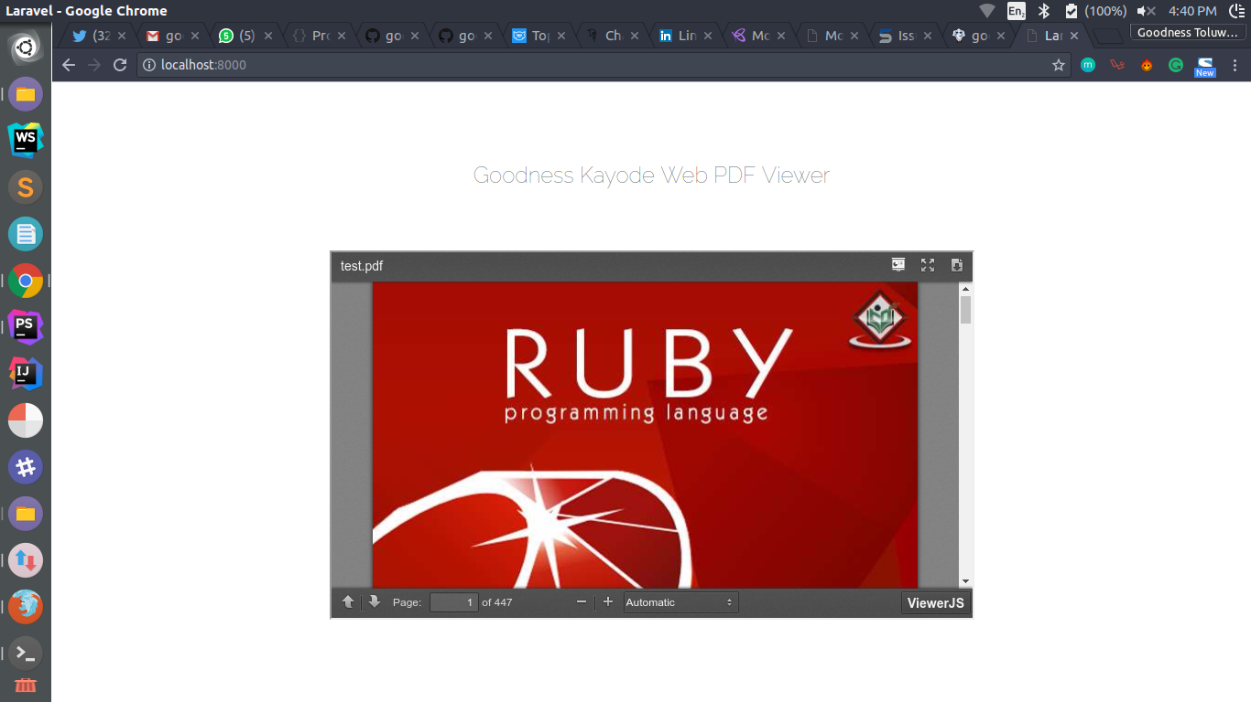](https://cloud.githubusercontent.com/assets/16525886/26499445/9483e444-422a-11e7-81cf-9569b8f33669.png)

**Note:**

After #../ in {{ asset('/laraview/#../folder-name/the-pdf-file.pdf') }}, what should follow is the folder name of the pdf files in the public folder then, the pdf file name can follow.

## Contribute

You can fork this package, contribute and submit a pull request. I will really love it.

## You want to appreciate me?

You can appreciate me by **starring** this repository and follow me on [Github](https://github.com/goodnesskay) , [twitter](https://twitter.com/goodnesskayode) and subscribe to my [Youtube](https://www.youtube.com/channel/UC3h5EkjLBS5VtpJRVRrMD-Q) Channel!

I love you like mad.

**Goodness Kayode | Pusher of Codes**

## License

MIT License (MIT).