VIETNAM GENERAL CONFEDERATION OF LABOR
TON DUC THANG UNIVERSITY
FACULTY OF INFORMATION TECHNOLOGY



SOFTWARE ENGINEERING FINAL REPORT

THE HOTEL MANAGEMENT SOFTWARE

Instructor: Dr NGUYỄN NGỌC PHIÊN
Executor: BÙI QUANG VINH - 523H0193
HÀ HUY TÍN - 523H0184
NGUYỄN VĂN MINH TRÍ - 523H0187

HO CHI MINH CITY, YEAR 2025
VIETNAM GENERAL CONFEDERATION OF LABOR
TON DUC THANG UNIVERSITY
FACULTY OF INFORMATION TECHNOLOGY



SOFTWARE ENGINEERING FINAL REPORT

THE HOTEL MANAGEMENT SOFTWARE

Instructor: Dr NGUYỄN NGỌC PHIÊN
Executor: BÙI QUANG VINH - 523H0193
HÀ HUY TÍN - 523H0184
NGUYỄN VĂN MINH TRÍ- 523H0187

HO CHI MINH CITY, YEAR 2025
ACKNOWLEDGEMENT

We would like to express our sincere gratitude to Dr Nguyen Ngoc Phien for his invaluable guidance and support throughout our Software Engineering course. His insightful feedback and detailed explanations significantly enhanced our understanding of the subject. We deeply appreciate his patience and dedication in helping us overcome challenges, as well as his willingness to share real-world experiences that enriched our learning journey. His enthusiasm for teaching and passion for web development inspired us to explore and apply new technologies with confidence. We are truly grateful for his encouragement and the knowledge he has imparted, and we feel honored to have had him as our instructor and mentor.

Ho Chi Minh City, 3rd Dec, 2025.
Author
(Signature and full name)

Vinh  Bui Quang Vinh | Tin  Ha Huy Tin
Tri
Nguyen Van Minh Tri

DECLARATION OF AUTHORSHIP
We hereby declare that this Final Reposssrt is the result of our own research and has been conducted under the scientific guidance of Dr. Nguyen Ngoc Phien. The research content and findings presented in this report are truthful and have not been published in any form before. The data included in tables and figures for analysis, evaluation, and discussion have been collected by the authors from various sources, which are clearly cited in the references section.
Additionally, this report contains some evaluations, analyses, and data from other authors and organizations, all of which are properly cited and referenced.
If any form of academic dishonesty is discovered, we take full responsibility for the content of this Software Engineering Final Report. Ton Duc Thang University is not responsible for any copyright or intellectual property violations caused by us during the research and report-writing process (if any).
Ho Chi Minh City, 3rd Dec, 2025.
Author
(Signature and full name)

Vinh  Bui Quang Vinh | Tin  Ha Huy Tin
Tri
Nguyen Van Minh Tri

EXECUTIVE SUMMARY
The Hotel Management Software project is a comprehensive software solution designed to support the daily operations and administrative processes of a hotel. The system aims to streamline essential hotel activities such as room type management, physical room assignment, customer booking, staff management, shift scheduling, service add-ons, and revenue reporting. It supports three key user roles: Admin, Staff, and Customer, each equipped with functions tailored to their responsibilities, thereby improving user experience and enhancing the overall operational efficiency of the hotel.

The system is implemented using PHP with an MVC architecture, ensuring clear separation between business logic, data management, and presentation layers. The backend is developed using PHP and MySQL to handle dynamic data processing, secure transactions, and real-time room availability checks. The database is built on MySQL, designed with referential integrity and normalization to ensure accuracy and consistency of customer reservations, room data, and transaction histories. Frontend technologies including HTML, CSS, JavaScript, and AJAX are used to provide an interactive and user-friendly interface. Security measures such as session validation and input sanitization are implemented to ensure safe and reliable system operation.

The main objective of this project is to help hotels and accommodation providers improve workflow efficiency, minimize manual errors, enhance customer satisfaction, and support staff in completing tasks more effectively. Customers can easily search for available rooms, create bookings, request additional services, and submit reviews, while staff can manage room assignments, verify bookings, handle shift schedules, and process customer requests. Administrators have full access to system data, including staff management, room setup, booking history, and financial reports.

Overall, this project strengthens the hotel’s capability to manage operations in a structured and efficient manner. By automating processes such as booking management, room allocation, and shift scheduling, the system significantly reduces operational workload and improves accuracy. Additionally, the platform enhances customer experience through faster service, clear information, and smooth interaction. The Hotel Management System enables hotels to maintain continuous and effective operations, ultimately improving business performance and service quality.

TABLE OF CONTENTS
LIST OF FIGURES 1
LIST OF TABLES 2
CHAPTER 1. INTRODUCTION 3
1.1 Purpose and Scope 3
1.2 Product Overview 3
1.2.1 Key Capabilities 4
1.2.2 Typical Usage Scenarios 4
1.3 Structure of Document 5
1.4 Terms, Acronyms, and Abbreviations 7
CHAPTER 2. PROJECT MANAGEMENT PLAN 8
2.1 Project Organization 8
2.2 Lifecycle Model Used 9
2.2.1 Advantages of Agile Scrum for This Project 10
2.2.2 Disadvantages Encountered 10
2.3 Risk Analysis 10
2.4 Hardware and Software Resource Requirements 12
2.4.1 Software Resource Requirements 12
2.4.2 Hardware requirements 12
2.4.3 New Software and Hardware Learned by Team Members 13
2.5 Monitoring, Reporting, and Controlling Mechanisms 13
2.5.1 Progress Monitoring: 13
2.5.2 Reporting Mechanisms: 14
2.5.3 Quality Control Mechanisms 15
2.6 Professional Standards 16
2.6.1 Software Engineering Standards 16
2.6.2 Ethical Conduct and Responsibility 17
2.6.3 Academic Integrity 17
2.6.4 Teamwork and Professionalism 18
2.7 Evidence all the artifacts have been placed under configuration management 18
2.8 Impact of the project on individuals and organization 19
2.8.1 Impact on Individuals 19
2.8.2 Impact on Organizations 21
2.8.3 Impact on Society 21
CHAPTER 3. REQUIREMENTS SPECIFICATIONS 22
3.1 Stakeholders for the system 22
3.2 Use case model 25
3.2.1 Actors for the system 25
3.2.2 Use cases 25
3.3 Graphical use case model and textual description for each use case 28
3.3.1 General use case 28
3.3.2 Use case Login 29
3.3.3 Use case View/Edit profile 31
3.3.4 Use case Search rooms 32
3.3.5 Use case Book rooms 34
3.3.6 Use case Make payments 37
3.3.7 Use Case Book services/amenities 39
3.3.8 Use case Request room services 41
3.3.9 Use case Add comments 43
3.3.10 Use case Manage reservations 44
3.3.11 Use case Manage rooms 46
3.3.12 Use case Manage service requests 48
3.3.13 Use case Manage services/amenities booking 50
3.3.14 Use case View financial report 52
3.3.15 Use case Manage room types 54
3.3.16 Use case Manage services 56
3.3.17 Use case Manage discount 58
3.3.18 Use case Manage blogs 60
3.3.19 Use case Manage comments 62
3.3.20 Use case Manage accounts 64
3.4 Functional requirements 66
3.5 Non-functional requirements 69
3.5.1 Performance Requirements 69
3.5.2 Usability Requirements 69
3.5.3 Reliability Requirements 70
3.5.4 Security Requirements 70
3.5.5 Maintainability Requirements 70
3.5.6 Scalability Requirements 71
3.5.7 Backup and Recovery Requirements 71
CHAPTER 4. ARCHITECTURE 71
4.1 Architecture style(s) used 71
4.2 Architectural model 72
4.3 Technology, software, and hardware used 76
4.3.1 Technologies 76
4.3.2 Software Tools 76
4.3.3 Hardware used 77
4.4 Rationale for your architectural style and model 77
CHAPTER 5. DESIGN 78
5.1 Database design 78
5.1.1 Database Schema Diagram 78
5.1.2 Entity Relationship Diagram 79
5.2 Static model - class diagram 80
5.3 Dynamic model – sequence diagrams 81
5.3.1 Login 81
5.3.2 Search Rooms 82
5.3.3 Manage Room Types & Rooms (Admin) 83
5.3.4 Place Booking 84
5.3.5 Manage Bookings (Staff) 85
5.3.6 Manage Staff 86
5.3.7 Shift Scheduling 87
5.3.8 Manage Revenue 88
5.3.9 Rate Rooms (Submit Review) 88
5.4 Rationale for Detailed Design Model 89
5.4.1 Rationale for Database Design 89
5.4.2 Rationale for Class Diagram Structure 90
5.4.3 Rationale for Sequence Diagrams 91
5.4.4 Overall Design Rationale 91
5.4.5 Traceability from Requirements to Detailed Design Model. 92
CHAPTER 6. TEST PLAN 93
6.1 Requirements/Specifications-based System Level Test Cases 94
6.2 Traceability of Test Cases to Use Cases 95
6.3 Techniques Used for Test Generation 96
6.3.1 Equivalence Partitioning (EP) 96
6.3.2 Boundary Value Analysis (BVA) 96
6.3.3 Decision Table Testing 96
6.3.4 Use Case-Based Testing 96
6.3.5 Requirements-Based Testing 97
6.4 Assessment of the Goodness of the Testsuite 97
6.4.1 Requirement Coverage 97
6.4.2 Use Case Coverage 97
6.4.3 Positive and Negative Testing 97
6.4.4 Boundary and Error Handling 97
6.4.5 Completeness and Consistency 97
REFERENCES 99

LIST OF FIGURES
Figure 5.1: Database Scheme Diagram 78
Figure 5.2: Entity Relationship Diagram 79
Figure 5.3: Class diagram 80
Figure 5.4: Login Sequence diagram 81
Figure 5.5: Search Rooms Sequence diagram 82
Figure 5.6: Manage Room Types & Rooms Sequence diagram 83
Figure 5.7: Place Booking Sequence diagram 84
Figure 5.8: Manage Bookings (Staff) Sequence diagram 85
Figure 5.9: Manage Staff Sequence diagram 86
Figure 5.10: Shift Scheduling Sequence diagram 87
Figure 5.11: Manage Revenue Sequence diagram 88
Figure 5.12: Rate Rooms Sequence diagram 89

LIST OF TABLES
Table 5-1: Traceability Matrix 92
Table 6-1: System Test Cases 94
Table 6-2: Test Case Traceability Matrix 95

INTRODUCTION

Purpose and Scope
The purpose of this project is to develop a comprehensive Hotel Management Software that streamlines and automates the daily operations of a hotel. The system is designed to handle room management, customer bookings, staff scheduling, service management, and revenue tracking. By digitizing these processes, the system aims to reduce manual workload, minimize human errors, improve operational efficiency, and enhance overall customer satisfaction.
This project specifically targets small to medium-sized hotels and accommodation providers. The system does not extend to large hotel chains with complex enterprise resource planning (ERP) requirements or international multi-property management systems.
In terms of software implementation, the system is developed using PHP as the primary programming language, with MySQL serving as the relational database management system. The user interface is designed using HTML, CSS, JavaScript, and Bootstrap framework to ensure a responsive and user-friendly experience across devices.
From a theoretical perspective, the project applies fundamental software engineering principles including system analysis and design. It utilizes Use Case diagrams to identify functional requirements and user roles, Entity Relationship Diagrams (ERD) to model the database structure, and follows the Monolithic Client-Server architecture with a modular, feature-based organization
This project does not cover advanced features such as microservices architecture, integration with international payment gateways, artificial intelligence-based pricing optimization, or mobile application development. These areas are considered beyond the current scope and objectives.

Product Overview
The Hotel Management Software is a web-based application designed to manage the complete lifecycle of hotel operations. It supports three primary user roles: Admin, Staff, and Customer, each with specific functionalities tailored to their responsibilities.

Key Capabilities
For Administrators:
- Manage room types and physical room inventory
- Define, modify, and delete different room categories
- Add, update, or remove accounts and assign roles
- Manage services/amenities
- Configure system settings and permissions
- Generate comprehensive revenue and occupancy reports
- Manage discount code
For Staff:
- Search and view real-time room availability
- Process customer bookings and handle reservations
- Manage check-in and check-out procedures
- Assign rooms to guests based on availability and preferences
- Handle customer service requests and add-on services
- Update booking statuses and payment records
For Customers:
- Search for available rooms based on dates and preferences
- View detailed room information including amenities, photos, and pricing
- Make online bookings with instant confirmation
- Request room services
- Track booking status and payment history
- Submit comments on hotels blogs

Typical Usage Scenarios
Customer Booking a Room: A customer visits the hotel website, searches for available rooms for specific dates, views room details and pricing, selects a preferred room type, enters guest information, confirms the booking, and receives a booking reference number via email.
Staff Processing a Booking: A staff member logs into the system, searches for available rooms to assist a customer, creates a new booking by entering guest details and selecting room type, processes payment and provides the booking confirmation to the customer
Admin Managing System: An administrator logs in, defines a new room type with pricing and amenities, creates a new staff account with appropriate role and permissions, creates promotional discount codes for upcoming campaigns, manages blog content and moderates customer comments, views comprehensive financial reports including revenue and occupancy rates, and exports data for analysis.Technology Stack and Architecture
The system is built using:
- Backend: PHP for server-side logic and business processing
- Database: MySQL for relational data storage and management
- Frontend: HTML, CSS, JavaScript, Bootstrap for responsive user interface
- Architecture: This monolithic client-server architectural approach balances simplicity straightforward development and maintenance, providing clear feature separation
- Server Environment: XAMPP for local development and testing

The product emphasizes a clean, intuitive interface, efficient database operations, secure authentication mechanisms, and modular codebase to support future enhancements and scalability.

Structure of Document
Chapter | Title | Description
1 | INTRODUCTION | Introduces the background, purpose, scope, and objectives of the project; provides an overview of the product and its capabilities; outlines the document structure and defines key terms and abbreviations.
2 | PROJECT MANAGEMENT PLAN | Details the project organization and team responsibilities; describes the lifecycle model adopted; presents risk analysis; specifies hardware and software requirements; defines deliverables and project schedule; explains monitoring and control mechanisms; addresses professional standards and configuration management; discusses project impact on stakeholders.
3 | REQUIREMENT SPECIFICATIONS | Identifies system stakeholders and their roles; presents use case models both graphically and textually; details functional requirements for each user role; specifies non-functional requirements including performance, security, usability, and reliability.
4 | ARCHITECTURE | Describes the architectural style and design pattern used (monolithic ); presents the architectural model showing system components and their interactions; lists technologies, software tools, and hardware used; provides rationale for architectural decisions.
5 | DESIGN | Describes the architectural style and design pattern used (MVC); presents the architectural model showing system components and their interactions; lists technologies, software tools, and hardware used; provides rationale for architectural decisions.
6 | TEST PLAN | Defines system-level test cases based on requirements and specifications; traces test cases to use cases ensuring complete coverage; describes test generation techniques used; assesses the quality and effectiveness of the test suite.
7 | DEMO | Demonstrating implemented system
REFERENCES | Lists of all references used in the report.

Terms, Acronyms, and Abbreviations
Term/Acronym | Definition
Admin | System Administrator with full access to all system functions
AJAX | Asynchronous JavaScript and XML
BVA | Boundary Value Analysis
CSS | Cascading Style Sheets
EP | Equivalence Partitioning
ERD | Entity Relationship Diagram
FR | Functional Requirement
HTML | HyperText Markup Language
HTTP | HyperText Transfer Protocol
MVC | Model-View-Controller architectural pattern
MySQL | Open-source relational database management system
PHP | Hypertext Preprocessor (server-side scripting language)
SQL | Structured Query Language
TC | Test Case
UC | Use Case
UI | User Interface
UML | Unified Modeling Language
XAMPP | Cross-platform Apache, MySQL, PHP, Perl development environment

PROJECT MANAGEMENT PLAN

Project Organization
The Hotel Management Software project was developed by a team of three students from Ton Duc Thang University's Faculty of Information Technology, under the guidance of Nguyễn Ngọc Phiên, MEng. The team adopted a collaborative and agile approach to manage tasks efficiently across all project phases including planning, requirement analysis, design, implementation, testing, and documentation.
Team Structure and Responsibilities
Team member | ID | Responsibilities
Bùi Quang Vinh | 523H0193 | - Lead developer for backend implementation using PHP  - Database design and MySQL implementation  - Develop core booking and room management modules  - Implement security features and session management  - Code optimization and bug fixing
Hà Huy Tín | 523H0184 | - Create sequence diagrams for system workflows  - Perform system testing and quality assurance  - Document test cases and results  Develop class diagrams and ERD  - Frontend-backend integration
Nguyễn Văn Minh Trí | 523H0187 | - Design and implement user interface using HTML/CSS/JavaScript  - Requirements gathering and analysis  - Design use case diagrams and specifications  - Project documentation and report writing

Lifecycle Model Used
The project adopted the Agile Scrum methodology, which is well-suited for small teams working on projects with evolving requirements and tight timelines. Scrum emphasizes iterative development, continuous feedback, and adaptive planning.
Key Characteristics of Scrum:
- Work is organized into time-boxed iterations called Sprints (typically 1-2 weeks)
- Each sprint produces a potentially deliverable product increment
- Regular team meetings ensure transparency and quick problem resolution
- Continuous testing and integration throughout development
- Flexibility to adapt to changing requirements

Advantages of Agile Scrum for This Project
- Flexibility: Allowed the team to adapt to new requirements and feedback from the instructor
- Frequent Deliverables: Produced working software incrementally, enabling early testing and validation
- Improved Communication: Daily stand-ups and sprint reviews fostered transparency and collaboration
- Early Problem Detection: Regular testing and integration helped identify issues quickly
- Team Empowerment: Self-organizing nature encouraged responsibility and innovation
- Risk Mitigation: Iterative approach reduced the risk of major failures late in the project

Disadvantages Encountered
- Time Management: Balancing coursework with sprint commitments was challenging
- Scope Control: Continuous feedback sometimes led to scope expansion
- Documentation: Agile's focus on working software required extra effort to maintain comprehensive documentation
- Experience Gap: Team members had limited prior experience with Scrum practices
Despite these challenges, the Agile Scrum approach proved effective for the project's scale and complexity, enabling the team to deliver a functional system within the academic timeline.

Risk Analysis
During the development of the Hotel Management Software, the team identified several potential risks that could impact project timeline, quality, or deliverables. Proactive risk analysis enabled the team to plan mitigation strategies and respond effectively when issues arose.
Technical Risks
Risk | Probability | Impact | Mitigation Strategy
Limited PHP/MySQL Experience | High | High | - Team members engaged in self-learning through online tutorials  - Instructor provided guidance and code examples  - Pair programming to share knowledge
Heavy Academic Workload | High | Medium | - Flexible sprint planning around exam schedules  - Clear task allocation to balance workload  - Early start on project activities
Integration Issues | Medium | Medium | - Incremental integration approach  - Regular testing after each module completion  - Use of version control (Git) to track changes
Communication Breakdown | Low | High | - Established communication channels (Zalo, Email)  - Regular team meetings  - Shared online documentation (Google Docs)
Resources Limitations | Low | Low | - Use of personal laptops for development  - XAMPP provides free local server environment  - Cloud backup of code and documents  - Selection of free and open-source tools  - Use of widely supported technologies (PHP, MySQL)  - Alternative tools identified as backup
Data Loss | Medium | High | - Regular code commits to GitHub repository  - Database backups after significant changes  - Cloud storage for documentation

Hardware and Software Resource Requirements

Software Resource Requirements
- Operating system: Windows 10/11
- Backend programming language: PHP
- Frontend technologies: Bootstrap, and standard HTML5/CSS.
- Database management system: MySQL
- Development tools:
  - Visual studio (Code editor)
  - XAMPP (Local Server Environment)
  - Git/GitHub (Version Control)
  - Draw.io (Diagram Design)

Hardware requirements
- Processor: Intel Core i5 (8th generation or higher) or equivalent AMD processor
- RAM: Minimum 8GB (16GB recommended for smoother development) Deliverables and Schedule
- Internet Connection: Stable broadband connection (for research, collaboration, and tool downloads)

New Software and Hardware Learned by Team Members
Throughout the project development, team members acquired new technical skills and knowledge:
- Advanced PHP programming techniques
- MySQL database design and optimization (indexing, query optimization)
- Security best practices
- Session management and authentication mechanism
- Diagram creation using Draw.io
- Software testing methodologies (equivalence partitioning, boundary value analysis)
- Git version control and GitHub collaboration
- Frontend development with Bootstrap framework
- Technical documentation writing

Monitoring, Reporting, and Controlling Mechanisms
To ensure the project stayed on track and met quality standards, the team implemented several monitoring, reporting, and control mechanisms throughout the development lifecycle.

Progress Monitoring:
1. Weekly Team Meetings:
- Frequency: Once per week (60-90 minutes)
- Participants: All team members
- Agenda:
  - Review sprint progress and task completion
  - Discuss technical challenges and solutions
  - Plan upcoming tasks
  - Review code quality and integration issues
  - Update project documentation
- Outcome: Documented meeting minutes with action items
2. Sprint Progress Tracking:
- Tool: Shared Google Sheets
- Content:
  - List of tasks for the current sprint
  - Task status (To Do, In Progress, Testing, Done)
  - Assigned team member
  - Estimated and actual completion time
- Review Frequency: Daily updates, reviewed in stand-ups

Reporting Mechanisms:
1. Sprint Review Meetings:
- Frequency: End of each sprint (every 2 weeks)
- Participants: Team members
- Activities:
  - Demonstrate completed features
  - Present working software increment
  - Collect feedback
  - Discuss deviations from sprint goals
- Output: Sprint review report documenting accomplishments and feedback
2. Sprint Retrospective:
- Frequency: After each sprint review
- Format: Internal team meeting
- Discussion Points:
  - What went well during the sprint?
  - What could be improved?
  - Action items for next sprint
- Benefit: Continuous process improvement
3. Code Review Reports:
- Frequency: Continuous (during development)
- Process:
  - Developer submits code via Git pull request
  - Another team member reviews code for quality, standards, and bugs
  - Feedback provided as comments
  - Code merged after approval
- Benefit: Maintained code quality and shared knowledge

Quality Control Mechanisms
1. Testing at Multiple Levels:
- Unit Testing: Individual functions tested by developers during coding
- Integration Testing: Modules tested together to ensure proper interaction
- System Testing: Complete system tested against requirements
- User Acceptance Testing: Instructor and team validated system meets expectations
2. Code Quality Standards:
- Naming Conventions: Consistent variable, function, and class names
- Code Comments: Inline comments for complex logic
- Indentation and Formatting: Consistent style across all files
- Security Checks: Input validation, SQL injection prevention, XSS protection
3. Version Control Discipline:
- Branching Strategy: Feature branches for new development, main branch for stable code
- Commit Messages: Clear, descriptive commit messages explaining changes
- Conflict Resolution: Prompt resolution of merge conflicts through team discussion
4. Tracking:
- Tool: GitHub Issues or shared bug tracking spreadsheet
- Process:
  - Bugs and issues logged with description, severity, and steps to reproduce
  - Assigned to responsible team member
  - Status updated until resolution
  - Verified by tester before closing

Professional Standards
Throughout the development of the Hotel Management Software, the team adhered to professional standards in software engineering, ethical conduct, and academic integrity.

Software Engineering Standards
IEEE Software Engineering Standards:

- Followed standard practices for requirements documentation, design, and testing
- Applied UML notation conventions for diagrams
- Structured code according to architectural principles
Coding Standards:
- Consistent Naming Conventions
- Code Documentation: Added comments to explain complex logic and function purposes
- Code Reusability: Created reusable functions and avoided code duplication
Database Design Standards:
- Applied normalization to minimize redundancy
- Used meaningful table and column names
- Implemented foreign key constraints to maintain referential integrity
- Created indexes on frequently queried columns for performance

Ethical Conduct and Responsibility
Data Privacy and Security:
- Applied input validation and sanitization to prevent SQL injection
- Used session management to protect user privacy
- Ensured sensitive customer and booking data is handled securely
Intellectual Property Respect:
- All code written is original work of the team
- Open-source libraries and frameworks are properly attributed
- No plagiarism of code or documentation from external sources
- References cited for any content or concepts borrowed from literature or online resources
Transparency and Honesty:
- Honest reporting of project progress, challenges, and limitations
- Acknowledgment of instructor guidance and peer contributions
- Clear distinction between completed and incomplete features

Academic Integrity
Original Work:
- All diagrams, code, and documentation are produced by the team
- Collaboration among team members is transparent and documented
- No unauthorized assistance from external parties
Proper Attribution:
- References section includes all sources consulted
- Acknowledgment section credits instructor and contributors
- Open-source tools and libraries are properly cited
Quality Assurance:
- Committed to delivering a functional, tested, and documented system
- Regular quality checks through code reviews and testing
- Ensured the system meets the defined requirements and objectives

Teamwork and Professionalism
Respectful Collaboration:
- Maintained professional and respectful communication
- Resolved conflicts constructively through discussion
- Shared workload fairly based on skills and availability
Responsibility and Accountability:
- Each team member took ownership of assigned tasks
- Timely completion of deliverables as per schedule
- Proactive communication of delays or challenges
Continuous Learning:
- Team members actively learned new technologies and tools
- Shared knowledge through pair programming and code reviews
- Sought feedback from instructor and incorporated improvements

Evidence all the artifacts have been placed under configuration management
Configuration management is critical to ensure that all project artifacts—including source code, documentation, diagrams, and test cases—are systematically stored, versioned, and accessible for collaboration and future reference.
The repository is accessible at: https://github.com/vinhhbui/vpc_hotel

Impact of the project on individuals and organization
The Hotel Management Software has significant positive impacts on multiple stakeholders, including customers, hotel staff, management, and the broader hospitality industry.

Impact on Individuals
1. For Customers:
Improved User Experience:
- Customers can easily search for available rooms online without needing to call or visit the hotel
- Real-time availability checking provides immediate booking confirmation
- Clear display of room details, pricing, and amenities helps customers make informed decisions
Convenience and Accessibility:
- 24/7 access to booking system from any device with internet connection
- Ability to manage bookings, request services, and track reservation status online
- Reduced waiting time for check-in and check-out processes
Transparency and Trust:
- Transparent pricing with no hidden fees
- Ability to view and submit reviews, building trust in the hotel's service quality
- Clear booking confirmation and reference numbers
2. For Hotel Staff:
Increased Efficiency:
- Automation of booking processes reduces manual data entry and paperwork
- Real-time room availability status minimizes errors in room assignment
- Centralized system for managing customer information and service requests
Reduced Workload:
- Quick access to booking details and customer history streamlines service delivery
- Less time spent on repetitive tasks allows staff to focus on customer service
Improved Job Satisfaction:
- User-friendly interface reduces frustration and learning curve
- Clear workflow processes minimize confusion and errors
- Recognition and performance tracking can boost motivation
3. For Administrators:
Better Decision-Making:
- Real-time data and analytics on occupancy rates, revenue, and customer preferences
- Detailed reports help identify trends, peak periods, and areas for improvement
Enhanced Control and Oversight:
- Centralized management of room inventory, pricing, and promotions
- Ability to configure system settings and user permissions
- Comprehensive audit trails for accountability and compliance
Strategic Planning:
- Historical data supports forecasting and capacity planning
- Customer feedback and ratings provide insights for service improvements
- Revenue reports help optimize pricing strategies and promotional campaigns

Impact on Organizations
1. For Hotels and Accommodation Providers:
Operational Efficiency:
- Streamlined processes reduce operational costs and minimize errors
- Faster booking and check-in/check-out procedures increase throughput
- Integrated system eliminates data silos and improves coordination
Revenue Growth:
- Online booking capability expands market reach beyond walk-in customers
- Dynamic pricing and promotion management optimize revenue
- Reduced no-shows through booking confirmations and reminders
Competitive Advantage:
- Modern, professional online presence attracts tech-savvy customers
- Better service quality improves customer retention and referrals
- Data-driven insights enable more agile responses to market changes
Scalability:
- System architecture supports expansion to multiple properties
- Modular design allows addition of new features (e.g., loyalty programs, mobile app)
- Cloud deployment potential enables access from anywhere

Impact on Society
For society, the system accelerates digital transformation within the hospitality sector, especially for small and mid-scale accommodation providers that traditionally rely on manual operations. By improving service efficiency, transparency, and data usage, it supports broader economic modernization and strengthens the competitiveness of local tourism businesses. The platform encourages sustainable operational practices through optimized resource allocation, reduced administrative waste, and better utilization of available rooms. It also elevates service quality expectations within the local hospitality community, fostering a more standardized and professional service environment.

In summary, the project narrows the gap between conventional hotel management methods and modern digital infrastructure, delivering tangible benefits to customers, businesses, and the wider community. It contributes to the growth of digital commerce, supports regional economic development, and advances society toward a more technologically integrated service ecosystem.

REQUIREMENTS SPECIFICATIONS

User Survey for the Hotel Management System
Interviewer | Interviewees | Interview role | Interview questions | Answer
Quang Vinh | Gia Bao | Staff | When you work in the hotel, what matters most to you? | Providing excellent guest experience and efficient booking processing.
Quang Vinh | Gia Bao | Staff | What difficulties do you face in working at the hotel? | Managing reservations and coordinating with different departments are the biggest challenges.
Huy Tin | Phuc Toan | Staff | What payment method do you use when handling bookings? | I usually use digital payments because they are convenient and secure for guests.
Huy Tin | Phuc Toan | Staff | What usually makes you change your work plan in the hotel? | Sudden booking changes, cancellations, or urgent guest service requests.
Minh Tri | Anh Kiet | Staff | If you could change one thing to improve your work, what would it be? | Optimizing the reservation and check-in process to save time.
Minh Tri | Anh Kiet | Staff | Which feature do you think would improve work efficiency? | Room availability tracking and quick access to guest booking information.

Stakeholders for the system
Stakeholder | Description | Responsibilities and Expectations
Customer | End users who search for rooms, place bookings, request services, make payments, and submit reviews. They expect convenience, speed, and accurate information. | - Search and book available rooms  - Request additional services  - Make payments  - Submit reviews and ratings  - Track booking status  - Expect convenience, speed, and accuracy
Staff | Hotel employees managing daily operations such as booking processing, room assignment, and guest services. They require an efficient interface to streamline workflow. | - Process customer bookings  - Manage room assignments and availability  - Handle check-in/check-out procedures  - Respond to customer service requests  - Manage shift schedules  - Expect user-friendly interface and efficient workflows
System Administrator | Technical user responsible for system configuration, user management, security, and overall system stability. Holds full administrative access. | - Manage room types and physical rooms  - Create and manage staff accounts  - Configure system settings and permissions  - Generate comprehensive reports  - Monitor system performance  - Expect full system access and control
Bussiness owner | Decision-maker overseeing hotel operations and financial performance. Uses system analytics to guide strategic decisions and ensure operational efficiency. | - Review financial and revenue reports  - Monitor customer satisfaction and service quality  - Oversee staff performance  - Use system data for strategic planning  - Expect improved efficiency, accuracy, and profitability

Use case model

Actors for the system
Actor | Description
Customer | User who searches rooms, places bookings, makes payments, requests services, and submits reviews. Interacts with the system primarily through the frontend.
Staff | Internal hotel employee handling daily operations such as booking management, room assignment, and check-in/check-out service.
System Administrator | Technical administrator responsible for user account management, system configuration, security, backups, and maintaining overall system stability. Has full access to system features.

Use cases
ID use case | Use case name | Description | Actors
UC01 | Login Account | Allows any user (Customer, Staff, Manager, System Administrator) to access the system by logging in with valid credentials. | Customer
UC02 | View/Edit profile | Allows a user (Customer) to view their personal profile information and optionally modify details like contact information or password. | Customer
UC03 | Search Rooms | Allows the Customer or Staff to search for room availability, types, and rates based on criteria like dates, occupancy, and room preferences. | Customer, Staff
UC04 | Book Rooms | Allows the Customer or Staff to make a new reservation by selecting room types, dates, and inputting/confirming guest information. | Customer,Staff
UC05 | Make Payments | Processes payment for bookings, services allowing selection of payment methods and generating receipts. | Customer, Staff
UC06 | Book services/amenities | Allows customers to browse available hotel and amenities, select items, and reserve them for a specific time or date. | Customer
UC07 | Request room services | Allows the Customer to request in-room services, such as ordering food from the hotel restaurant, requesting extra towels, or cleaning. | Customer
UC08 | Add comments | Allows the Customer to submit feedback, reviews, or comments regarding a blog | Customer
UC09 | Manage reservations | Allows the Manager to view, modify, confirm, or cancel guest reservations and manage the overall booking schedule and occupancy levels. | Manager
UC10 | Manage rooms | Allows the Manager to update room status (e.g., available, occupied, needs cleaning) | Manager
UC11 | Manage service requests | Allows the Manager to view, assign, prioritize, and track the fulfillment status of all guest requests (e.g., room service, maintenance requests). | Manager
UC12 | Manage services/amenities booking | Allows the Manager to oversee and manage the inventory and scheduling of all bookable services and amenities offered by the hotel. | Manager
UC13 | View financial report | Allows the Admin (or Manager to generate and view comprehensive reports on sales, revenue, occupancy rates, and overall financial performance. | Admin
UC14 | Manage room types | Allows the Admin to define, modify, and delete different room categories (e.g., Suite, Family, Deluxe) | Admin
UC15 | Manage services | Allows the Admin to define, modify, and delete the list of available services and amenities the hotel offers, along with pricing and descriptions. | Admin
UC16 | Manage discount | Allows the Admin to create, modify, activate, and deactivate discount codes | Admin
UC17 | Manage blogs | Allows the Admin to create, edit, and publish content (e.g., articles, news, local guides) | Admin
UC18 | Manage comments | Allows the Admin to review, moderate, approve, or delete comments and reviews submitted by customers. | Admin
UC19 | Manage accounts | Allows the Admin to create, modify, suspend, and manage all user accounts within the system | Admin

Graphical use case model and textual description for each use case

General use case
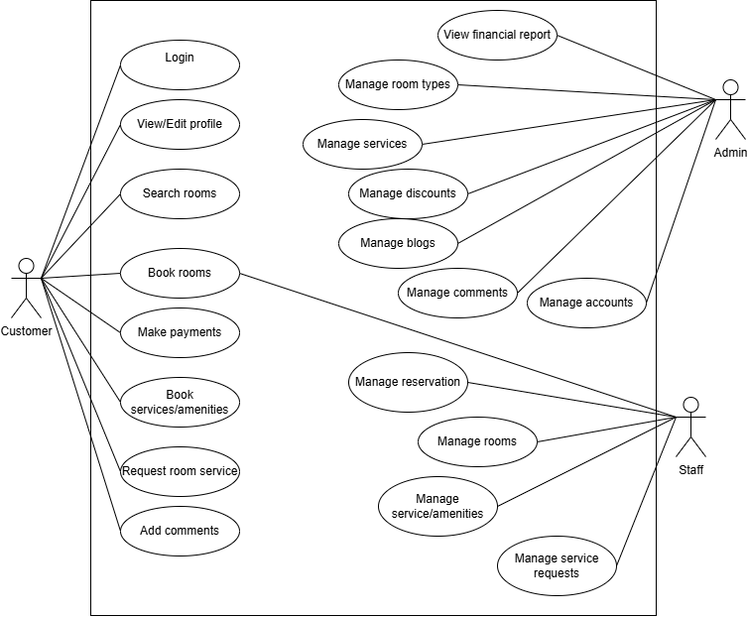

Use case Login
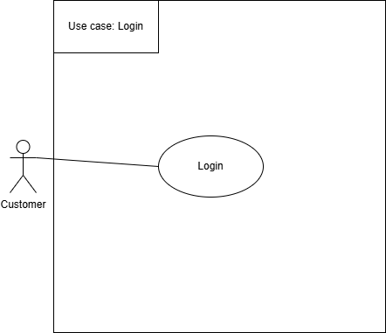
Use case ID | UC01
Use case name | Login
Scenario | User wants to access the hotel booking system.
Triggering event | User clicks the “Login” button on the screen.
Brief description | This use case allows users to access the system using an account previously assigned. When valid credentials are provided, the system grants access to further functionalities.
Actor | Customer
Related use cases | None
Stakeholders | User: Provide username and password to the system.
Preconditions | Users have a registered account.  The system is online.
Postconditions | Login successful: can use the system features.  Login failed: the system will show an error message.
Flow of events | Actor | System
 | - User opens login form.  - User enters username and password.  - User clicks “Login”. | The system displays the login form.  The system verifies credentials.  If valid: Redirect to dashboard.  If invalid: Show error message.  User can use the functions corresponding to the account.
Exception conditions | - If the User enters the wrong syntax then the system reports an error  - System checks all modified fields against data rules (e.g., email format, phone length, required fields)..

Use case View/Edit profile
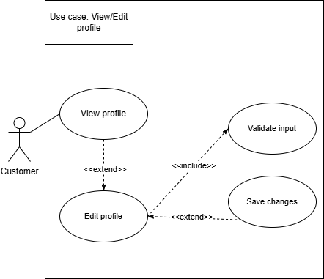
Use case ID | UC02
Use case name | View/Edit profile
Scenario | A Customer wants to review their personal details, loyalty information, or update their contact information.
Triggering event | User clicks the "My Profile" or "Account Settings" link/button in the system menu.
Brief description | This use case allows the Customer to access and display their personal details and booking history. Optionally, they can modify and save changes to information
Actor | Customer
Related use cases | None
Stakeholders | User: Ensure personal and contact information is accurate.
Preconditions | The User (Customer) must be logged into the system (Postcondition of UC01). The system must hold an existing profile record for the Customer.
Postconditions | Login successful: can use the system features.  Login failed: the system will show an error message.
Flow of events | Actor | System
 | 1. User clicks "My Profile."  2. (Optional Path: Edit Profile)  2.1. User clicks "Edit Profile."  2.2. User modifies fields  2.3. User clicks "Save Changes.". | 2.2 System checks all modified fields against data rules (e.g., email format, phone length, required fields).The system displays the login form.
Exception conditions | 2.2. If any input fails validation the system highlights the error field and requires the user to correct it.  2.3. If the database update fails, the system displays a "Failed to save" error message.

Use case Search rooms
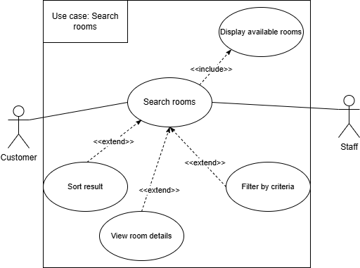
Use case ID | UC03
Use case name | Search rooms
Scenario | A Customer wants to find available rooms based on specific criteria such as check-in/check-out dates, room type, number of guests, and price range.
Triggering event | User clicks the "Search Rooms" or "Book Now" button, or accesses the room search page.
Brief description | This use case allows the Customer or Staff to search for available rooms by entering search criteria. The system displays matching results with room details, availability, and pricing information.
Actor | Customer
Related use cases | UC04
Stakeholders | Customer/Staff: Find suitable rooms that meet their requirements and budget.
Preconditions | The system must have room inventory data available. For Staff actors, they must be logged into the system.
Postconditions | Search successful: System displays a list of available rooms matching the criteria.  No results found: System displays a message indicating no rooms match the search criteria.
Flow of events | Actor | System
 | 1. User accesses the room search page.  2. User enters search criteria (check-in date, check-out date, number of guests, optional: room type, price range).  3.User clicks "Search" button. | 1. System displays the search form with fields for dates, room type, number of guests, and price range.  2.1 System validates the input criteria (dates are valid, check-in is before check-out, dates are not in the past).  2.2 System queries the database for available rooms matching the criteria.  3.1 System displays search results showing room details (type, capacity, amenities, price, images).
Exception conditions | 2.1 If dates are invalid or check-in is after check-out, system displays an error message requesting valid dates.  2.2 If check-in date is in the past, system displays an error message.  2.3 If no rooms match the criteria, system displays "No available rooms found" message with suggestions to adjust search criteria.  3.3 If database query fails, system displays "Search temporarily unavailable" error message.

Use case Book rooms
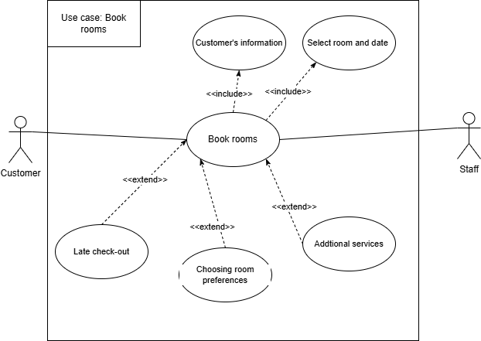
Use case ID | UC04
Use case name | Book rooms
Scenario | A Customer or Staff wants to create a reservation by selecting room types, specifying dates, and entering guest information.
Triggering event | User clicks the "Book Now" button on a selected room or accesses the booking page.
Brief description | This use case allows the Customer or Staff to make a new reservation by selecting available rooms, entering check-in/check-out dates, providing guest information, and confirming the booking. The system validates availability and generates a booking confirmation.
Actor | Customer, Staff
Related use cases | UC03, UC05
Stakeholders | Customer/Staff: Successfully reserve rooms and receive booking confirmation.
Preconditions | Available rooms must exist in the system. The user must have completed a room search (UC03) or selected a room from the catalog. For Customer actors, they must be logged into the system.
Postconditions | Booking successful: System creates a reservation record, assigns a unique booking reference number, and displays confirmation details.  Booking failed: System displays an error message and the reservation is not created.
Flow of events | Actor | System
 | 1. User selects a room from search results or room catalog  2. User enters/confirms check-in and check-out dates. |  3. User enters guest information (name, contact details, special requests)  4. User clicks "Confirm Booking" button. | 1.1 System displays the booking form with selected room details (type, dates, price). 5.1 System validates all required fields are completed.  4.2 System verifies room availability for the selected dates.  4.3 System calculates total charges including taxes and fees.  4.4 System creates the reservation record in the database.  4.5 System generates a unique booking reference number.  5. System displays booking confirmation with reference number and reservation details.  5.1 System sends confirmation email/SMS to the customer.
Exception conditions | 4.1 If required fields are missing, system highlights the missing fields and requests completion.  4.2 If the selected room is no longer available, system displays "Room unavailable" message and suggests alternative rooms.  4.4 If database operation fails, system displays "Booking failed, please try again" error message.  5.1 If email/SMS sending fails, system still confirms the booking but logs the notification failure.

Use case Make payments
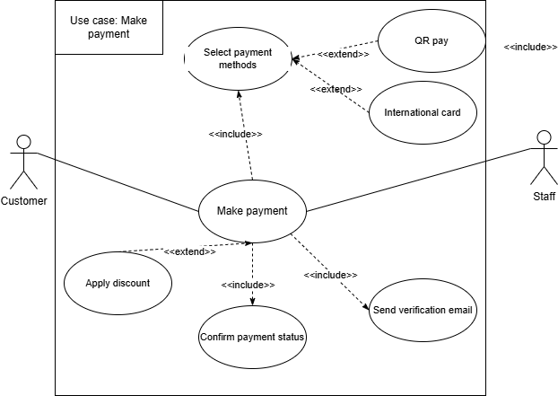
Use case ID | UC05
Use case name | Make Payments
Scenario | A Customer or Staff wants to process payment for a booking or service using their preferred payment method.
Triggering event | User clicks the "Proceed to Payment" or "Make Payment" button after confirming a booking or service.
Brief description | This use case allows the Customer or Staff to process payment for bookings and services by selecting a payment method, entering payment details, applying discount codes if available, and receiving a receipt upon successful transaction.
Actor | Customer, Staff
Related use cases | UC04, UC06
Stakeholders | Customer/Staff: Complete payment securely and receive transaction confirmation.
Preconditions | A booking or service order must exist and require payment. The user must be logged into the system. The total amount to be paid must be calculated and displayed.
Postconditions | Payment successful: System records the payment transaction, updates booking/service status to paid, and generates a receipt.  Payment failed: System displays an error message and the booking/service remains unpaid.
Flow of events | Actor | System
 | 1. User accesses the payment page for their booking/service.  2. User selects payment method (credit card, bank transfer, e-wallet).  3. User clicks "Confirm Payment" button. | 1.1 System displays payment summary with itemized charges, taxes, and total amount.  2.1 System displays appropriate payment input fields based on selected method.  3.1 System validates the discount code.  5.1 System validates payment information format.  3.2 System processes payment transaction through payment gateway.  3.3 System records payment transaction in the database.  3.4 System updates booking/service status to paid.  3.5 System generates a unique transaction ID and receipt.  6. System displays payment confirmation with receipt details.  6.1 System sends receipt via email/SMS to the customer.
Exception conditions | 3.1 If discount code is invalid or expired, system displays "Invalid discount code" error message.  5.1 If payment details are incomplete or invalid format, system highlights error fields and requests correction.  5.2 If payment processing fails (insufficient funds, card declined, network error), system displays payment failure message with reason.  5.3 If database operation fails, system attempts to reverse the payment transaction and displays error message.  6.1 If receipt sending fails, system still confirms payment but logs the notification failure.

Use Case Book services/amenities
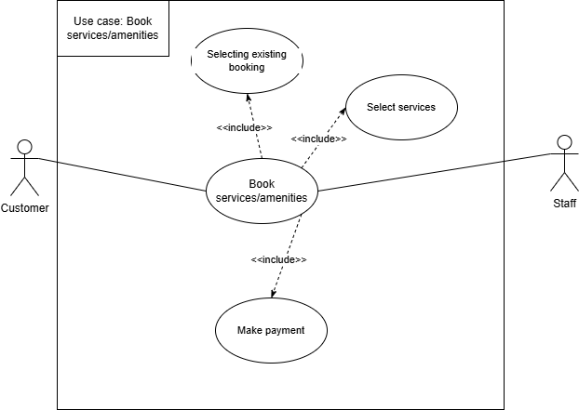

Use case ID | UC06
Use case name | Book Services/Amenities
Scenario | A Customer wants to browse and book available hotel services and amenities such as spa treatments, gym access, pool reservations, restaurant bookings, or tours.
Triggering event | User clicks the "Services" or "Amenities" menu option, or accesses the services booking page.
Brief description | This use case allows the Customer to browse available hotel services and amenities, view descriptions and pricing, select desired items, specify date and time preferences, and complete the booking.
Actor | Customer
Related use cases | UC04
Stakeholders | The user must be logged into the system. The system must have a catalog of available services and amenities with pricing and availability data.
Preconditions | The user must be logged into the system. The system must have a catalog of available services and amenities with pricing and availability data.
Postconditions | Booking successful: System creates a service/amenity reservation record, confirms the booking, and displays confirmation details.  Booking failed: System displays an error message and the service/amenity is not reserved.
Flow of events | Actor | System
 | 1.User accesses the services/amenities page.  2. User browses services and selects a service/amenity  3. User selects desired date and time for the service.User specifies quantity or number of participants if applicable.  User adds additional services if desired  4. User clicks "Confirm Booking" button. | 1.1 System displays the catalog of available  2.1 System displays detailed information (description, pricing, duration, images, availability).  3.1 System validates all required fields are completed.  3.2 System checks service availability for selected date and time..  3.3 System calculates total charges for all selected services.  4.1 System creates the service booking record in the database.  4.2 System generates a unique booking reference number.  4.3 System displays booking confirmation with reference number and booking details.
Exception conditions | 3.1 If required fields are missing, system highlights the missing fields and requests completion.  3.2 If the service is unavailable for the selected date/time, system displays "Time slot unavailable" message and suggests alternative times.  3.3 If database operation fails, system displays "Booking failed, please try again" error message.

Use case Request room services
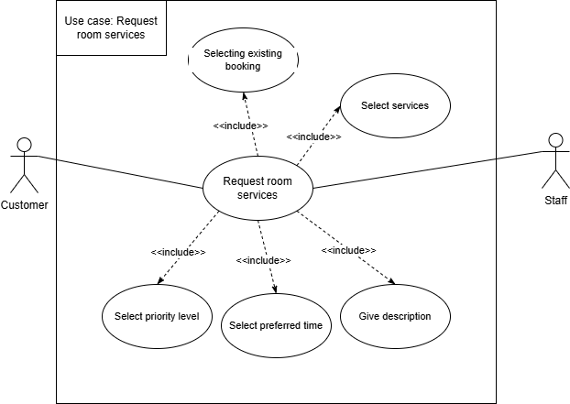
Use case ID | UC07
Use case name | Request Room Services
Scenario | A Customer wants to request in-room services such as ordering food from the hotel restaurant, requesting housekeeping items, scheduling room cleaning, or reporting maintenance issues.
Triggering event | User clicks the "Room Service" button or accesses the room service request page from their room dashboard.
Brief description | User clicks the "Room Service" button or accesses the room service request page from their room dashboard.
Actor | Customer
Related use cases | UC04
Stakeholders | Receive timely and accurate room services to enhance their stay experience.
Preconditions | The user must be logged into the system. The customer must have an active room reservation. The system must have service request categories and options configured.
Postconditions | Request successful: System creates a service request record, assigns a tracking number, queues the request for staff, and displays confirmation.  Request failed: System displays an error message and the request is not submitted.
Flow of events | Actor | System
 | 1. User accesses the room service request page. |  2. User selects service category.  3. User enters service details (items to order, specific requests, problem description).  4. User specifies urgency level (urgent, normal)  5.User clicks "Submit Request" button. | 1.1 System displays available service categories (food/beverage, housekeeping, maintenance, other).  2.1 System displays relevant options and fields based on selected category.  5.1 System validates all required fields are completed.  5.2 System creates the service request record in the database.  5.3 System assigns a unique request tracking number.  5.4 System queues the request and routes it to the appropriate department/staff.  6. System displays confirmation with tracking number and estimated response time.
Exception conditions | 7.1 If required fields are missing, system highlights the missing fields and requests completion.  7.2 If database operation fails, system displays "Request submission failed, please try again" error message.  8.1 If staff notification fails, system logs the failure but still records the request for manual processing.  8.2 If customer notification fails, system still confirms the request but logs the notification failure.

Use case Add comments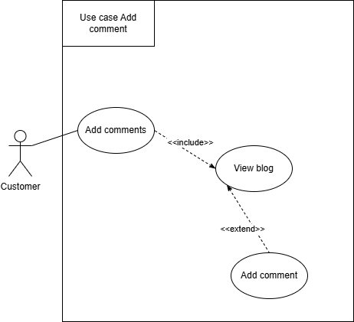
Use case ID | UC08
Use case name | Add comments
Scenario | A Customer wants to submit feedback, reviews, or comments regarding a blog post.
Triggering event | User clicks the "Add Comment" or "Leave a Review" button on a blog post.
Brief description | This use case allows the Customer to submit comments or feedback on blog posts. The system stores the comment for moderation and displays confirmation.
Actor | Customer
Related use cases | None
Stakeholders | Customer: Share their opinions and feedback on blog content.
Preconditions | The user must be logged into the system. A blog post must exist and be published.
Postconditions | Comment submitted: System saves the comment for moderation and displays confirmation.  Comment failed: System displays an error message and the comment is not saved.
Flow of events | Actor | System
 | 1. User views a blog post and clicks "Add Comment".  2. User types their comment in the text field.  3. User clicks "Submit Comment" button. | 1.1 System displays the comment input form.  3.1 System validates the comment (not empty, appropriate length).  3.2 System saves the comment with pending status.  3.3 System displays "Comment submitted for review" confirmation message.
Exception conditions | 3.1 If comment is empty or too short, system displays "Please enter a valid comment" error message.  3.2 If database operation fails, system displays "Failed to submit comment, please try again" error message.

Use case Manage reservations

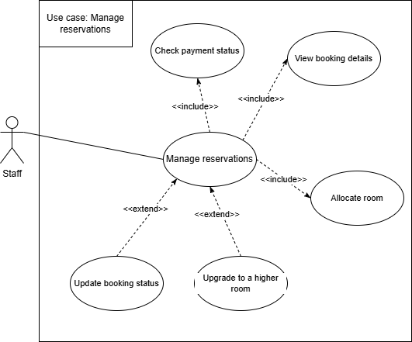
Use case ID | UC09
Use case name | Manage reservation
Scenario | A Staff wants to view, modify, confirm, or cancel guest reservations and monitor overall booking schedule and occupancy levels.
Triggering event | Staff clicks the "Manage Reservations" menu option or accesses the reservation management dashboard.
Brief description | This use case allows the Manager to oversee all guest reservations, modify booking details, confirm or cancel reservations, and monitor occupancy levels through a centralized dashboard.
Actor | Staff
Related use cases | UC04
Stakeholders | Staff: Efficiently manage all reservations and optimize hotel occupancy.
Preconditions | The user must be logged into the system as a Staff. Reservation records must exist in the system.
Postconditions | Management successful: System updates reservation data and displays confirmation.  Management failed: System displays an error message and changes are not saved.
Flow of events | Actor | System
 | 1. Manager accesses the reservation management page.  2. Staff searches/filters reservations by date, status, guest name, or room.  3. Staff selects a reservation to view details  4.Staff performs action (modify, confirm, or cancel) | 1.1 System displays the reservation dashboard with list of all bookings and occupancy summary.  2.1 System displays filtered results.  3.1 System displays full reservation information.  4.1 System validates the action and updates the reservation record.  4.2 System displays confirmation message.
Exception conditions | 4.1 If modification conflicts with availability, system displays "Action cannot be completed" error message.  4.1 If database operation fails, system displays "Failed to update reservation" error message.  4.3 If customer notification fails, system logs the failure but completes the action.

Use case Manage rooms
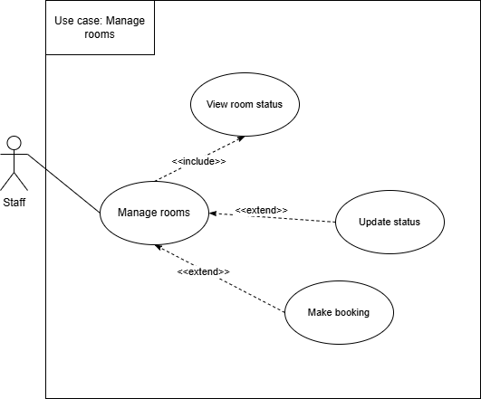
Use case ID | UC10
Use case name | Manage rooms
Scenario | A Staff wants to update room status and monitor room availability in real-time.
Triggering event | Staff clicks the "Manage Rooms" menu option or accesses the room management dashboard
Brief description | This use case allows the Staff to update room status such as available, occupied, under maintenance, or needs cleaning, and monitor the overall room inventory.
Actor | Staff
Related use cases | None
Stakeholders | Staff: Maintain accurate room status to optimize operations and guest satisfaction.
Preconditions | The user must be logged into the system as a Staff. Room inventory must exist in the system.
Postconditions | Update successful: System updates room status and displays confirmation.  Update failed: System displays an error message and status is not changed.
Flow of events | Actor | System
 | Staff accesses the room management page.  rooms by floor, type, or status.  2. Staff searches/filters  3.Staff selects a room to view details.  4. Staff updates room status (available, occupied, maintenance, cleaning). | 1.1 System displays room status dashboard showing all rooms and their current status.  2.1 System displays filtered results.  3.1 System displays room information and status history.  4.1 System validates the status change.  4.2 System updates the room record.  4.3 System displays confirmation message.
Exception conditions | 4.1 If status change conflicts with existing reservations, system displays "Cannot change status" error message.  4.2 If database operation fails, system displays "Failed to update room status" error message.

Use case Manage service requests
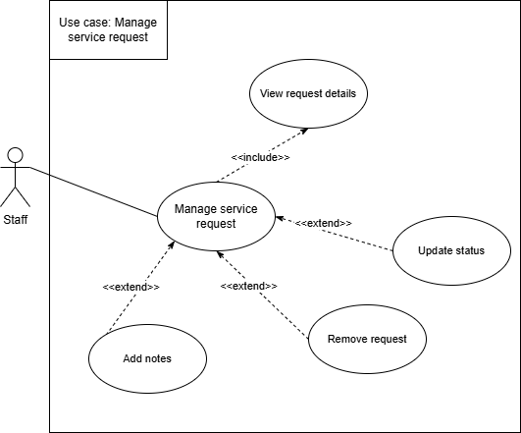

Use case ID | UC11
Use case name | Manage Service Requests
Scenario | A Staff wants to view, assign, prioritize, and track the fulfillment status of all guest service requests.
Triggering event | Staff clicks the "Manage Service Requests" menu option or accesses the service request management dashboard.
Brief description | This use case allows the Staff to oversee all guest service requests, assign them to appropriate staff, set priority levels, and monitor completion status.
Actor | Staff
Related use cases | UC07
Stakeholders | Staff: Ensure timely fulfillment of guest requests and maintain service quality.
Preconditions | The user must be logged into the system as a Staff. Service request records must exist in the system.
Postconditions | Management successful: System updates service request data and displays confirmation.  Management failed: System displays an error message and changes are not saved.
Flow of events | Actor | System
 | 1. Staff accesses the service request management page.  2.Staff searches/filters requests by status, priority, date, or room number.  3. Staff selects a service request to view details.  4/ Staff performs action (assign to staff, set priority, update status, add notes). | 1.System displays the service request dashboard with all pending and active requests.  2. System displays filtered results.  3./ System displays full request information and history.  4. System validates the action and updates the request record.  4.System displays confirmation message.
Exception conditions | 4: If assigned staff is unavailable or invalid, system displays "Cannot assign request" error message.  4: If database operation fails, system displays "Failed to update request" error message.

Use case Manage services/amenities booking
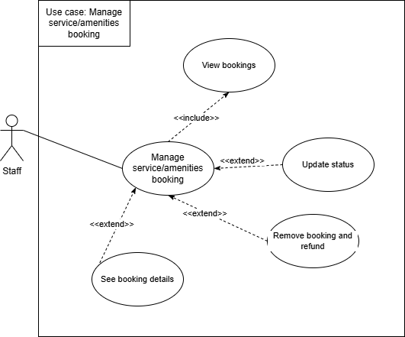

Use case ID | UC12
Use case name | Manage Services/Amenities Booking
Scenario | A Staff wants to view, assign, prioritize, and track the fulfillment status of all guest service requests.
Triggering event | Staff clicks the "Manage Services/Amenities" menu option or accesses the services management dashboard.
Brief description | This use case allows the Staff to view all service and amenity bookings, adjust availability and capacity, manage schedules, and handle booking conflicts.
Actor | Staff
Related use cases | UC06
Stakeholders | Staff: Optimize service utilization and prevent overbooking or conflicts.
Preconditions | The user must be logged into the system as Staff. Service and amenity records must exist in the system.
Postconditions | Management successful: System updates service/amenity data and displays confirmation.  Management failed: System displays an error message and changes are not saved.
Flow of events | Actor | System
 | - Staff accesses the services/amenities management page.  - Staff searches/filters bookings by service type, date, or status.  - Staff selects a service/amenity booking to view details.  - Staff performs action (adjust availability, modify schedule, handle conflicts, update capacity). | 1.System displays the services/amenities dashboard with all bookings and availability calendar.  2. System displays filtered results.  2. System displays full booking information and schedule.  4. System validates the changes.  5. System updates the service/amenity records.  6. System displays confirmation message.
Exception conditions | 4: If changes conflict with existing bookings, system displays "Conflict detected" warning message.  4: If database operation fails, system displays "Failed to update service" error message.  4 : If customer notification fails, system logs the failure but completes the update.

Use case View financial report
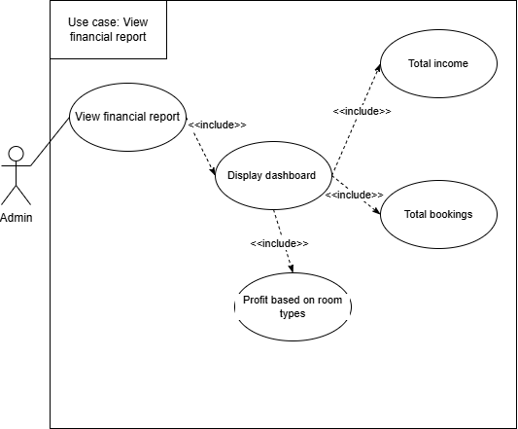
Use case ID | UC13
Use case name | View Financial Report
Scenario | An Admin wants to generate and view comprehensive reports on sales, revenue, occupancy rates, and overall financial performance.
Triggering event | Admin clicks the "Financial Reports" menu option or accesses the reporting dashboard.
Brief description | This use case allows the Admin to generate and view various financial reports including sales revenue, occupancy rates, payment analysis, and performance metrics for specified time periods.
Actor | Admin
Related use cases | None
Stakeholders | Admin: Monitor financial performance and make informed business decisions.
Preconditions | The user must be logged into the system as Admin. Financial transaction data must exist in the system.
Postconditions | Report generated: System displays the requested financial report with relevant data.  Report failed: System displays an error message and report is not generated.
Flow of events | Actor | System
 | - Admin accesses the financial reports page.  - Admin selects report type (revenue, occupancy, payment analysis, sales breakdown).  - Admin clicks "Generate Report" button. | - System displays the financial reporting dashboard with available report options.  - System validates the date range and criteria.  - System retrieves data from the database.  - System calculates metrics and generates the report.  - System displays the report with charts, graphs, and tables.
Exception conditions | If date range is invalid, system displays "Invalid date range" error message.  If no data exists for the selected criteria, system displays "No data available for this period" message.  If database query fails, system displays "Failed to generate report" error message.  If export fails, system displays "Export failed, please try again" error message.

Use case Manage room types
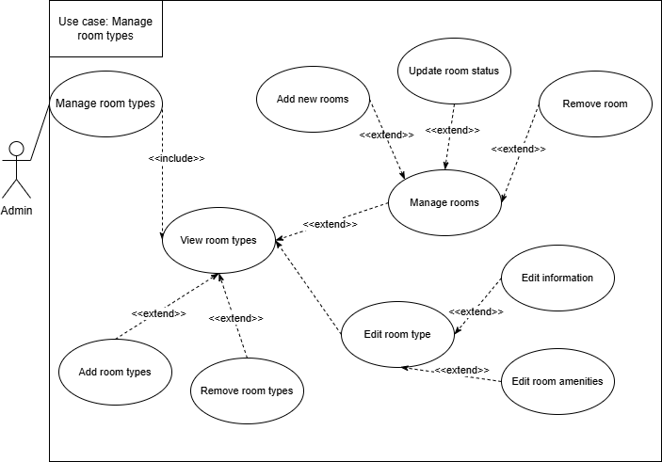
Use case ID | UC14
Use case name | Manage room types
Scenario | An Admin wants to define, modify, and delete different room categories
Triggering event | Admin clicks the "Manage Room Types" menu option or accesses the room types management page.
Brief description | This use case allows the Admin to create new room categories, modify existing room type details including pricing and amenities, and delete obsolete room types.
Actor | Admin
Related use cases | UC03, UC04, UC09
Stakeholders | Admin: Maintain accurate room type catalog to support booking operations.
Preconditions | The user must be logged into the system as Admin.
Postconditions | Management successful: System updates room type data and displays confirmation.  Management failed: System displays an error message and changes are not saved.
Flow of events | Actor | System
 | - Admin accesses the room types management page.  - Admin selects action (create new, edit existing, or delete room type).  - Admin enters/modifies room type details (name, description, capacity, amenities, pricing).  - Admin clicks "Save" or "Delete" button. | - System displays the list of existing room types.  - System validates all input fields.  - System saves changes or deletes the room type record.  - System displays confirmation message.  - System updates the room inventory to reflect changes.
Exception conditions | If required fields are missing or invalid, system highlights error fields and requests correction.  deleting a room type that has active bookings, system displays "Cannot delete, room type in use" error message.  If database operation fails, system displays "Failed to save changes" error message.

Use case Manage services
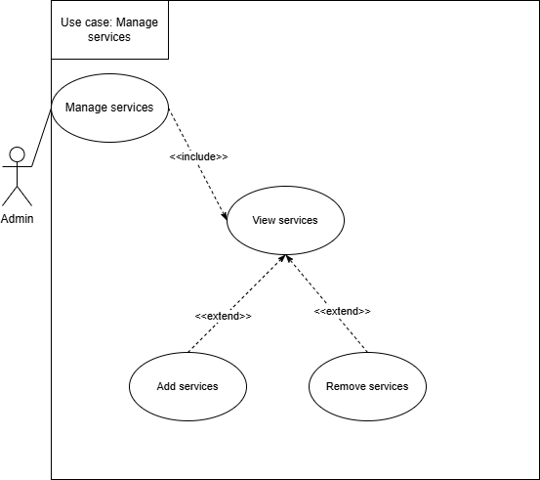

Use case ID | UC15
Use case name | Manage services
Scenario | An Admin wants to define, modify, and delete the list of available services and amenities the hotel offers, along with pricing and descriptions.
Triggering event | Admin clicks the "Manage Services" menu option or accesses the services management page.
Brief description | This use case allows the Admin to create new service offerings, modify existing service details including descriptions and pricing, and delete services no longer offered.
Actor | Admin
Related use cases | UC06, UC12
Stakeholders | Admin: Maintain accurate service catalog to support customer bookings.
Preconditions | The user must be logged into the system as Admin.
Postconditions | Management successful: System updates service data and displays confirmation.  Management failed: System displays an error message and changes are not saved.
Flow of events | Actor | System
 | - Admin accesses the services management page.  - Admin selects action (create new, edit existing, or delete service).  - Admin enters/modifies service details (name, description, category, pricing, availability, capacity).  - Admin clicks "Save" or "Delete" button. | - System displays the list of existing services categorized by type.  - System displays appropriate form based on selected action.  - System validates all input fields.  - System saves changes or deletes the service record.  - System displays confirmation message.  - System updates the service catalog to reflect changes.
Exception conditions | If required fields are missing or invalid, system highlights error fields and requests correction.  If deleting a service that has active bookings, system displays "Cannot delete, service has pending bookings" error message.  If database operation fails, system displays "Failed to save changes" error message.

Use case Manage discount

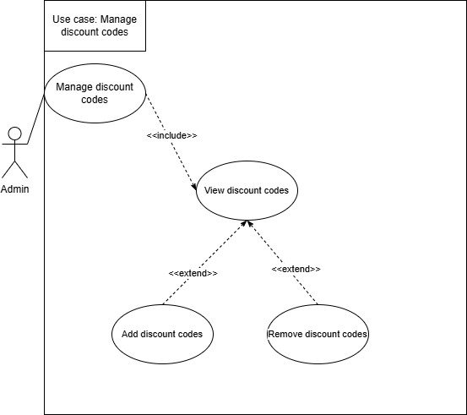
Use case ID | UC16
Use case name | Manage discount
Scenario | An Admin wants to create, modify, activate, and deactivate discount codes for promotional campaigns.
Triggering event | Admin clicks the "Manage Discounts" menu option or accesses the discount management page.
Brief description | This use case allows the Admin to create promotional discount codes with customizable parameters, modify existing discounts, and activate or deactivate discount campaigns.
Actor | Admin
Related use cases | UC05
Stakeholders | Admin: Create and manage promotional campaigns to drive bookings and revenue.
Preconditions | The user must be logged into the system as Admin.
Postconditions | Management successful: System updates discount data and displays confirmation.  Management failed: System displays an error message and changes are not saved.
Flow of events | Actor | System
 | - Admin accesses the discount management page.  - Admin selects action (create new, edit existing, activate, or deactivate discount).  - Admin enters/modifies discount details (code, type, value, validity period, usage limits, eligibility).  - Admin clicks "Save" button. | - System displays the list of existing discount codes with status.  - System displays appropriate form based on selected action.  - System validates all input fields and checks for duplicate codes.  - System saves changes or updates discount status.  - System displays confirmation message.
Exception conditions | If required fields are missing or invalid, system highlights error fields and requests correction.  If discount code already exists, system displays "Discount code already in use" error message.  If database operation fails, system displays "Failed to save discount" error message.

Use case Manage blogs
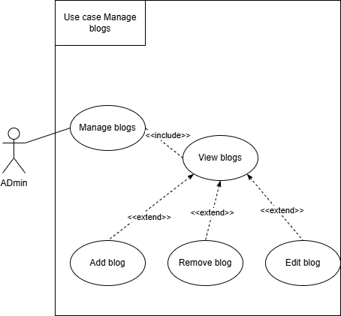

Use case ID | UC17
Use case name | Manage blogs
Scenario | An Admin wants to create, edit, and publish content such as articles, news, and local guides on the hotel blog.
Triggering event | Admin clicks the "Manage Blogs" menu option or accesses the blog management page.
Brief description | This use case allows the Admin to create new blog posts, edit existing content, publish or unpublish posts, and organize blog content by categories and tags.
Actor | Admin
Related use cases | UC08
Stakeholders | Admin: Maintain engaging blog content to attract customers and provide helpful information.
Preconditions | The user must be logged into the system as Admin.
Postconditions | Management successful: System updates blog data and displays confirmation.  Management failed: System displays an error message and changes are not saved.
Flow of events | Actor | System
 | - Admin accesses the blog management page.  - Admin selects action (create new, edit existing, publish, or unpublish blog post).  - Admin enters/modifies blog details (title, content, images, category, tags, publish date).  - Admin clicks "Save" or "Publish" button. | - System displays the list of existing blog posts with status (published, draft, scheduled).  - System displays appropriate editor form based on selected action.  - System validates all required fields.  - System saves changes or updates blog post status.  - System displays confirmation message.
Exception conditions | If required fields are missing, system highlights error fields and requests completion.  If database operation fails, system displays "Failed to save blog post" error message.  If image upload fails, system displays "Failed to upload image" error message.

Use case Manage comments
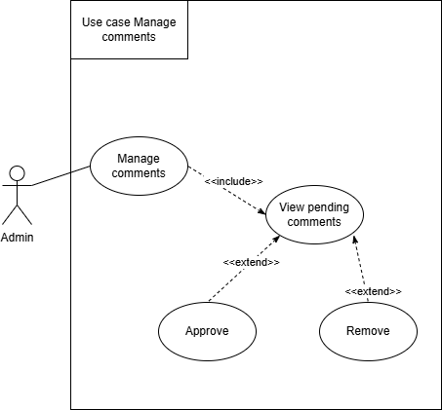
Use case ID | UC18
Use case name | Manage comments
Scenario | An Admin wants to review, moderate, approve, or delete comments and reviews submitted by customers.
Triggering event | Admin clicks the "Manage Comments" menu option or accesses the comment moderation page.
Brief description | This use case allows the Admin to review customer comments, approve pending submissions, edit inappropriate content, delete spam or offensive comments, and respond to customer feedback.
Actor | Admin
Related use cases | UC08
Stakeholders | Admin: Maintain quality and appropriateness of customer feedback displayed on the platform.
Preconditions | The user must be logged into the system as Admin.
Postconditions | Management successful: System updates comment status and displays confirmation.  Management failed: System displays an error message and changes are not saved.
Flow of events | Actor | System
 | - Admin accesses the comment management page.  - Admin filters comments by status (pending, approved, rejected) or blog post.  - Admin selects a comment to review.  - Admin performs action (approve, edit, delete, or respond to comment). | - System displays the list of all comments with status and submission date.  - System displays filtered results.  - System displays full comment details and customer information.  - System validates the action and updates the comment record.  - System displays confirmation message.
Exception conditions | If database operation fails, system displays "Failed to update comment" error message.  If attempting to approve an already approved comment, system displays "Comment already approved" message.

Use case Manage accounts
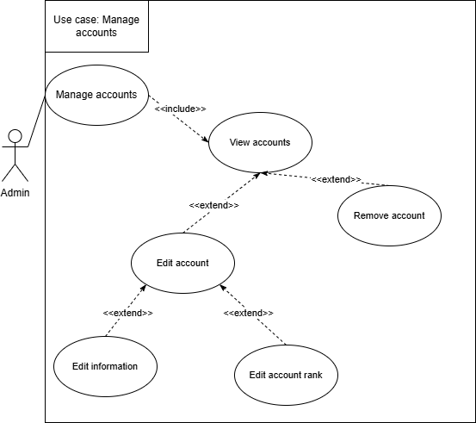
Use case ID | UC19
Use case name | Manage accounts
Scenario | An Admin wants to create, modify, suspend, and manage all user accounts within the system.
Triggering event | Admin clicks the "Manage Accounts" menu option or accesses the account management page.
Brief description | This use case allows the Admin to create new user accounts, modify account details, assign roles and permissions, suspend or deactivate accounts, and reactivate suspended accounts.
Actor | Admin
Related use cases | UC01
Stakeholders | Admin: Maintain secure and organized user account system with appropriate access controls.
Preconditions | The user must be logged into the system as Admin.
Postconditions | Management successful: System updates account data and displays confirmation.  Management failed: System displays an error message and changes are not saved.
Flow of events | Actor | System
 | - Admin accesses the account management page.  - Admin filters/searches accounts by role, status, or username.  - Admin selects action (create new, edit existing, suspend, deactivate, or reactivate account).  - Admin enters/modifies account details (username, email, role, permissions, status).  - Admin clicks "Save" button. | - System displays the list of all user accounts with roles and status.  - System displays filtered results.  - System displays appropriate form based on selected action.  - System validates all input fields and checks for duplicate usernames/emails.  - System saves changes or updates account status.  - System displays confirmation message.
Exception conditions | If required fields are missing or invalid, system highlights error fields and requests correction.  If username or email already exists, system displays "Username/Email already in use" error message.  If database operation fails, system displays "Failed to save account changes" error message.

Functional requirements
Customers:
- User Authentication, Authorization and Profile Management: Allows users to log in to the system and customers can view their personal profile information including contact details, booking history, and preferences. They can modify details such as name, email, phone number, address, and password.
- Room search and reservation processing: Customers can search for available rooms by specifying criteria such as check-in/check-out dates, number of guests, room type preferences, and price range. Then they can make reservations.by selecting desired room types, specifying stay dates, entering guest information, selecting add-on services, and confirming booking details. The system validates availability and generates a booking confirmation.
- Payment processing: Customers can process payments for their bookings and services using various payment methods (cash, bank transfer, credit card, e-wallet, etc.), apply available discount codes or promotional offers, and receive printed or digital receipts/invoices.
- Services/Amenities Booking: Customers can browse available hotel services and amenities (spa, gym, pool, restaurant reservations, tours, etc.), view descriptions and pricing, select desired items, specify date and time preferences, and complete bookings.
- Room Services Request Submission: Customers can submit in-room service requests such as ordering food and beverages from the hotel restaurant, requesting housekeeping items (extra towels, pillows, toiletries), scheduling room cleaning, or reporting maintenance issues.
- Customer Comments Submission: Customers can submit feedback, reviews, ratings, and comments regarding blog posts, hotel experiences, services, or facilities. They can view their previously submitted comments and edit or delete them if permitted.

Staff
- Reservation Overview and Management: Staff can view all guest reservations in a centralized dashboard, modify booking details (dates, room types, guest information), confirm pending reservations, cancel bookings with appropriate reasons, monitor overall occupancy levels, and analyze booking patterns and trends.
- Room Status Management: Staff can update room status in real-time (available, occupied, under maintenance, needs cleaning, out of service), assign rooms to reservations, track room readiness, coordinate with housekeeping for room preparation, and generate room status reports.
- Service Requests Oversight: Staff can view all guest service requests in a centralized queue, assign requests to appropriate staff members or departments, set priority levels (urgent, high, normal, low), track fulfillment status and completion time, communicate with guests regarding request updates, and generate service performance reports.
- Services/Amenities Booking Management: Staffs can oversee the inventory and scheduling of all bookable hotel services and amenities, set availability calendars and capacity limits, adjust pricing and service descriptions, monitor booking rates and utilization, handle booking conflicts or overbooking situations, and coordinate with service providers.

Admin
- Financial Reporting and Analytics: Admin can view comprehensive financial reports including sales revenue, occupancy rates and trends, revenue breakdown by room types and services, payment method analysis, profit margins, calculate financial performance indicators, and present visual analytics through interactive charts and graphs.
- Room Type Configuration Admin can define new room categories, modify existing room type details including name, description, base capacity, maximum occupancy, configure pricing structures with base rates and seasonal pricing, specify included amenities and features, upload room images
- Service Catalog Management: Admin can define and maintain the complete catalog of hotel services and amenities, add new service offerings with detailed descriptions and images, set pricing structures and service duration, specify availability schedules and capacity constraints
- Discount Administration: Admin can create promotional discount codes with customizable parameters including discount type (percentage or fixed amount usage limits per customer and overall)
- Content Management System: Admin can create engaging blog content including articles about local attractions, travel tips, hotel news, and special events, write and format blog posts edit and update existing blog entries, publish or unpublish posts to control visibility
- Comment Moderation System: Admin can review all comments and reviews submitted by customers across blog posts, service feedback, and booking reviews, approve pending comments for publication, edit inappropriate content
- User Account Administration: Admin can, assign and modify user roles and permission levels with granular access control, deactivate accounts permanently for terminated employees.

Non-functional requirements
Non-functional requirements define the quality attributes, performance standards, and operational constraints of the Hotel Management System.

Performance Requirements
- The system shall respond to user actions within 2 seconds under normal load conditions
- The system shall support at least 100 concurrent users without performance degradation
- Room search and availability queries shall return results within 1.5 seconds
- Database operations shall complete within 1 second for standard queries
- Page load times shall not exceed 3 seconds on standard internet connections

Usability Requirements
- The interface shall be responsive and compatible with desktop, tablet, and mobile devices
- Common tasks shall be completable within 3 steps or fewer
- The system shall provide clear labels, icons, and error messages throughout
- Visual feedback shall be displayed for all user actions (loading, success, errors)
- Navigation shall remain consistent across all pages
- Help documentation shall be accessible from any page

Reliability Requirements
- The system shall maintain 99% uptime during operating hours
- Session data and form inputs shall be preserved during system interruptions
- Booking data integrity shall be maintained during network or server issues
- Critical functions shall include redundancy measures to prevent data loss
- Errors shall be handled gracefully with user-friendly messages

Security Requirements
- All sensitive data shall be transmitted via HTTPS with SSL/TLS encryption
- Role-based access control shall enforce the following restrictions:
- Customers: access only personal bookings and profile
- Staff: access booking management but not financial reports or system settings
- Admin: full system access including financial data and configuration
- All critical actions shall be logged with timestamps and user identification
- All inputs shall be validated and sanitized to prevent injection attacks
- Database access shall use authentication with appropriate privilege levels

Maintainability Requirements
- Code shall include inline comments explaining complex logic and functions
- Coding standards shall follow conventions for consistency
- Logs shall include timestamps, user IDs, IP addresses, and error details
- Database schema shall be normalized with documented relationships
- Configuration settings shall be stored separately from source code

Scalability Requirements
- The system shall support growth in rooms, users, and bookings without architectural redesign
- Migration from local to cloud hosting shall require minimal configuration changes
- Performance shall remain stable during peak periods and increased load
- The database shall use indexing and optimization for efficient data handling
- The architecture shall support horizontal or vertical scaling as needed
- Multi-property management shall be achievable with minimal code modifications

Backup and Recovery Requirements
- Automatic daily backups
- Backups shall run during low-traffic hours (e.g., 3:00 AM)
- System recovery shall be achievable within 30 minutes from the latest backup
- Incremental backups shall be supported to optimize storage
- Backup integrity tests shall be performed monthly
- Transaction logs shall enable recovery to the point of failure.

ARCHITECTURE

Architecture style(s) used
The Hotel Management Software adopts a Monolithic Client-Server architecture with a modular, feature-based organization. The system is hosted on a local server environment provided by XAMPP, where PHP scripts handle all business logic, data management, and user interface rendering.
In this architecture:
- The client is a web browser that sends HTTP requests to the server when users perform actions such as searching rooms, placing bookings, or managing operations.
- The server runs PHP scripts on XAMPP, processes requests, executes business logic, interacts with the MySQL database, and generates dynamic HTML pages.
- The database is MySQL, storing all persistent data including users, rooms, bookings, payments, staff information, and reviews.
Each module contains PHP files that combine business logic and presentation, directly interacting with the MySQL database using SQL queries. This approach provides clear feature separation, code reusability through shared components, straightforward development and maintenance, and easy deployment on standard web hosting environments, making it suitable for small to medium-sized hotel operations.
This architectural approach balances simplicity with organization, providing clear feature separation while maintaining the straightforward nature of procedural PHP development, making it suitable for the Hotel Management Software's requirements and development constraints.

Architectural model
To effectively implement the architecture described, the system is designed following a Monolithic Client-Server model, in which all processing responsibilities—including business logic, data management, and dynamic page generation—are centralized on the server. The client interacts purely through a standard web browser interface. This model provides a clear separation between the presentation layer (client) and the backend operations (server and database), ensuring efficient communication, simplified deployment, and straightforward maintenance.
The architecture consists of three main components:
1. Client (Web Browser)
The client is the interface layer where Customers, Staff, and Administrators access the Hotel Management Software. It runs in web browsers and sends HTTP requests (GET/POST) to communicate with the server.
- Users interact with the system by filling out forms (booking details, guest information, login credentials), clicking buttons (search rooms, confirm booking, update status), navigating between pages (homepage, booking history, admin dashboard), and viewing dynamic content rendered as HTML/CSS with JavaScript enhancements.
- The browser sends HTTP requests to specific PHP scripts on the server to perform operations such as searching available rooms, placing bookings, processing payments, managing staff schedules, viewing financial reports, or updating room information.
- After the server processes the request, it responds with dynamically generated HTML pages that are rendered and displayed in the user's browser, presenting updated information such as search results, booking confirmations, or error messages.
2. Server (XAMPP – PHP Application with Feature-Based Organization)
The server runs on XAMPP, using PHP to handle application logic. The system employs a feature-based modular structure where functionality is organized into separate directories (/booking, /staff, /admin, /portal) with related PHP files grouped together. Server responsibilities include:
  - Receives and routes requests: Intercepts HTTP requests from the client and directs them to the appropriate PHP script based on the requested URL (e.g., booking/booking_step.php handles guest information collection, staff/bookings.php displays all reservations for staff management).
  - Executes business logic: Processes operations such as checking room availability by querying booking records and date ranges, validating guest information and payment details, calculating total booking costs including room rates and add-on services, updating booking statuses (pending, confirmed, checked-in, completed), managing staff shift assignments, and generating financial statistics reports.
  - Database interaction: Executes SQL queries against the MySQL database for data operations (Create bookings, Read room availability, Update customer information, Delete cancelled reservations). Database connection is established through shared scripts to ensure consistency across all modules.
  - Dynamic page generation: Creates HTML output dynamically through PHP scripts that fetch database records, applies conditional logic based on user roles and permissions, formats data for presentation, and outputs complete HTML documents sent back to the client browser.
  - Session management and authentication: Maintains user sessions to track logged-in users, verifies user credentials, enforces role-based access control (customers access booking features, staff manage operations, admin configures system settings), and protects pages from unauthorized access.
3. Database (MySQL)
MySQL serves as the relational database, handling all persistent data storage for the application. Tables are normalized to ensure data consistency and eliminate duplication.
  - Data storage: The database stores user, room types and physical room inventory, customer booking records with guest details and dates, payment transactions and invoice information, staff information and shift schedules, customer reviews and ratings, and system configuration settings.
  - Data operations: SQL queries from PHP scripts handle record insertion (bookings, user registration), data retrieval with filters, update existing records (changing booking status, modifying room information), and delete records (removing cancelled bookings, deactivating staff accounts).
  - Data integrity: The database enforces referential integrity through foreign key constraints linking bookings to rooms and customers, uses primary keys to uniquely identify records, implements NOT NULL constraints on required fields, and maintains indexes on frequently queried columns (check-in dates, room numbers, customer IDs) for improved query performance.
  - Centralized access: Database access occurs exclusively through server-side PHP scripts, preventing direct client connections, maintaining security and data consistency.

This design gives each component specific responsibilities, enabling the system to operate cohesively within a monolithic structure. The Client-Server approach with modular PHP structure delivers::
- Clear separation of concerns – Presentation logic (HTML/CSS in browser), business logic (PHP scripts on server), and data storage (MySQL database) are distinctly separated yet work together seamlessly.
- Fast request processing – HTTP communication is straightforward, dependable, and universally compatible by all web browsers and hosting environments.
- Modular code organization – Feature-based directory structure makes it easy to locate, modify, and extend specific functionalities without affecting unrelated parts of the system.
- Straightforward development and maintenance – Developers can quickly understand the codebase structure, add new features by creating PHP files in appropriate directories, and debug issues by tracing request flow through specific scripts.
- Easy deployment – The entire application runs on a single server (XAMPP during development) and can be deployed by simply copying files and importing the database, without complex configuration or distributed system management.
All components work together in a unified PHP-based codebase hosted on XAMPP and accessed by users via standard web browsers, making the Hotel Management Software suitable for small to medium-sized hotel operations.

Technology, software, and hardware used

Technologies
Backend technologies:
- PHP 7.4+ (procedural with targeted OOP)
- MySQL 8.0 for relational database management
- Apache web server (via XAMPP) for local development
Frontend Technologies:
- HTML5 for page structure and semantic markup
- CSS3 for styling and layout design
- Bootstrap 5 framework for responsive UI components and grid system
- JavaScript for client-side interactions and form validation
- PHPMailer for sending booking confirmation emails

Software Tools

Development Environment:
- XAMPP for local development server
- Visual Studio Code as primary code editor
- Git for version control and collaborative development
- GitHub for remote repository hosting and code backup
Design and Documentation Tools:
- Draw.io for creating UML diagrams (use cases, sequence, class, ERD)
- Microsoft Word for project documentation and report writing
- Web browsers (Chrome, Firefox, Edge) with Developer Tools for debugging and testing

Hardware used
Development Hardware:
- Laptop/Desktop with Intel Core i5 (8th gen or higher) or equivalent AMD processor
- Minimum 8GB RAM
- 256GB SSD for faster file operations and application performance
- Stable internet connection for research, library downloads, and collaboration

Rationale for your architectural style and model
The Hotel Management System deliberately adopts a monolithic client-server architecture with layered design because it represents the optimal balance of development speed, performance, maintainability, and operational simplicity for a high-functionality luxury resort system in the Vietnamese market.
This architectural style was chosen for the following key reasons:
- Maximum development velocity — A small team can deliver a complete, polished system in record time
- Performance where it matters most — Room availability checking with overlapping dates, early check-in/late check-out options is extremely complex. Using stored procedures + a dedicated PHP class provides sub-second response times
- Full control and minimal abstraction leakage. Our team needed precise control over booking logic, promotion application, addon pricing rules, and QR-based check-in. A monolithic approach with stored procedures gives exactly that
- Proven pattern in the target market. This exact style dominates luxury hotel and resort websites across Vietnam and Southeast Asia. It is instantly understandable to local developers, integrates seamlessly with local payment gateways (VNPay, MoMo), and is cost-effective to host and maintain.
- Ease of deployment and operations — The entire system deploys as a single codebase + database. No containers, no separate API services required. It runs perfectly on standard shared hosting or a single VPS
By choosing this pragmatic, battle-tested monolithic layered architecture, the system achieves professional-grade functionality, excellent performance, and long-term maintainability — making it the correct and responsible engineering decision for a luxury resort booking platform.

DESIGN

Database design

Database Schema Diagram
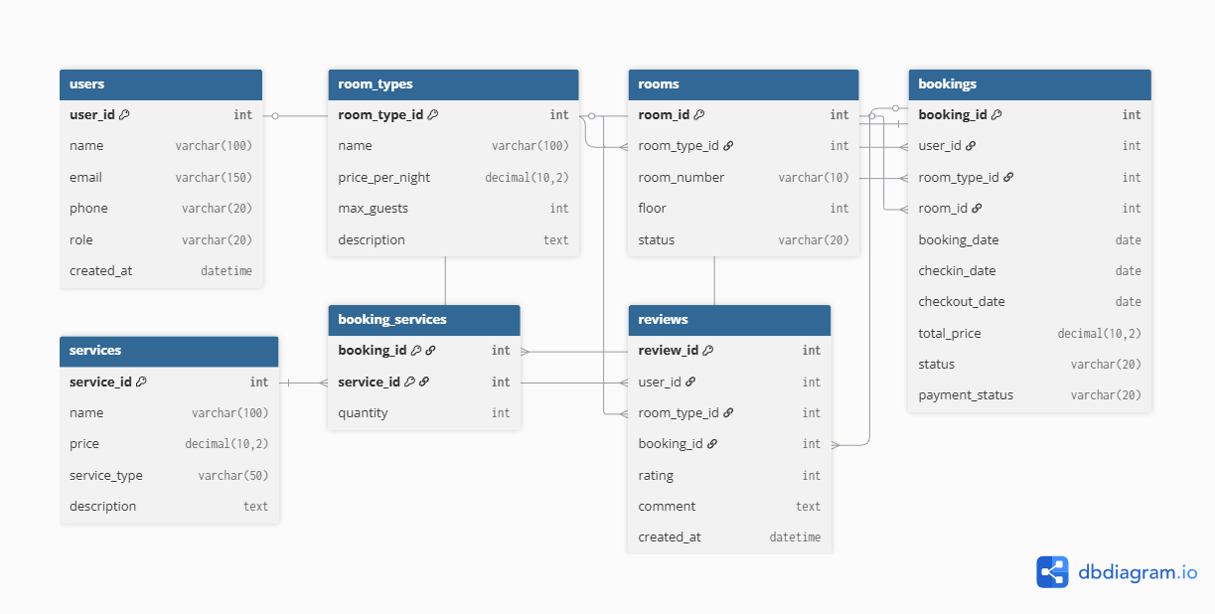
Figure 5.1: Database Scheme Diagram

Entity Relationship Diagram
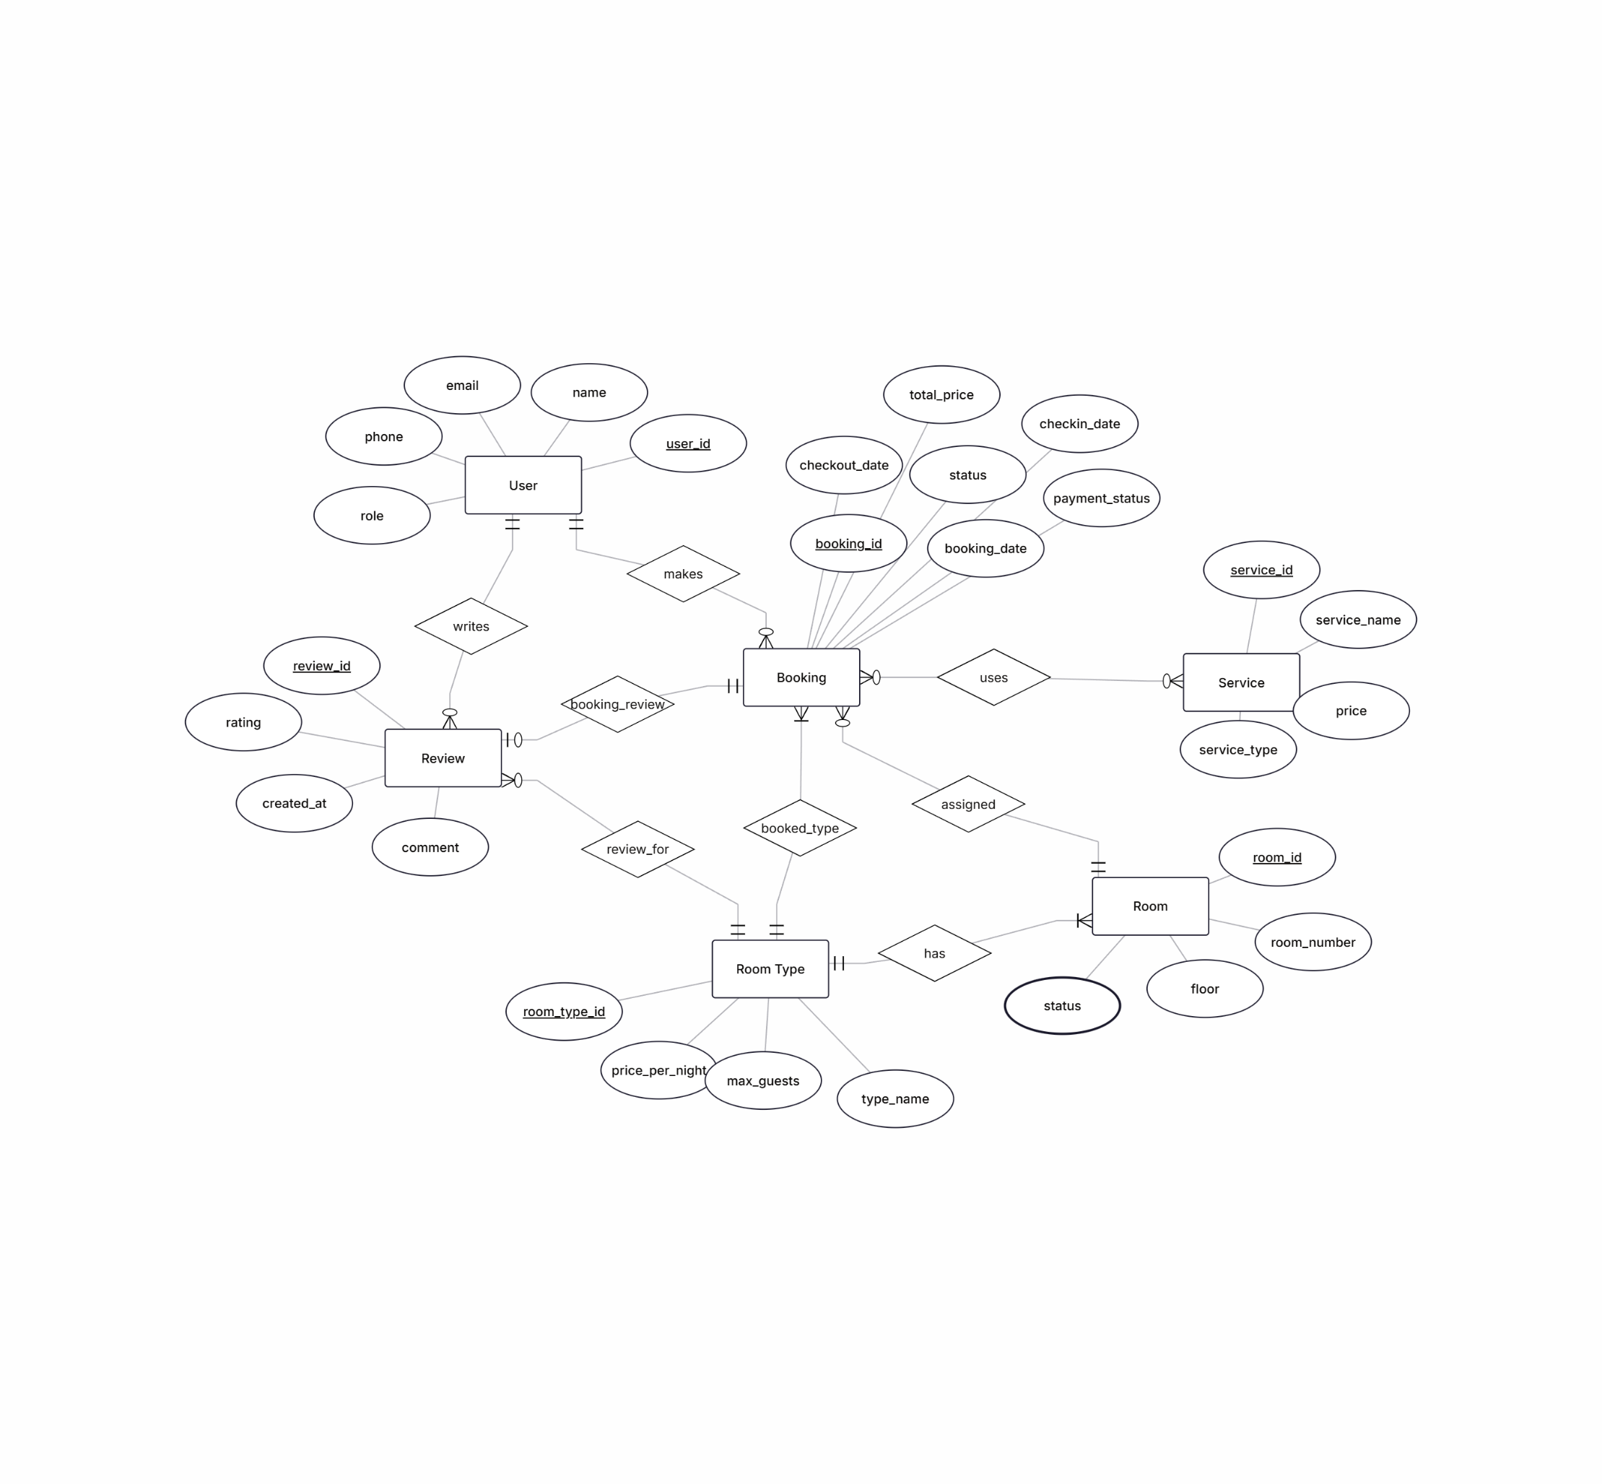
Figure 5.2: Entity Relationship Diagram

Static model - class diagram
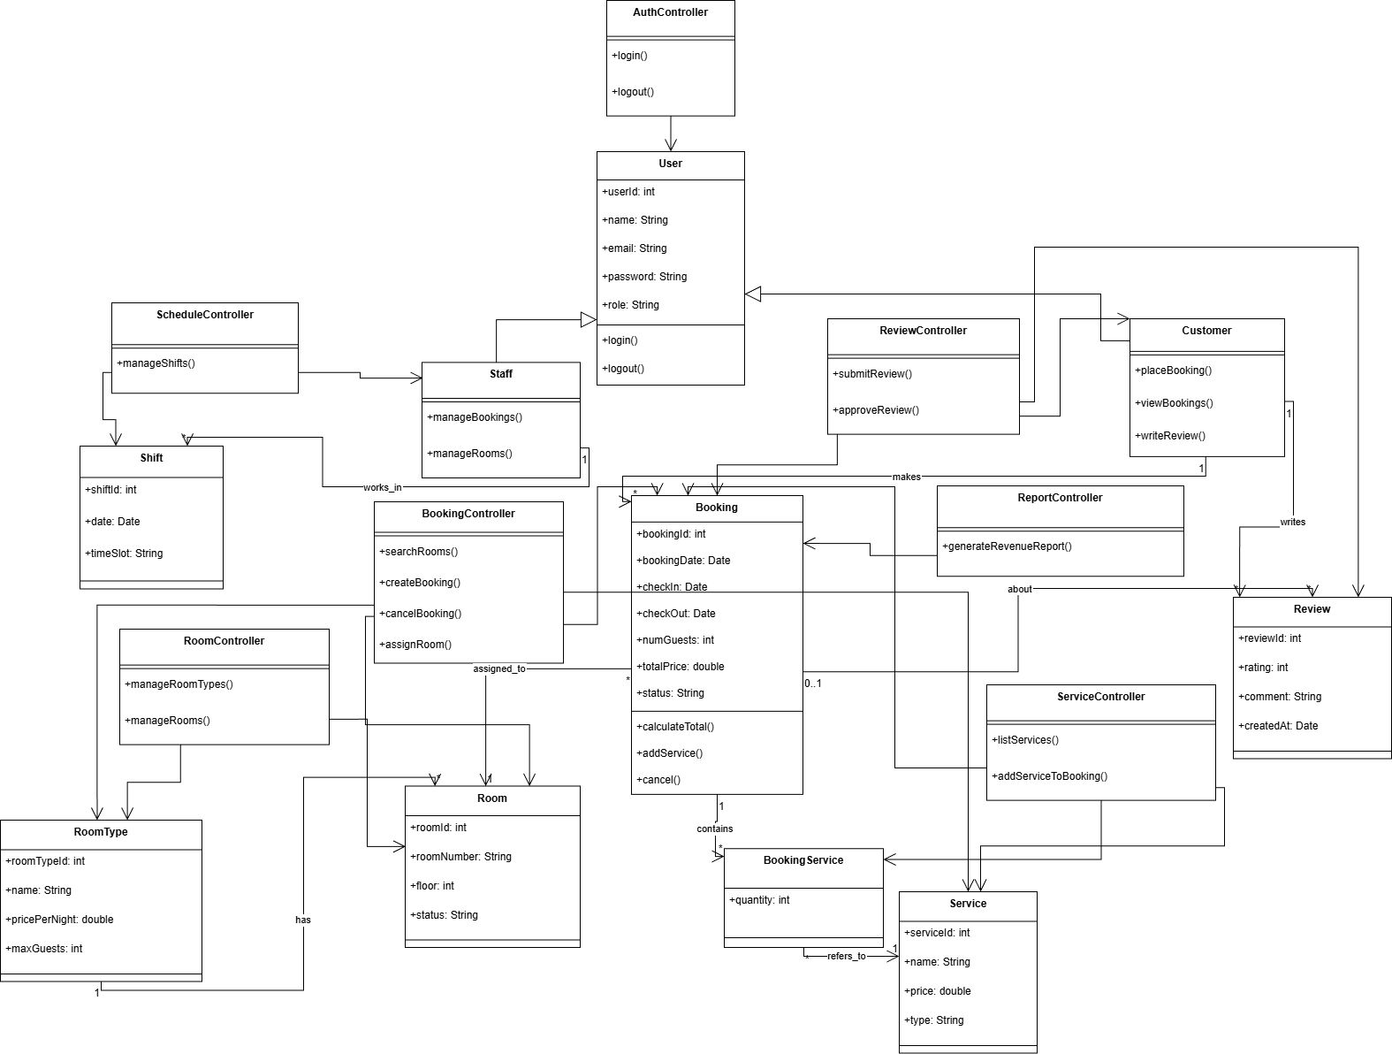
Figure 5.3: Class diagram

Dynamic model – sequence diagrams

Login
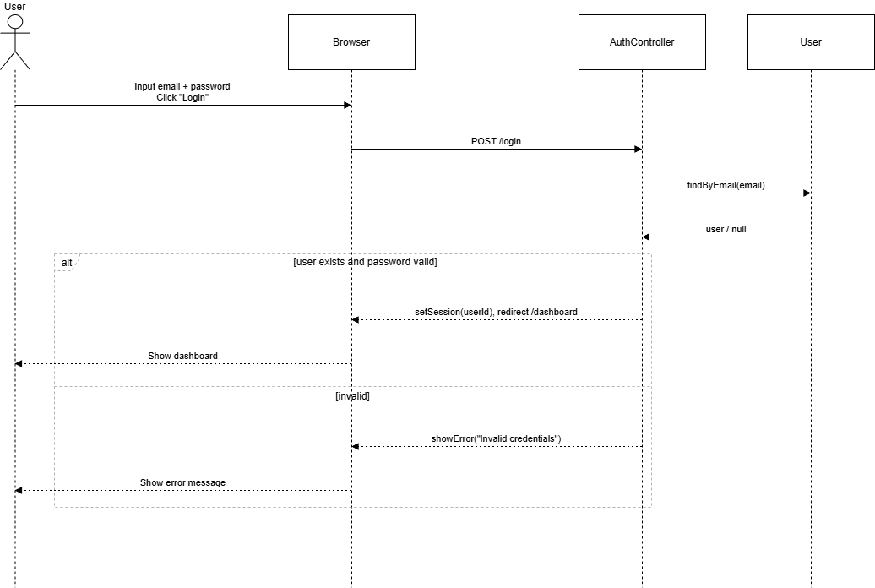
Figure 5.4: Login Sequence diagram

Search Rooms
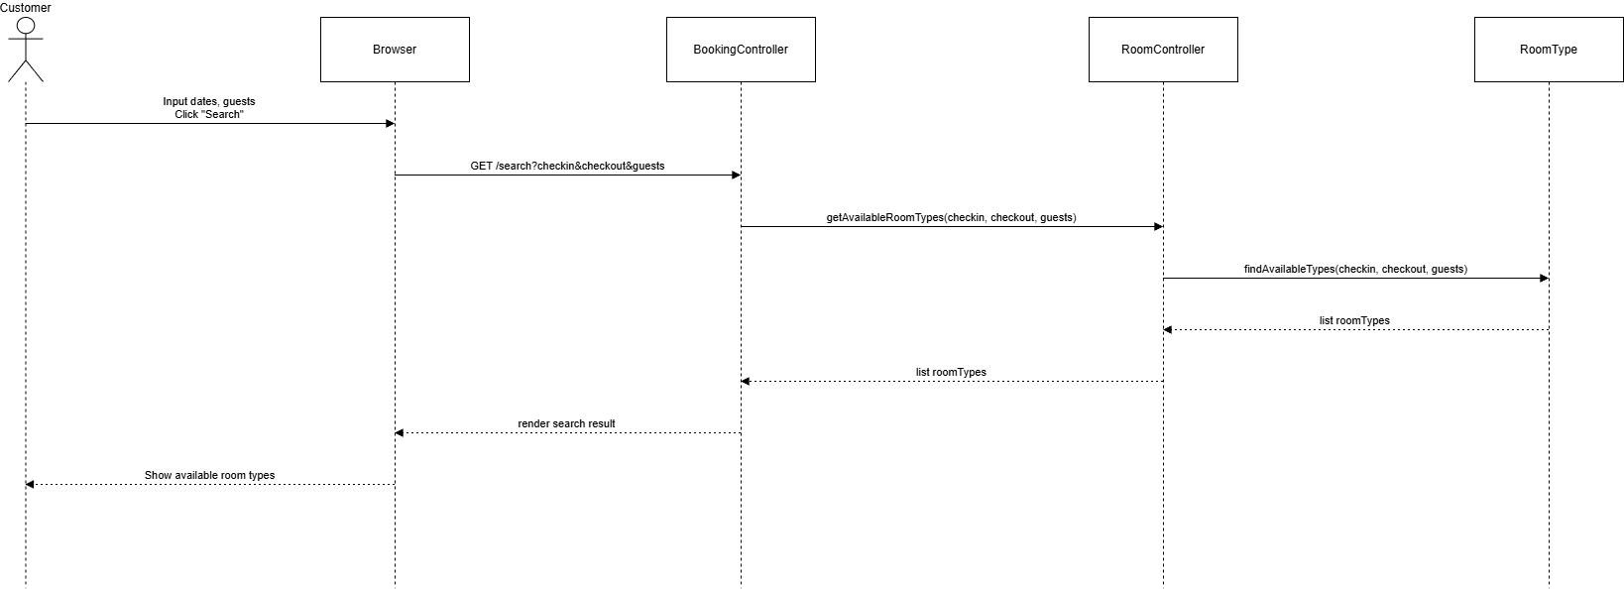
Figure 5.5: Search Rooms Sequence diagram

Manage Room Types & Rooms (Admin)
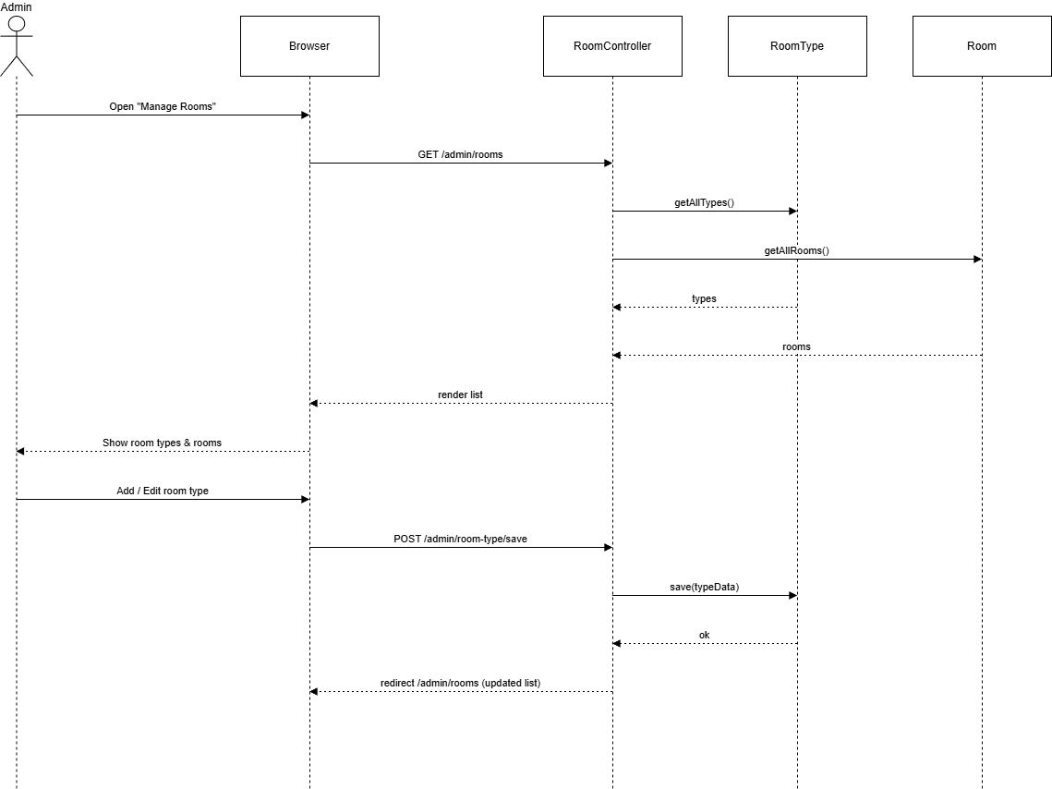
Figure 5.6: Manage Room Types & Rooms Sequence diagram

Place Booking
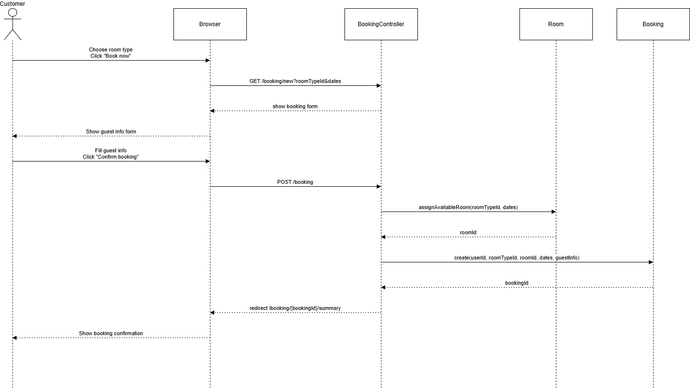
Figure 5.7: Place Booking Sequence diagram

Manage Bookings (Staff)
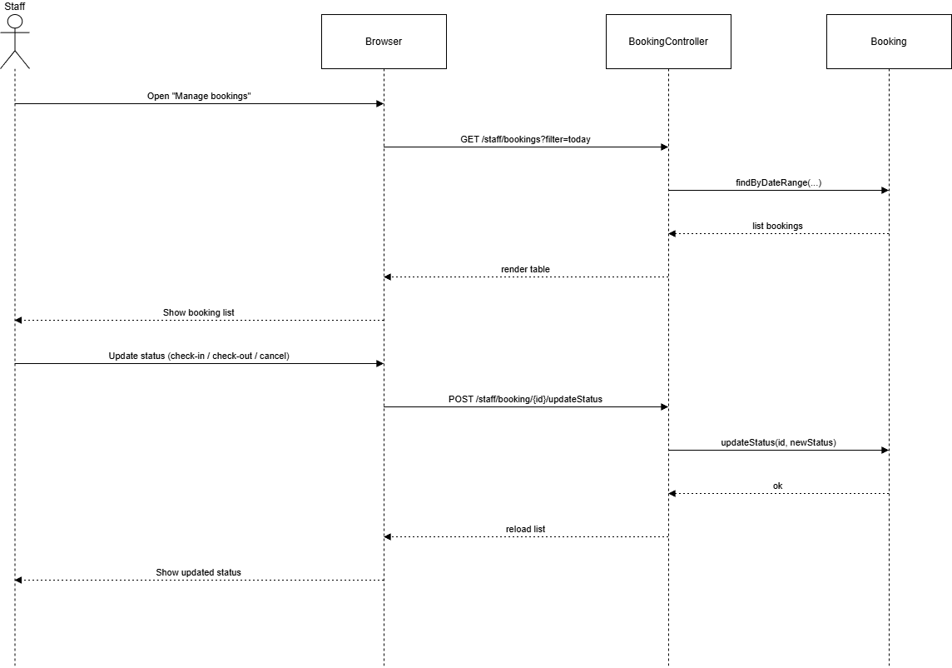
Figure 5.8: Manage Bookings (Staff) Sequence diagram

Manage Staff
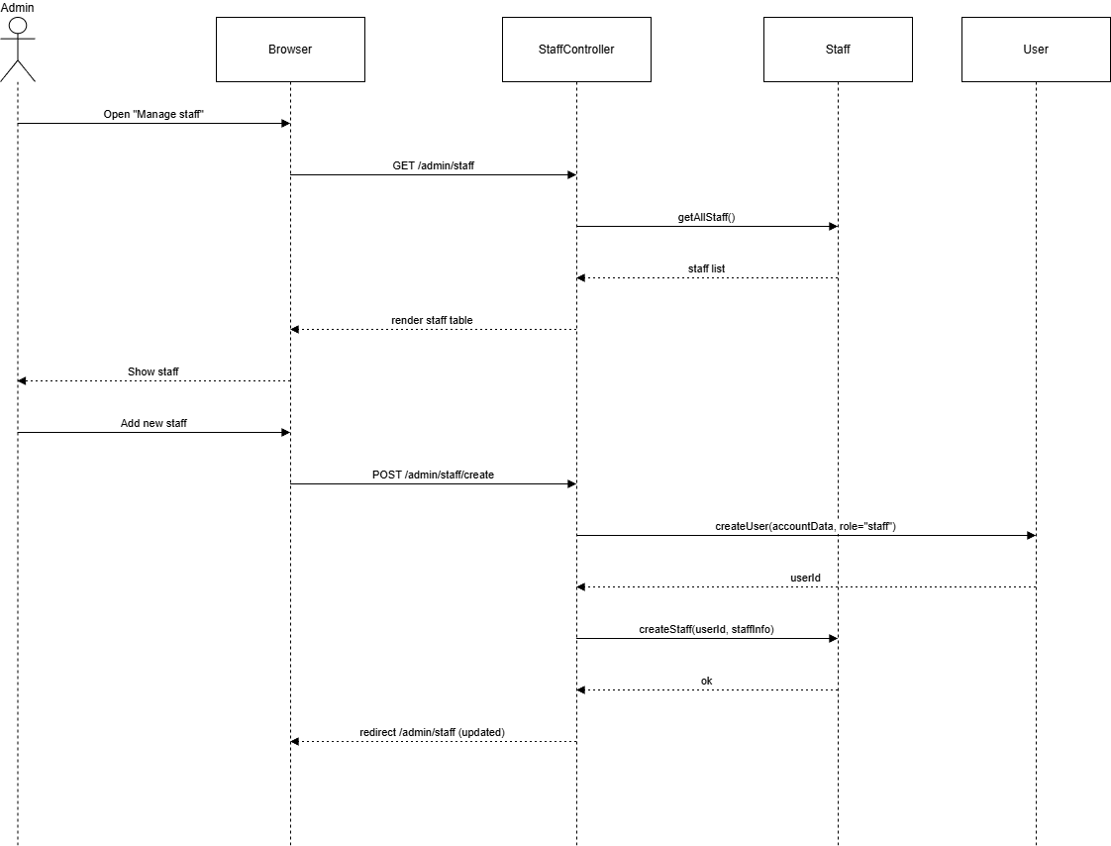
Figure 5.9: Manage Staff Sequence diagram

Shift Scheduling
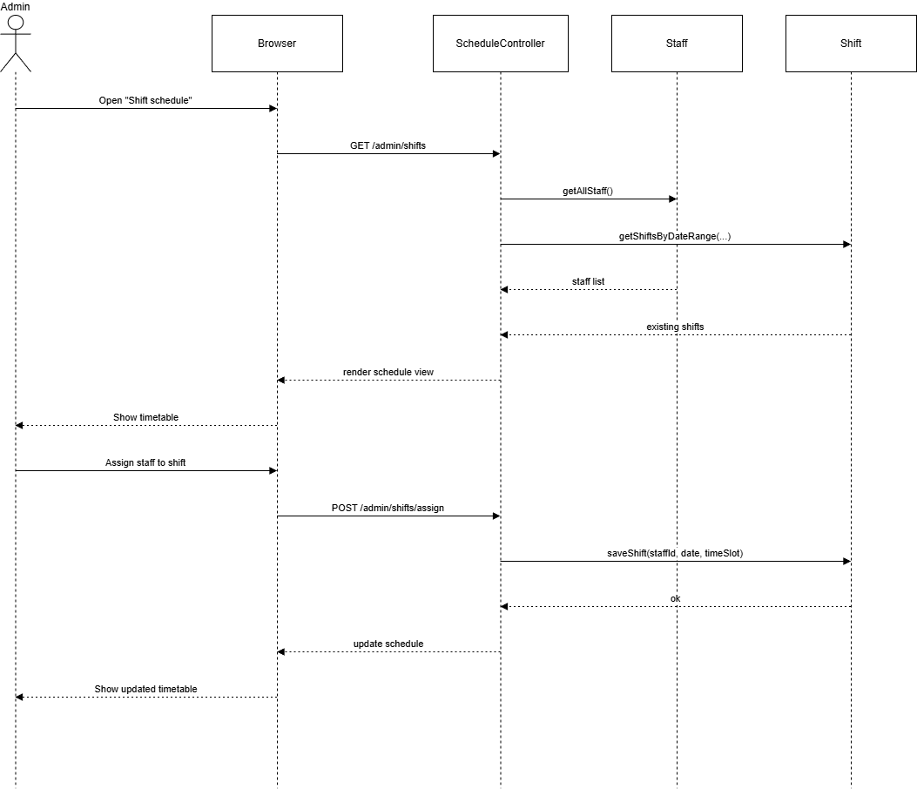
Figure 5.10: Shift Scheduling Sequence diagram

Manage Revenue
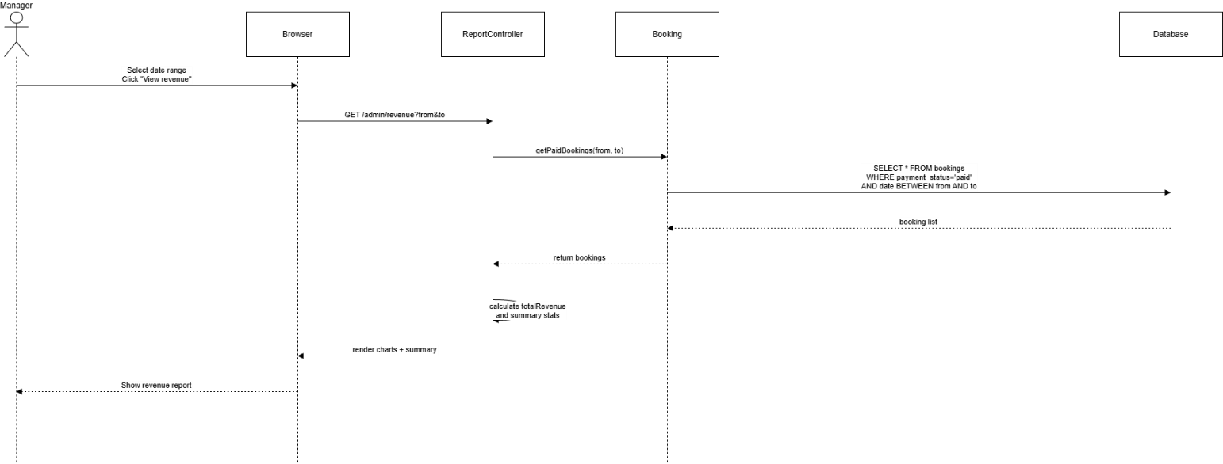
Figure 5.11: Manage Revenue Sequence diagram

Rate Rooms (Submit Review)
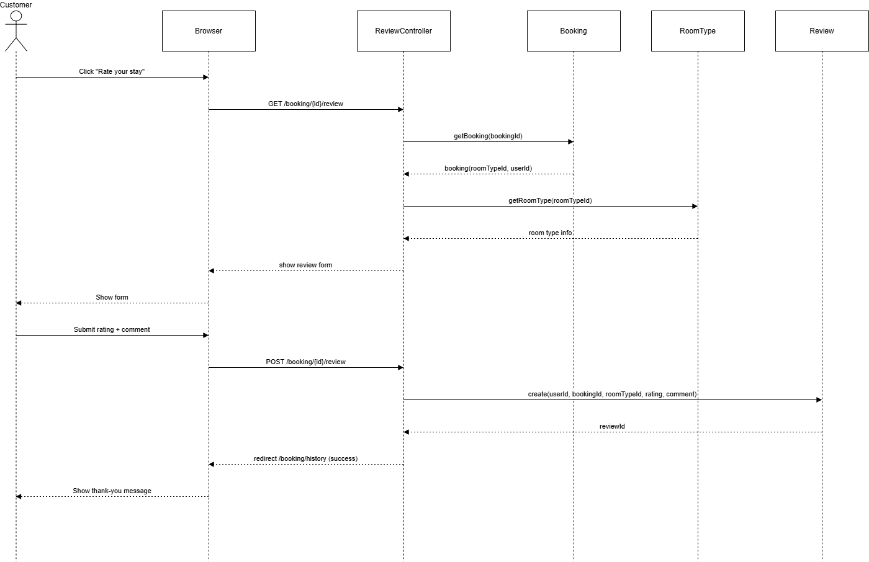
Figure 5.12: Rate Rooms Sequence diagram

Rationale for Detailed Design Model
- The detailed design model of the Hotel Management System is developed based on the functional requirements, use case specifications, and the adopted architectural style. The rationale behind the design focuses on four key principles: modularity, maintainability, scalability, and consistency between requirements and implementation.

Rationale for Database Design
- The database schema is constructed following normalization rules (primarily up to 3NF), ensuring that data redundancy is minimized while maintaining referential integrity. Core business entities such as Users, Rooms, Room Types, Bookings, Services, Add-ons, and Reviews are modeled as separate tables to reflect the actual business structure of a hotel.
  - Entities are separated logically:
    - rooms and room_numbers differentiate between room categories and specific physical rooms.
    - bookings manages reservation details, guest information, pricing, and payment status.
    - booking_addons captures additional services requested by guests.
    - reviews stores customer feedback for quality assessment.
  - Foreign key constraints ensure valid relationships between tables, preventing invalid booking references or orphaned service items.
  - Indexes are added on frequently queried fields (e.g. check-in date, room_id, booking_status, payment_status) to improve performance during search operations.
- This structure supports both current system needs and future expansions such as dynamic pricing, housekeeping management, or integration with third-party platforms.

Rationale for Class Diagram Structure
- The class diagram follows the Model–View–Controller (MVC) architecture commonly used in PHP-based web systems. This architecture provides a logical and maintainable separation of concerns:
  - Models (User, RoomType, Room, Booking, Addon, Review) represent the data layer.
  - Controllers (AuthController, BookingController, RoomController, ServiceController, ReviewController, ReportController) handle business logic and system interaction.
  - Views are responsible for user interface (not included in static diagram as per standard SAD practice).
- This structure enables:
  - Easy maintenance and code readability.
  - Clear mapping between use cases and responsible classes.
  - Ability to modify one layer without affecting others.
  - Increased scalability when adding new features such as promotions, housekeeping tasks, or staff roles.

Rationale for Sequence Diagrams
- Sequence diagrams are designed to accurately reflect the real-world workflow of hotel operations. Each diagram focuses on one functional requirement such as login, room searching, booking creation, review submission, or revenue reporting.
- The reationale includes:
  - Identifying precise interactions between actors, controllers, and models.
  - Ensuring each user action triggers the correct sequence in the system.
  - Clarifying system behavior before implementation.
  - Providing developers with clear execution flow during coding.
  - Ensuring consistency with use case descriptions.

Overall Design Rationale
- Overall, the detailed design model:
  - Ensures traceability between requirements, use cases, class interactions, and database structure.
  - Provides a flexible and extensible architecture appropriate for hotel management workflows.
  - Enhances performance with indexing and optimized queries.
  - Supports real-world constraints (e.g., room availability, booking overlaps, early/late check-in policies).
  - Facilitates system validation by professors, developers, and stakeholders.
- The design therefore ensures that the system is robust, scalable, maintainable, and aligned with the functional and non-functional requirements.

Traceability from Requirements to Detailed Design Model.
- Traceability ensures that every functional requirement defined during the analysis phase is fully reflected in the detailed design models, including the class diagram, sequence diagrams, and database schema. This section demonstrates the relationships between requirements and the implemented design components, ensuring completeness, consistency, and correctness of the system architecture.
- The traceability matrix below maps each Functional Requirement (FR) to the corresponding Use Case (UC), Sequence Diagram, Class Diagram elements, and Database Entities involved in implementing that requirement. This verification step ensures that no requirement is omitted and that the system design aligns with the specified functionalities of the hotel management system.

Table 5-1: Traceability Matrix
Functional Requirement | Use Case | Sequence Diagram | Class Diagram Elements | Database Entities
FR1 – User Login & Authentication | UC01 Login | Login | User, AuthController | users
Search Available Rooms | UC02 Search Rooms | Search Rooms | RoomController, Room, RoomType | rooms, room_numbers, room_availability
Manage Room Types & Physical Rooms | UC03 Manage Rooms | Manage Rooms | RoomController, RoomType, Room | rooms, room_numbers
Create Booking | UC04 Create Booking | Place Booking | BookingController, Booking | bookings, booking_addons
Manage Bookings | UC05 Manage Bookings | Manage Orders | BookingController, Booking | bookings
Manage Staff | UC06 Manage Staff | Manage Staff | StaffController, Staff | users, staff_shifts
Staff Shift Scheduling | UC07 Shift Scheduling | Shift Scheduling | StaffController, Shift | staff_shifts
Generate Revenue Reports | UC08 Manage Revenue | Revenue Reporting | ReportController, Booking | bookings
Rate Room / Submit Review | UC09 Rate Room | Rate Room | ReviewController, Review | reviews

Explanation
- The matrix demonstrates that:
  - Every functional requirement (FR1–FR9) is associated with one or more use cases.
  - Each use case is represented by a corresponding sequence diagram that models the dynamic behavior of the system.
  - The sequence diagrams map directly to relevant classes in the class diagram, ensuring architectural consistency.
  - All functionalities are supported by appropriate database entities, maintaining full alignment between logical design and physical implementation.
- This traceability ensures that the system is designed systematically, meets all functional expectations, and can be validated easily by stakeholders, developers, and instructors. It also guarantees that no requirement is omitted during design and implementation.

TEST PLAN
- The testing plan aims to verify that the Hotel Management System satisfies all functional requirements defined during the analysis phase. This chapter provides system-level test cases derived from requirements and use cases, traceability of test cases to functional behavior, testing techniques used for test design, and an evaluation of the overall quality and coverage of the testsuite.

Requirements/Specifications-based System Level Test Cases
- The following table presents system-level test cases designed based on the functional requirements (FR1–FR9) and use case specifications of the system.
Table 6-1: System Test Cases
TC ID | Related Requirement | Description | Input | Expected Output | Actual Output
TC01 | FR1 – Login | Login with valid credentials | email, password | Redirect to dashboard | System redirected to dashboard successfully
TC02 | FR1 – Login | Login with invalid password | email, wrong password | Show “Invalid credentials” | Error message displayed correctly
TC03 | FR2 – Search Rooms | Search rooms with valid date range | check-in date, check-out date | Show list of available rooms | System showed correct available rooms
TC04 | FR2 – Search Rooms | Search with check-out date earlier than check-in | invalid date range | Show “Invalid date range” | System shows date error correctly
TC05 | FR3 – Manage Rooms | Admin adds a new room type | room type data | Room type added | Room type created successfully
TC06 | FR4 – Create Booking | Create booking with valid data | guest info, room selection | Booking saved + reference | Booking created, reference displayed
TC07 | FR4 – Create Booking | Attempt booking a room already booked | existing booking date overlap | Booking rejected | System rejected booking with conflict message
TC08 | FR5 – Manage Bookings | Update booking status | booking ID, new status | Status updated | Status updated correctly in UI and DB
TC09 | FR6 – Manage Staff | Add new staff account | staff details | Staff created | Staff account added and visible in staff list
TC10 | FR7 – Shift Scheduling | Assign staff to a shift | staff ID, date, time | Shift assigned | Shift stored and displayed in schedule page
TC11 | FR8 – Revenue Reporting | Generate monthly revenue report | month-year | Show total revenue | Revenue generated correctly
TC12 | FR9 – Rate Room | Submit a rating after booking | rating, comment | Review saved | Review stored & displayed on room page

Traceability of Test Cases to Use Cases
Table 6-2: Test Case Traceability Matrix
Test Case | Use Case | Related Requirement
TC01 | UC01 Login | FR1
TC02 | UC01 Login | FR1
TC03 | UC02 Search Rooms | FR2
TC04 | UC02 Search Rooms | FR2
TC05 | UC03 Manage Rooms | FR3
TC06 | UC04 Create Booking | FR4
TC07 | UC04 Create Booking | FR4
TC08 | UC05 Manage Bookings | FR5
TC09 | UC06 Manage Staff | FR6
TC10 | UC07 Shift Scheduling | FR7
TC11 | UC08 Manage Revenue | FR8
TC12 | UC09 Rate Room | FR9

Techniques Used for Test Generation
- The following software testing techniques were applied to design the system-level test cases:

Equivalence Partitioning (EP)
- Used for form-based inputs such as login credentials, booking information, and staff data.
Example: Valid vs invalid credential groups.

Boundary Value Analysis (BVA)
- Used for date selection in room searching and booking, especially for validating check-in and check-out boundaries.

Decision Table Testing
- Applied to business rules including:
  - Room availability checking
  - Preventing overlapping bookings
  - Shift assignment constraints

Use Case-Based Testing
- Each use case was analyzed to derive:
  - Main success scenarios
  - Alternative flows
  - Error paths
- This ensures all functional behavior is tested at least once.

Requirements-Based Testing
- Each requirement (FR1–FR9) was mapped to one or more test cases to ensure full coverage..
- These combined techniques ensure both breadth and depth in the test suite.

Assessment of the Goodness of the Testsuite
- The quality (goodness) of the testsuite is assessed according to standard software testing metrics and qualitative evaluation.

Requirement Coverage
- 100% of functional requirements (FR1–FR9) are tested.
- Each requirement has at least one dedicated test case.

Use Case Coverage
- All 9 use cases (UC01–UC09) are covered.
- Both primary and alternate flows are tested.

Positive and Negative Testing
- The suite includes:
  - Valid input scenarios (positive tests)
  - Invalid or extreme cases (negative tests)
    - Helps detect robustness issues.

Boundary and Error Handling
- Boundary tests for:
  - Date ranges
  - Room availability
  - Staff scheduling rules

Completeness and Consistency
- No duplicated test cases
- One-to-one mapping ensures traceability
- Test descriptions are clear and reproducible

REFERENCES

[1] Ian Sommerville, [2011], Software Engineering 9th Edition, Pearson, Boston.

[2] Katalon. (n.d.). Equivalence class partitioning: A complete guide. Katalon. https://katalon.com/resources-center/blog/equivalence-class-partitioning-guide.

