# ReactJS - Origami Platform Workshop - Part 4

## Overview

Last time we have to implement **private**, **public** and make the already created **forms** **wok**. If you missed some of these parts, **go back and** **complete** **them** **before** **you continue**.

* Once we have **authentication** in our app. The next step Is to **protect** **the** **routes**
  + If guest user **tries** to **access** some of the **private** **parts**, he should be **redirected** to the **publications** or **404** **page**
  + If some of the **already logged in user tries to access** the **public** **parts**, he should be **redirected** to the **publications** or **404** page
* Refactor **all class components** to **functional** **components** that work with **hooks**

### Public parts

This parts can be accessed by any **guest user** (not logged in).

#### Publications

Publications view **shows all created posts** from the database.

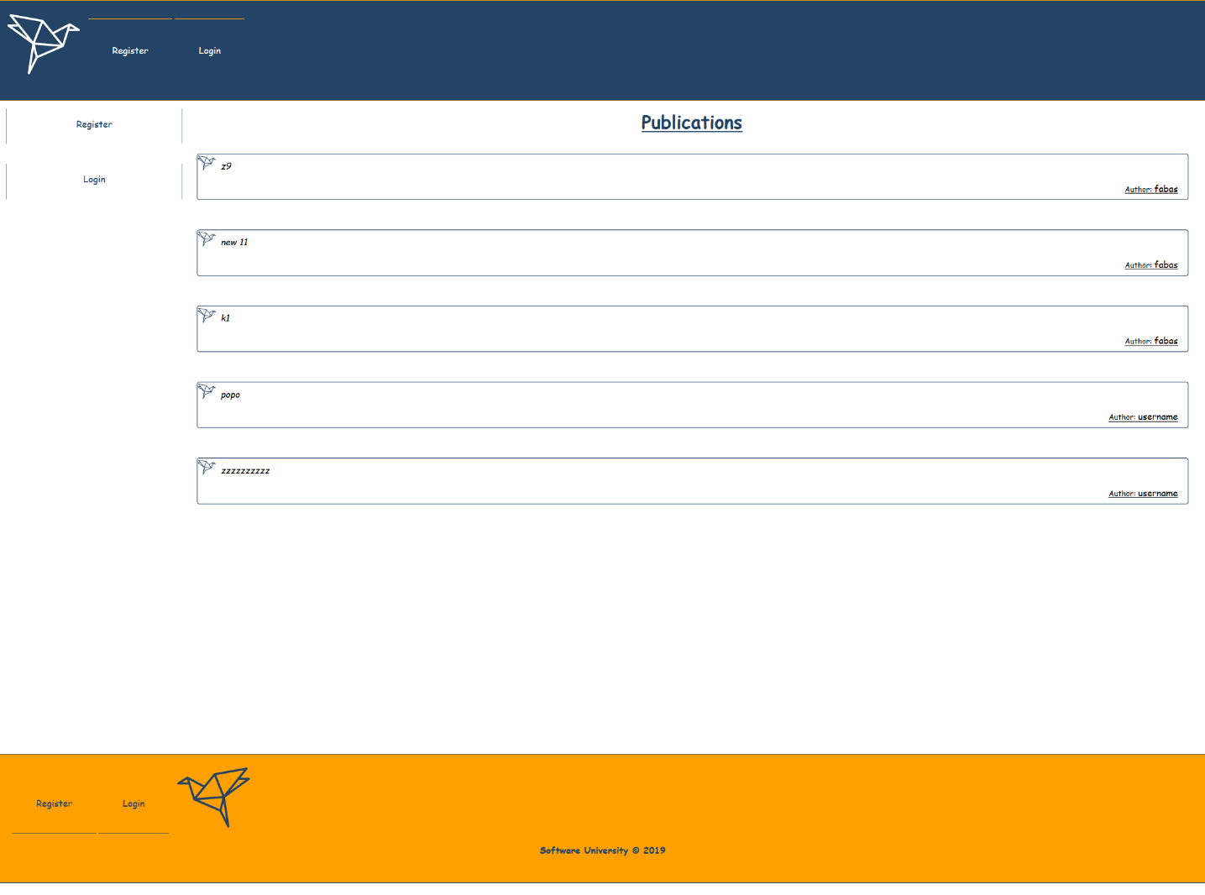

#### Register

**Register form** should make a **post request** with the given data to the **API** and create a user

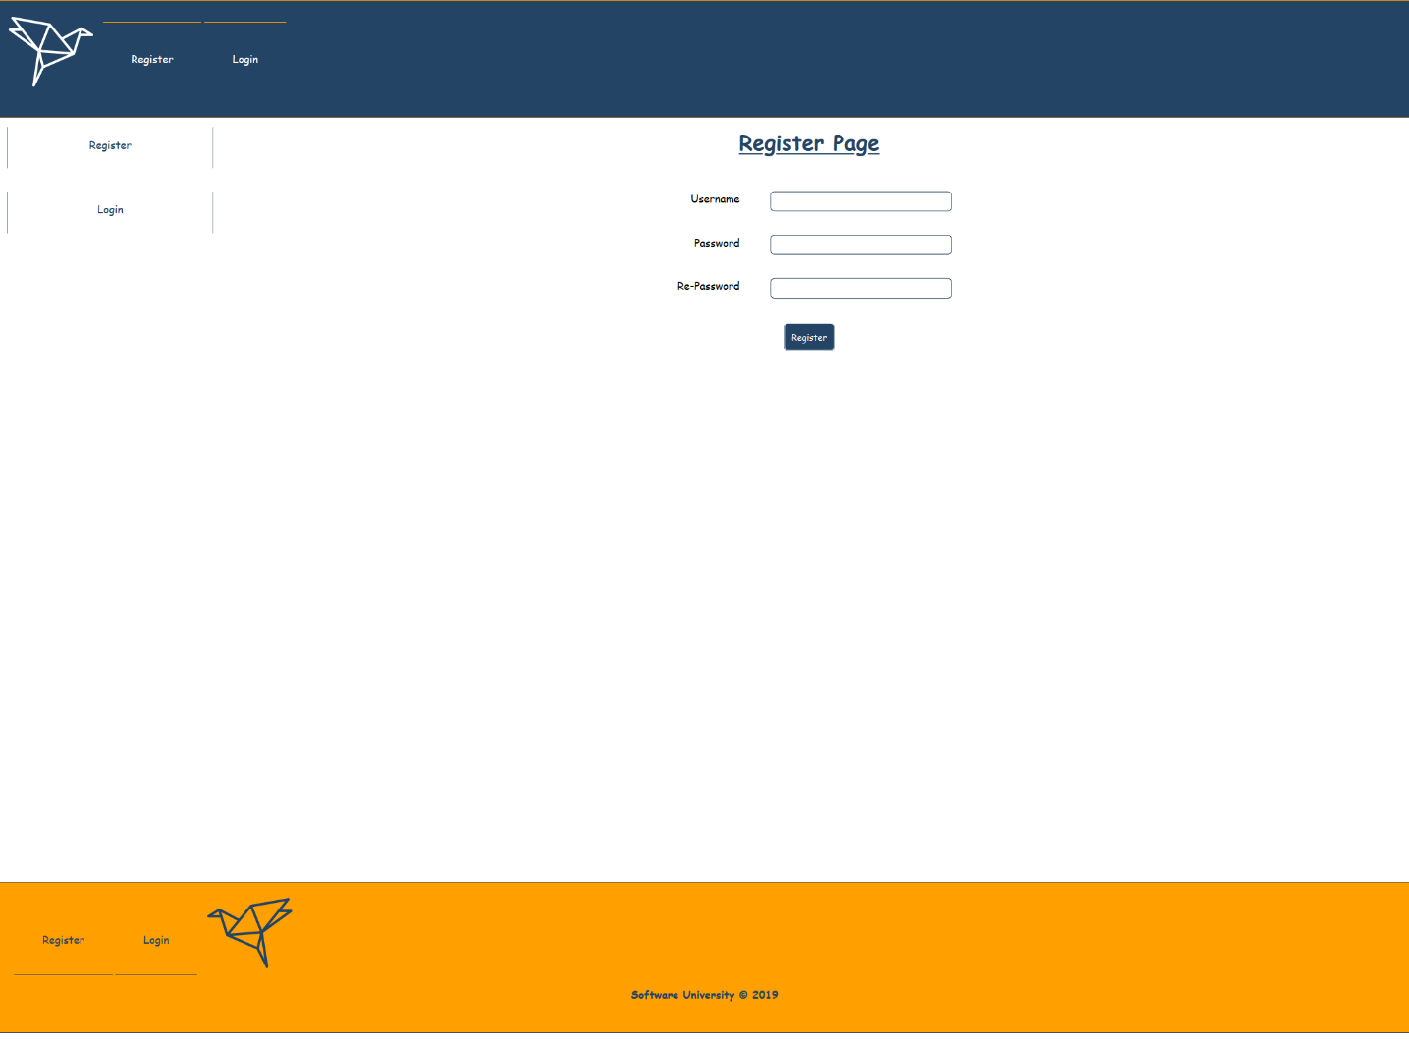

#### Login

Login form should also make a **post request** with the given data to the **API**, and if the **provided data** is **valid,** you should authorize the user (**can see the public parts**).

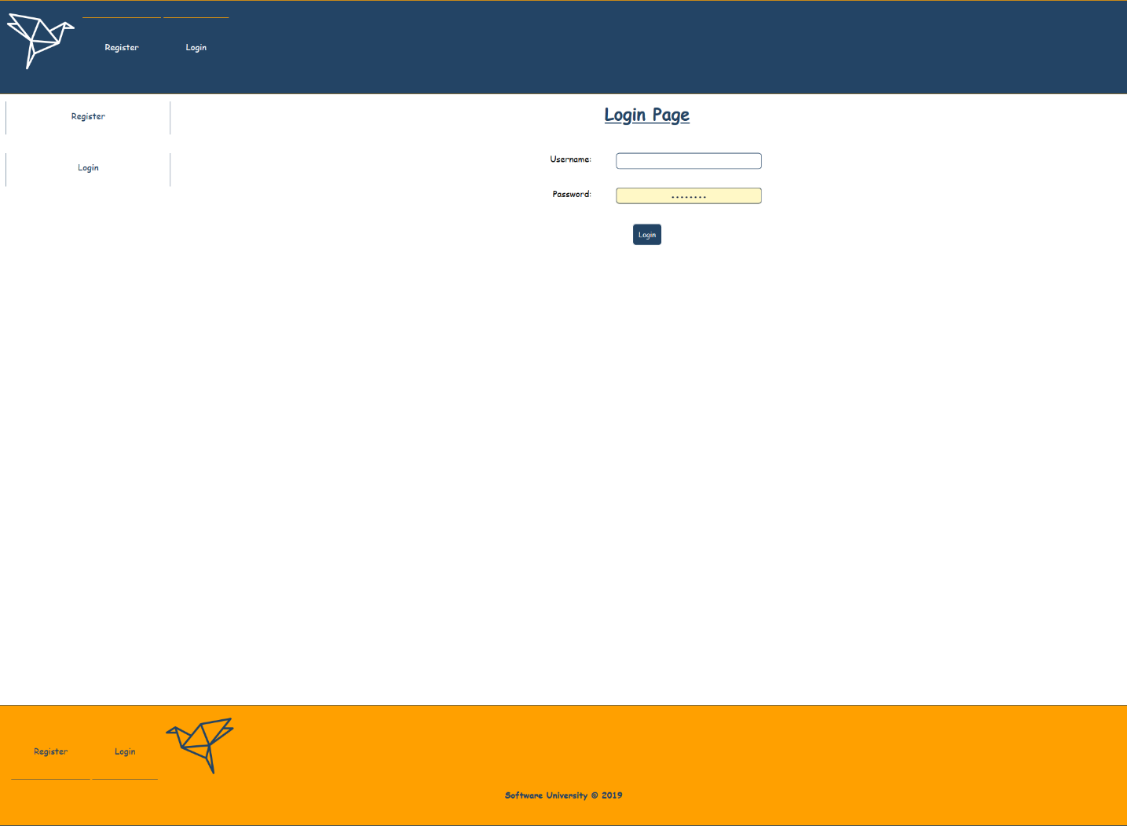

### Private parts

Private parts should be accessed only by **logged in users** (**authorized with jwt token from the given API**).

#### Publications

Publications view **shows all created posts** from the database

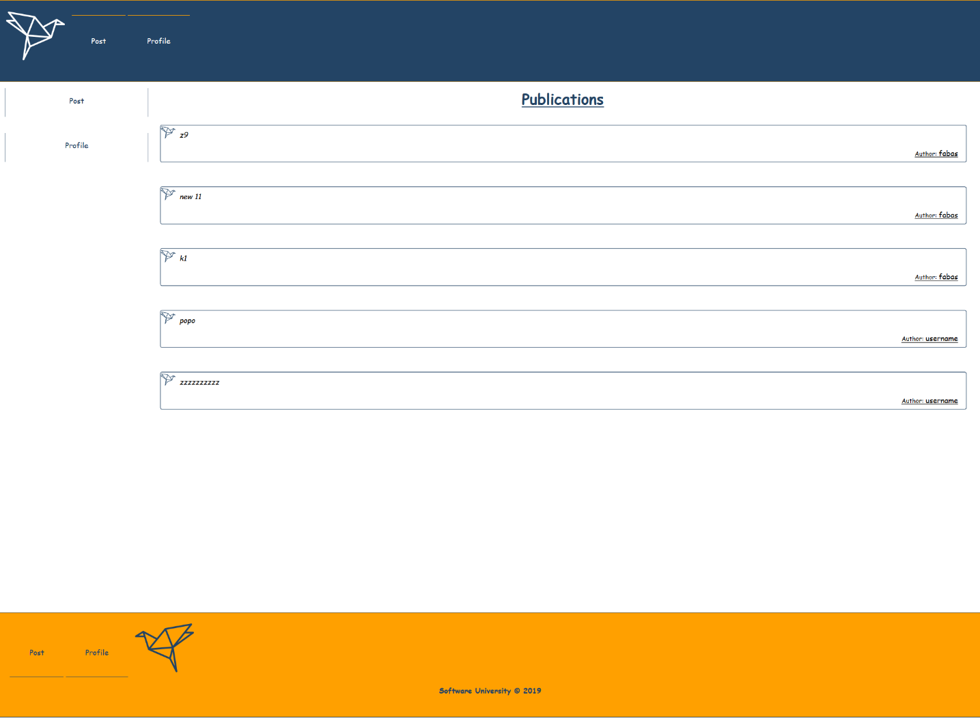

#### Profile

Profile page **shows** information about the currently logged-in user. This is his **username**, **total posts count** and the **top 3 of his recent posts**. Also, you should show a [**Logout**] **button**, which can be pressed and clear the **provided jwt** token from the API and redirect the user to the **publications page**.

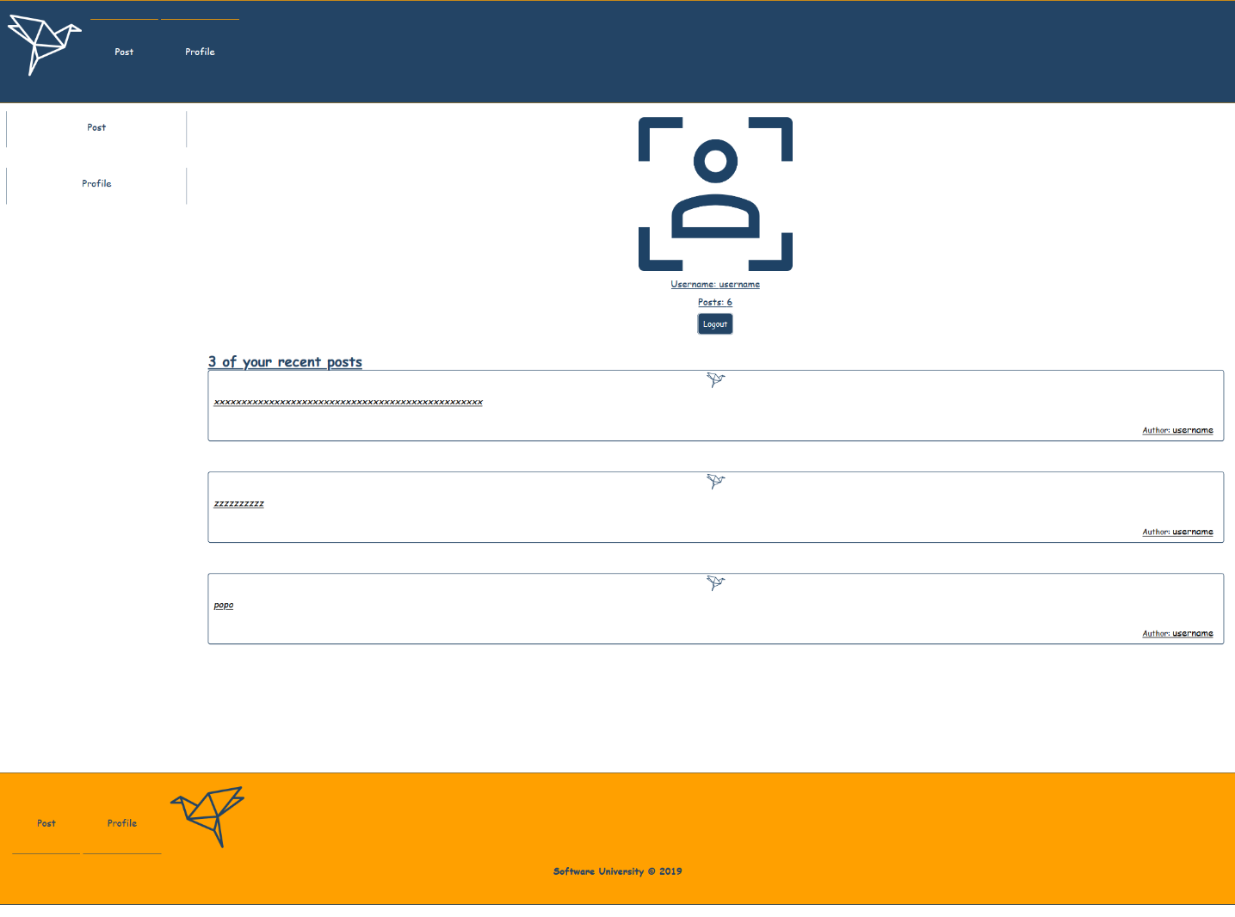

#### Post

In **Post view,** the form with the textarea should be able to make a **post request** with the given **post** **description**. If that happens, the user should be redirected to the **publication view**.

Also, this view, show the **top 3 recent posts** from the database.

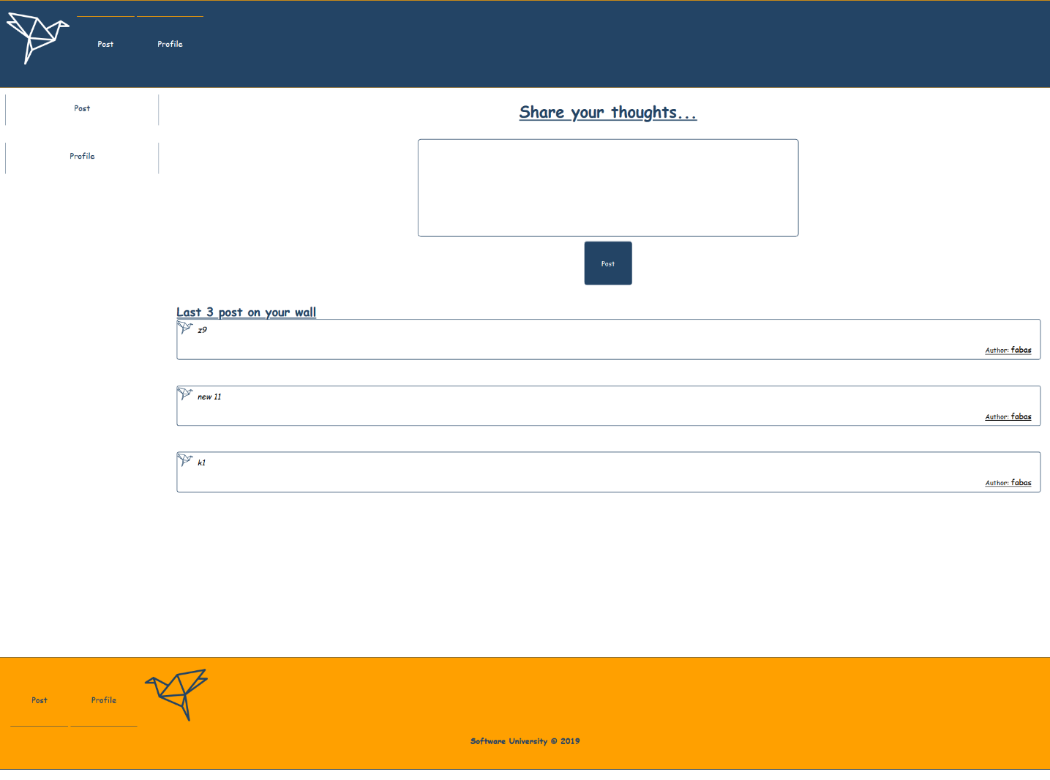

## Database

Use the provided **REST API** build with **Express.js** and **MongoDB**

### Server

The server will listen on port **9999** by default and **recognize** the following **paths** with **methods**:

* **Get request - 'localhost:9999/api/origami/all'**
* **Get request - 'localhost:9999/api/origami/mine**
* **Post request - 'localhost:9999/api/origami/'**
* **Post request - 'localhost:9999/api/user/register'**
* **Post request - 'localhost:9999/api/user/login'**
* **Post request - 'localhost:9999/api/user/logout**

***Good Luck 😊***