z
HANOI UNIVERSITY OF SCIENCE AND TECHNOLOGY SCHOOL OF INFORMATION AND COMMUNICATION TECHNOLOGY FACULTY OF COMPUTER SCIENCE
IT3100E



Electrical Circuit Simulation

Mini-Project Proposal
GROUP 6:
Instructor: Ph.D. Tran The Hung
Class ID: 152626
Members: Bui Huu Vinh 20235575
Mai Anh Vo Vuong 20235580
Duong Hung Anh 20235469
Nguyen Khac Viet Anh 20235471
Tran Hoang Duong 20214888
Pham Quoc Thai 20235558

CONTENTS

Contents

Table of Contents 1
- Assignment of members 1
  - Task Assignment . . . . . . . . . . . . . . . . . . . . . . . . . . . . . . . . . . . . . . 1
- Mini-project Description 3
  - Mini-project overview . . . . . . . . . . . . . . . . . . . . . . . . . . . . . . . . 3
  - Mini-project requirement . . . . . . . . . . . . . . . . . . . . . . . . . . . . . . . 3
  - Use Case Diagram . . . . . . . . . . . . . . . . . . . . . . . . . . . . . . . . . . . 4
    - Set up Electrical Circuit Type . . . . . . . . . . . . . . . . . . . . . . . . 4
    - Adding Circuit Components . . . . . . . . . . . . . . . . . . . . . . . . 4
    - Review on Circuit Display and Circuit Analysis . . . . . . . . . . . . . 5
- Design 6
  - General Class Diagram . . . . . . . . . . . . . . . . . . . . . . . . . . . . . . . . 6
  - Package Details . . . . . . . . . . . . . . . . . . . . . . . . . . . . . . . . . . . . 7
    - model package : . . . . . . . . . . . . . . . . . . . . . . . . . . . . . . . . 7
    - GUI package 10
    - Execute 17
- References 19
CHAPTER 1. ASSIGNMENT OF MEMBERS

Chapter 1

Assignment of members
  - Task Assignment

Details for classes

    - ElectricalElement package
      - Capacitor.java
      - ElectricalElement.java
      - Inductor.java
      - Resistor.java
      - TestElement.java

VoltageSource package
      - AC.java
      - DC.java
      - VoltageSource.java

Circuit package
      - Circuit.java
      - ParallelCircuit.java
      - SerialCircuit.java
      - TestCircuit.java

CircuitDrawing package
      - ACGUI.java
      - CapacitorGUI.java
      - DCGUI.java
      - ElementGUI.java
      - InductorGUI.java
      - MainGUI.java
      - ResistorGUI.java
      - TestDrawing.java

screen package
      - AddAC.java
      - AddCapacitor.java
      - AddComponent.java
      - AddDC.java
      - AddInductor.java
      - AddResistor.java
      - BuildScreen.java
      - DisplayScreen.java
CHAPTER 2. MINI-PROJECT DESCRIPTION

Chapter 2

Mini-project Description

MINI-PROJECT OVERVIEW
In this project, our group needs to create an Electrical Circuit Simulator that let users build an electrical circuit and perform circuit analysis on it.
Throughout the collaborator, we control our progress by using Version Control, specially on Github.
To build this Simulator successfully, we also need to construct an Use Case Diagram and Class Diagrams in the development process.
For GUI, we decided to use Swing as our UI toolkit because Swing provides a rich set of GUI components such as buttons, labels, text fields, tables, and more. It also includes layout managers for arranging components within containers, event handling mechanisms for capturing user interactions, and various utility classes for handling graphics, fonts, and colors.

Mini-project requirement
As mentioned above, we have to develop a Simulator to display a custom circuit and the circuit analysis which strictly follow the Modern Physic Rules.
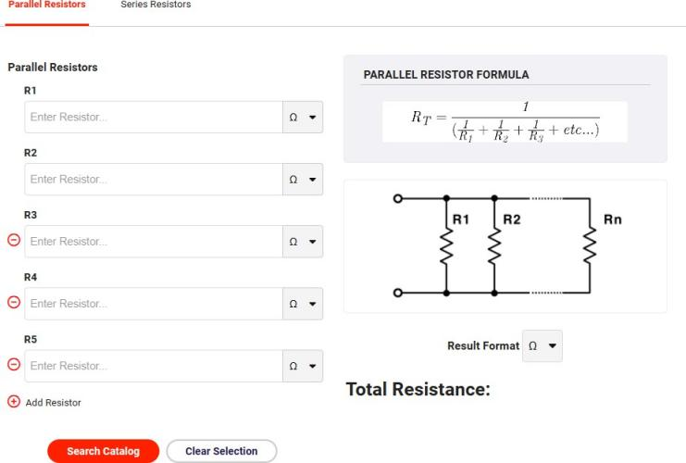

Figure 2.1: Sample simulator GUI

About GUI, Figure 2.1 illustrates a demo Interface which include two main parts: Choos-
IT3100E - Object Oriented Programming 3
  - USE CASE DIAGRAM

ing two types of circuits: Parallel circuit and serial circuit by choosing first or second tab on the navigation bar; Adding Circuit Components with values and unit then submit.
In our simulator, Users can add difference kinds of components: resistors, capacitors, inductors. After pressing the "Submit" button, a Circuit Display and Circuit Analysis will appear on the next frame.
Short Circuit Detection is also implemented to warn the Users whenever they are con- structing an Short Circuit in order to make appropriate changes on Circuit Structure.

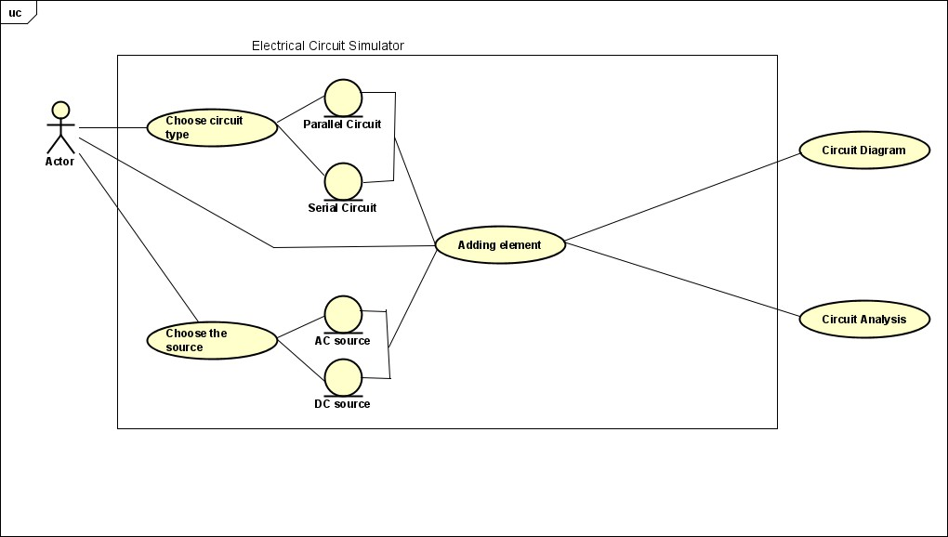
Use Case Diagram

Figure 2.2: Use Case Diagram

Set up Electrical Circuit Type
      - At first, Users have to choose which type of Circuit they want to construct: Parallel Circuit or Serial Circuit.
      - While setting up the Circuit, Users also have to choose which type of Voltage Source: AC Source or DC Source. Users will add the value of Voltage Source following with the unit.
      - In Figure 2.3, We choose Parallel Circuit from navigate tab and choosing AC Source with Voltage of 200V and frequency of 50Hz

Adding Circuit Components
      - Users will choose what components to be added into the Circuit with maximum num- ber of components is 5.

4 IT3100E - Object Oriented Programming
  - USE CASE DIAGRAM

- By adding new components with values, the Simulator will inform the Users if Short Circuit is detected.
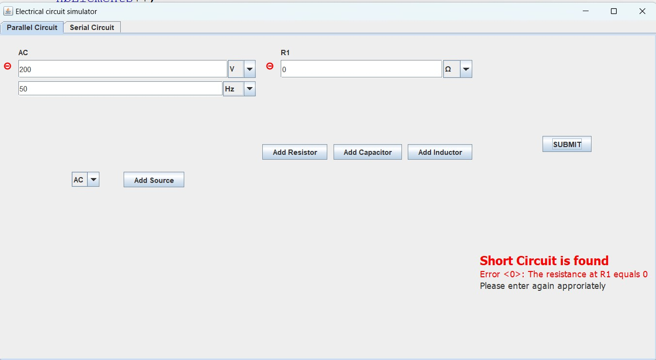

Figure 2.3: Short Circuit Detection

Review on Circuit Display and Circuit Analysis
      - After pressing the"SUBMIT" button, a new frame will be displayed with the image of constructed circuit with a table of circuit analysis.
      - From the result, Users can easily determine what to substitute and go back to the first frame to re-construct the circuit
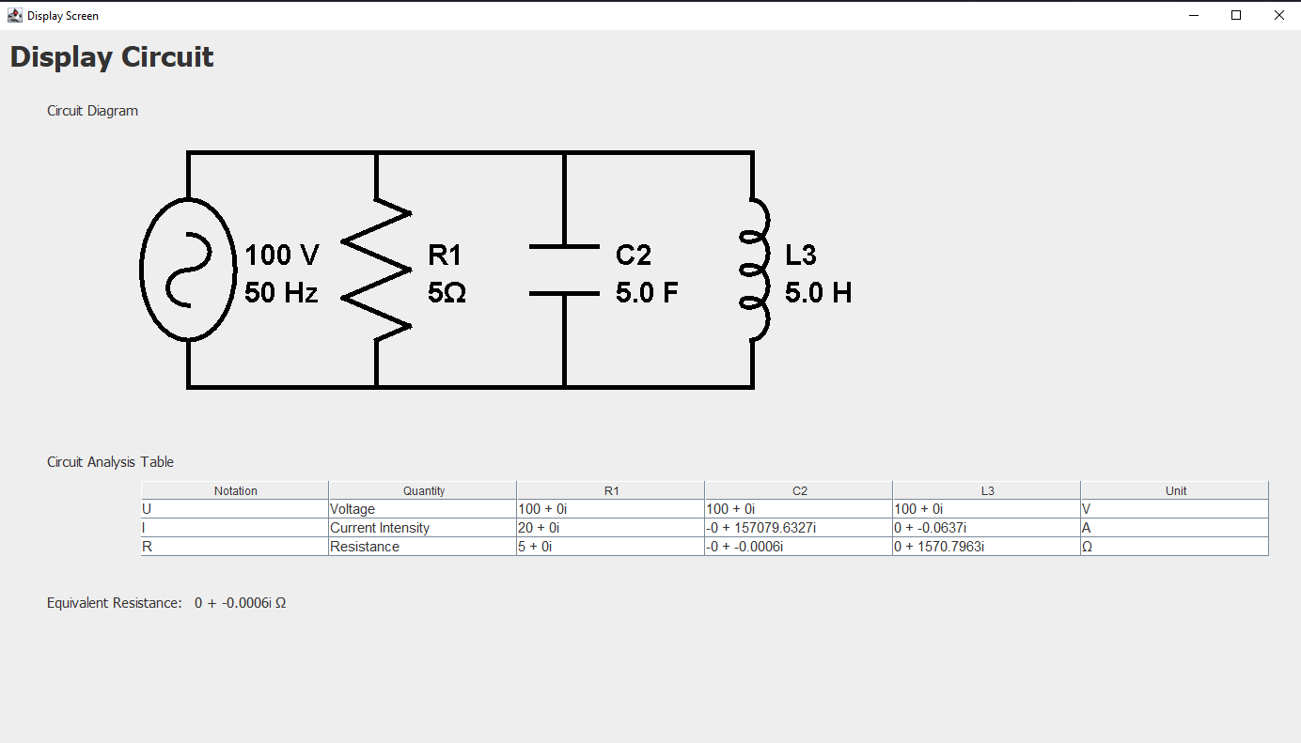

Figure 2.4: Example Circuit
CHAPTER 3. DESIGN

Chapter 3

Design

GENERAL CLASS DIAGRAM
Our General Class Diagram consists of 3 packages: Execute, GUI and model.

In model package, we divided three main sub-packages which are Circuit, ElectricalEle- ment and VoltageSource.

The same in GUI package, we split it into two main sub-packages which are screen and

CircuitDrawing
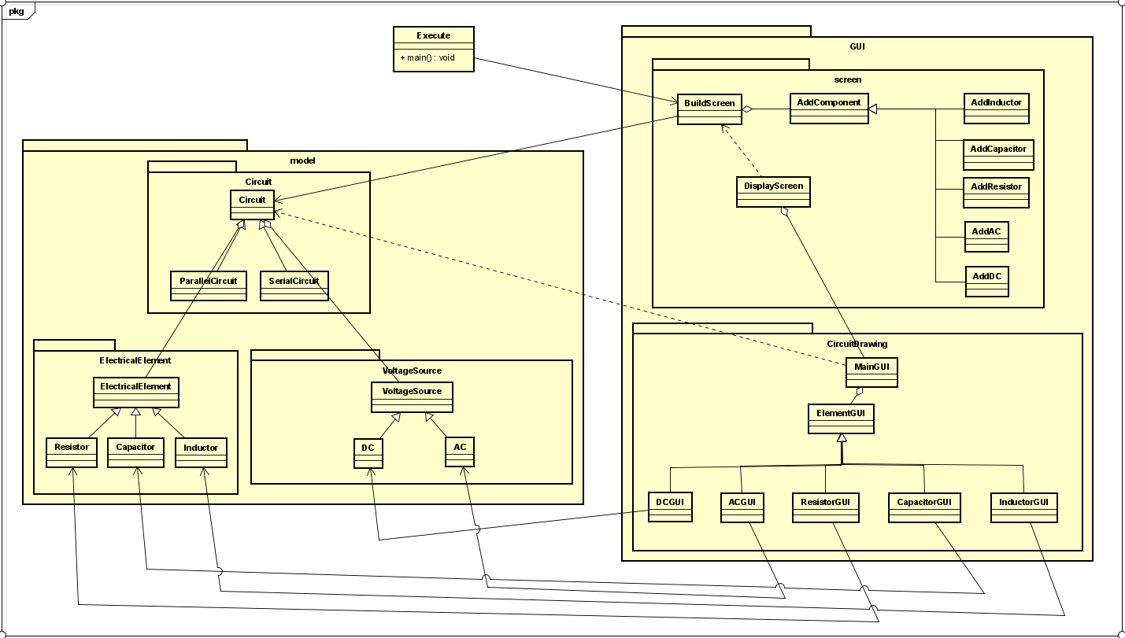

Figure 3.1: General Class Diagram
  - PACKAGE DETAILS

Package Details

model package :
Here we observe a specific view of model package which was developed based on the needs of elements in an Electrical Circuit.
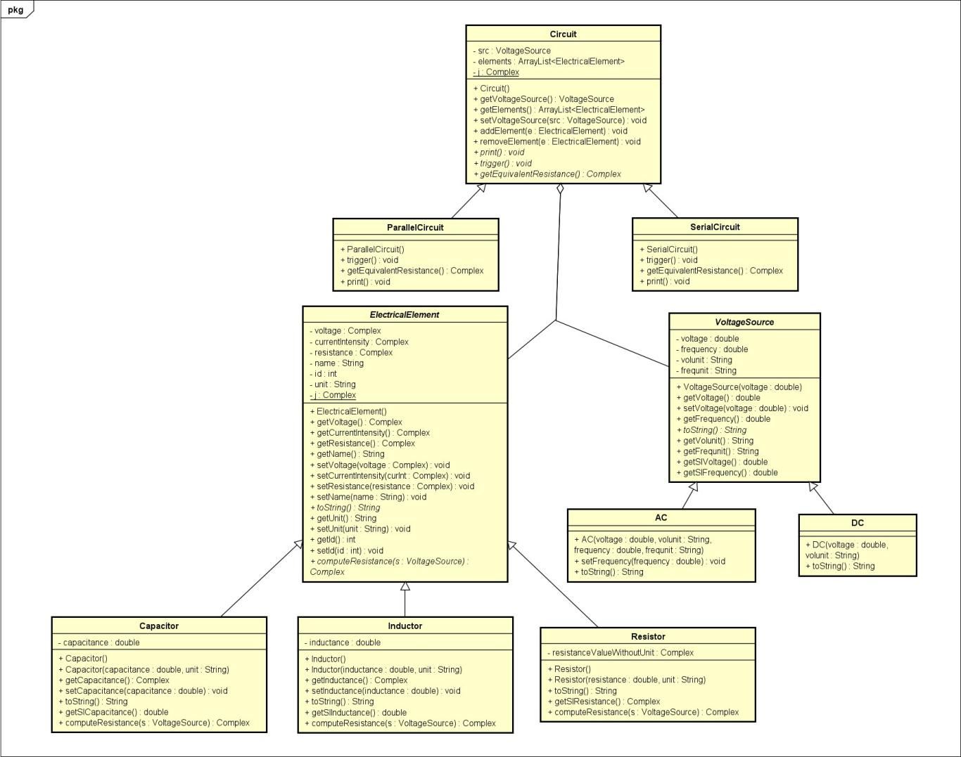

Figure 3.2: model package

Circuit: This class is used to create an Electrical Circuit as the Users constructed.
      - Its Attributes are:
        - src : this attribute is an instance of VoltageSource class.
        - elements : this attribute is a list of added ElectricalElement class as the Users chose to add into the Circuit.
        - j: this is attribute represent a complex number 0 + 1i.
      - Its Methods are:
        - Circuit() : standard constructor for the class.
        - getVoltageSource() : return the value of VoltageSource class.
        - getElements() : return the list of added ElectricalElement instances by the Users.
        - setVoltageSource(src : VoltageSource) : set the value of VoltageSource class.
IT3100E - Object Oriented Programming 7
  - PACKAGE DETAILS

- addElement(e : ElectricalElement) : add an ElectricalElement instance to the Circuit.
- removeElement(e : ElectricalElement) : remove an ElectricalElement instance from the Circuit.
- trigger() : this method create a specific behavior which is pre-programmed in
ParallelCircuit class and SerialCircuit class.
- getEquivalentResistance(): return the value of equivalent resistance of the Circuit.

ParallelCircuit : this class define one out of two type of Circuit.
- Its Attributes are:
  - this class inherited from Circuit so it have all the Attributes and Methods of
Circuit class.
- Its Methods are:
  - ParallelCircuit() : standard constructor.
  - trigger() : this method set the voltage attribute of ElectricalElement equals to the voltage of VoltageSource class and compute the resistance and intensity
of all ElectricalElement in the Circuit in Complex form.
  - getEquivalentResistance() : return the equivalent resistance of the Circuit.

SerialCircuit : this class define the last type of Circuit.
- Its Attributes are:
  - this class inherited from Circuit so it have all the Attributes and Methods of
Circuit class.
- Its Methods are:
  - SerialCircuit() : standard constructor.
  - trigger() : this method set the voltage attribute of ElectricalElement equals to the voltage of VoltageSource class and compute the resistance and intensity
of all ElectricalElement in the Circuit in Complex form.
  - getEquivalentResistance() : return the equivalent resistance of the Circuit.
VoltageSource : this class define the source of the Circuit that chose by Users.
- Its Attributes are:
  - voltage : the value chose by Users.
  - frequency : the value chose by Users.
  - volunit : the type of units for voltage chose by Users.
  - frequnit : the type of units for frequency chose by Users.
- Its Methods are:
  - VoltageSource(voltage : double) : standard constructor.
  - getVoltage() : return the voltage attribute value.
  - setVoltage(voltage : double) : set the value for voltage attribute.
  - getFrequency() : return the frequency attribute value.
  - toString() : print out the chosen result values by the Users.
  - getVolunit() : return the volunit attribute value.
  - getFrequnit() : return the frequnit attribute value.
  - getSIVoltage() : return the actual voltage value corresponds to volunit attribute value.

8 IT3100E - Object Oriented Programming
  - PACKAGE DETAILS

* getSIFrequency() : return the actual frequency value corresponds to frequnit
attribute value.
AC : this class define one out of two types of VoltageSource that chose by Users.
- Its Attributes are:
  - This class inherited from the VoltageSource class so it consists all the At- tributes and Methods of VoltageSource.
- Its Methods are:
  - AC(voltage : double, volunit: String, frequency : double, frequnit : String) : stan- dard constructor.
  - setFrequency(frequency : double) : set the frequency values chose by Users.
DC : this class define the last types of VoltageSource that chose by Users.
- Its Attributes are:
  - This class inherited from the VoltageSource class so it consists all the At- tributes and Methods of VoltageSource.
- Its Methods are:
  - DC(voltage : double, volunit : String) : standard constructor.
ElectricalElement : this class is programmed to denote real-life electrical elements which is Capacitor, Inductor, Resistor.
- Its Attributes are:
  - voltage : define the voltage values of the element.
  - currentIntensity : define the intensity values of the element.
  - resistance : define the resistance values of the element.
  - name : define the alias of the element.
  - id : define the index of the element.
  - unit : define the unit of the element.
  - j: this is attribute represent a complex number 0 + 1i.
- Its Methods are:
  - ElectricalElement() : standard constructor.
  - getVoltage() : return the voltage values.
  - getCurrentIntensity() : return the currentIntensity values.
  - getResistance() : return the resistance values.
  - getName() : return the name values.
  - setVoltage(voltage : Complex) : set the voltage values.
  - setCurrentIntensity(curInt : Complex) : set the currentIntensity values.
  - setResistance(resistance : Complex) : set the resistance values.
  - setName(name : string) : set the name values.
  - toString() : print out the chosen result values by the Users.
  - getUnit() : return unit attribute value.
  - setUnit(String unit) : set unit attribute values.
  - getId() : return id attribute value.
  - setId() : set id attribute values.
  - computeResistance(s: VoltageSource) : abstract class compute resistance based on types of electrical element
Capacitor : this class define a capacitor in the Circuit
  - PACKAGE DETAILS

    - Its Attributes are:
      - This class inherited from the ElectricalElement class so it consists all the At- tributes and Methods of ElectricalElement.
      - capacitance : define the capacitance value.
    - Its Methods are:
      - Capacitor() : standard constructor.
      - Capacitor(capacitance : double) : constructor by a capacitance value.
      - getCapacitance() : return the value of capacitance.
      - setCapacitance(capacitance : Complex) : set the value of capacitance.
      - toString() : print out the chosen result values by the Users.
      - getSICapacitance() : return the actual capacitance value corresponds to unit
attribute value.
      - computeResistance(s: VoltageSource) : override method in ElectricalElement class, compute resistance with capacitor
Inductor : this class define an inductor in the Circuit
    - Its Attributes are:
      - This class inherited from the ElectricalElement class so it consists all the At- tributes and Methods of ElectricalElement.
      - inductance : define the inductance value.
    - Its Methods are:
      - Inductor() : standard constructor.
      - Inductor(inductance : double) : constructor by an inductance value.
      - getInductance() : return the value of inductance.
      - setInductance(inductance : Complex) : set the value of inductance.
      - toString() : print out the chosen result values by the Users.
      - getSIInductance() : return the actual inductance value corresponds to unit at- tribute value.
      - computeResistance(s: VoltageSource) : override method in ElectricalElement class, compute resistance with inductor
Resitor : this class define an resitor in the Circuit
    - Its Attributes are:
      - This class inherited from the ElectricalElement class so it consists all the At- tributes and Methods of ElectricalElement.
    - Its Methods are:
      - Resitor() : standard constructor.
      - Resitor(resistance : double) : constructor by a resistance value.
      - toString() : print out the chosen result values by the Users.
      - computeResistance(s: VoltageSource) : override method in ElectricalElement class, only return the resistance attribute value.

GUI package
In GUI package, we divied the diagram into two main diagrams: screen diagram and Cir- cuitDrawing diagram.
BuildScreen : this method define a GUI display where the Users can manipulate the
Simulator directly to customize their own Electrical Circuit.
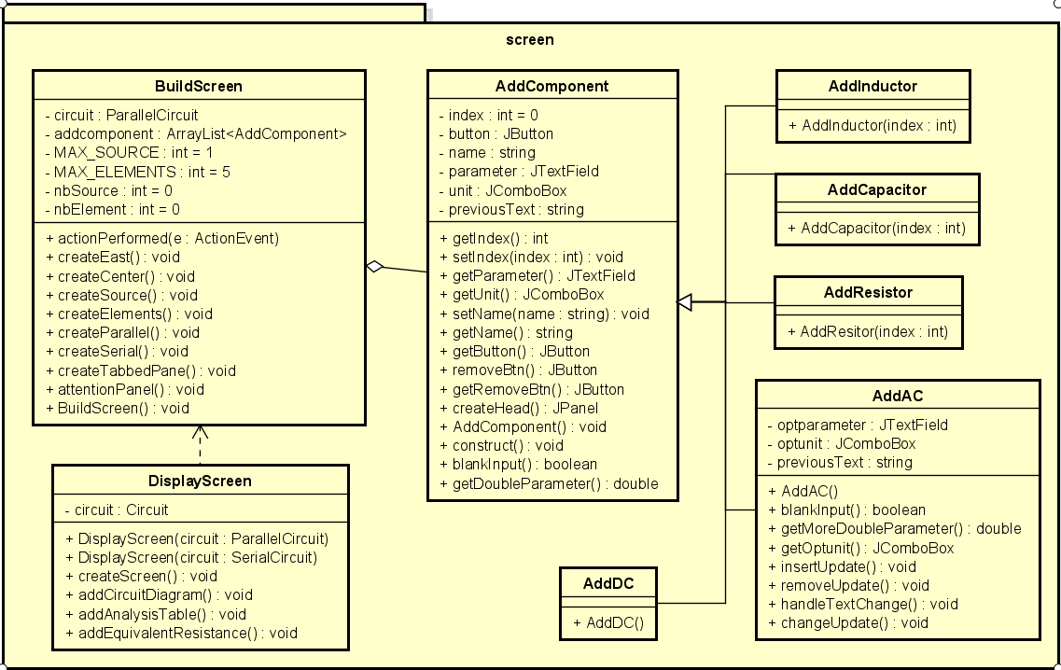
  - PACKAGE DETAILS

Figure 3.3: screen package

- Its Attributes are:
  - circuit : Represents the Circuit being built. It can be either a ParallelCircuit
or a SerialCircuit object.
  - addcomponents : ArrayList containing the components like VoltageSource and
ElectricalCElement being added to the Circuit.
  - nbElements : Current number of ElectricalElement added to the Circuit.
  - nbSource : Current number of VoltageSource added to the Circuit.
  - MAX_SOURCE : Maximum number of VoltageSource allowed.
  - MAX_ELEMENTS : Maximum number of ElectricalElement allowed.
- Its Methods are:
  - createEast() : Creates and returns the JPanel for the east side of the Build- Screen GUI, which includes the "SUBMIT" button.
  - createCenter() : Creates and returns the JPanel for the center of the Build- Screen GUI, which includes the source and elements panels.
  - createSource() : Creates and returns the JPanel for the source panel, which allows the User to add VoltageSource to the Circuit.
  - createElements() : Creates and returns the JPanel for the elements panel, which allows the User to add ElectricalElements to the Circuit.
  - createParallel() : Creates and returns the JPanel for the ParallelCircuit mode.
  - createSerial() : Creates and returns the JPanel for the SerialCircuit mode.
  - createTabbedPane() : Creates and returns the JTabbedPane that contains the
ParallelCircuit and SerialCircuit modes.
  - attentionPanel() : Creates and returns a JPanel that displays an attention mes- sage if a Short Circuit or other errors are found in the Circuit.
  - PACKAGE DETAILS

* BuildScreen() : Constructor of the BuildScreen class. Sets up the GUI compo- nents and initializes the Circuit and component lists.
AddComponent : this method helps the Users to manipulate the Simulator directly to customize their own Electrical Circuit.

- Its Attributes are:
  - index :An integer variable that represents the index of the component.
  - button : A JButton object that represents the button associated with the com- ponent.
  - name : A string variable that stores the name of the component.
  - parameter : A JTextField object that represents the parameter input field.
  - unit : A JComboBox object that stores the units for the component.
  - previousText : A string variable that holds the previous text value of the pa- rameter input field.
- Its Methods are:
  - getIndex() : Returns the index of the component.
  - setIndex(index : int) : Sets the index of the component.
  - getParameter() : Returns the JTextField object representing the parameter in- put field.
  - getUnit() : Returns the JComboBox object representing the unit selection.
  - setName(String name) : Sets the name of the component.
  - getName() : Returns the name of the component.
  - getButton() : Returns the JButton object associated with the component.
  - removeBtn() : Private method that creates and returns a JButton with a custom "remove" icon.
  - getRemoveBtn() : Returns the remove button associated with the component.
  - createHead() : Creates and returns a JPanel representing the header section of the component.
  - AddComponent() : Constructor for the AddComponent class. Sets the compo- nent as not visible.
  - construct() : Constructs and initializes the component by setting its layout, adding labels, input fields, and listeners.
  - blankInput() : Checks if the parameter input field is empty and returns a boolean value indicating the result.
  - getDoubleParameter() : Retrieves the double value from the parameter input field.
  - Note: The RemoveIcon class is an inner class that implements the Icon inter- face and is responsible for painting a custom "remove" icon for the remove button.
AddInductor : this method helps the Users to manipulate the Simulator directly to add
Inductor object as they constructed.

- Its Attributes are:
  - this class inherited the AddComponent so it consists all Attributes and Meth- ods of AddComponent class.
- Its Methods are:
  - addInductor(index : int) : Constructor with index values.

12 IT3100E - Object Oriented Programming
  - PACKAGE DETAILS

AddCapacitor : this method helps the Users to manipulate the Simulator directly to add
Capacitor object as they constructed.

- Its Attributes are:
  - this class inherited the AddComponent so it consists all Attributes and Meth- ods of AddComponent class.
- Its Methods are:
  - addCapacitor(index : int) : Constructor with index values.
AddResistor : this method helps the Users to manipulate the Simulator directly to add
Resistor object as they constructed.

- Its Attributes are:
  - this class inherited the AddComponent so it consists all Attributes and Meth- ods of AddComponent class.
- Its Methods are:
  - addResistor(index : int) : Constructor with index values.
AddAC : this method helps the Users to manipulate the Simulator directly to add AC
object as they constructed.

- Its Attributes are:
  - this class inherited the AddComponent so it consists all Attributes and Meth- ods of AddComponent class.
  - optparameter : A JTextField object that represents the optional parameter input field.
  - optunit : A JComboBox object that stores the units for the optional parameter.
  - previousText : A string variable that holds the previous text value of the op- tional parameter input field.
- Its Methods are:
  - AddAC() : Constructor for the AddAC class. Sets the name of the component as "AC" and initializes the unit selection for the main parameter and optional parameter.
  - blankInput() : Overrides the blankInput() method from the parent class. Checks if both the main parameter and optional parameter input fields are empty and returns a boolean value indicating the result.
  - getMoreDoubleParameter() : Retrieves the double value from the optional pa- rameter input field.
  - getOptunit() : Returns the JComboBox object representing the unit selection for the optional parameter.
  - insertUpdate() : method is triggered when text is inserted into the optparameter text field. It calls the handleTextChange() method.
  - removeUpdate() : method is triggered when text is removed from the optparam- eter text field. It updates the previousText variable with the current text value of the optparameter field.
  - handleTextChange() : method is defined within the insertUpdate() method. It is responsible for handling the text change event. In this case, it attempts to parse the text as a double value. If an exception occurs, indicating that the
IT3100E - Object Oriented Programming 13
  - PACKAGE DETAILS

text is not a valid double value, it sets the text of the optparameter field back to the previous value stored in the previousText variable.
AddDC : this method helps the Users to manipulate the Simulator directly to add DC
object as they constructed.

- Its Attributes are:
  - this class inherited the AddComponent so it consists all Attributes and Meth- ods of AddComponent class.
- Its Methods are:
  - addDC() : standard constructor.
DisplayScreen : this method define a GUI display where the Users can manipulate the
Simulator directly to customize their own Electrical Circuit.

- Its Attributes are:
  - circuit : Represents the Circuit object to be displayed.
- Its Methods are:
  - DisplayScreen(circuit : ParallelCircuit) : Constructor that creates a DisplayScreen object for a ParallelCircuit.
  - DisplayScreen(circuit : SerialCircuit) : Constructor that creates a DisplayScreen object for a SerialCircuit.
  - createScreen() : Creates the display screen by setting the size, title, layout, and other properties of the frame.
  - addCircuitDiagram() : Adds the circuit diagram to the display screen.
  - addAnalysisTable() : Adds the circuit analysis table to the display screen.
  - addEquivalentResistance() : Adds the equivalent resistance label to the display screen.

CircuitDrawing Diagram is a GUI package which show the image of inserting compo- nents into the User’s Electrical Circuit.

MainGUI : this method define the main GUI display in the Electrical Circuit Simulator.

- Its Attributes are:
  - circuit : Represents the Circuit object to be displayed.
- Its Methods are:
  - MainGUI() : The constructor of the MainGUI class. It takes a Circuit object as a parameter and initializes the circuit attribute.
  - paintComponent(g : Graphics) : An overridden method from the JPanel class that is responsible for painting the components on the panel. It takes a Graph- ics object as a parameter and is called automatically when the panel needs to be painted. Inside this method, it iterates over the elements in the Circuit and calls the appropriate drawing method (draw) based on the type of ele- ment (Resistor, Capacitor, Inductor). It also draws the VoltageSource(AC or DC) based on its type.
  - PACKAGE DETAILS

ElementGUI : this method define a GUI display for all the ElectricalElement objects and
VoltageSource object in the Electrical Circuit.

- Its Attributes are:
  - circuit : Represents the Circuit object to be displayed.
  - seed : An integer representing the seed value for the ElementGUI. It is based on the size of the elements in the Circuit.
- Its Methods are:
  - ElementGUI() : The constructor of the ElementGUI class. It takes a Circuit
object as a parameter and initializes the circuit and seed attributes.
  - getCircuit() : A method that returns the Circuit object associated with the El- ementGUI.
  - getSeed() : A method that returns the seed value of the ElementGUI.
  - draw(g : Graphics) : An abstract method that defines the drawing functionality for the ElementGUI. It takes a Graphics object as a parameter and is imple-
mented in the subclasses to draw specific elements on the graphics context.

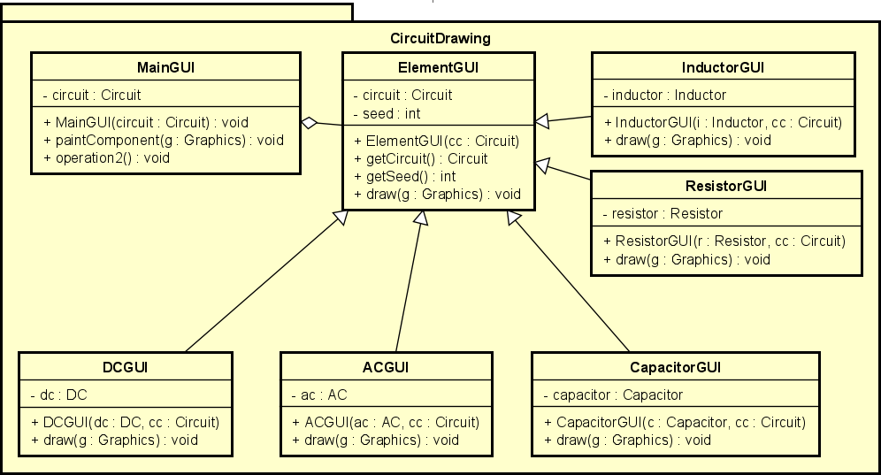

Figure 3.4: CircuitDrawing package

InductorGUI : this method define a GUI display for the Inductor object in the Electrical Circuit.

- Its Attributes are:
  - PACKAGE DETAILS

    - This class inherited ElementGUI so it consists all the Attributes and Methods of ElementGUI class.
    - inductor : Represents the Inductor object to be displayed.
- Its Methods are:
  - InductorGUI(i : Inductor,cc: Circuit) : The constructor of the InductorGUI class. It takes an Inductor object and a Circuit object as parameters and initializes the inductor attribute and the inherited attributes from the ElementGUI class.
  - draw(g : Graphics) : An abstract method that defines the drawing functionality for the ElementGUI. It takes a Graphics object as a parameter and is imple- mented in the subclasses to draw specific elements on the graphics context.

ResistorGUI : this method define a GUI display for the Resistor object in the Electrical Circuit.

- Its Attributes are:
  - This class inherited ElementGUI so it consists all the Attributes and Methods of ElementGUI class.
  - resistor : Represents the Resistor object to be displayed.
- Its Methods are:
  - ResistorGUI(r : Resistor,cc: Circuit) : The constructor of the ResistorGUI class. It takes an Resistor object and a Circuit object as parameters and initializes the resistor attribute and the inherited attributes from the ElementGUI class.
  - draw(g : Graphics) : An abstract method that defines the drawing functionality for the ElementGUI. It takes a Graphics object as a parameter and is imple- mented in the subclasses to draw specific elements on the graphics context.

CapacitorGUI : this method define a GUI display for the Capacitor object in the Electri- cal Circuit.

- Its Attributes are:
  - This class inherited ElementGUI so it consists all the Attributes and Methods of ElementGUI class.
  - capacitor : Represents the Capacitor object to be displayed.
- Its Methods are:
  - CapacitorGUI(c : Capacitor,cc: Circuit) : The constructor of the Capacitor class. It takes an Capacitor object and a Circuit object as parameters and initializes the resistor attribute and the inherited attributes from the ElementGUI class.
  - draw(g : Graphics) : An abstract method that defines the drawing functionality for the ElementGUI. It takes a Graphics object as a parameter and is imple- mented in the subclasses to draw specific elements on the graphics context.

ACGUI : this method define a GUI display for the AC object in the Electrical Circuit.

- Its Attributes are:
  - PACKAGE DETAILS

- This class inherited ElementGUI so it consists all the Attributes and Methods of ElementGUI class.
- ac : Represents the AC object to be displayed.
- Its Methods are:
  - ACGUI(ac : AC,cc: Circuit) : The constructor of the ACGUI class. It takes an AC object and a Circuit object as parameters and initializes the ac attribute and the inherited attributes from the ElementGUI class.
  - draw(g : Graphics) : An abstract method that defines the drawing functionality for the ElementGUI. It takes a Graphics object as a parameter and is imple- mented in the subclasses to draw specific elements on the graphics context.

DCGUI : this method define a GUI display for the DC object in the Electrical Circuit.

- Its Attributes are:
  - This class inherited ElementGUI so it consists all the Attributes and Methods of ElementGUI class.
  - dc : Represents the DC object to be displayed.
- Its Methods are:
  - DCGUI(dc : DC,cc: Circuit) : The constructor of the DC class. It takes an DC object and a Circuit object as parameters and initializes the dc attribute and the inherited attributes from the ElementGUI class.
  - draw(g : Graphics) : An abstract method that defines the drawing functionality for the ElementGUI. It takes a Graphics object as a parameter and is imple- mented in the subclasses to draw specific elements on the graphics context.

Execute
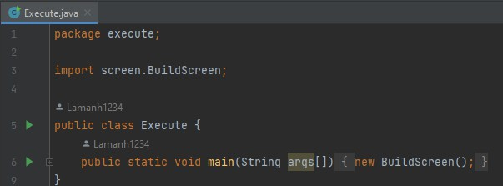

Figure 3.5: model package

On Execute Class, we define a main() class where we create new BuildScreen and run as starting our Electrical Circuit Simulator.
  - PACKAGE DETAILS

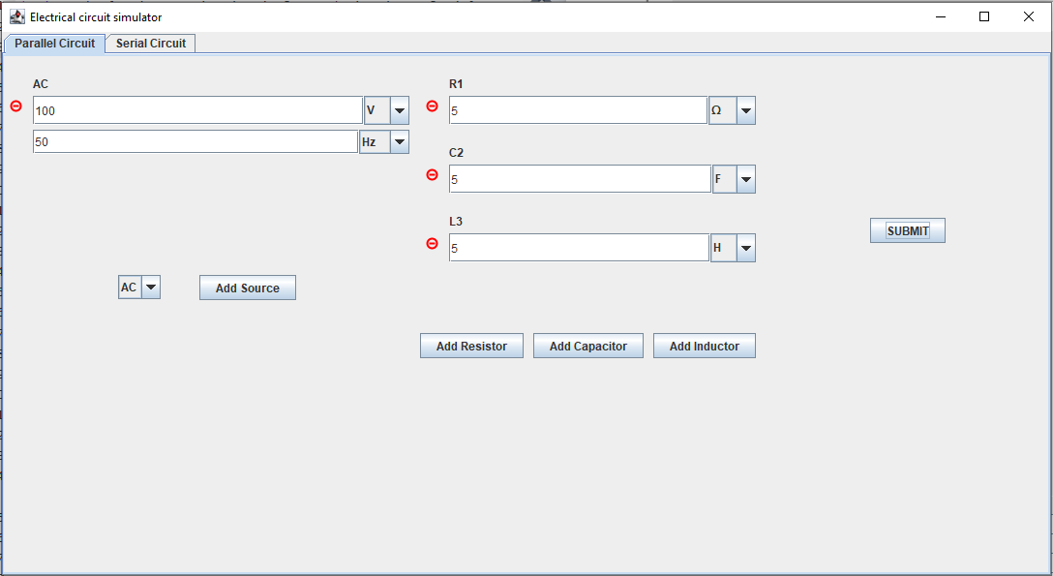

Figure 3.6: model package
CHAPTER 4. REFERENCES

Chapter 4

References

    - We applied this Documentation as our guide for Graphics drawing:

      - https://docs.oracle.com/javase%2F7%2Fdocs%2Fapi%2F%2F/java/awt/Graphics2D.html

    - Our GUI is refered from the link allocated in the Mini-project Topics:

      - https://www.digikey.com/en/resources/conversion-calculators/conversion-calculator- parallel-and-series-resistor

    - Our Mini-project requires downloading The Apache Commons Mathematics Library which is through the link below:

      - https://archive.apache.org/dist/commons/math/binaries/commons-math3-3.6.1- bin.zip

IT3100E - Object Oriented Programming 19

