SquidWork Database Project
Phase 1 Progress Submission - Conceptual Design
Submission scope: this document reports the work completed for Phase 1 only. Logical mapping, SQL implementation, mock data, UI/backend integration, and final defense are future milestones.

A. Project Identity
Item | Information
Course | INT1313 - Databases
Project | #3 - Freelance Marketplace Ecosystem (Mini-Upwork)
Team | Squid
Submission | Phase 1 - Weeks 3-4 conceptual design
Status | In progress; Phase 1 design prepared

Team members and current ownership
Member | Email | Phase 1 responsibility
Le Minh Thien | n24dccn167@student.ptithcm.edu.vn | Requirements, business rules, EER design
Nguyen Ngoc Vinh | n24dccn183@student.ptithcm.edu.vn | Report integration and conceptual model review
Nguyen Tuan Vy | n24dccn184@student.ptithcm.edu.vn | Scenario analysis and relationship review

1. Scope and problem statement
SquidWork is a small freelance marketplace database concept. It records how a client posts a job, how freelancers submit proposals, how an accepted proposal becomes a contract, and how the contract is divided into milestones. Reviews are included because reputation is part of how users choose to work with one another.
The Phase 1 boundary is conceptual: identify the users, business objects, rules, and relationships needed by the scenario. Implementation details are intentionally deferred to later phases.

2. Requirements

2.1 Functional requirements
ID | The system must...
FR-01 | register a user and store common account information.
FR-02 | allow a user to act as a client, a freelancer, or both.
FR-03 | allow a client to post and manage jobs.
FR-04 | allow a freelancer to submit a proposal for a job.
FR-05 | allow an accepted proposal to create one contract.
FR-06 | allow a contract to contain ordered milestones.
FR-07 | record payments and transactions related to milestones.
FR-08 | allow parties to review each other after a contract.
FR-09 | summarize ratings received by a user.

2.2 Non-functional requirements
ID | Requirement
NFR-01 | The design should preserve referential integrity between related business objects.
NFR-02 | Identifiers and names should be consistent and suitable for later relational implementation.
NFR-03 | The model should support traceability from each business rule to an entity or relationship.
NFR-04 | The final database should be extensible without changing the core marketplace lifecycle.

3. Business rules
ID | Business rule
BR-01 | Each user has a unique identifier and a unique email address.
BR-02 | A user may be a client, a freelancer, or both.
BR-03 | A client can post many jobs; each job belongs to one client.
BR-04 | A job belongs to one category and can receive many proposals.
BR-05 | A freelancer can submit many proposals but at most one proposal for a specific job.
BR-06 | An accepted proposal may create at most one contract.
BR-07 | Each contract has one client, one freelancer, and many milestones.
BR-08 | Milestones are ordered within a contract.
BR-09 | A milestone may have zero or one payment.
BR-10 | A review belongs to one contract and has one reviewer and one reviewee.
BR-11 | A reviewer cannot review the same reviewee twice for the same contract.
BR-12 | A user can have one rating summary derived from reviews received.

4. EER model
Figure 1 shows the conceptual overview. USER is the supertype. CLIENT_PROFILE and FREELANCER_PROFILE are overlapping subtypes because the same account may use both roles. FREELANCER_SKILL is an associative entity used to resolve the freelancer-skill many-to-many relationship in the later logical design.
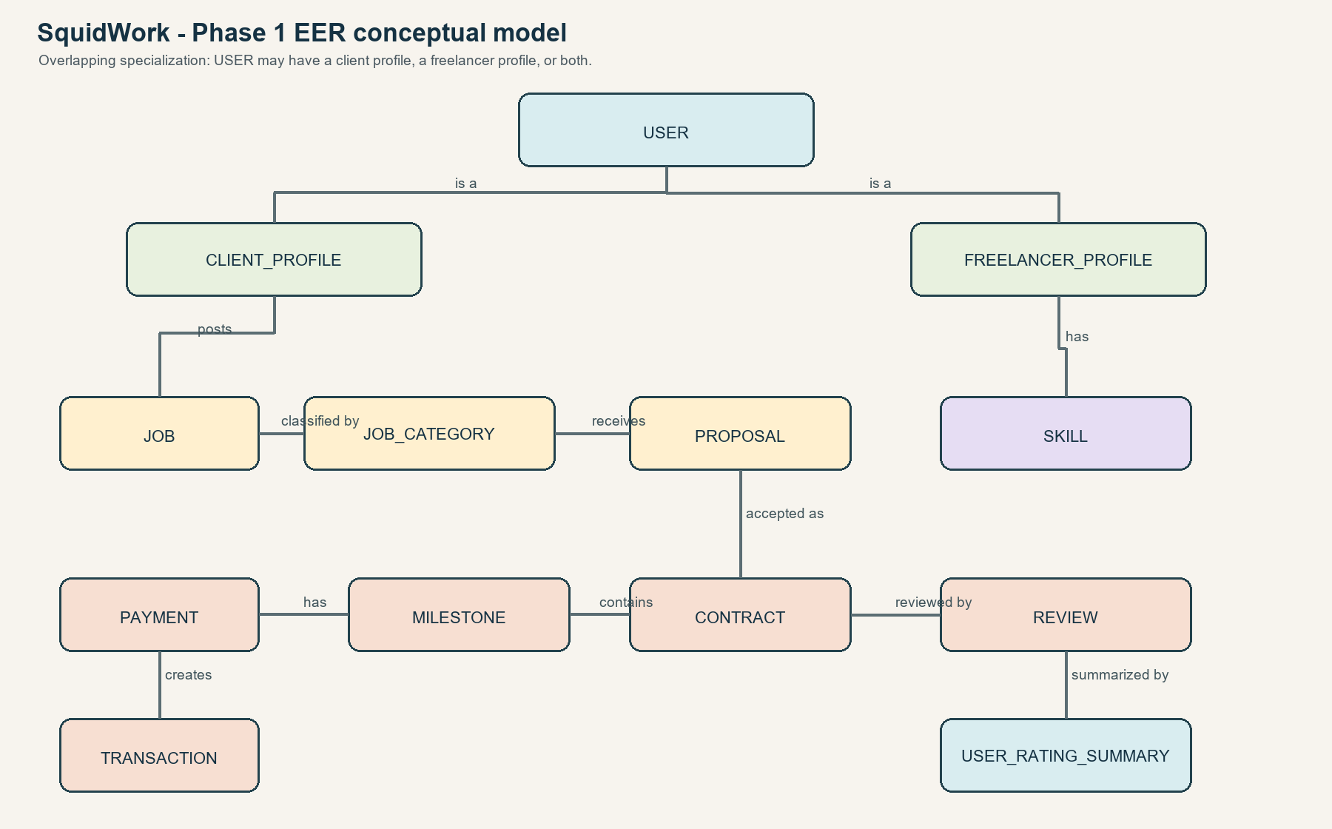
Figure 1. SquidWork Phase 1 EER conceptual overview

4.1 Main entities
Entity | Purpose
USER | Common identity and account information.
CLIENT_PROFILE | Client-specific information for users who post jobs.
FREELANCER_PROFILE | Freelancer-specific information for users who submit proposals.
JOB | A piece of work posted by a client.
JOB_CATEGORY | Classification used to group jobs.
PROPOSAL | An offer submitted by a freelancer for a job.
CONTRACT | The agreement created from an accepted proposal.
MILESTONE | An ordered deliverable within a contract.
PAYMENT / TRANSACTION | Financial records associated with milestone payment.
REVIEW / USER_RATING_SUMMARY | Feedback and derived reputation information.
SKILL / FREELANCER_SKILL | Freelancer capabilities and their association.

4.2 Relationships and cardinalities
Relationship | Cardinality | Explanation
USER - CLIENT_PROFILE | 1 to 0..1 | A user may have zero or one client profile.
USER - FREELANCER_PROFILE | 1 to 0..1 | A user may have zero or one freelancer profile.
CLIENT_PROFILE - JOB | 1 to N | A client may post many jobs; each job has one client.
JOB_CATEGORY - JOB | 1 to N | A category may contain many jobs.
JOB - PROPOSAL | 1 to N | A job may receive many proposals.
FREELANCER_PROFILE - SKILL | M to N | Resolved through FREELANCER_SKILL.
PROPOSAL - CONTRACT | 1 to 0..1 | Only an accepted proposal may create a contract.
CONTRACT - MILESTONE | 1 to N | A contract contains ordered milestones.
MILESTONE - PAYMENT | 1 to 0..1 | A milestone may be unpaid or have one payment.
CONTRACT - REVIEW | 1 to N | A completed contract may receive reviews.
USER - USER_RATING_SUMMARY | 1 to 0..1 | A user may have one derived summary.

5. Phase 1 status and next steps
Completed for this submission: scenario analysis, scope boundary, functional and non-functional requirements, explicit business rules, overlapping specialization, entity list, and relationship/cardinality analysis.
Next milestones: map the EER model to relations and justify normalization; then implement DDL, mock data, queries, views/triggers, and finally connect a simple application. Those items are not claimed as completed in this Phase 1 report.

6. Contribution plan
Member | Contribution for this submission
Le Minh Thien | Requirements, business rules, EER design
Nguyen Ngoc Vinh | Report integration and conceptual model review
Nguyen Tuan Vy | Scenario analysis and relationship review

The table summarizes the team's working ownership for the Phase 1 submission.

