CONTENTS

1. Guest user 2

2. QA user 2

3. Power user 3

4. Admin user 4

**Test Central User Rules**

***This document is to define which functions user will be used when logging with an account (Guest, QA, Power or Admin)***

# Guest user

* Dashboard menu: *env versions, daily results, search results*
* Projects (ATG, ACCR, Web Services…) menu: show *view results* if exist results in Database.
* Users menu: *sign in*

# QA user

* Dashboard menu: env versions, schedules, daily results, search results
* Projects ( ATG, ACCR, Web Services, Narnia, Content ) menu:

|  |  |  |  |  |  |
| --- | --- | --- | --- | --- | --- |
|  | **ATG** | **ACCR** | **WEB SERVICES** | **NARNIA** | **CONTENT** |
| Default | **- run scripts**  **- upload result**  **- config**  - upload PIN  - upload Promotion | **- run scripts**  **- upload result**  **- config**  - upload PIN  - upload MOAS  - content Platform Checker | **- run scripts**  **- upload result**  **- config**  - upload PIN | **- run scripts**  **- upload result**  **- config** | **- run scripts**  **- upload result**  **- config** |
| Optional  ( show **view results** link if existing result in Database) | - view results | - view results | - view results | - view results | - view results |

* Utilities menu: *account clear, customer lookup, device linking, device lookup, geoip lookup, pin redemption, pin status.*

Note: hide PROD environment for **account clear** and **pin redemption** functions.

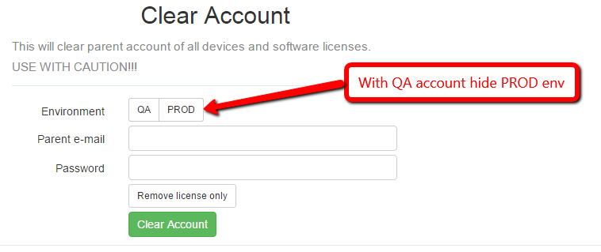

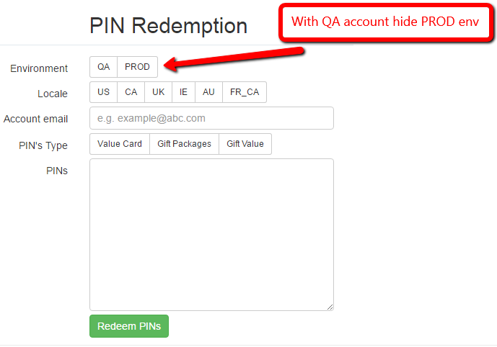

* Users menu: *Help & FAQs, sign out*

# Power user

Including all QA rules and show PROD environment for **account clear** and **pin redemption** functions.

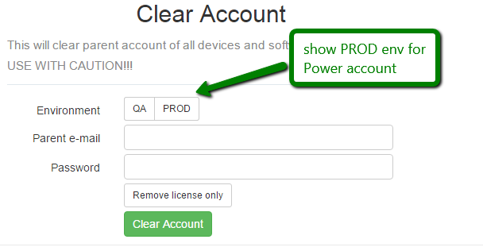

# Admin user

Including all Power rules and some rules (add*/edit user, audit log, config, email rollups, stations settings)* in Users menu link.

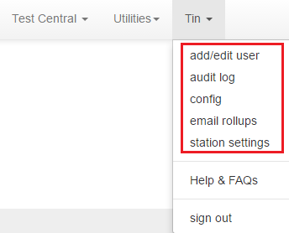

* Show Test Central menu with links: *view results, run scripts*

