21095551_MaiLuuHuuVinh
Link git : https://github.com/vinhmai2109551/Mobile/tree/main/21095551_Mailuuhuuvinh_Day3
BÀI LÀM
bookstore-online-gio1
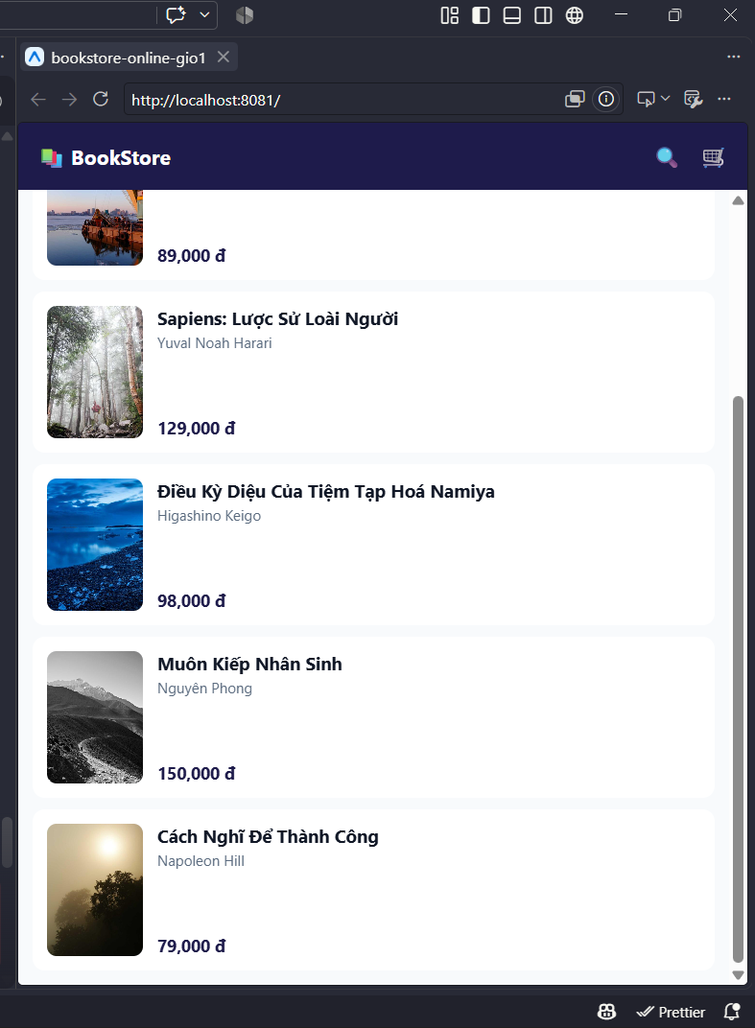

bookstore-online-gio2
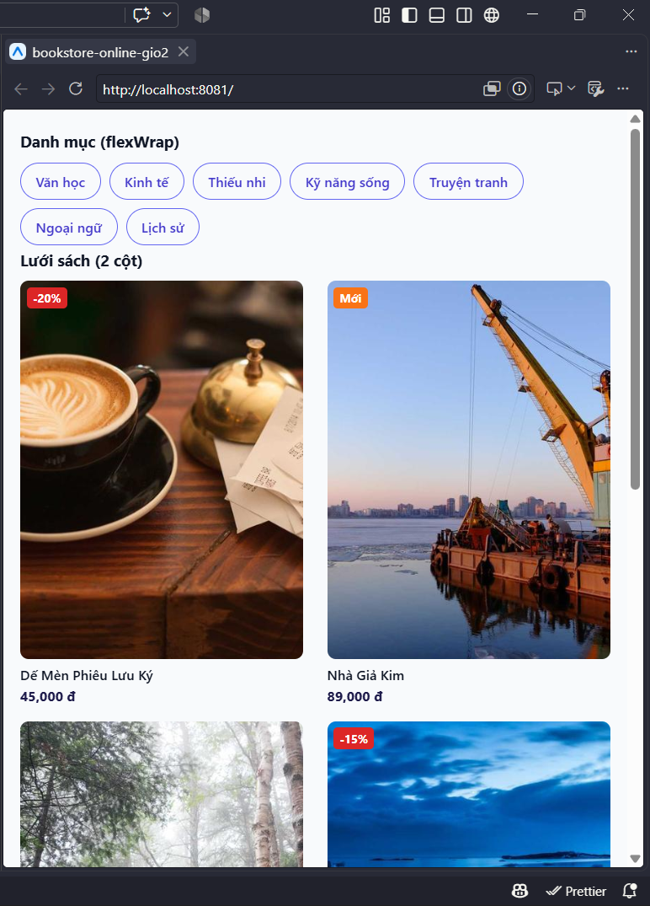
bookstore-online-gio3
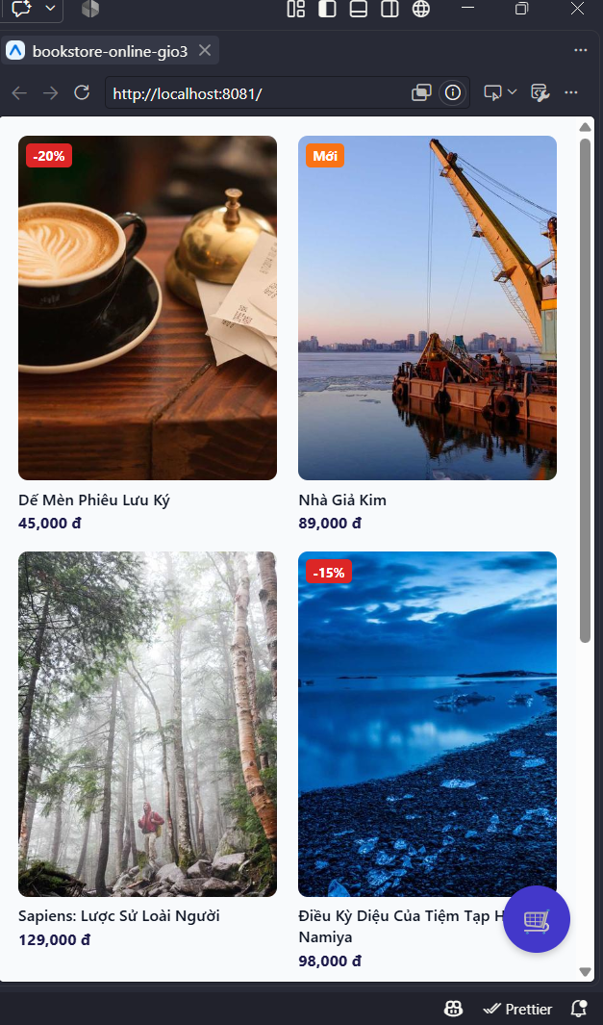
bookstore-online-tonghop
