**LAB13**

**1.**

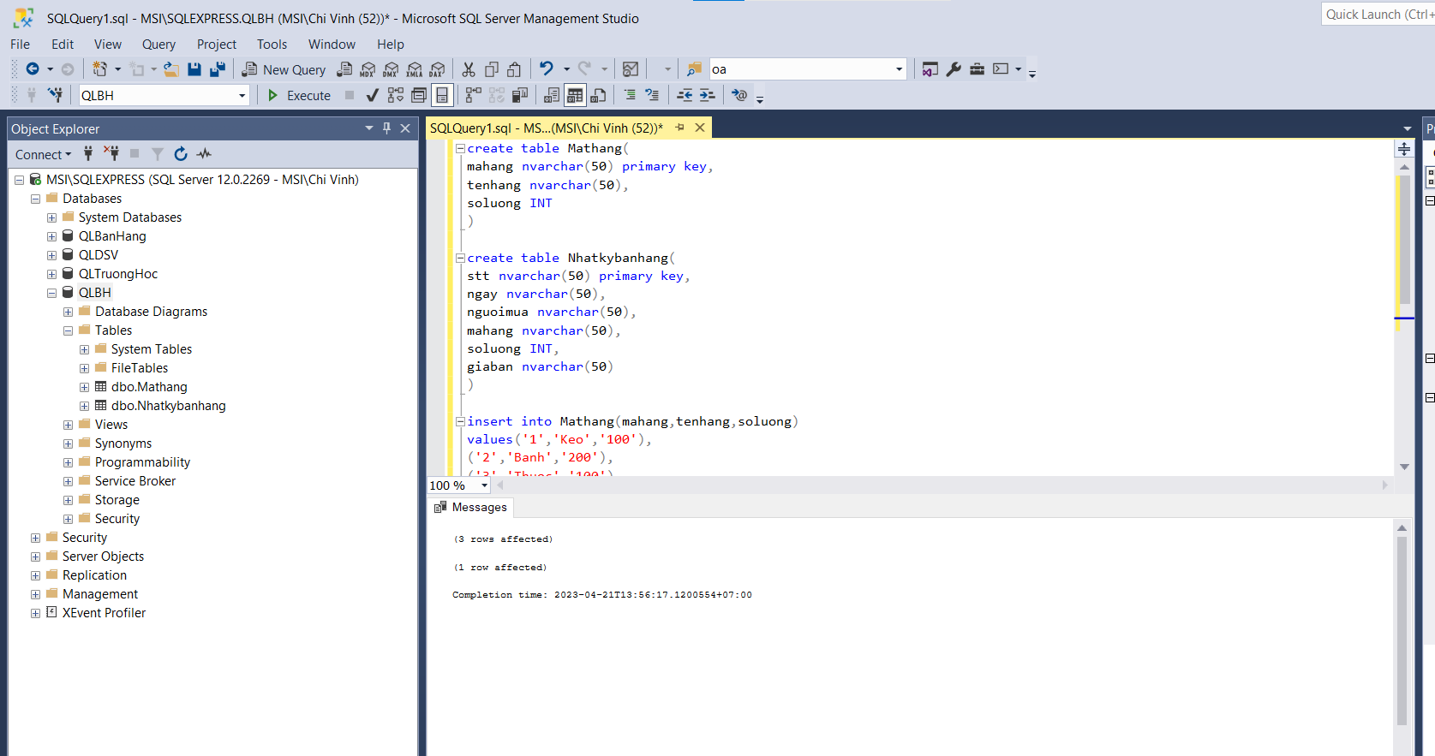

**2.**

