Nguyễn Chí Vĩnh – 09CNPM1

0950080011

Câu 1

Câu 2

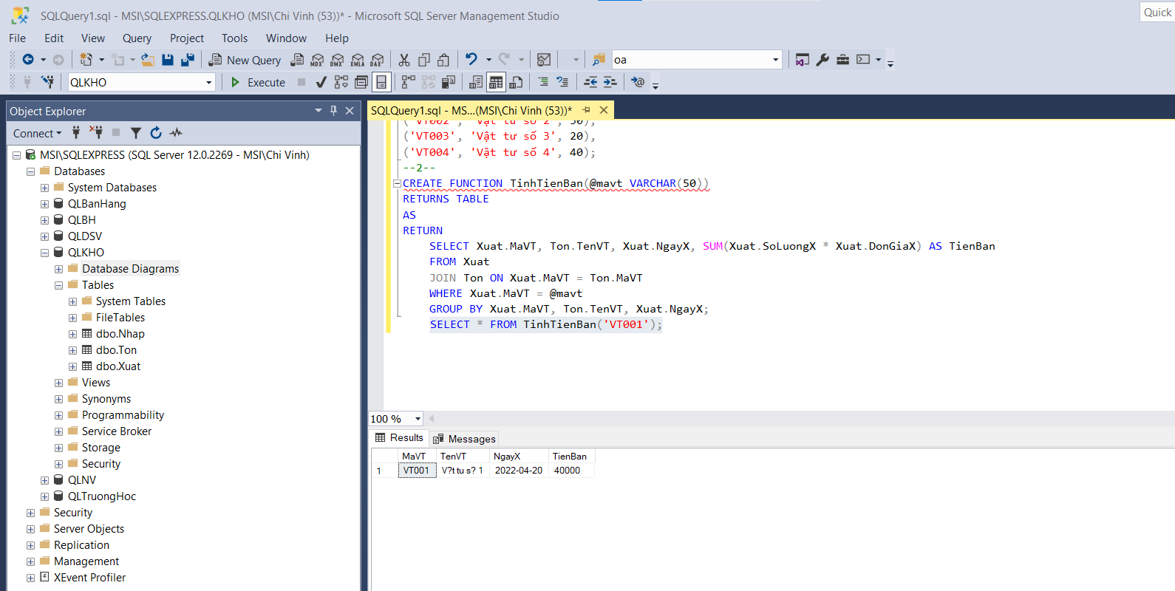

Câu 3

Câu 4

