Nguyễn Chí Vĩnh-09CNPM1

0950080011

Lab4

Tạo view cho lab2

2.

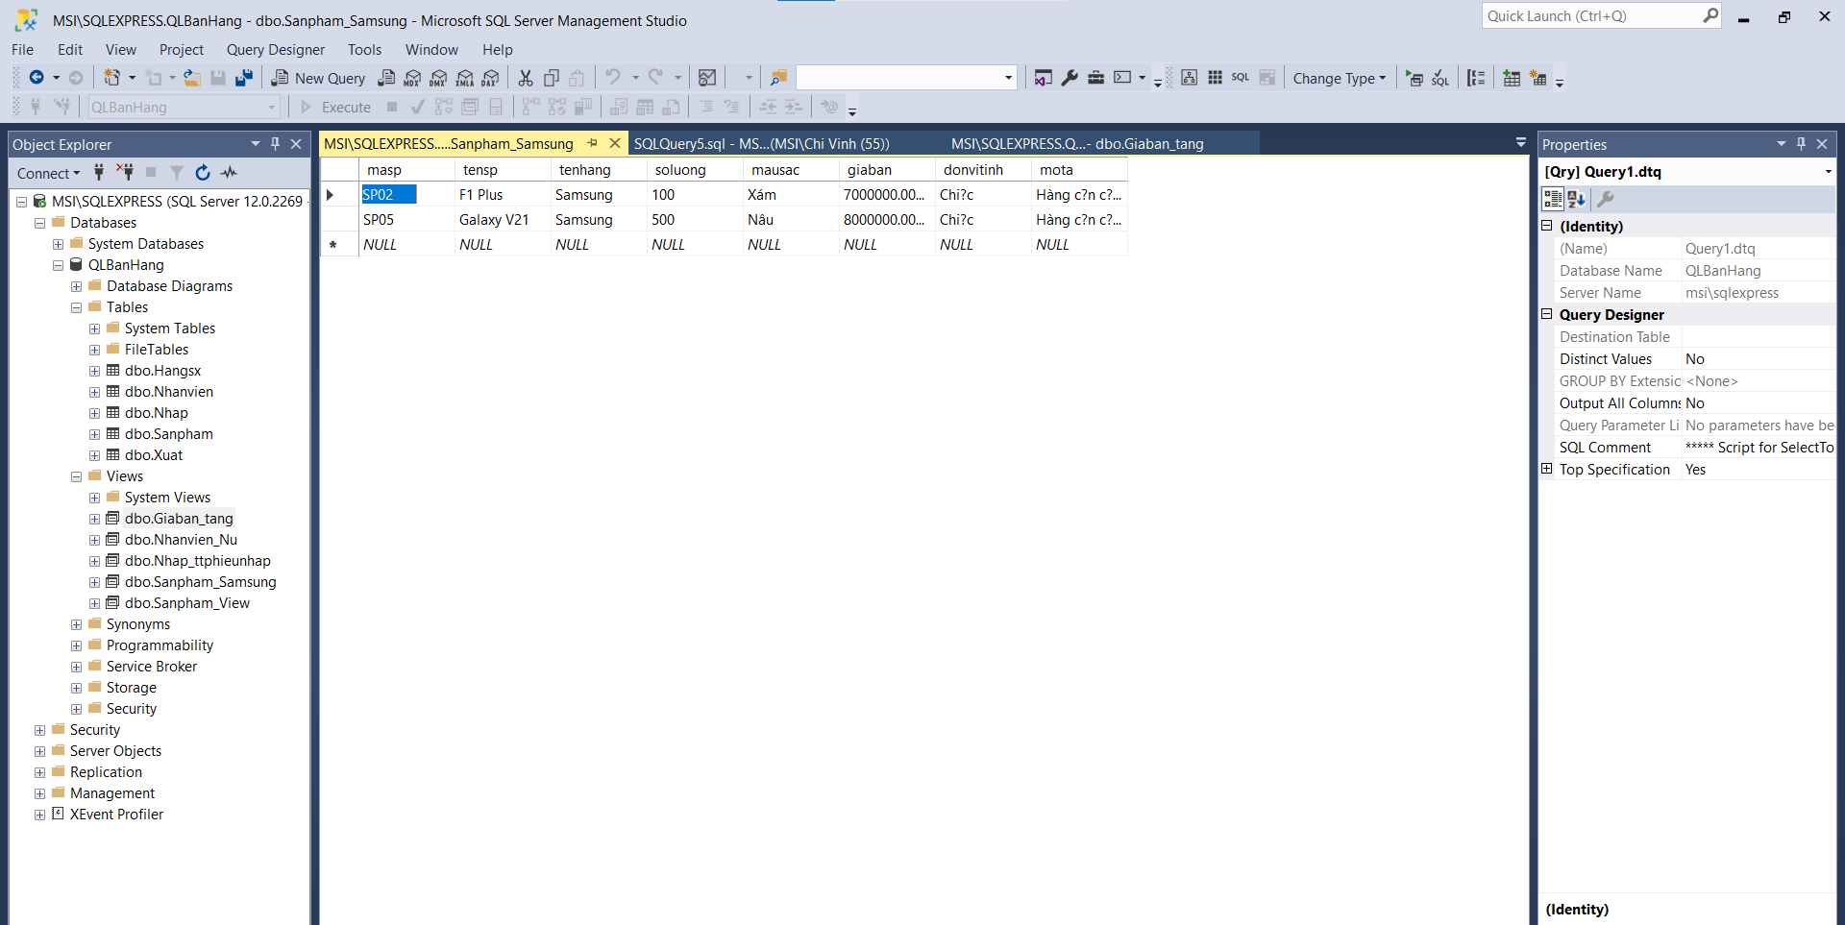

3.

4.

5.

6.

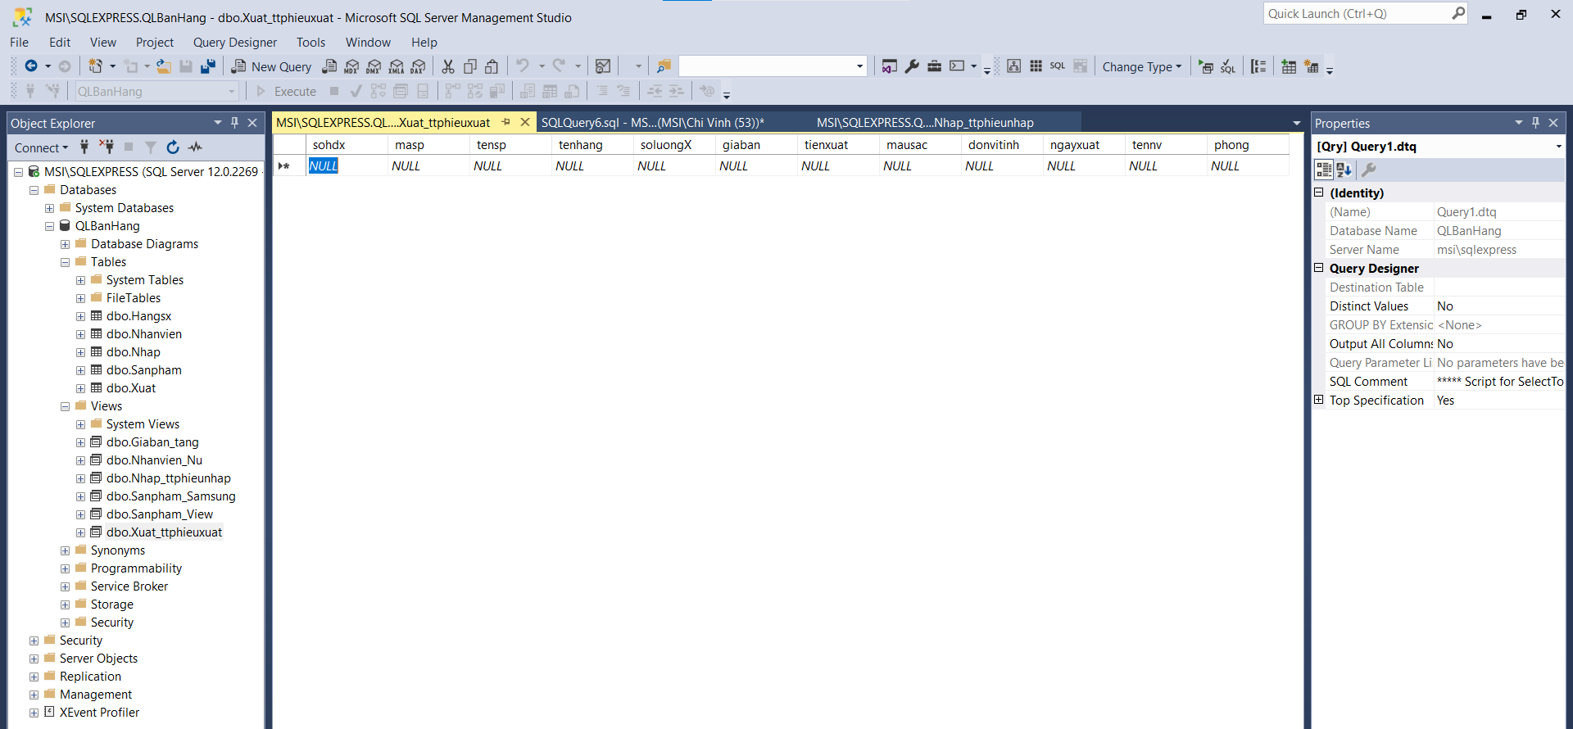

7.

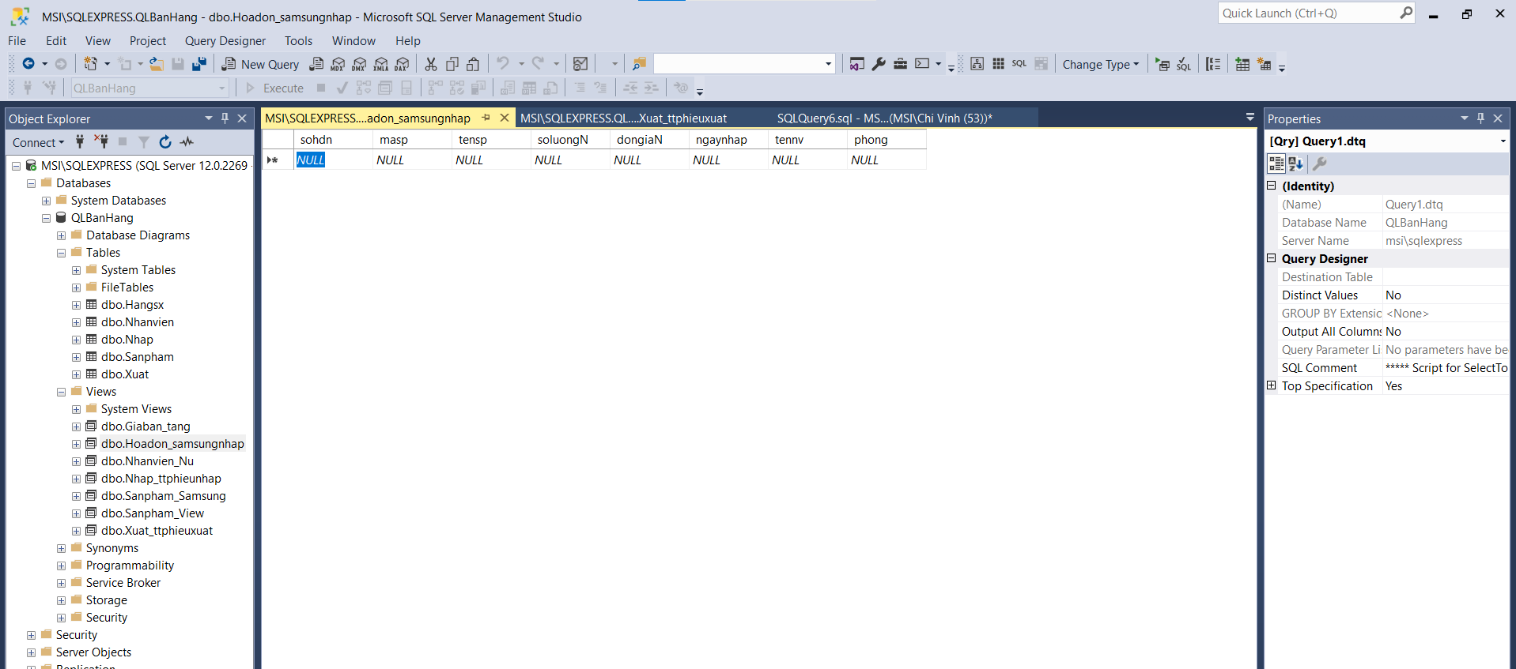

8.

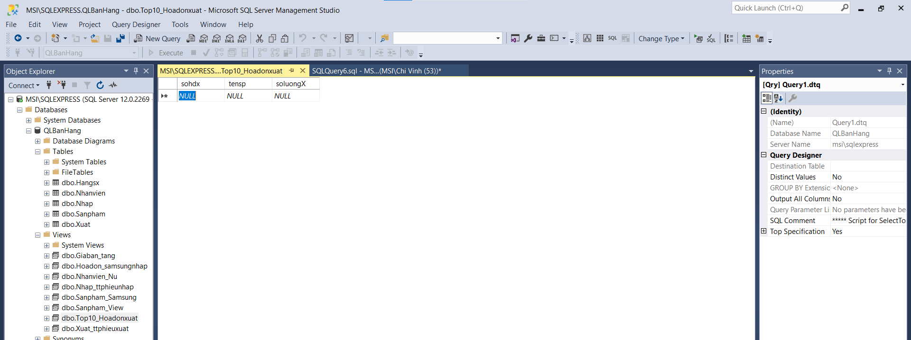

9.

10.

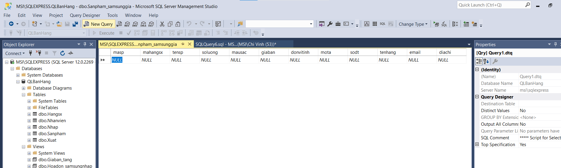

11.

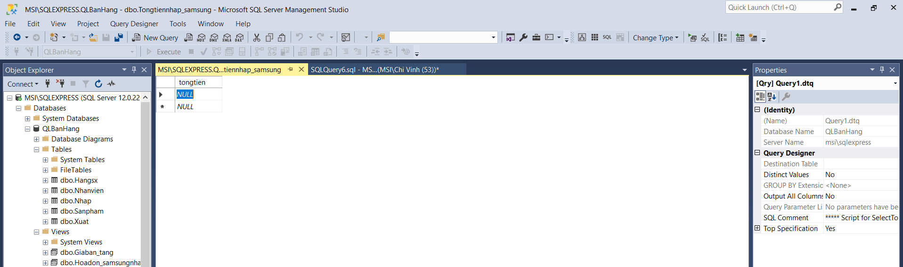

13.

14.

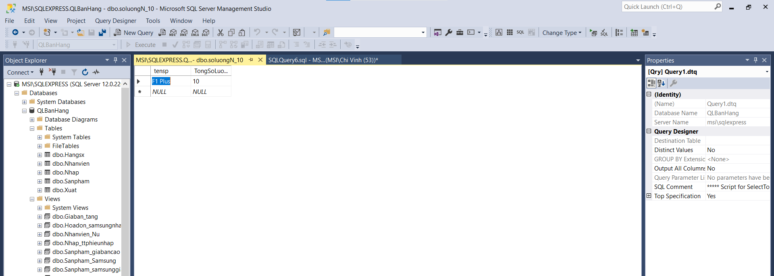

15.

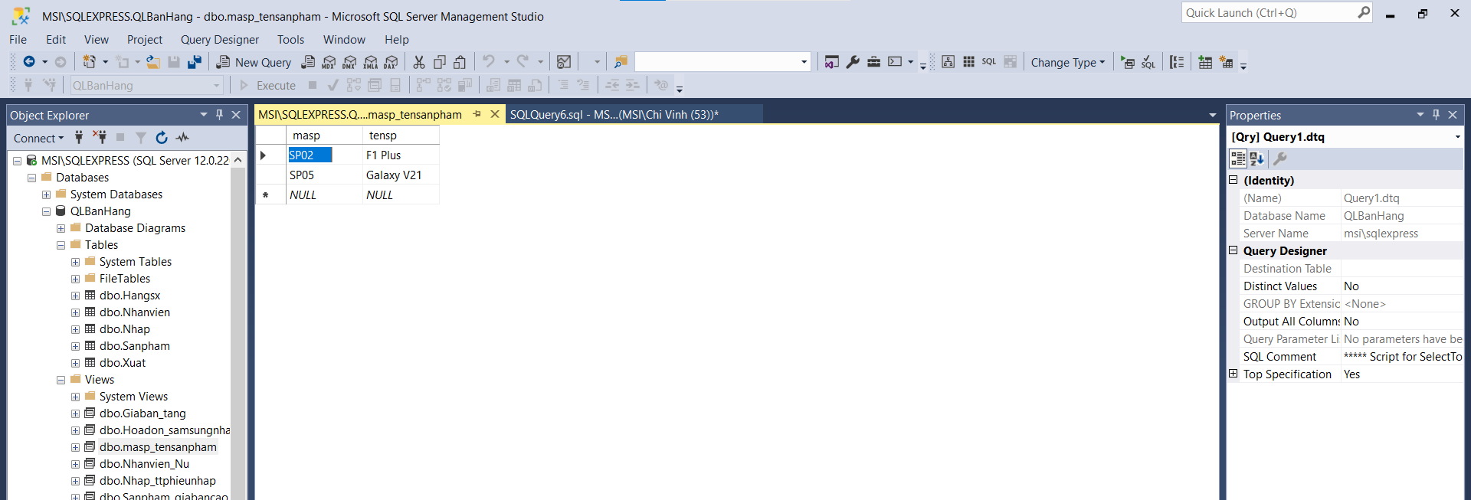

16.

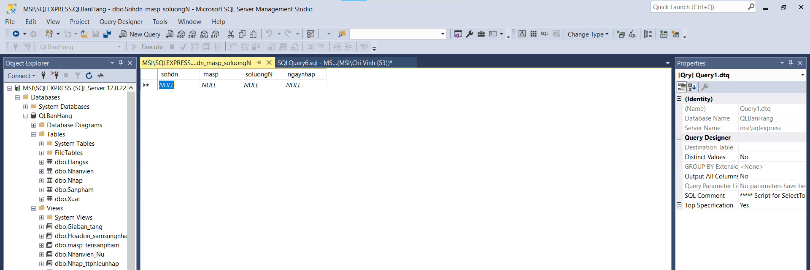

17.

