# Amnhac.timnhanh.com(yume.vn)

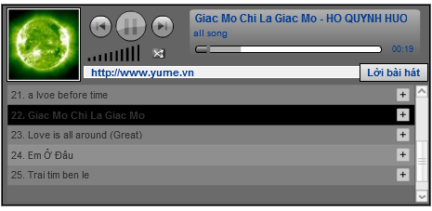

Thông tin lấy được:

1. Tên bài hát-ca sĩ-tác giả
2. Link object
3. Link gốc tới trang chủ
4. Link serive(trong thẻ object) để download : được mã hóa,chưa thể lấy được

xmlPath=http://amnhac.timnhanh.com/getxml/0/35A52164/6fbf3171b57efe6efcaafce367fef587/783383/1442799961.xml

**kết quả trả về:**

<playlist>

<track

idSong="48329"

idUser="782869"

userName="vechaiday"

hexKey="35A5A5C9"

fName="1244362401_1313895063.mp3"

hostName="http://amnhac.timnhanh.com/"

title="Chuy?n Ngày Xua" singer="Hi?n Th?c"

totalTime="241000"

playlist="" picPlaylist="http://static.timnhanh.com/yumemusic/20090527/images/graphics/noimage_playlist_75x75.gif">

</track>

</playlist>

**IDM download link gốc dạng:**

http://streaming.timnhanh.com/7d76e4d71313741c06fd8fe10c501da0/4a2b6570/music/mp3/20081127/ugmohl_insane/12277463901170886114.mp3

1. Lyric dạng service trong thẻ object

getLyric=http://amnhac.timnhanh.com/player/getLyric/&amp;colorAux=0x6FD4FF&amp;colorMain=0x0b70b8'

Title dang :

<title>Tiếng Đàn Tôi - Đức Tuấn - Phạm Duy - YuMe</title>

Embed trong thẻ <Script></script> thứ 7

<script>

var p4 = '1243615034';

var p3 = 783383;

var p2 = '873ed41d37618497169fdb293830ddf7';

var p1 = '35A52164';

var intDecSongId = 14436;

var intMemberId = 783383;

var intMaxLengthDiary = 3000;

var intTotalPlaylistMember = 0;

var intLastestPlaylistID = 0;

var start = 'half';

var mark = 9;

var rateType = 1;

var item_type = 'music';

var strMemberUsername = "thuyvi81";

var strTitle = "Tiếng Đàn Tôi";

var song_ishot = "0";

var intAppUIMemberId = "-1";

var strFlashUpload = '';

var strEmbedBlog = "<object width='463' height='269'><param name='movie' value ='http://static.timnhanh.com/yumemusic/flashplayer/flsongblog.swf?xmlPath=http://amnhac.timnhanh.com/getxml/0/35A52164/6fbf3171b57efe6efcaafce367fef587/783383/1442799961.xml&amp;getLyric=http://amnhac.timnhanh.com/player/getLyric/&amp;colorAux=0x6FD4FF&amp;colorMain=0x0b70b8'></param><param name='wmode' value='transparent'><param name='allowscriptaccess' value='always'></param>< src='http://static.timnhanh.com/yumemusic/flashplayer/flsongblog.swf?xmlPath=http://amnhac.timnhanh.com/getxml/0/35A52164/6fbf3171b57efe6efcaafce367fef587/783383/1442799961.xml&getLyric=http://amnhac.timnhanh.com/player/getLyric/&amp;colorAux=0x6FD4FF&amp;colorMain=0x0b70b8' type='application/x-shockwave-flash' width='463' height='269' wmode='transparent' allowscriptaccess='always'></embed></object>";

</script>