**Lab 15: Cloud Computing**

**Course Name**: Ethical Hacking and Offensive Security(HOD401)

**Student Name**: Nguyễn Trần Vinh – SE160258

**Instructor Name**: Mai Hoàng Đỉnh

**Lab Due Date**: 1/11/2023

**1. Perform S3 Bucket Enumeration using Various S3 Bucket Enumeration Tools**

1.1 Enumerate S3 Buckets using lazys3

- Open Parrot

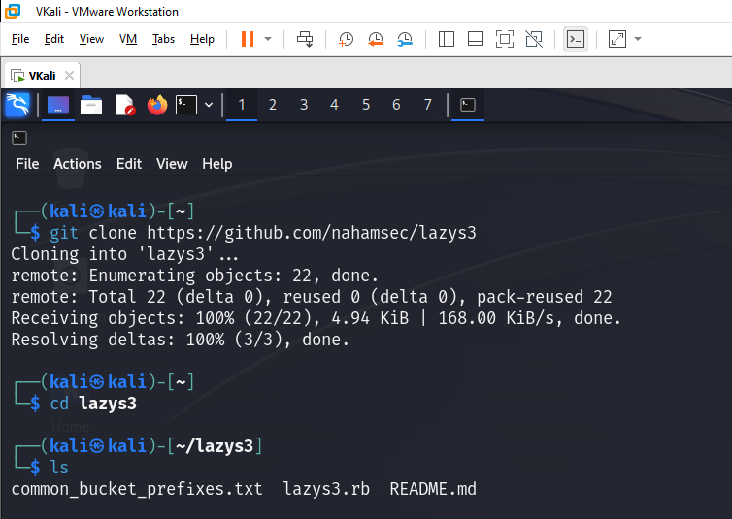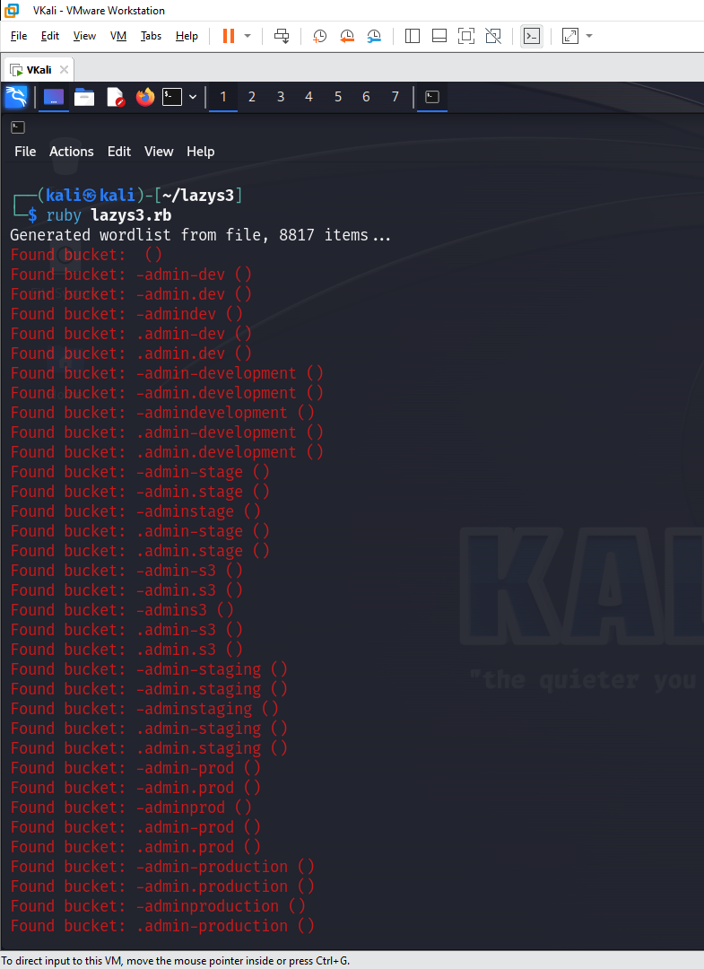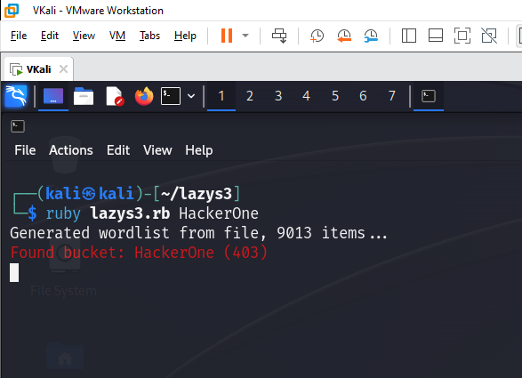

1.2 Enumerate S3 Buckets using S3Scanner

- Open Parrot

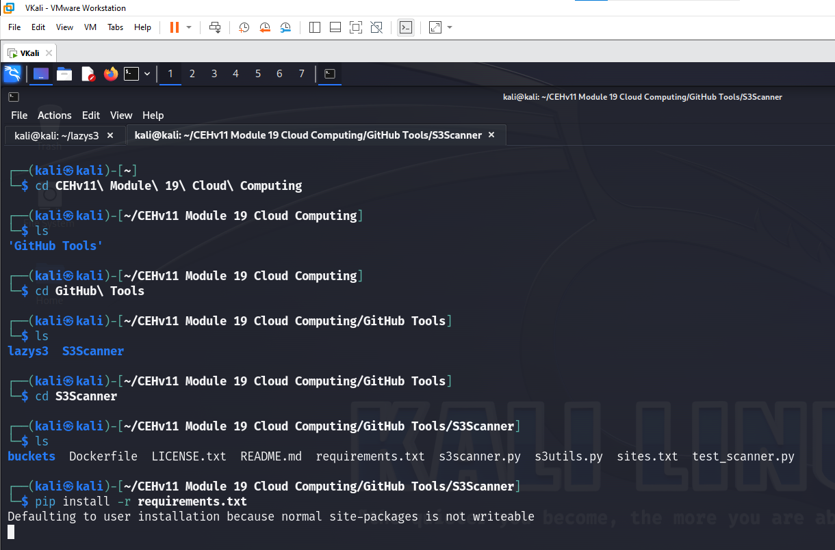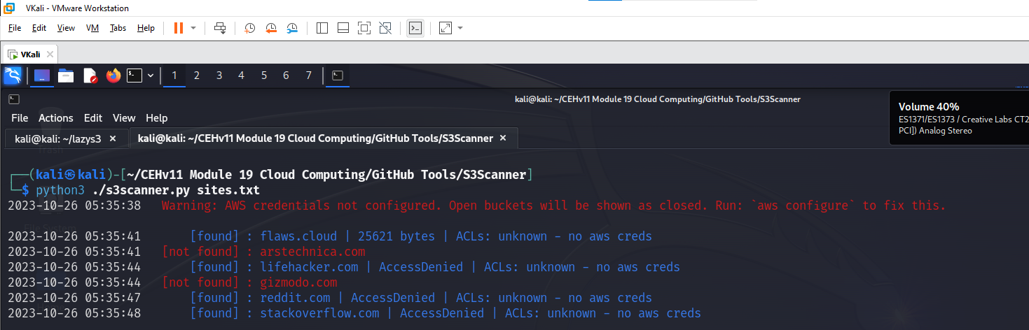

**2. Exploit S3 Buckets**

2.1 Exploit Open S3 Buckets using AWS CLI

- Open Parrot

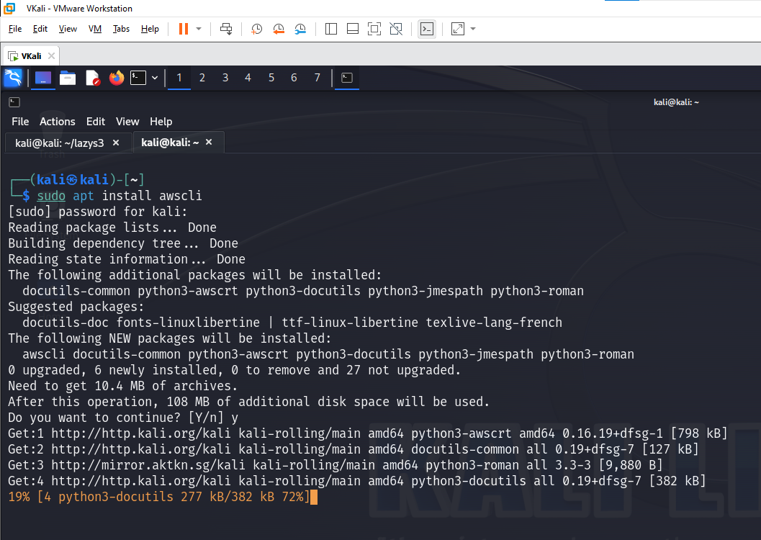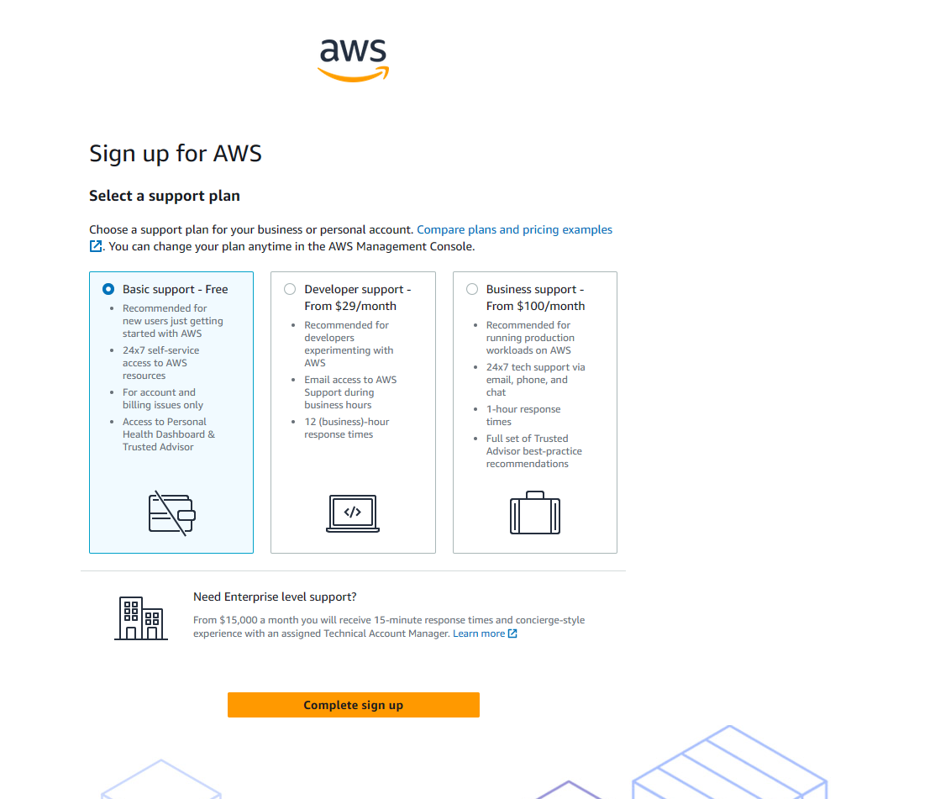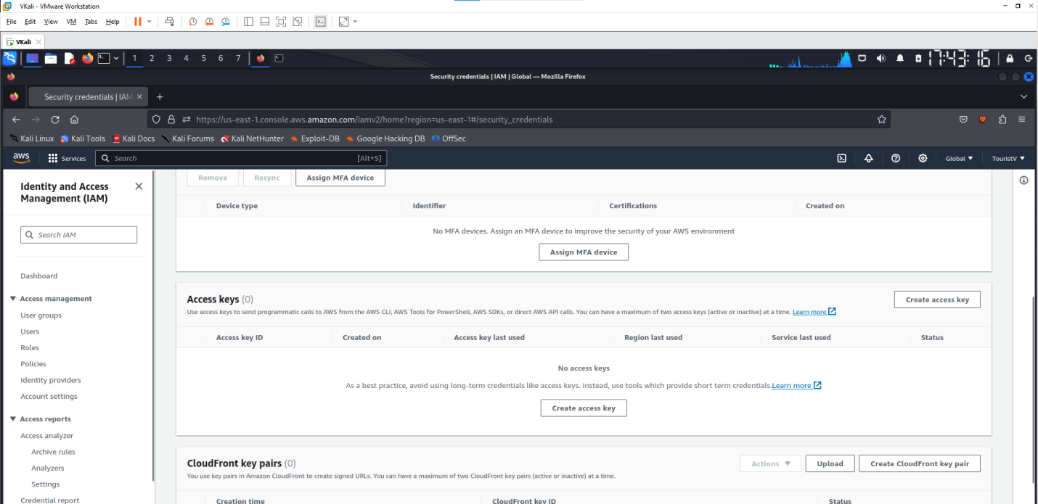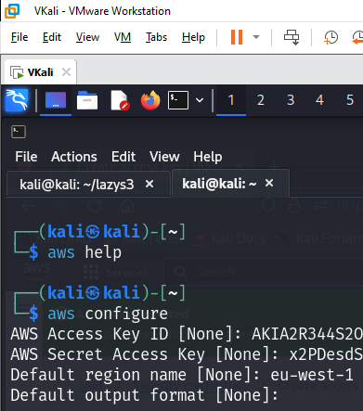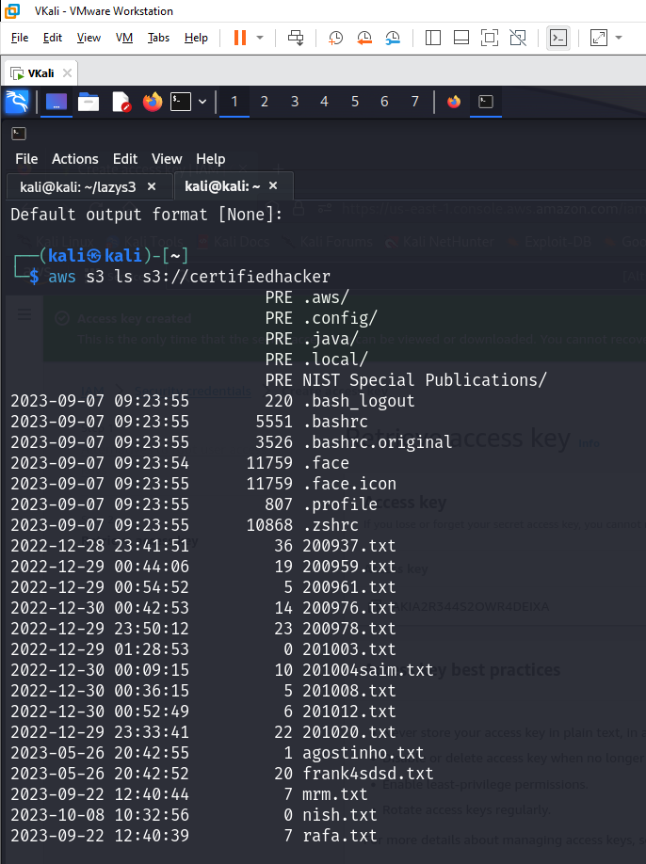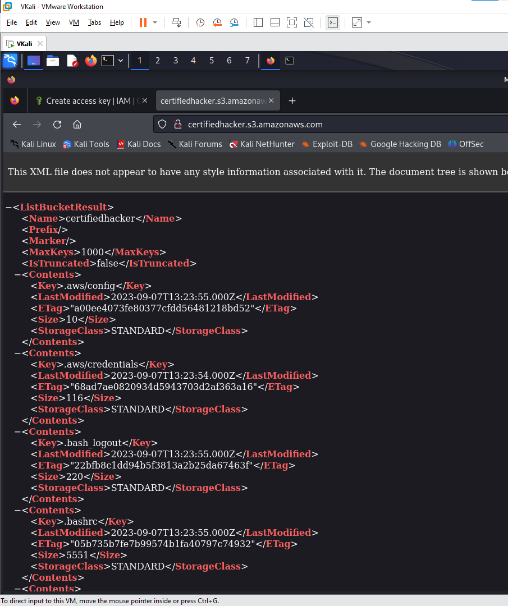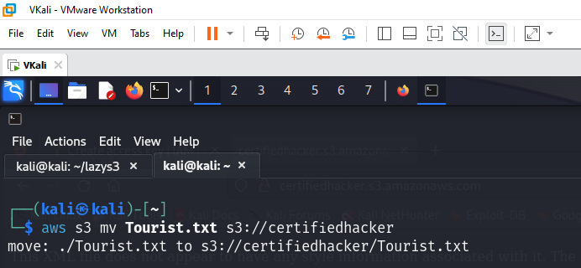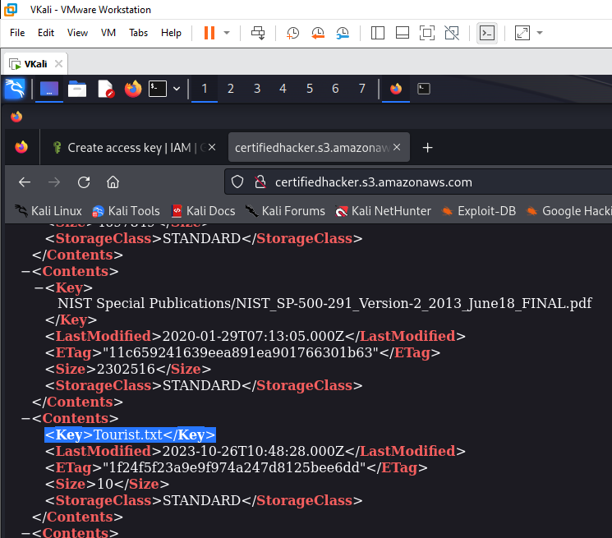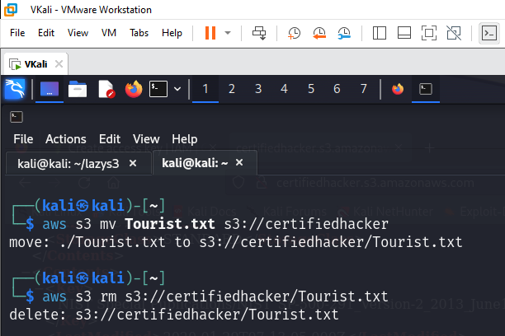

**3. Perform Privilege Escalation to Gain Higher Privileges**

3.1 Escalate IAM User Privileges by Exploiting Misconfigured User Policy

- Open Parrot

