Lab 15: Cloud Computing
Course Name: Ethical Hacking and Offensive Security(HOD401)
Student Name: Nguyễn Trần Vinh – SE160258
Instructor Name: Mai Hoàng Đỉnh
Lab Due Date: 1/11/2023

1. Perform S3 Bucket Enumeration using Various S3 Bucket Enumeration Tools
1.1 Enumerate S3 Buckets using lazys3
- Open Parrot
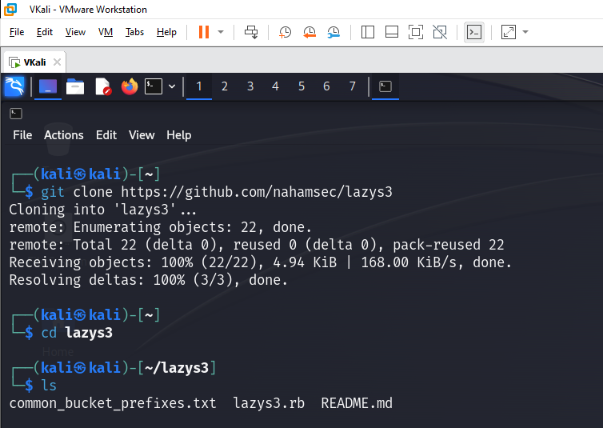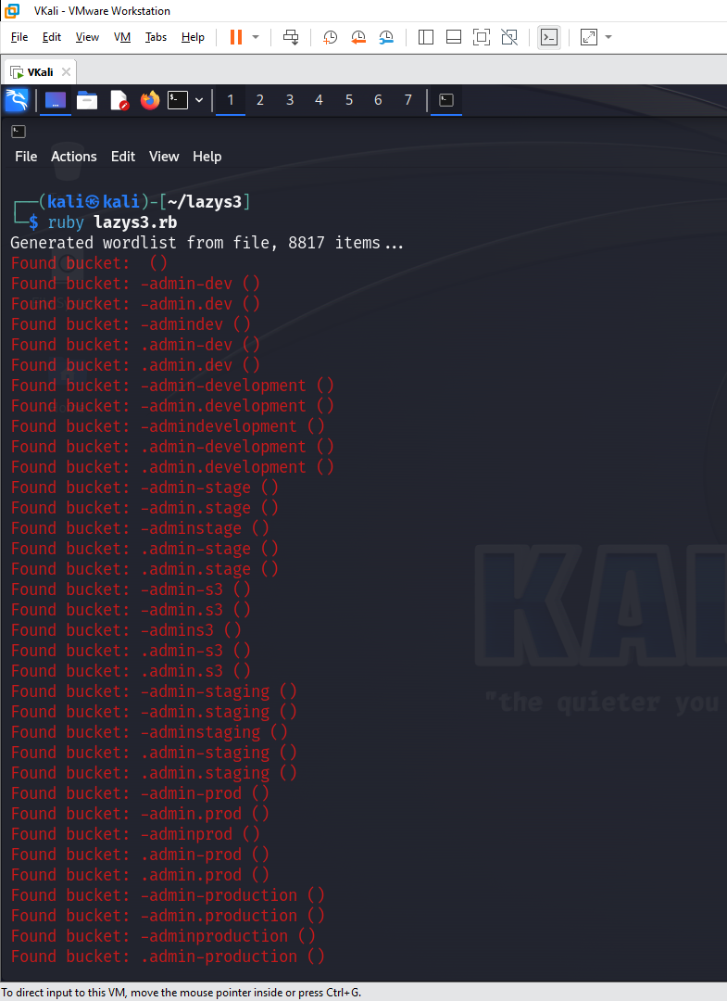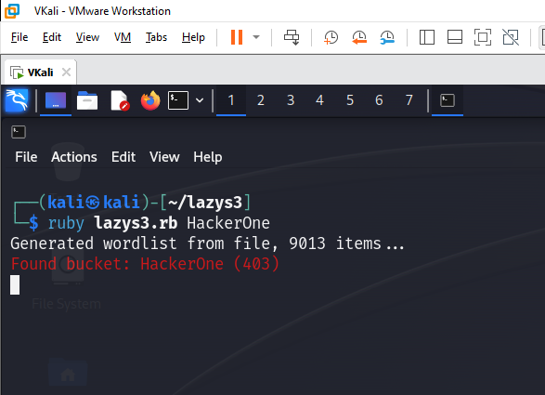

1.2 Enumerate S3 Buckets using S3Scanner
- Open Parrot
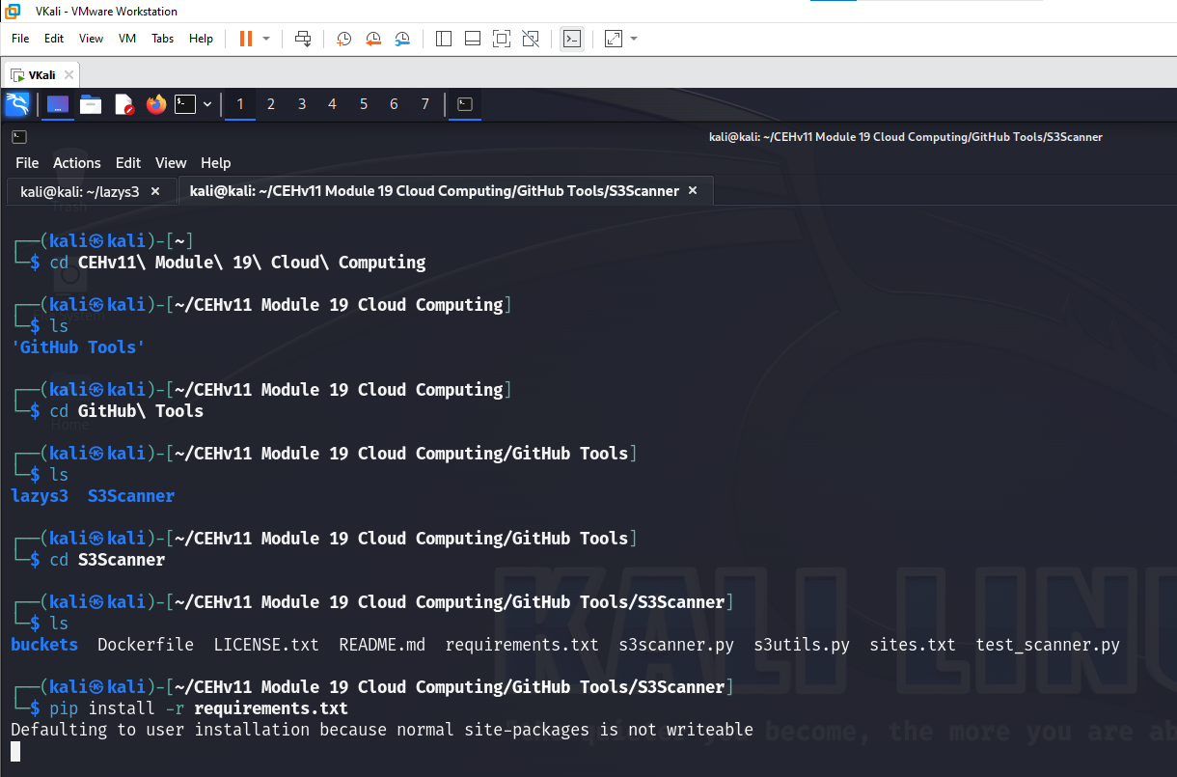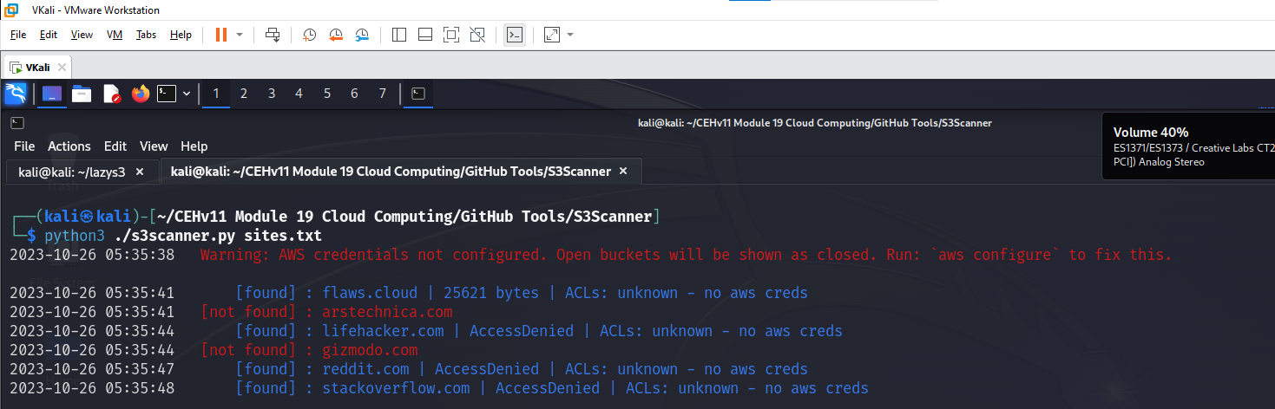

2. Exploit S3 Buckets
2.1 Exploit Open S3 Buckets using AWS CLI
- Open Parrot
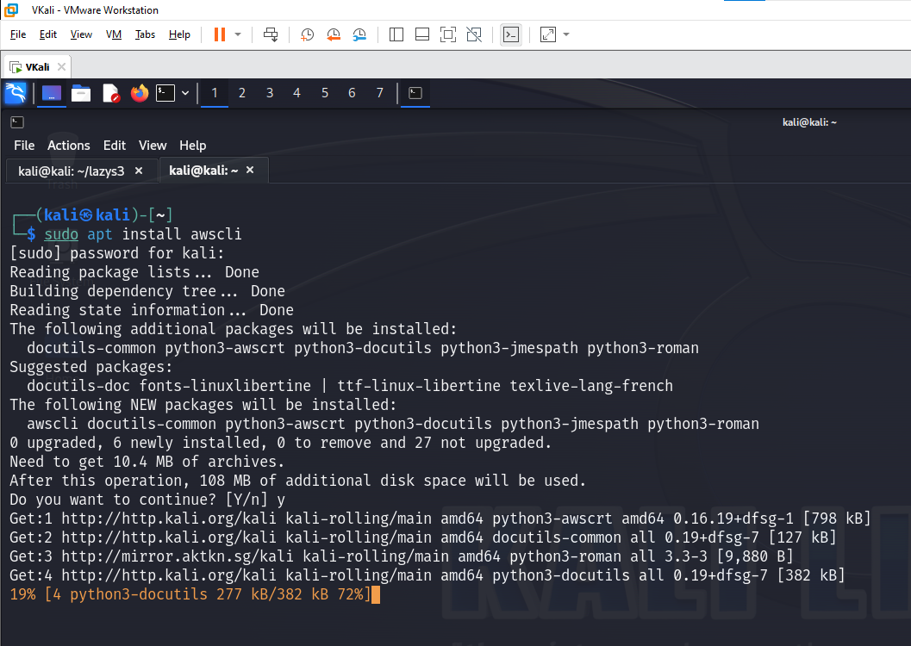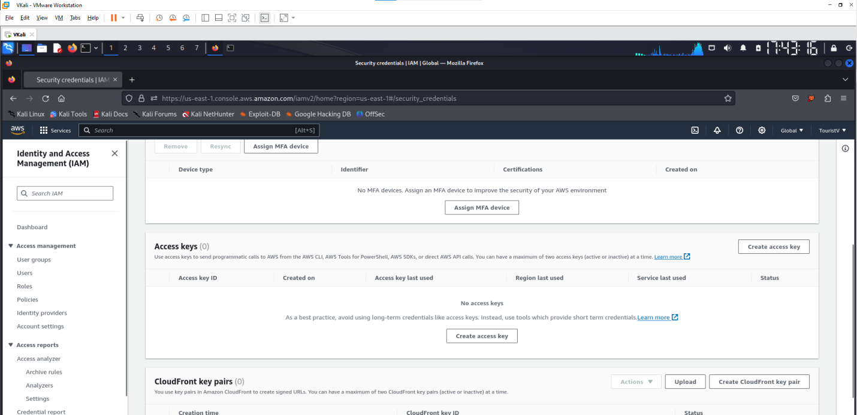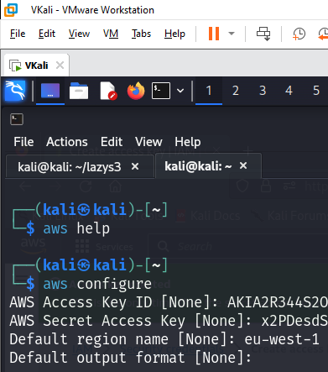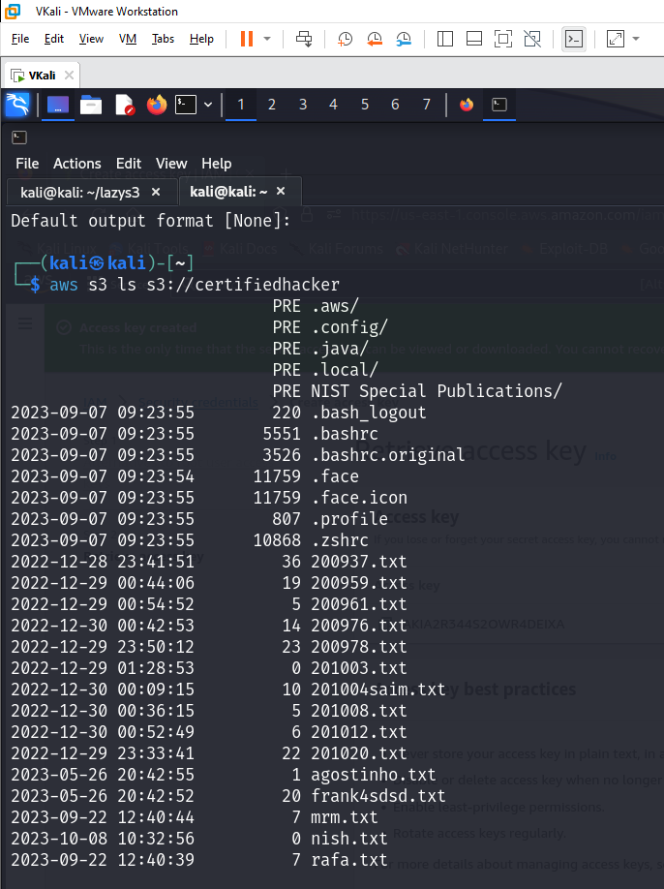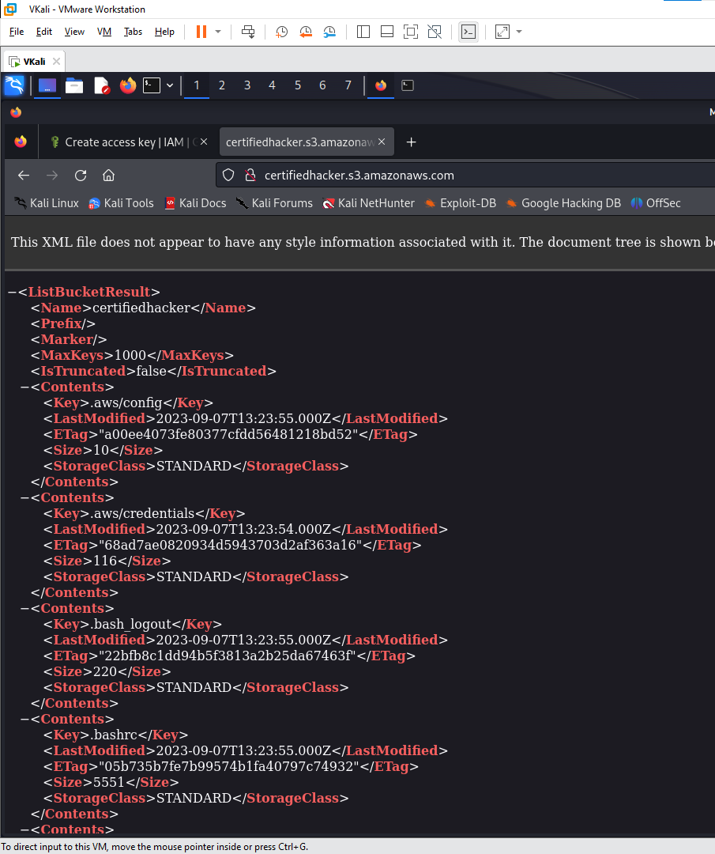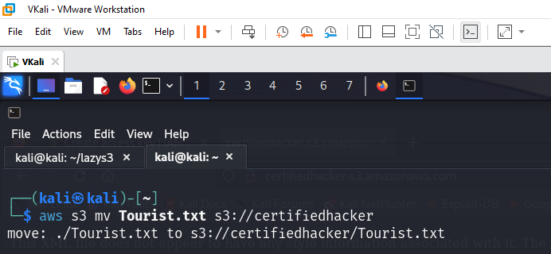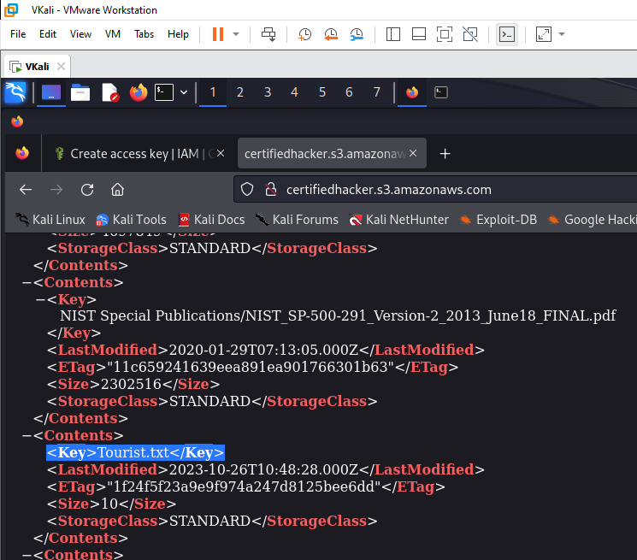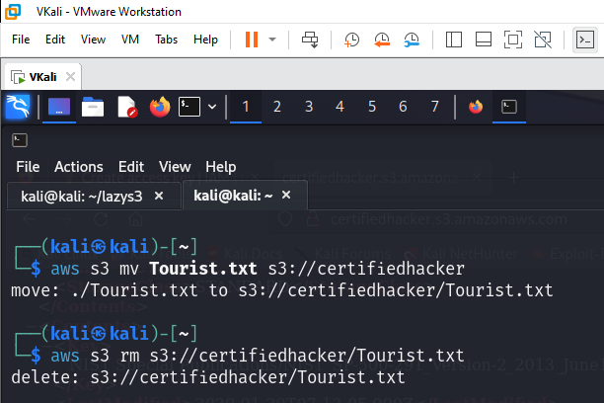

3. Perform Privilege Escalation to Gain Higher Privileges
3.1 Escalate IAM User Privileges by Exploiting Misconfigured User Policy
- Open Parrot
