**Quản lý hợp đồng + thông tin thanh toán**

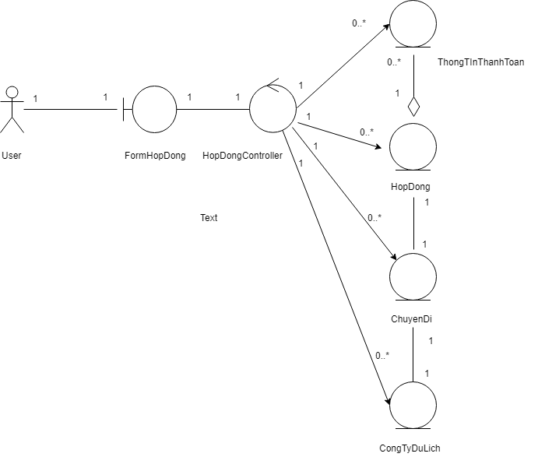

|  |  |  |
| --- | --- | --- |
| **FormHopDong** | | |
| Operation | Tên hàm | Ý nghĩa |
| * LoadDSHopDong() |  |
| * LoadDSThongTinThanhToan() |  |
| * ThemHopDong(): bool |  |
| * SuaHopDong(): bool |  |
| * XoaHopDong() : bool |  |
| * TimKiemHopDong() |  |
| * ThemTTThanhToan(): bool |  |
| * SuaTTThanhToan(): bool |  |
| * XoaTTThanhToan() : bool |  |

|  |  |  |
| --- | --- | --- |
| **HopDongController** | | |
| Operation | Tên hàm | Ý nghĩa |
| * loadTableHopDong() |  |
| * loadTableThanhToan(maHopDong) |  |
| * loadCombobox() |  |
| * getMaChuyenDi_CogTy(maChuyenDi :String, maCongTy:String) |  |
| * addHopDong():bool |  |
| * deleteHopDong():bool |  |
| * updateHopDong(): bool |  |
| * timHopDong() |  |
| * addThanhToan():bool |  |
| * deleteThanhToan():bool |  |
| * updateThanhToan(): bool |  |
| * tongThanhToan() |  |
| * conNo() |  |

|  |  |  |
| --- | --- | --- |
| **ThanhToan** | | |
| Attribute | Tên thuộc tính | Ý nghĩa |
| * maHopDong: String |  |
| * lanThanhToan: int |  |
| * ngayThanhToan: Date |  |
| * soTien: Float |  |
| Operation | Tên hàm | Ý nghĩa |
| * maxLanThanhToan( maHopDong: String): int |  |
| * themThanhToan(maHopDong:String, lanThanhToan: int, ngayThanhToan: Date, soTien: float):bool |  |
| * xoaThanhToan(maHopDong: String, lanThanhToan int):bool |  |
| * suaThanhToan(maHopDong: String, lanThanhToan: int, ngayThanhToan: Date, soTien: float): bool |  |
| * get(),set() |  |

|  |  |  |
| --- | --- | --- |
| **HopDong** | | |
| Attribute | Tên thuộc tính | Ý nghĩa |
| * maHopDong: String |  |
| * maChuyenDi: String |  |
| * maCongTy: String |  |
| * triGia: Float |  |
| * trangThai: String |  |
| * ngayKy: Date |  |
| Operation | Tên hàm | Ý nghĩa |
| * get(),set() |  |
| * getlistHopDong(): |  |
| * ObservableList<HopDong>   getlistThanhToan(): ObservableList<ThanhToan> |  |
| * themHopDong( maHopDong: String, maChuyenDi: String, maCongTy: String, triGia: float, ngayKy: Date): bool |  |
| * TongTienThanhToan(maHopDong: String): float |  |
| * getTriGiaHD(maHopDong: String): float |  |
| * MaxMaHopDong(): int |  |
| * SuaHopDong( maHopDong: String, maChuyenDi: String, maCongTy: String, triGia: float, ngayKy: Date): bool |  |
| * xoaHopDong( maHopDong: String): bool |  |
| * SearchHopDong(maHopDong: String): ObservableList<HopDong> |  |