User Instructions

General Introduction

Welcome to our experiment. Please read the following instructions carefully.

This experiment was designed to study decision-making during a series of games involving money exchange between groups of users. During the games you will try to maximize your earnings. Your earnings depend on your decisions as well as decisions of the other participants.

Game Play

This experiment comprises 4 games that will be played in an arbitrary order (for instance, it might be that game 3 is played before game 1). Each game contains a certain number of rounds where two participants will interact for exchanging money. The number of rounds for each game will remain unknown to users during the experiment. Users can go at their pace at any moment during the game. However, we will wait for all the users at the end of each round before starting the next one.

At the start of each game, participants are given €10 of virtual money to start with. Participants can continue to play even if the balance of their account becomes negative.

The group of participants to this experiment is composed of participants in France and in US.

This game is composed of a random number of rounds. In each round a participant in France will randomly be assigned to a partner in US. The same participants might be assigned to interact in two successive rounds.

All of your responses will be completely anonymous.

Getting Paid

At the end of the experiment, we will collect total money you earn through four games. Each user will receive as a participation fee a voucher of € 10. Additionally, two users of the group that will earn most during the experiment will receive an additional voucher of € 10.

Game 1 (Simple game)

Introduction

At each round each user will be either sender or receiver. The role of users will be randomly assigned at the beginning of each round.

The sender will start and send an amount of money to the receiver. The sending amount cannot exceed €10 in all rounds. The amount received by the receiver will be 3*amount sent by the sender. Then, the receiver will send some amount back. However, in this case, three will not multiply the amount sent.

For example, let us take two users A (sender) and B (receiver). A sends €7 to B. B receives €21 (3*7). He sends back €11. At the end of the round, the total amount will be €14 for A and €20 for B.

It is not possible for the receiver to send more than three times the money sent by the sender. In our previous example, B cannot send back more than €21 to A.

Game Play

During the game, you will interact with other users through an application as below.

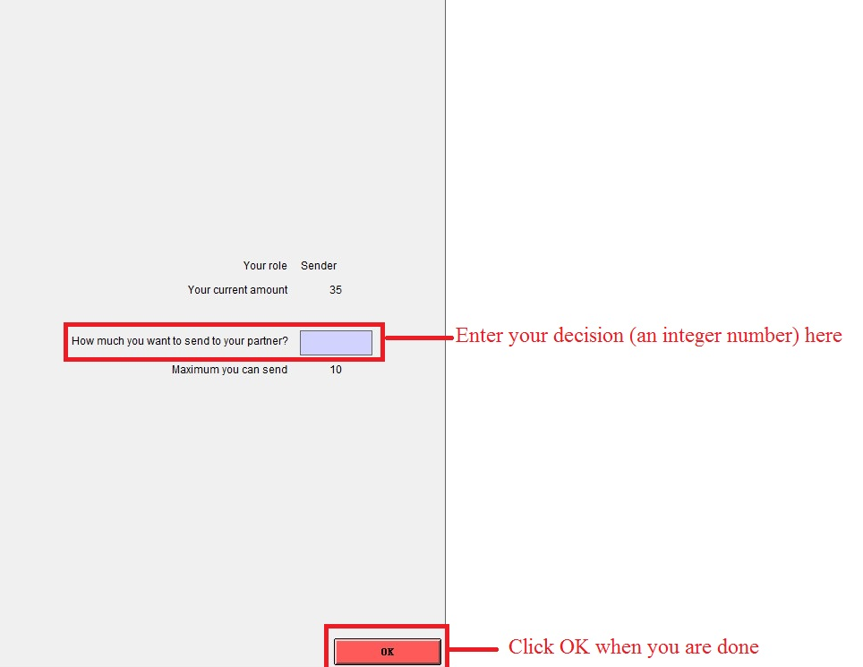

Picture 1. The screenshot when you are a sender

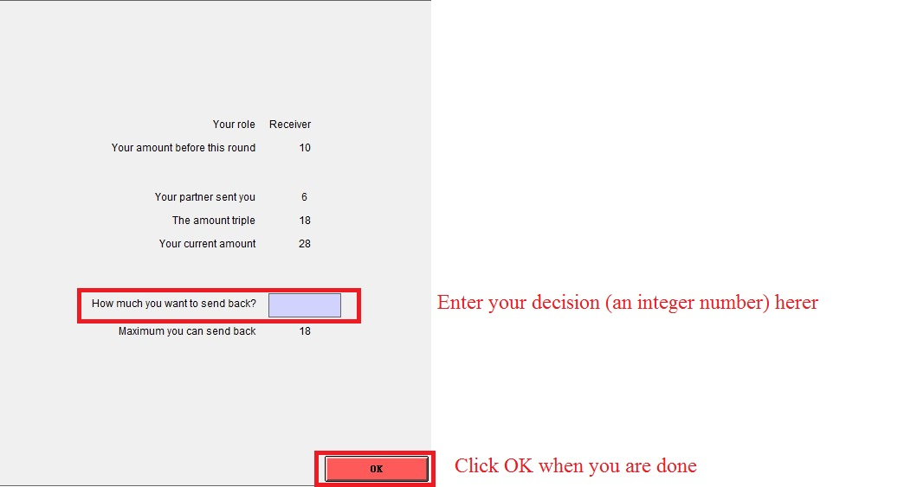

Picture 2. The screenshot when you are a receiver

Game 2 (Partner Information game)

This game is similar to Game 1 (Simple game), with the exception that it introduces the notion of explicit trust among users. Each user X will have assigned different trust scores by each partner Y during the game based on the behavior of X (the amount sent and the amount sent back) during interactions with Y.

Trust score ranges from 0 to 1.0, with higher trust score meaning higher contributions in the past. For example, let us consider three users A, B and C. A can have a trust score 0.7 in B, and a trust score 0.4 in C. B can have a trust score 0.6 in A and 1.0 on C.

Suppose that a round involves a sender X and a receiver Y. Before each round, the sender X will be informed about the trust score of the receiver Y computed based on previous interactions between the two users. At his turn, before sending backs an amount, the receiver Y is informed about the trust score of the sender X.

After each round two trust scores will be computed: the trust score of user X on Y and the trust score of user Y on X. The trust of user Y on X is computed based on the amount initially sent by user X to Y. The trust of user X on Y is computed based on the amount sent back by Y. These two trust scores are updated at each interaction between X and Y: the value of the trust score computed in the current interaction between X and Y is aggregated to trust score computed during previous interactions.

Trust score is equal to 0.5 before any interactions among users.

Please notice that, trust score is just information. The user has full right to decide how much he sends each round.

Game 3 (Agreement game)

This game is similar to Game 1 with the exception that it introduces the notion of contract between two users. The contract specifies that if the sender sends an amount a, then the receiver sends back an amount of b. Before each round, the US partner can propose a contract to the French partner. The French partner can accept or reject the contract.

If the case of rejection, the round will continue as in Game 1.

If the French partner accepts the contract, the round will be based on the contract specified. A contract fee of €2 will be applied for both participants. As in Game1 partners will have randomly assigned the role of sender or receiver. It has to be noticed that, if a user accepts a contract, it does not mean that he/she has to follow the contract. The user has full right to decide how much he/she sends in the current round.

Note that, following the contract means your amount for sending / sending back is equal or greater than the one specified in the contract.

Game 4 (Combined Agreement and Partner Information game)

Users can consider this game as a combination of Game 2 and Game 3.

Before each round, the partner can propose a contract with a user. Also, at each interaction between two users, the system will let the user know the trust score of his partner.

There is a fee of 2 euros for accepting the contract and no penalty exists for rejecting the contract.

If the user follows the contract, his trust score given by his partner in that round will be 1. If the user does not follow the contract, his trust score assigned by other players will be reduced by 10%. If the sender does not follow the contract, the receiver is free to select how much he/she wants to send back, and his/her trust score will be updated as in the case there is no contract.

