User Instructions

General Introduction

Welcome to our experiment. Please read the following instructions carefully.

This experiment was designed to study decision-making during a series of games involving money exchange between groups of users. During the games you will try to maximize your earnings. Your earnings depend on your decisions as well as decisions of the other participants.

Game Play

This experiment comprises three games that will be played in an arbitrary order (for instance, it might be that game 3 is played before game 1). Each game contains a certain number of rounds where two participants will interact for exchanging money. The number of rounds for each game will remain unknown to users during the experiment. Users can go at their pace at any moment during the game. However, we will wait for all the users at the end of each round before starting the next one. At the completion of the three games you will be asked to complete a questionnaire related to the experimented games.

At the start of each game, participants are given €10 of virtual money to start with. Participants can continue to play even if the balance of their account becomes negative.

This game is composed of a random number of rounds. In each round pairs of two participants will be assigned to play with each other. We will discuss details about rules of this pairing for each game.

All of your responses will be completely anonymous.

Getting Paid

At the end of the experiment, we will collect total money you earn throughout the three games. Each user will receive as a participation fee a voucher of € 10. Additionally, one user of the group that will earn most during the experiment will receive an additional voucher of € 10.

Game 1 (Simple game)

Introduction

In each round a participant will randomly be assigned to a different partner. However, the same participants could be assigned to interact in two successive rounds. In each round each user will be either sender or receiver. The role of users will be randomly assigned at the beginning of each round.

The sender will start and send an amount of money to the receiver. The sending amount cannot exceed €10 in all rounds. The amount received by the receiver will be 3*amount sent by the sender. Then, the receiver will send some amount back. However, in this case, three will not multiply the amount sent.

For example, let us take two users A (sender) and B (receiver). A sends €7 to B. B receives €21 (3*7). He sends back €11. At the end of the round, the total amount will be €14 for A and €20 for B.

It is not possible for the receiver to send more than three times the money sent by the sender. In our previous example, B cannot send back more than €21 to A.

Game 2 (Repeated Partner Game)

This game is similar with Game 1, except that in this game, you will play with a partner successively in several rounds. After several rounds you will be assigned to a different partner. The system will inform you in each round whether you play or not with the same partner as in the previous round.

Game 3 (Partner Information Game)

This game is similar to Game 1 (i.e., the partner will be most probably changed after each round), with the exception that it introduces the notion of explicit trust between pairs of users. Each user X will have assigned different trust scores from each partner Y during the game based on the behavior of X (the amount sent and the amount sent back) during interactions with Y.

Trust score ranges from 0 to 1.0, with higher trust score meaning higher contributions in the past. For example, let us consider three users A, B and C. A can have a trust score 0.7 in B, and a trust score 0.4 in C. B can have a trust score 0.6 in A and 1.0 on C.

Suppose that a round involves a sender X and a receiver Y. Before each round, the sender X will be informed about the trust score of the receiver Y computed based on previous interactions between the two users. At his turn, before sending back an amount, the receiver Y is informed about the trust score of the sender X.

After each round two trust scores will be computed: the trust score of user X on Y and the trust score of user Y on X. The trust of user Y on X is computed based on the amount initially sent by user X to Y. The trust of user X on Y is computed based on the amount sent back by Y. These two trust scores are updated at each interaction between X and Y: the value of the trust score computed in the current interaction between X and Y is aggregated to trust score computed during previous interactions.

Trust score is equal to 0.5 before any interactions among users.

Please notice that, trust score is just information. The user has full right to decide how much he sends each round.
Game Play

During the game, you will interact with other users through an application as below. Additional information such as trust score will be added during a corresponding game, but the main screen remains the same.

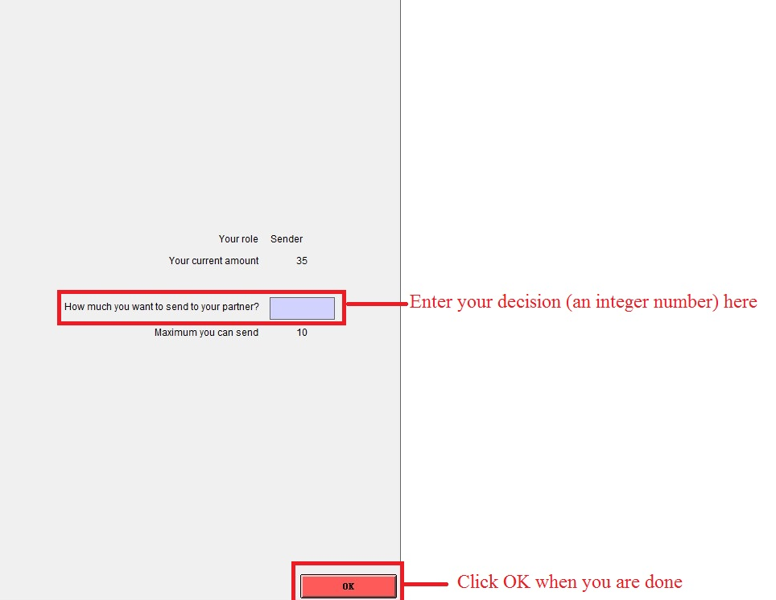

Picture 1. The screenshot when you are a sender

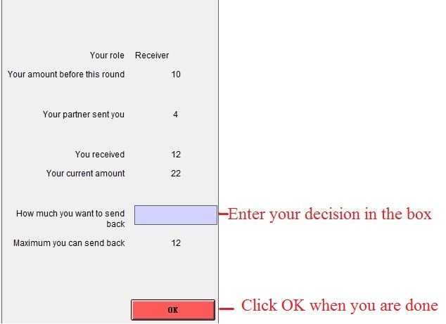

Picture 2. The screenshot when you are a receiver

