User Instructions

General Introduction

Welcome to our experiment. Please read the following instructions carefully.

This experiment was designed to study decision-making during a series of games involving money exchange between groups of users. During the games you will try to maximize your earnings. Your earnings depend on your decisions as well as decisions of the other participants.

Game Play

This experiment comprises four games that will be played in an arbitrary order. Each game contains a certain number of rounds where two participants will interact for exchanging money. The number of rounds for each game will remain unknown to users during the experiment. Users can go at their pace at any moment during the game. However, we will wait for all the users at the end of each round before starting the next one. At the completion of the four games you will be asked to complete a questionnaire related to the experimented games.

In each round of the experiment, two participants will randomly be assigned to play together.

At the start of the first game, participants are given €10 of virtual money to start with. Participants can continue to play even if the balance of their account becomes negative. The amount earned during all four games is accumulated, meaning that the amount you have at the end of a game becomes the initial amount you have at the beginning of a successive game.

Getting Paid

At the end of the experiment, we will sum up the amount you earned throughout the four games. Each user will receive as a participation fee a voucher of € 10. Additionally, one user of the group of participants who earns most during the experiment will receive an additional voucher of € 10.

Game 1 (Simple game)

In each round a participant will randomly be assigned to a different partner. However, the same participants could be assigned to interact in two successive rounds. In each round each user will be randomly assigned as either sender or receiver.

The sender will start and send an amount of money to the receiver. The sending amount cannot exceed €10 in all rounds. The amount received by the receiver will be tripled, i.e. it equals three times the amount sent by the sender. Then, the receiver will send some amount back. However, in this case, the amount sent back is not tripled.

For example, let us take two users A (sender) and B (receiver) that have initially €10 each. A sends €7 to B. B receives €21 (3*7). He sends back €11. At the end of the round, the total amount will be €14 for A and €20 for B.

The receiver cannot send back more than he just received. In our previous example, B cannot send back more than €21 to A.

Game 2 (Partner Identity Game)

This game is similar to Game 1, but during an interaction the system displays you the identity of your partner as well as show your identity to your partner. Identities are represented by means of fixed unique nicknames that are used throughout the game. You cannot know the real identity of your partner, and vice versa.

Game 3 (Partner Information Game)

This game is similar to Game 1, with the exception that it introduces the notion of explicit trust between pairs of users. Each user X will have assigned different trust scores from each partner Y during the game based on the behavior of X (the amount sent and the amount sent back) during interactions with Y. These trust scores are dynamic and they are updated after each interaction among X and Y.

Trust score ranges from 0 to 1.0, with higher trust score meaning higher contributions in the past. For example, let us consider three users A, B and C. A can have a trust score 0.7 in B, and a trust score 0.4 in C. B can have a trust score 0.6 in A and 1.0 on C.

Suppose that a round involves a sender X and a receiver Y. Before each round, the sender X will be informed about the trust score of the receiver Y computed based on previous interactions between the two users. At his turn, before sending back an amount, the receiver Y is informed about the trust score of the sender X.

After each round the trust score of user X on Y and the trust score of user Y on X will be updated. The value of the trust score computed in the current interaction between X and Y during the current round is aggregated to trust score computed during previous interactions. The trust of user Y on X for the current round is computed based on the amount initially sent by user X to Y. The trust of user X on Y for the current round is computed based on the amount sent back by Y.

Trust score is equal to 0.5 before any interactions among users.

Please notice that, trust score is just information. The user has full right to decide how much he sends each round.

Game 4 (Partner Identity and Information Game)

You can consider this game is the combination of game 2 and 3: for each round, the system displays you the identity and trust score of your partner.
Game Screen

During the game, you will interact with other users through an application as below. Additional information such as identity and trust score will be added during a corresponding game, but the main screen remains the same.

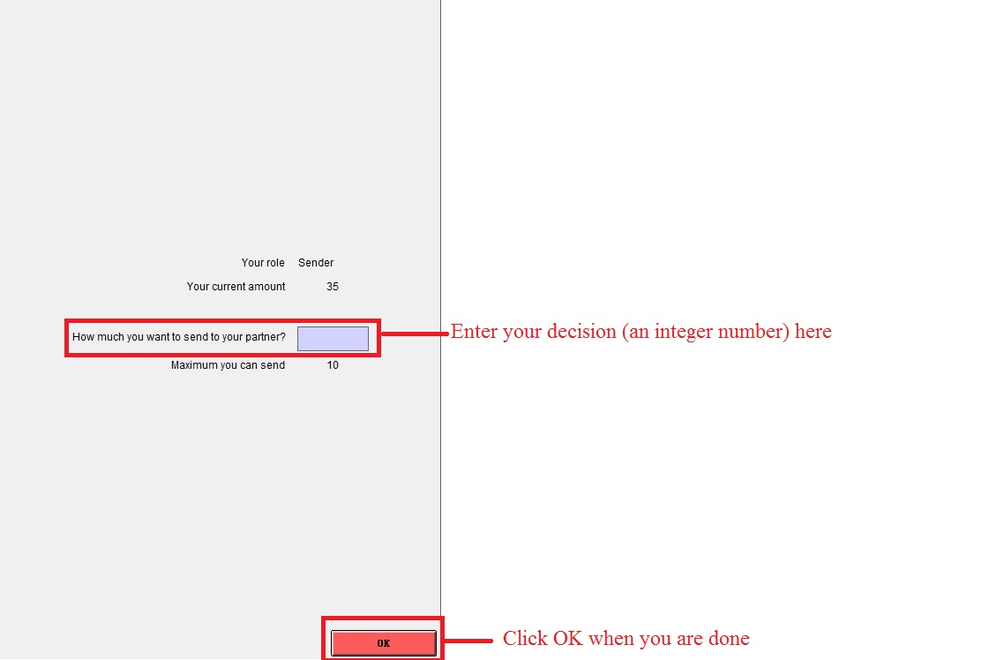

Picture 1. The screenshot when you are a sender

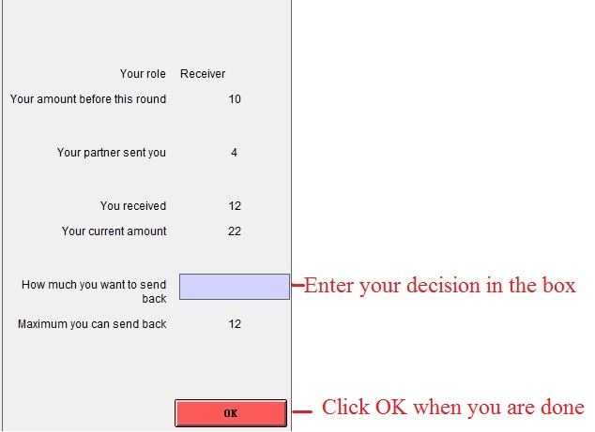

Picture 2. The screenshot when you are a receiver

