Questionnaire

Page 0: Personal information (obligation for zTree)

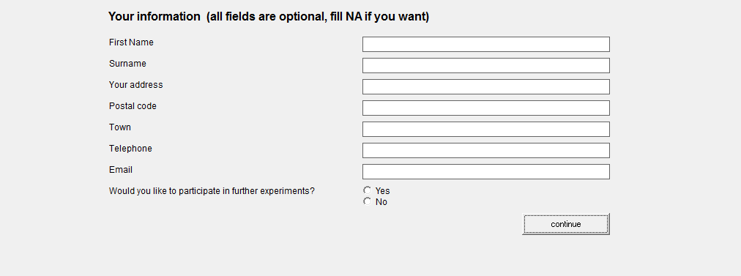

Page 1: Birth year and major in university

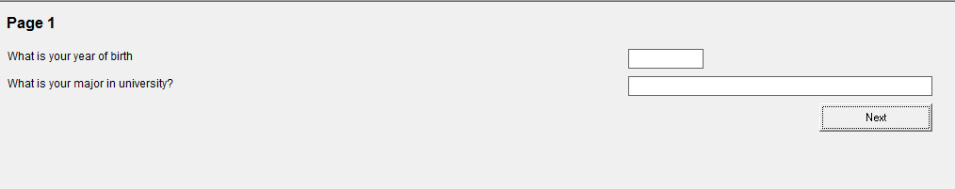

Page 2: Prior expectation

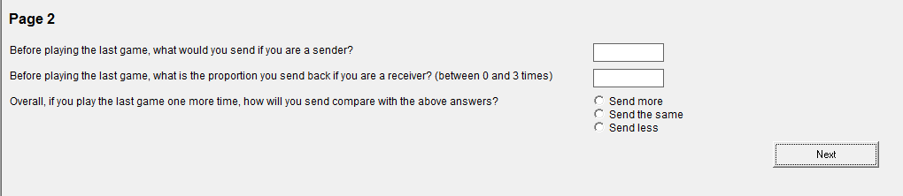

Page 3: Game survey

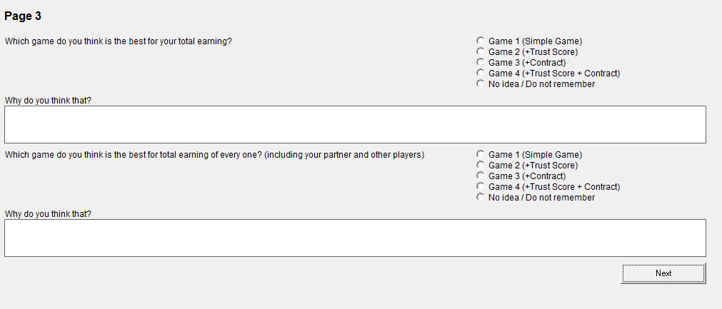

Page 4: Influence of supported information

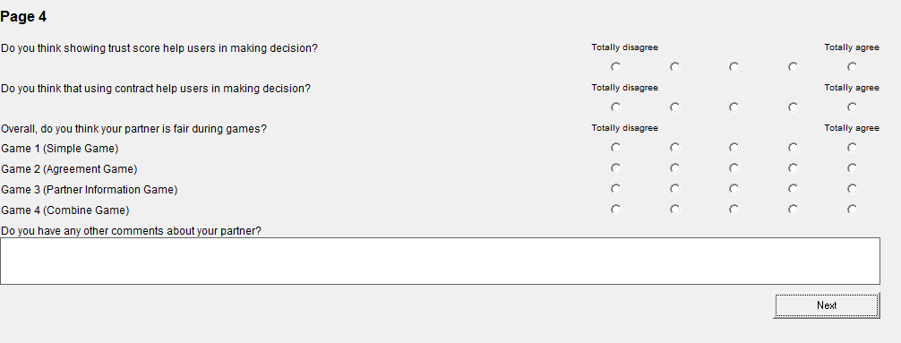

Page 5: Survey about contract

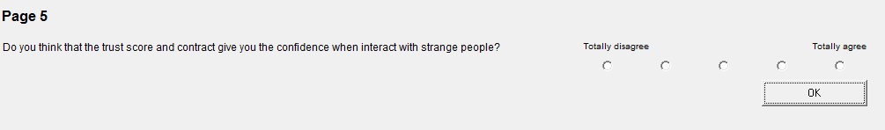
Page 6: Open comment

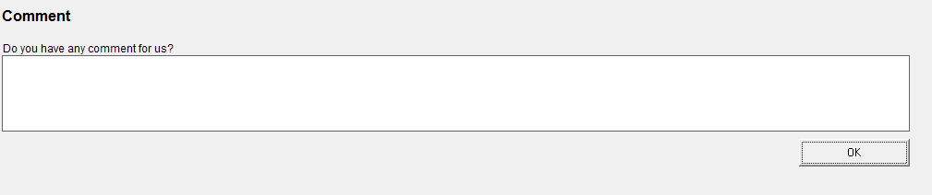

Page 7: Thank you



