1. Rotation Matrix ([rodrigues.pdf (duke.edu)](https://courses.cs.duke.edu/fall13/compsci527/notes/rodrigues.pdf))

Rotation Vector: based on Euler’s theorem, stating that every rotation can be described by an axis of rotation and an angle around it. A compact representation of axis and angle is a three-dimensional rotation vector whose direction is the axis and whose magnitude is the angle in radians. The axis is oriented so that the acute-angle rotation is counterclockwise around it.

Rotation vector: $r = \left[\begin{matrix}θ_{x} & θ_{y} & θ_{z}\end{matrix}\right]$

Estimate Rotation Matrix:

$$θ←norm\left(r\right) \\ r ← \frac{r}{θ} \\ R = cos(θ)I + (1-cos(θ) r r^{T} + sin(θ)\left[\begin{matrix}0 & -r_{z} & r_{y} \\ r_{z} & 0 & -r_{z} \\ -r_{y} & r_{x} & 0\end{matrix}\right]$$

1. How to find Rotation vector and Transform vector

In typical camera pinhole equation

ViewMatrix in OpenCv

$$s\left[\begin{matrix}u \\ v \\ 1\end{matrix}\right] = \left[\begin{matrix}f_{x} & 0 & c_{x} \\ 0 & f_{y} & c_{y} \\ 0 & 0 & 1\end{matrix}\right] \left[\begin{matrix}r_{11} & r_{12} & r_{12} \\ r_{21} & r_{22} & r_{23} \\ r_{31} & r_{32} & r_{33}\end{matrix} \begin{matrix}t_{1} \\ t_{2} \\ t_{3}\end{matrix}\right] \left[\begin{matrix}X \\ Y \\ \begin{matrix}Z \\ 1\end{matrix}\end{matrix}\right]$$

Use Ransac equation to solve Perspective-*n*-Point (PnP) problem ( *solvePnPRansac* function in OpenCV) then estimate rotation vector and tranformation vector

1. ViewMatrix (in OpenGL)
$$\left[\begin{matrix}r_{11} & r_{12} & r_{12} \\ r_{21} & r_{22} & r_{23} \\ \begin{matrix}r_{31} \\ 0\end{matrix} & \begin{matrix}r_{32} \\ 0\end{matrix} & \begin{matrix}r_{33} \\ 0\end{matrix}\end{matrix} \begin{matrix}t_{1} \\ t_{2} \\ \begin{matrix}t_{3} \\ 1\end{matrix}\end{matrix}\right]$$

2. Camera matrix (OpenCV)

$$\left[\begin{matrix}f_{x} & 0 & c_{x} \\ 0 & f_{y} & c_{y} \\ 0 & 0 & 1\end{matrix}\right]$$

Where ( fx,fy) focal length and ( cx,cy) optical centers

1. Distortion coefficients (Opencv)

Distortion coefficients is used to describe the distortion of camera

Distortion coefficients: dc = $\left[\begin{matrix}k_{1} & k_{2} & \begin{matrix}p_{1} & p_{1} & k_{3}\end{matrix}\end{matrix}\right]$

Tangential distortion

$$x_{distorted} = x + \left[2p_{1}xy + p_{2}(r^{2} + 2x^{2})\right]$$

$$y_{distorted} = y + \left[p_{1}(r^{2} + 2y^{2}) + 2p_{2}xy\right]$$

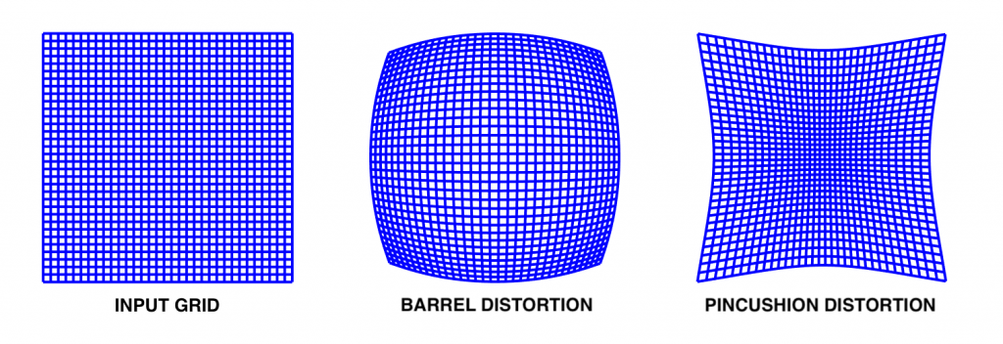

Radial distortion

$$x_{distorted} = x(1 + k_{1}r^{2} + k_{1}r^{4} + k_{3}r^{6}$$

$$y_{distorted} = y(1 + k_{1}r^{2} + k_{1}r^{4} + k_{3}r^{6}$$

1. Transformation matrix

Transformation matrix in OpenGL:

Transformation matrix create by using OpenCV ([Calibrated Cameras in OpenGL without glFrustum ← (ksimek.github.io)](http://ksimek.github.io/2013/06/03/calibrated_cameras_in_opengl/))

* NOTE:
* The camera's frame are not the same in opencv and opengl. Y axis and Z axis are inverted.
* How matrixes are stored is not the same neither. Opengl matrixes are column major order whereas they are row major order in Opencv

1. ViewMatrix calculation
2. Use Aruco Maker
3. Aruco maker

$$s\left[\begin{matrix}u \\ v \\ 1\end{matrix}\right] = \left[\begin{matrix}f_{x} & 0 & c_{x} \\ 0 & f_{y} & c_{y} \\ 0 & 0 & 1\end{matrix}\right] \left[\begin{matrix}r_{11} & r_{12} & r_{12} \\ r_{21} & r_{22} & r_{23} \\ r_{31} & r_{32} & r_{33}\end{matrix} \begin{matrix}t_{1} \\ t_{2} \\ t_{3}\end{matrix}\right] \left[\begin{matrix}X \\ Y \\ \begin{matrix}Z \\ 1\end{matrix}\end{matrix}\right]$$

Tọa độ maker trong môi trường

Tọa độ maker trên ảnh 2D (x,y)

Vì ta xem như maker có tâm ở gốc tọa độ nên maker trong trong môi trường 3D nên

Point1

Point2

Point4

Point3

y

Tọa độ các góc: Point1(-len/2, len/2,0)

Point2(len/2, len/2,0)

x

Point3(len/2, -len/2,0)

Point4(-len/2, -len/2,0)

1. Non maker

$$s\left[\begin{matrix}u \\ v \\ 1\end{matrix}\right] = \left[\begin{matrix}f_{x} & 0 & c_{x} \\ 0 & f_{y} & c_{y} \\ 0 & 0 & 1\end{matrix}\right] \left[\begin{matrix}r_{11} & r_{12} & r_{12} \\ r_{21} & r_{22} & r_{23} \\ r_{31} & r_{32} & r_{33}\end{matrix} \begin{matrix}t_{1} \\ t_{2} \\ t_{3}\end{matrix}\right] \left[\begin{matrix}X \\ Y \\ \begin{matrix}Z \\ 1\end{matrix}\end{matrix}\right]$$

Tọa độ keypoint object 3D

Tọa độ kepoint của obj trên ảnh

Tương tự tọa độ object cũng nằm ở vị trí góc tọa độ

B1: matching keypoint

B2: Tìm sence_corner

Mat H = findHomography(obj, scene, RANSAC); tìm ma trận chuyển đổi H

perspectiveTransform(obj_corners, scene_corners, H); sence_corners = H * obj_corner

B3: xác định obj_corner như dùng aruco