**Business Memo**

***Background***

Given the continuing flatness of the US yield curve, CBC has decided to dramatically shorten the duration of its bond portfolio. Rachel Garner from CBC wants to invest $500 million in short-term US debt for the next 3 years, and is considering GNMA adjustable rate mortgage bonds (ARMs). They are funding this position by borrowing at LIBOR minus a spread of roughly 35 bps. The client wants healthy returns that will cover this borrowing cost. GNMA ARMs are an attractive option, but are exposed to a variety of risks. CBC wants us to help them manage the risks associated with mortgage bonds. We found a mispricing of GNMA ARMs in the market and there is an opportunity to share the profits with the client using their $500 million capital while addressing all of their risk concerns.

***Alternatives***

CBC considers 2 alternatives to getting in a GNMA ARMs deal with us: rolling Eurodollar and rolling treasury rates. These 2 alternatives are not attractive for the following reasons:

* Rolling Treasuries: CBC will only lose money because their borrowing cost is LIBOR - 35bps. The TED spreads for all years are significantly higher than 35bps. They will always be rolling at a rate lower than their borrowing cost. The PV distribution of rolling treasuries and paying their borrowing costs is:

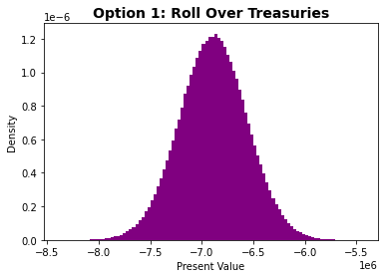

* Rolling Eurodollar: They will only make 35bps a year, since they will be rolling at LIBOR. The PV distribution of rolling treasuries and paying their borrowing costs is:

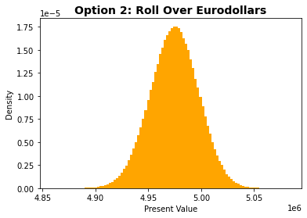

***Client Risk Concerns***

Buying a 3-year GNMA ARMs exposes CBC to 3 different risks, which they want WD to manage:

1. LIBOR risk: The client is exposed to the risk that LIBOR will go up, which will make their borrowing cost to fund the position increase.
2. Prepayment risk: The mortgage holders may prepay their mortgages, making the interest component of the payments less. The principle and prepayment rates are forecasted to be 10% or 40%, depending on the interest rate each year.
3. Repo risk: The client may not get back the $500 million at the end of year 3 to pay back their parent bank.

We can help the client manage these risks, receive a healthier return than their alternative options, and take a cut of the profits for ourselves with the below term structures.

***Deal Terms***

We will engage with the client in a standard three-year GNMA swap. CBC would pay us $500 million in exchange for a series of floating payments above their borrowing cost from year 1 to year 3, and a lump sum payment of $500 million at the end of year 3 to repay their parent bank. We will pay CBC the LIBOR at the end of each year plus a spread of 5bps. This is 5bps above the return from rolling Eurodollar, which completely hedges risk (1) and risk (3), and on top of that, hedges default risk since GNMA ARMs are insured against default.

In exchange for those payments, we will take over all payments made by the GNMA ARMs. This means that all the prepayment risks are passed from them to us, which hedges risk (2) for the client. We will have to hedge these risks ourselves.

According to our analysis, 5bps is a fair premium to give the client because it gives us a good enough 95% VaR (discussed below), while still giving the client a healthy spread.

From year 4 to year 9, WD will continue to receive the cash flows of the GNMA ARMs (principal, interest, and prepayments). At the end of year 10, WD will receive the remaining balance of the GNMA ARMs and interest. This number varies depending on the prepayment rates. The cash flows for both CBC and WD are: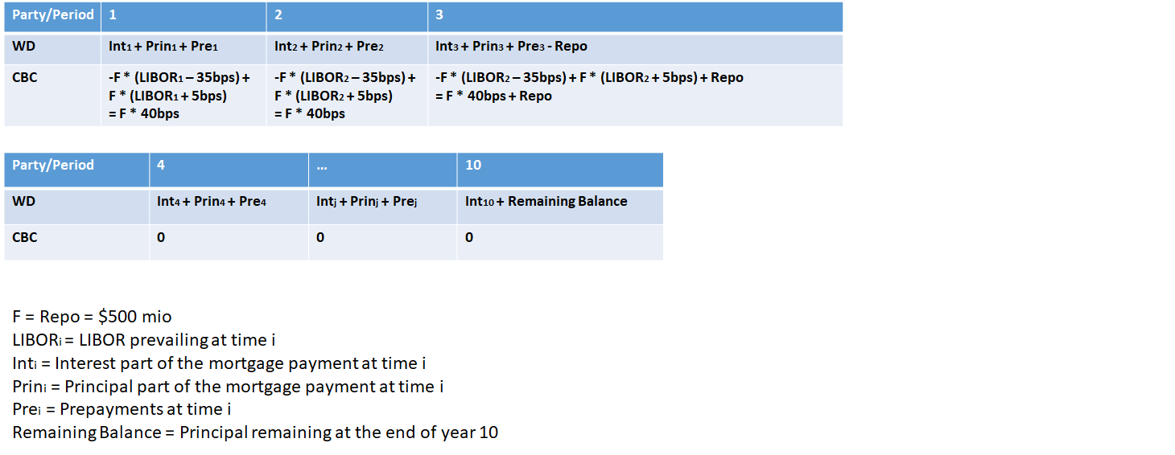

***Modeling***

* Data: We use the current (provided) treasury rate, TED spread, treasury volatility, and TED spread volatility term structure to model the payments.
* Simulations: We did 1,000,000 Monte Carlo simulations for the treasury rate and TED spread. Assuming correlation = 0.1 for the dW terms, we use the Hull-White interest rates model to model the treasury rate paths and the TED spread paths. The Hull-White model variation that we use is:



We calibrate θt by minimizing the squared difference between the empirical and market discount factors using an initial θ guess of 0.03 and mean reversion rate α of 0.1. The calibrated θ for each period is:



We use the same process for the calibration of the θt term for the TED spread paths with the mean reversion rate of 1.8 and initial TED spread guess of 0.03. The calibrated theta is:



We decided to use the Hull-White model over the Black-Derman-Toy model because of our familiarity with the model and its generality/popularity.

* Rates Calculations: We created a matrix for each of the rates calculated where each row is one path, and each column is one period. The rates needed to be calculated are LIBOR, GNMA rate, and Prepayment rate.
  + LIBOR: calibrated and simulated CMT rate plus the TED spread.
  + GNMA rate: CMT rate plus teaser rate and depending on each path, seasoned rate subjected to a periodic and lifetime cap.
  + Prepayment rate: 10% or 40% depending on whether it financially makes sense to prepay in each period in each path. It financially makes sense to prepay if the spread between the GNMA rate and CMT rate plus teaser is higher than the threshold of 40bps (bank’s charge of closing costs).
* Cash Flows Calculations: Given these rates and incorporating the service fee of 20bps, we can calculate the cash flows of each path. Some paths will have a majority of cash flows happening at the earlier periods because of prepayments of 40%, while others have no 40% prepayments, and the payment at year 10 will be much larger. The payments for different paths can look like:

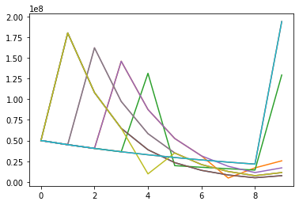

***Valuations***

We did valuations for the 3 options the client has, including the mean, 95% VaR, and 99% VaR.

|  |  |  |  |
| --- | --- | --- | --- |
| Option/Value ($ mil) | Mean | 95% VaR | 99% VaR |
| Rolling CMT | -6.889 (0.328 SE) | -7.429 | -7.655 |
| Rolling Eurodollar | 4.974 (0.023 SE) | 4.937 | 4.921 |
| GNMA ARMs | 5.634 (0.026 SE) | 5.592 | 5.574 |

In the 5% and 1% worst case scenarios, rolling Eurodollar and entering the standard GNMA ARMs swap still result in a positive PnL, but engaging in a GNMA ARMs with us results in a better return thanks to the 5bps premium offered. The PV distribution for the client under GNMA ARMs is:

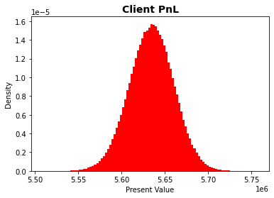

***WD Risk Concerns***

Since we are taking over all the payments from CBC and paying them LIBOR + 6bps, we are exposed to 2 major risks: (1) LIBOR risk and (2) interest rate cap risk. LIBOR can shoot up during the first 3 years and we will have to pay them more than we want, and interest rate could shoot up, which generally would be beneficial for us because of less prepayment and a higher interest payment, but the GNMA rate is capped at the periodic and lifetime cap. The unhedged distribution of our PnL is:

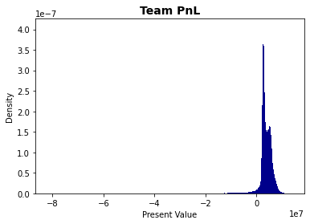

The distribution is very favorable for us, as most of it is positive. However, for the bad scenarios, the loss is significant. The mean, 95% VaR, and 99% VaR are:

|  |  |  |  |
| --- | --- | --- | --- |
| Unhedged WD PnL | Mean | 95% VaR | 99% VaR |
| Value ($ mil) | 3.713 (2.528 SE) | 1.465 | -5.703 |

The standard error is high due to the discretization of prepayment rate, whose probability derives from the interest rate paths. As a result, the 99% VaR is significant, which calls for necessary hedging.

***Hedging Strategies***

We need to hedge (1) LIBOR risk and (2) Interest rate cap risk.

1. LIBOR risk: To hedge libor risk, we will engage in 2 swaps with 2 different market makers. In the first swap, we receive **LIBOR + 5bps** and pay a fair fixed rate of **0.0414**. In the second swap, we receive a fair fixed rate of **0.0325** and pay **CMT**. Under this hedge, we turn our exposure from LIBOR to CMT. The fair fixed rate in both swaps are calculated by minimizing the absolute difference between the payments of the 2 legs to make the PV of the cash flows neutral in year 0.
2. Interest rate cap risk: The first 3 years when we are still engaged in the swap with CBC are the most important years because of the cash outflows that we pay CBC. Moreover, prepayments in the early years are larger due to high remaining balance and thus are more sensitive to interest rates. It is important that we hedge the cap risk in year 2 and year 3. Year 1’s rate is fixed so it’s not necessary to hedge.

We hedge this risk by buying interest rate caps at strike **0.0375** for year 2 and 0.04 for year 3. We choose these strikes because they are 1 standard deviation above the mean rate for year 2 and year 3 respectively.This way, we rarely miss out on any potential periodic gains. Adding the transaction cost of 1 basis point, the fair value for a $100 face cap expiring in year 2 is **$0.362**, and that in year 3 is **$0.568**. These are obtained by discounting the payoffs of the simulated paths. Most paths do not cross the strike, and thus the caps are cheap.

We will buy $1 billion face of these caps. Since they are cheap and we have achieved our hedges, it is reasonable to expose ourselves to some upside potentials from the caps.

The distribution is even more attractive now that it shrinks towards the mean: we give up some upside potential in the mean and the 95% VaR, but the 99% VaR shrinks 5 times. The mean, 95% VaR, and 99% VaR of our hedged PnL are:

|  |  |  |  |
| --- | --- | --- | --- |
| WD PnL | Mean | 95% VaR | 99% VaR |
| Value ($ mil) | 3.700 (2.566 SE) | 1.444 | -1.085 |

The distribution of our hedged PnL is:

