**1.How to compare two JSON have the same properties without order?**

let obj1={

    "name":"Person1",

    "Age":5

}

let obj2={

    "Age":5,

    "name":"Person1"

}

 var flag=true;

 if(Object.keys(obj1).length==Object.keys(obj2).length){

    for(keys in obj1){

        if(obj1.keys==obj2.keys){

        continue;

    }else{

        flag=false;

        break;

    }

    }

 }

else{

    flag=false;

}

console.log(flag)

Output=true

**2. Use the rest countries’ API URL-> https://restcountries.com/v3.1/all and display all the countries flag in the console.**

|  |
| --- |
| var request=new XMLHttpRequest()          request.open('GET','https://restcountries.com/v3.1/all')          request.send()          request.onload=function(){              var data=JSON.parse(request.response)              console.log(data)        //for in loop;              for( i in data){              console.log(data[i].flag)          }      // for of loop;        for(element of data){          console.log(element.flag)        }      // for loop;      for(let i=0;i<data.length;i++){          console.log(data[i].flag)      }      output;        } |

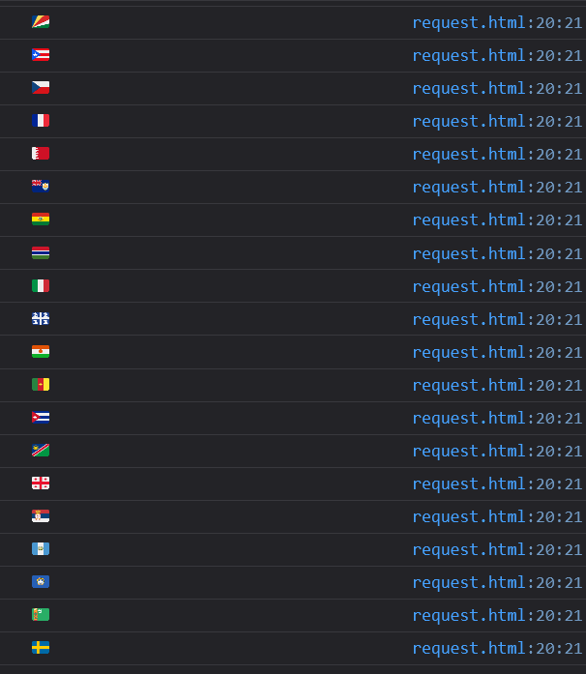

**3. use the same rest countries API and print all the countries name, region ,sub region and population.**

|  |
| --- |
| var request=new XMLHttpRequest()          request.open('GET','https://restcountries.com/v3.1/all')          request.send()          request.onload=function(){              var data=JSON.parse(request.response)              // console.log(data)        //for in loop;              for( i in data){              console.log(data[i].name.common)          }      // for of loop;        for(element of data){          console.log(element.region)        }      // for loop;      for(let i=0;i<data.length;i++){          console.log(data[i].subregion)          console.log(data[i].population)      }      output; |

