HPELs MX – Gen 1 – Coding Java Assessment

1. Database created in MySql. Custom table created.

Spring boot application created with dependencies Spring Web, Spring Boot Dev tool, JPA, MySql, Lombok.

1. Evidence of our POST method.

Evidence of our GET method.

1. Inserted data.

1. Java console screen shot when we do successful insert.

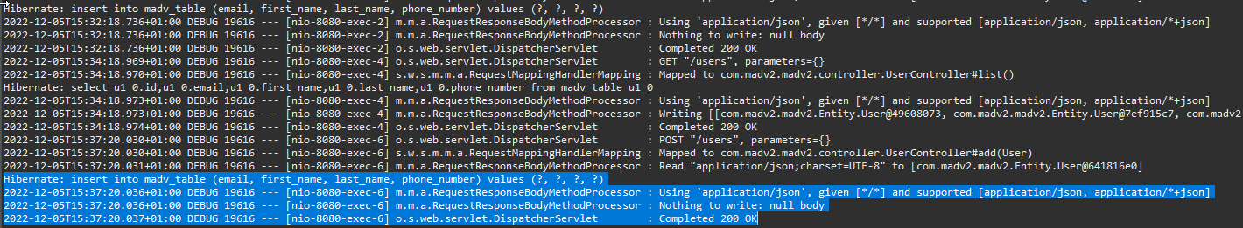

1. Front-end



