**Pulse Width Modulation (PWM)**

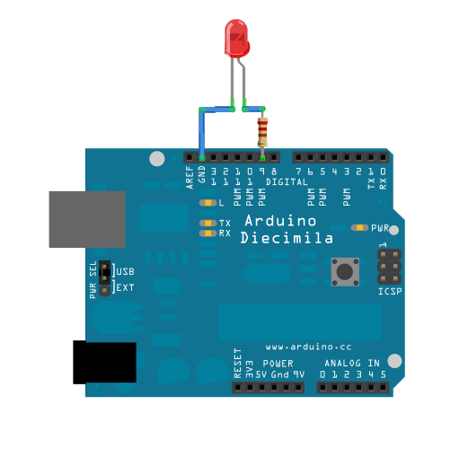

**Pulse Width Modulation (PWM)**

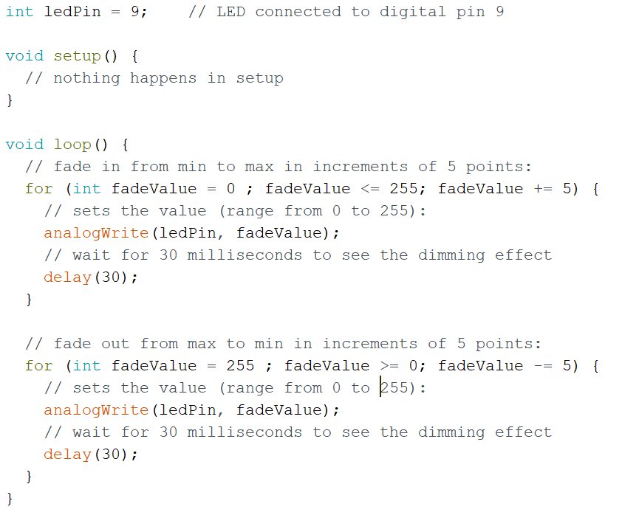

**Pulse Width Modulation (PWM)**



**Pulse Width Modulation (PWM)**



**Pulse Width Modulation (PWM)**



**Pulse Width Modulation (PWM)**



**Pulse Width Modulation (PWM)**



**Pulse Width Modulation (PWM)**



**Pulse Width Modulation (PWM)**



**Pulse Width Modulation (PWM)**



**DC Brushed Motor**

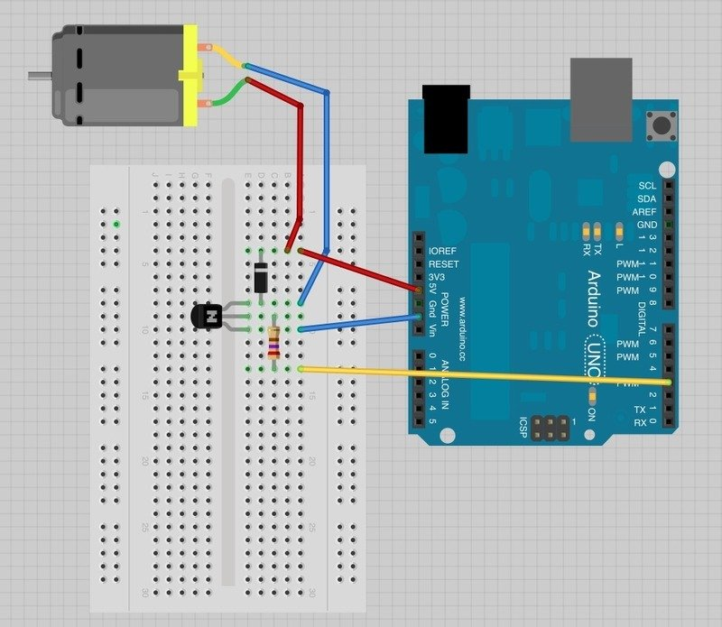

**DC Brushed Motor**

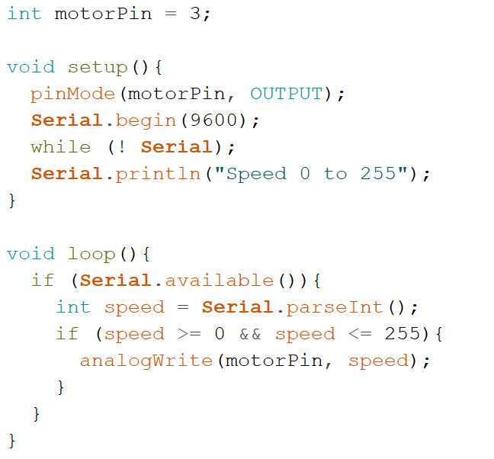

**DC Brushed Motor**



**DC Brushed Motor**



**DC Brushed Motor**



**DC Brushed Motor**



**DC Brushed Motor**



**DC Brushed Motor**



**DC Brushed Motor**



**DC Brushed Motor**

