dados

Autogenerated data summary from dataMaid

2024-12-16 20:12:43.366445

# Data report overview

The dataset examined has the following dimensions:

| Feature | Result |
| --- | --- |
| Number of observations | 61500 |
| Number of variables | 14 |

### Checks performed

The following variable checks were performed, depending on the data type of each variable:

|  | character | factor | labelled | haven labelled | numeric | integer | logical | Date |
| --- | --- | --- | --- | --- | --- | --- | --- | --- |
| Identify miscoded missing values | × | × | × | × | × | × |  | × |
| Identify prefixed and suffixed whitespace | × | × | × | × |  |  |  |  |
| Identify levels with < 6 obs. | × | × | × | × |  |  |  |  |
| Identify case issues | × | × | × | × |  |  |  |  |
| Identify misclassified numeric or integer variables | × | × | × | × |  |  |  |  |
| Identify outliers |  |  |  |  | × | × |  | × |

Please note that all numerical values in the following have been rounded to 2 decimals.

# Summary table

|  | Variable class | # unique values | Missing observations | Any problems? |
| --- | --- | --- | --- | --- |
| X | integer | 61500 | 0.00 % |  |
| ANO_ELEICAO | integer | 5 | 0.00 % |  |
| DT_ELEICAO | character | 5 | 0.00 % |  |
| SG_UF | character | 1 | 0.00 % | × |
| NM_MUNICIPIO | character | 1 | 0.00 % | × |
| NR_SECAO | integer | 153 | 0.00 % |  |
| DS_CARGO | character | 4 | 0.00 % | × |
| NR_VOTAVEL | integer | 655 | 0.00 % | × |
| NM_VOTAVEL | character | 739 | 0.00 % | × |
| QT_VOTOS | integer | 238 | 0.00 % | × |
| NR_LOCAL_VOTACAO | integer | 18 | 0.00 % | × |
| ID | character | 991 | 0.00 % | × |
| NR_PARTIDO | integer | 29 | 0.00 % |  |
| DS_SIT_TOT_TURNO | character | 6 | 0.00 % |  |

# Variable list

## X

| Feature | Result |
| --- | --- |
| Variable type | integer |
| Number of missing obs. | 0 (0 %) |
| Number of unique values | 61500 |
| Median | 30750.5 |
| 1st and 3rd quartiles | 15375.75; 46125.25 |
| Min. and max. | 1; 61500 |

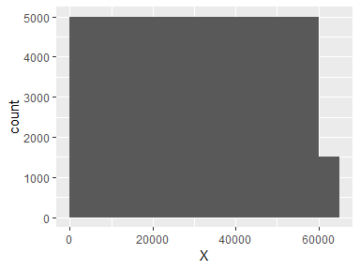

## ANO_ELEICAO

* Note that this variable is treated as a factor variable below, as it only takes a few unique values.

| Feature | Result |
| --- | --- |
| Variable type | integer |
| Number of missing obs. | 0 (0 %) |
| Number of unique values | 5 |
| Mode | “2020” |
| Reference category | 2004 |

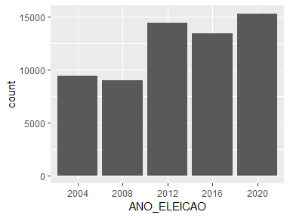

## DT_ELEICAO

| Feature | Result |
| --- | --- |
| Variable type | character |
| Number of missing obs. | 0 (0 %) |
| Number of unique values | 5 |
| Mode | “15/11/2020” |

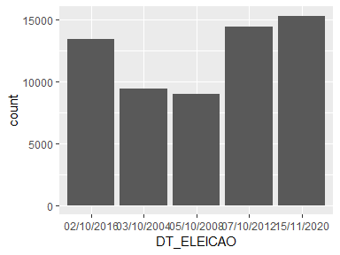

## SG_UF

* The variable only takes one (non-missing) value: "SP". The variable contains 0 % missing observations.

## NM_MUNICIPIO

* The variable only takes one (non-missing) value: "JABOTICABAL". The variable contains 0 % missing observations.

## NR_SECAO

| Feature | Result |
| --- | --- |
| Variable type | integer |
| Number of missing obs. | 0 (0 %) |
| Number of unique values | 153 |
| Median | 76 |
| 1st and 3rd quartiles | 32; 119 |
| Min. and max. | 1; 184 |

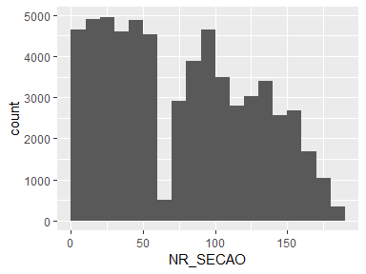

## DS_CARGO

| Feature | Result |
| --- | --- |
| Variable type | character |
| Number of missing obs. | 0 (0 %) |
| Number of unique values | 4 |
| Mode | “Vereador” |

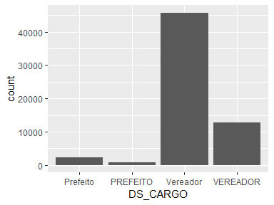

* Note that there might be case problems with the following levels: "Prefeito", "PREFEITO", "Vereador", "VEREADOR".

## NR_VOTAVEL

| Feature | Result |
| --- | --- |
| Variable type | integer |
| Number of missing obs. | 0 (0 %) |
| Number of unique values | 655 |
| Median | 22500 |
| 1st and 3rd quartiles | 14444; 40023 |
| Min. and max. | 11; 90999 |

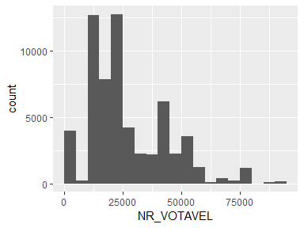

* Note that the following possible outlier values were detected: "11", "12", "13", "15", "17", …, "40", "43", "45", "51", "55" (3 values omitted).

## NM_VOTAVEL

| Feature | Result |
| --- | --- |
| Variable type | character |
| Number of missing obs. | 0 (0 %) |
| Number of unique values | 739 |
| Mode | “CARMO JORGE MARQUES REINO” |

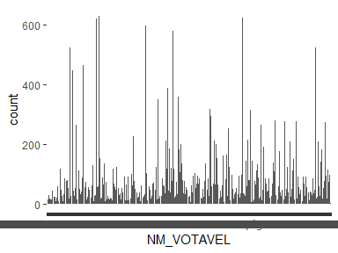

* Note that the following levels have at most five observations: "ELIZABETH MARTINS VALDASTRI SANTELLO", "JULIANA ROCHA", "MARIA ANTONIA MIGUEL DA SILVA", "MARIA ASCENCAO BEDIN CAMARGO", "PATRICIA BROCHIERI RIBEIRO", "REGINA CELIA DA SILVA ALMEIDA", "ZENIRA RODRIGUES DE SOUZA", "ZOE ROSA SILVA DE SOUZA".
* Note that there might be case problems with the following levels: "Partido da Social Democracia Brasileira", "PARTIDO DA SOCIAL DEMOCRACIA BRASILEIRA", "Partido Socialista Brasileiro", "PARTIDO SOCIALISTA BRASILEIRO".

## QT_VOTOS

| Feature | Result |
| --- | --- |
| Variable type | integer |
| Number of missing obs. | 0 (0 %) |
| Number of unique values | 238 |
| Median | 2 |
| 1st and 3rd quartiles | 1; 4 |
| Min. and max. | 1; 278 |

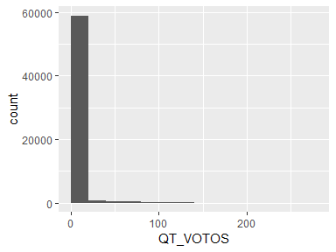

* Note that the following possible outlier values were detected: "25", "26", "27", "28", "29", …, "253", "254", "255", "265", "278" (204 values omitted).

## NR_LOCAL_VOTACAO

| Feature | Result |
| --- | --- |
| Variable type | integer |
| Number of missing obs. | 0 (0 %) |
| Number of unique values | 18 |
| Median | 1074 |
| 1st and 3rd quartiles | 1023; 1104 |
| Min. and max. | 1015; 1996 |

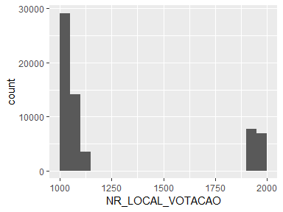

* Note that the following possible outlier values were detected: "1015".

## ID

| Feature | Result |
| --- | --- |
| Variable type | character |
| Number of missing obs. | 0 (0 %) |
| Number of unique values | 991 |
| Mode | “2016_23” |

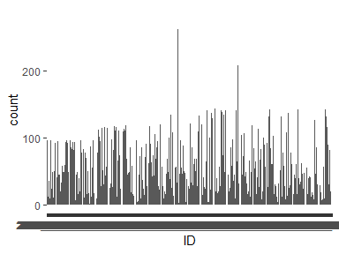

* Note that the following levels have at most five observations: "2004_40230", "2012_12112", "2012_12300", "2012_12350", "2012_40222", …, "2016_19001", "2016_19034", "2020_18148", "2020_20200", "2020_36999" (2 values omitted).

## NR_PARTIDO

| Feature | Result |
| --- | --- |
| Variable type | integer |
| Number of missing obs. | 0 (0 %) |
| Number of unique values | 29 |
| Median | 23 |
| 1st and 3rd quartiles | 15; 40 |
| Min. and max. | 10; 90 |

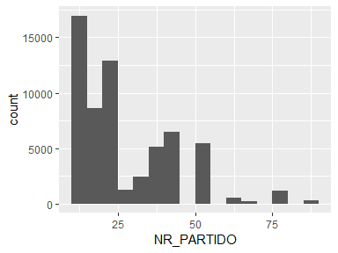

## DS_SIT_TOT_TURNO

| Feature | Result |
| --- | --- |
| Variable type | character |
| Number of missing obs. | 0 (0 %) |
| Number of unique values | 6 |
| Mode | “SUPLENTE” |

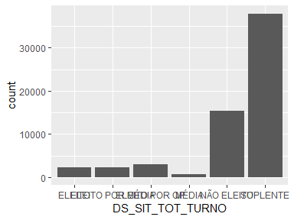

Report generation information:

* Created by: Could not determine from system (username: user).
* Report creation time: seg dez 16 2024 20:12:49
* Report was run from directory: C:/Users/user/Documents
* dataMaid v1.4.1 [Pkg: 2021-10-08 from CRAN (R 4.4.2)]
* R version 4.4.1 (2024-06-14 ucrt).
* Platform: x86_64-w64-mingw32/x64(America/Sao_Paulo).
* Function call: dataMaid::makeDataReport(data = dados)