create database pet_shop;

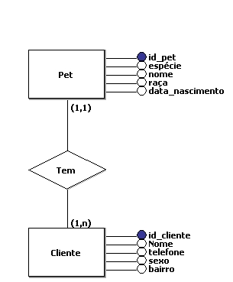

use pet_shop;

create table cliente (

id_cliente int primary key auto_increment,

nome varchar (40),

telefone int (11),

sexo varchar (9),

bairro varchar (40)

) auto_increment = 0;

create table pet (

id_pet int primary key auto_increment,

especie varchar (20),

nome varchar (40),

raca varchar (40),

data_nascimento date,

fk_cliente int,

foreign key (fk_cliente) references cliente(id_cliente)

) auto_increment = 101 ;

insert into cliente values

(null, 'Victor heinrick',1193747401, 'Masculino', 'jd. Ibirapuera'),

(null, 'Victor Gabriel', 1193521426, 'Masculino', 'jd. Vergueiro'),

(null, 'Ana Silva', 1195389204, 'Feminino', 'jd. dos Reis'),

(null, 'Thalita Silva', 1196482057, 'Feminino', 'jd. Ibirapuera'),

(null, 'Matheus Ismael', 1191230284, 'Masculino', 'jd. Ibirapuera'),

(null, 'Geovanna Oliveira', 1197868981, 'Feminino', 'Angela'),

(null, 'Gabriel Oliveria', 1193443729, 'Masculino', 'jd. dos Reis');

insert into pet values

(null, 'Cachorro', 'Verão', 'Husky Siberiano', '2010-12-13', 2),

(null, 'Cachorro', 'Fantasma', 'Husky Siberiano', '2010-06-24', 1),

(null, 'Gato', 'Lady', 'Persa', '2014-01-29', 2),

(null, 'Cagado', 'Flash', 'Cagado', '2006-10-10', 3),

(null, 'Cachorro', 'Inverno', 'Husky Siberiano', '2010-12-13', 4),

(null, 'Cachorro', 'Nymeria', 'Husky Siberiano', '2010-12-13', 5),

(null, 'Ave', 'Cocorico', 'Cacatua', '2018-03-22', 3),

(null, 'Gato', 'Bichano', 'Siames', '2016-12-13', 6),

(null, 'Ave', 'Piu-piu', 'Canario', '2018-10-02', 7),

(null, 'Cachorro', 'Rex', 'Vira-Lata', '2017-04-18', 7);

select * from cliente;

select * from pet;

alter table cliente modify nome varchar (50);

select * from pet where especie like 'cachorro';

select nome, data_nascimento from pet;

select * from pet order by nome asc;

select * from cliente order by bairro desc;

select * from pet where nome like 'v%';

select * from cliente where nome like '%Oliveira';

update cliente set telefone = 1194752387 where id_cliente = 7;

select * from cliente;

select * from cliente as clt, pet as pt where clt.id_cliente = pt.fk_cliente;

select * from cliente where sexo like 'Feminino';

alter table cliente drop column sexo;

delete from pet where id_pet = 107;

select * from pet ;

drop table pet;

drop table cliente;