**Linux**

This message is shown once a day. To disable it please create the

/home/vinii/.hushlogin file.

vinii@LAPTOP-V2VRP9UU:~$ cd stepin

-bash: cd: stepin: No such file or directory

vinii@LAPTOP-V2VRP9UU:~$ ls

vinii@LAPTOP-V2VRP9UU:~$ mkdir stepin

vinii@LAPTOP-V2VRP9UU:~$ ls

stepin

vinii@LAPTOP-V2VRP9UU:~$ cd stepin

vinii@LAPTOP-V2VRP9UU:~/stepin$ c

c: command not found

vinii@LAPTOP-V2VRP9UU:~/stepin$ ls

vinii@LAPTOP-V2VRP9UU:~/stepin$ vi sum.c

vinii@LAPTOP-V2VRP9UU:~/stepin$ gcc sum.c && ./a.out

Command 'gcc' not found, but can be installed with:

sudo apt install gcc

vinii@LAPTOP-V2VRP9UU:~/stepin$ sudo apt update

[sudo] password for vinii:

Get:1 http://security.ubuntu.com/ubuntu noble-security InRelease [126 kB]

Hit:2 http://archive.ubuntu.com/ubuntu noble InRelease

Get:3 http://archive.ubuntu.com/ubuntu noble-updates InRelease [126 kB]

Get:4 http://archive.ubuntu.com/ubuntu noble-backports InRelease [126 kB]

Get:5 http://security.ubuntu.com/ubuntu noble-security/main amd64 Packages [1052 kB]

Get:6 http://archive.ubuntu.com/ubuntu noble/universe amd64 Packages [15.0 MB]

Get:7 http://security.ubuntu.com/ubuntu noble-security/main Translation-en [183 kB]

Get:8 http://security.ubuntu.com/ubuntu noble-security/main amd64 Components [21.5 kB]

Get:9 http://security.ubuntu.com/ubuntu noble-security/main amd64 c-n-f Metadata [7068 B]

Get:10 http://security.ubuntu.com/ubuntu noble-security/universe amd64 Packages [879 kB]

Get:11 http://security.ubuntu.com/ubuntu noble-security/universe Translation-en [194 kB]

Get:12 http://archive.ubuntu.com/ubuntu noble/universe Translation-en [5982 kB]

Get:13 http://security.ubuntu.com/ubuntu noble-security/universe amd64 Components [52.2 kB]

Get:14 http://security.ubuntu.com/ubuntu noble-security/universe amd64 c-n-f Metadata [17.0 kB]

Get:15 http://archive.ubuntu.com/ubuntu noble/universe amd64 Components [3871 kB]

Get:16 http://security.ubuntu.com/ubuntu noble-security/restricted amd64 Packages [1554 kB]

Get:17 http://security.ubuntu.com/ubuntu noble-security/restricted Translation-en [341 kB]

Get:18 http://archive.ubuntu.com/ubuntu noble/universe amd64 c-n-f Metadata [301 kB]

Get:19 http://security.ubuntu.com/ubuntu noble-security/restricted amd64 Components [212 B]

Get:20 http://archive.ubuntu.com/ubuntu noble/multiverse amd64 Packages [269 kB]

Get:21 http://security.ubuntu.com/ubuntu noble-security/restricted amd64 c-n-f Metadata [468 B]

Get:22 http://security.ubuntu.com/ubuntu noble-security/multiverse amd64 Packages [18.5 kB]

Get:23 http://archive.ubuntu.com/ubuntu noble/multiverse Translation-en [118 kB]

Get:24 http://security.ubuntu.com/ubuntu noble-security/multiverse Translation-en [4288 B]

Get:25 http://security.ubuntu.com/ubuntu noble-security/multiverse amd64 Components [208 B]

Get:26 http://archive.ubuntu.com/ubuntu noble/multiverse amd64 Components [35.0 kB]

Get:27 http://security.ubuntu.com/ubuntu noble-security/multiverse amd64 c-n-f Metadata [380 B]

Get:28 http://archive.ubuntu.com/ubuntu noble/multiverse amd64 c-n-f Metadata [8328 B]

Get:29 http://archive.ubuntu.com/ubuntu noble-updates/main amd64 Packages [1311 kB]

Get:30 http://archive.ubuntu.com/ubuntu noble-updates/main Translation-en [263 kB]

Get:31 http://archive.ubuntu.com/ubuntu noble-updates/main amd64 Components [164 kB]

Get:32 http://archive.ubuntu.com/ubuntu noble-updates/main amd64 c-n-f Metadata [13.5 kB]

Get:33 http://archive.ubuntu.com/ubuntu noble-updates/universe amd64 Packages [1115 kB]

Get:34 http://archive.ubuntu.com/ubuntu noble-updates/universe Translation-en [285 kB]

Get:35 http://archive.ubuntu.com/ubuntu noble-updates/universe amd64 Components [377 kB]

Get:36 http://archive.ubuntu.com/ubuntu noble-updates/universe amd64 c-n-f Metadata [26.0 kB]

Get:37 http://archive.ubuntu.com/ubuntu noble-updates/restricted amd64 Packages [1640 kB]

Get:38 http://archive.ubuntu.com/ubuntu noble-updates/restricted Translation-en [358 kB]

Get:39 http://archive.ubuntu.com/ubuntu noble-updates/restricted amd64 Components [212 B]

Get:40 http://archive.ubuntu.com/ubuntu noble-updates/restricted amd64 c-n-f Metadata [492 B]

Get:41 http://archive.ubuntu.com/ubuntu noble-updates/multiverse amd64 Packages [33.2 kB]

Get:42 http://archive.ubuntu.com/ubuntu noble-updates/multiverse Translation-en [6772 B]

Get:43 http://archive.ubuntu.com/ubuntu noble-updates/multiverse amd64 Components [940 B]

Get:44 http://archive.ubuntu.com/ubuntu noble-updates/multiverse amd64 c-n-f Metadata [592 B]

Get:45 http://archive.ubuntu.com/ubuntu noble-backports/main amd64 Packages [39.9 kB]

Get:46 http://archive.ubuntu.com/ubuntu noble-backports/main Translation-en [9152 B]

Get:47 http://archive.ubuntu.com/ubuntu noble-backports/main amd64 Components [7084 B]

Get:48 http://archive.ubuntu.com/ubuntu noble-backports/main amd64 c-n-f Metadata [272 B]

Get:49 http://archive.ubuntu.com/ubuntu noble-backports/universe amd64 Packages [28.0 kB]

Get:50 http://archive.ubuntu.com/ubuntu noble-backports/universe Translation-en [17.1 kB]

Get:51 http://archive.ubuntu.com/ubuntu noble-backports/universe amd64 Components [28.3 kB]

Get:52 http://archive.ubuntu.com/ubuntu noble-backports/universe amd64 c-n-f Metadata [1304 B]

Get:53 http://archive.ubuntu.com/ubuntu noble-backports/restricted amd64 Components [216 B]

Get:54 http://archive.ubuntu.com/ubuntu noble-backports/restricted amd64 c-n-f Metadata [116 B]

Get:55 http://archive.ubuntu.com/ubuntu noble-backports/multiverse amd64 Components [212 B]

Get:56 http://archive.ubuntu.com/ubuntu noble-backports/multiverse amd64 c-n-f Metadata [116 B]

Fetched 36.0 MB in 27s (1335 kB/s)

Reading package lists... Done

Building dependency tree... Done

Reading state information... Done

143 packages can be upgraded. Run 'apt list --upgradable' to see them.

vinii@LAPTOP-V2VRP9UU:~/stepin$ vi filecmd

vinii@LAPTOP-V2VRP9UU:~/stepin$ cat filecmd

File handling commands are:

mkdir

rmdir

cd

pwd

rm

touch

nano

vi

ls

wc

cat

cac

p

mv

nano filecmd

more filecmd

less filecmd ,tail filecmd , head filecmd , tail +5 filecmd

nano sample.txt

inside this fle having s.no name price

cat sample.txt

cut -c 1-3 sample.txt

cut -d ‘:’ -f2 sample.txt

cut -d ‘:’ -f2,3 sample.txt

Merge two files

nano f1

nano f2

cat f2

paste f1 f2

paste -d ‘:’ f1 f2

paste -s f1 f2

cat sample.txt

sort sample.txt

sort sample.txt -r

sort -t ‘:’ -k2 sample.txt

sort -t ‘:’ -k3 sample.txt

sort -t ‘:’ -k4 sample.txt

replacing command

cat sample.txt

tr ‘:’ ‘|’ < sample.txt

cat sample.txt

ls

tr ‘:’ ‘|’ < sample.txt > s1.txt

ls

cat s1.txt

tr ‘:0’ ‘|$’ < sample.txt

tr -s ‘0’ < sample.txt

cat sample.txt

tr -d ‘0’ < sample.txt

nano example.txt

cat example.txt

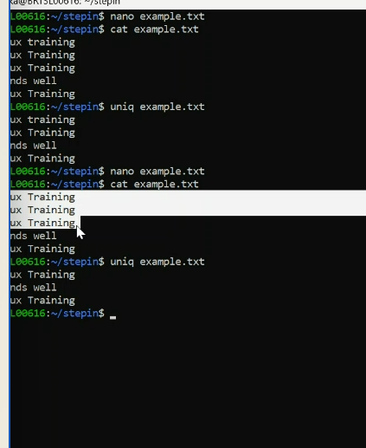

Uniq example.txt

---------------------------------------------------------------------------------------------------

ls

cat sample.txt

cat s1.txt

cmp sample.txt s1.txt

diff sample.txt s1.txt

Sed -> stream Editor

S -> substitute text

G -> globa; replacement

-I -> edit the file

/pattern/d ->delete the file

/pattern/a -> append the file

/pattern/a -> print the file

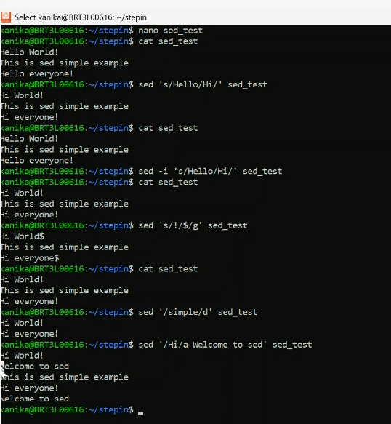

File permission commands

ls -l

filename __

read r

write w

execute x

chmod 462 s1.txt

ls -l s1.txt  
history