Economic dynamics and policy impacts of Labour Force and Social Welfare in Ireland.

**Programming for Data Analytics Report**

**Author**: Vinicius Carrarini Cabral

**Date:** December 29, 2024

**Organisation:** National College of Ireland

Introduction

The dynamics of labour force participation and social protection schemes are critical to evaluate a nation’s economic health and social well-being.

Labour market dynamics, with growth in employment and low unemployment rates, are fundamental indicators of economic vitality. Investment in social protection enhances labour force participation and prevents the loss of productive capital, which assists with overall economic health.

According to the World Bank, “The labour force is the supply of labour available for producing goods and services in an economy. It includes people who are currently employed and people who are unemployed but seeking work, as well as first-time job seekers. Not everyone who works is included, however. Unpaid workers, family workers, and students are often omitted, and some countries do not count members of the armed forces” (World Bank, n.d.).

As for social protection, “Social protection refers to the set of policies and programs aimed at preventing or protecting all people against poverty, vulnerability, and social exclusion throughout their life cycles, with a particular emphasis towards vulnerable groups.” (United Nations (2021))

Objectives

The goal is to investigate economic patterns and assess policy impacts to understand Ireland’s economic health. This analysis aims to uncover insights into how social protection influences unemployment and enhances labour force participation, providing a data-driven foundation for informed policy decisions.

To achieve the desirable outputs, this report will focus on answering four questions using three different datasets.

1. How labour force participation, employment, and unemployment have evolved from 1998 to 2023. Analyse trends and understand their implications for economic health.
2. Investigate trends of social protection schemes recipients over time and across counties. Evaluate if disparities in scheme uptake are statistically significant over the years.
3. Provide insights into the effectiveness of social protection programs for the labour force, examining the relationship between jobseeker allowance and benefit, and unemployment.
4. Exploring the relationship between social protection expenditures and unemployment.

Dataset - Description

**Labour force dataset**

The [QLF01 - Persons aged 15 years and over](https://data.cso.ie/table/QLF01) - Labour Force Survey (LFS), conducted by Central Statistical Office (CSO), Ireland. Provides insights into the labour market trends in Ireland. The dataset contains International Labour Classification (ILO) economic status by gender and by quarter from 1998 to 2024 for persons aged 15 years and over. It is freely available on the CSO website and open to use for analysis, research, and publication, providing proper attribution to the CSO as the source.

**Social protection dataset**

The [Welfare recipients by scheme and county](https://data.gov.ie/dataset/welfare-recipients-by-scheme-and-county) dataset is published by the Department of Social Protection, Ireland. It includes the welfare number of recipients for each scheme, categorised by county and quarter, covering the period from 2014 to 2024 (Q3). Licensed under Creative Commons Attribution 4.0, given the proper attribution.

**Social protection expenditure dataset**

The [SPEA02 - Social Benefits Protection Expenditure by function](https://data.cso.ie/table/SPEA02) - was conducted by the Central Statistical Office (CSO), Ireland. Outlines the gross expenditure on social protection in Ireland, divided into eight categories - sickness/health care; disability; old age; survivors; family/children; unemployment; housing; and social exclusion. The time coverage is from 2000 to 2021. It is freely available on the CSO website and open to use for analysis, research, and publication, providing proper attribution to the CSO as the source.

Dataset – Exploration and Cleaning

**Labour force dataset**

The CSV file was loaded in pandas and consists of 4494 rows and 10 columns.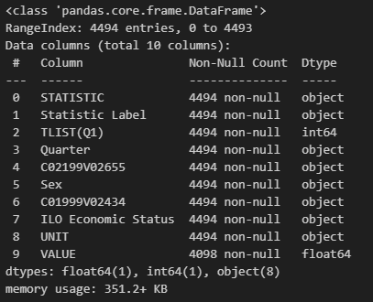

For the cleaning process, the columns were reviewed to identify the need for any adjustments.

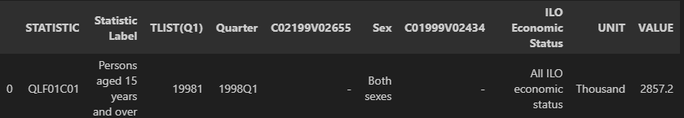

The columns retained for analysis were Quarter, ILO Economic Status and VALUE.  
Before removing unnecessary columns, the Sex column values were filtered to include only “both sexes”. As gender separation was not required for this analysis.

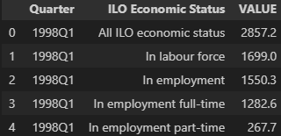

The next steps were performed:

* Year and period were extracted from the Quarter column.
* In ILO Economic Status, the variables filtered were in labour force, in employment, Unemployed and not in labour force.
* The values for individuals required a multiplication by 1000 for accurate calculations.
* Renaming all the columns and variables was made for clarity.

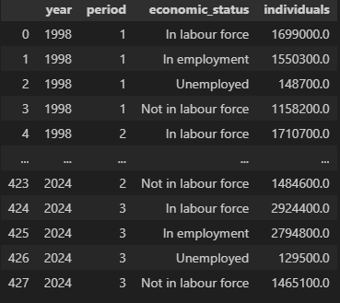

When the cleaning was done, a basic analysis to understand the dataset was made.  
  
No missing values, duplicates, or outliers were identified in the data.

The describe () function was applied for a basic descriptive statistic. Additionally, the group by () was used on the economic status column before applying the describe () function.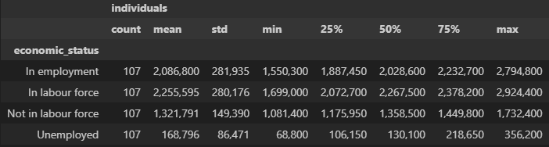

**Social protection dataset**

The CSV file was loaded in pandas and consists of 23894 rows and 9 columns.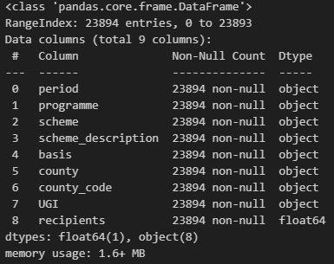



The next steps were performed:

* Year and period were extracted from the period column.
* ‘Unknown’ (845) and ‘All’ (874) values were filtered out of the county column.
* Filtered columns: period, scheme description, county and recipients.
* For clarity, columns and variables were renamed.
* Recipients were changed from float64 to int32

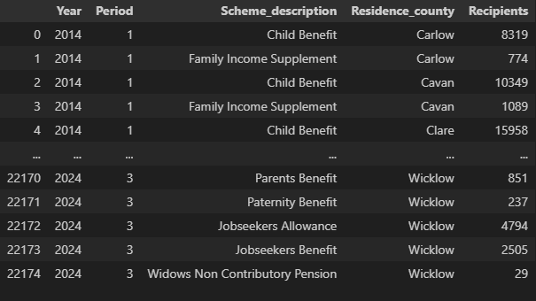

The year range goes from 2014 to 2024 in four periods each (2024 has just 3 quarters).  
The scheme description column has 22 unique variables, and the residence county has 26 unique counties.

It was found that 2535 outliers were in the dataset. But it was decided to keep the values since it makes sense to have outliers in different schemes and population-sized counties.

No missing values, duplicates were found.

After applying descriptive analysis, some insights about the data were identified.









The high-impact schemes show significant variability across regions, as reflected by a large standard deviation, which aligns with population differences (e.g., Dublin: 1,458,154 vs. Leitrim: 35,199, Census 2022). Moderately used schemes include Disability Allowance, Household Benefits, and Carers Allowance (mean ~4,000), while low-use schemes like Paternity Benefits and Back to Work Scheme have a mean around 200. During the pandemic, extreme circumstances caused unusually high values despite low counts.

**Social protection expenditure dataset**

The CSV file was loaded into pandas and consists of 253 rows and 8 columns.

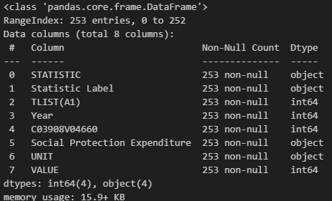



This dataset is used for analysing the unemployment benefits expenditure; therefore, it is unnecessary to examine the other variables.

Next steps for cleaning and exploring the dataset:

* Filtered columns: Year, Social Protection Expenditure, UNIT, VALUE.
* All column names were renamed for consistency and clarity.
* Values in the social protection expenditure column were also renamed to improve interpretability.

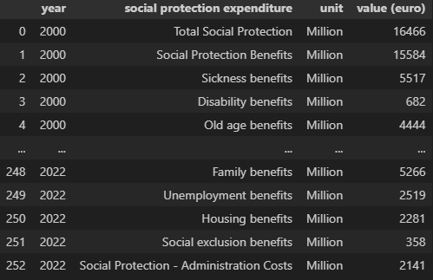

The dataset covers the years 2000 to 2022, and the social protection column has 11 unique values.

It was found 32 outliers on Total Social Protection and Social Protection Benefits. As the analysis will be made mainly on unemployment benefits, it is not necessary to take any actions.

Data Analysis – Insights

**Objective 1 - How labour force participation, employment, and unemployment have evolved from 1998 to 2023. Analyse trends and understand their implications for economic health.**

To understand the dynamics between the labour force and social welfare, it is crucial to analyse trends in labour force participation, unemployment, and employment over time. Between 1998 and 2023, Ireland faced major economic shifts, including the early 2000s boom, the global financial crisis, and COVID-19, highlighting the economy’s resilience and labour market evolution during these events.

*figure 1 – Trendline showing the economic activity from 1998 to 2024(Q3).*

Overall, the graphic suggests a steady growth in labour force participation and employment since 1998. There was a noticeable dip in employment and a corresponding spike in unemployment during the global crisis in 2008, but Ireland has shown a resilient economy, with employment levels recovering over time.

Additionally, there has been a mild increase in individuals out of the labour force, likely reflecting an ageing population, a challenge faced by many countries across Europe.

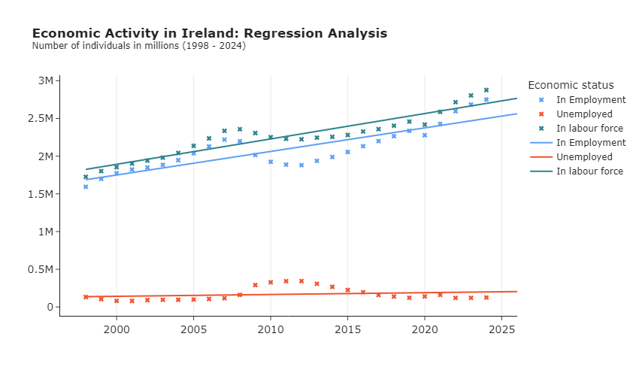  
*figure 2 - Regression analysis of employment, unemployment and labour force from 1998 to 2024(Q3).*

A basic linear regression predicted labour force trends for 2026. On average, the labour force grows by 33,623 individuals per year, with 31,230 in employment and 2,393 in unemployment, indicating economic expansion and stable participation. By 2026, projections show 2,561,401 employed, potentially lower than 2024, and unemployment slightly rising to 204,282.

**Objective 2 - Investigate trends of social protection schemes recipients over time and across counties. Evaluate if disparities in scheme uptake are statistically significant over the years.**

Social protection schemes support and protect people against poverty, vulnerability and social exclusion. The objective is to examine these schemes across counties and over time, from 2014 to 2024. This analysis aims to provide an overview of Ireland’s social protection programs and look for valuable insights into their effectiveness.

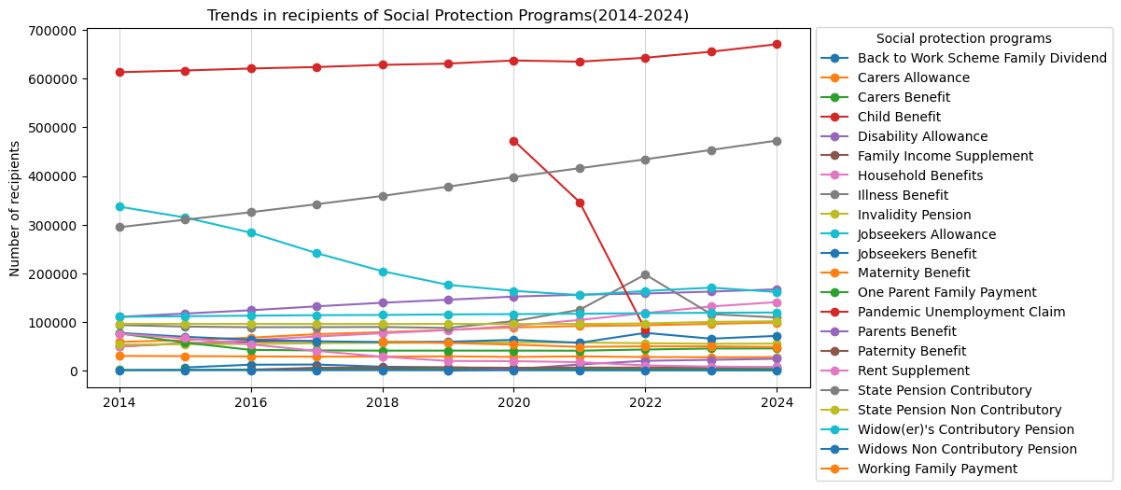

*figure 3 – Annual trend in the total number of recipients for each social protection program in Ireland (2014 – 2024).*

Overall, there are clear disparities in the number of recipients across different schemes. Child Benefit has the highest number of recipients, followed by Pandemic Unemployment Claim (for a small period), State Pension Contributory and Jobseeker Allowance. All other programs are below 100,000 recipients.

For a better view, the five schemes with the highest recipients were highlighted.

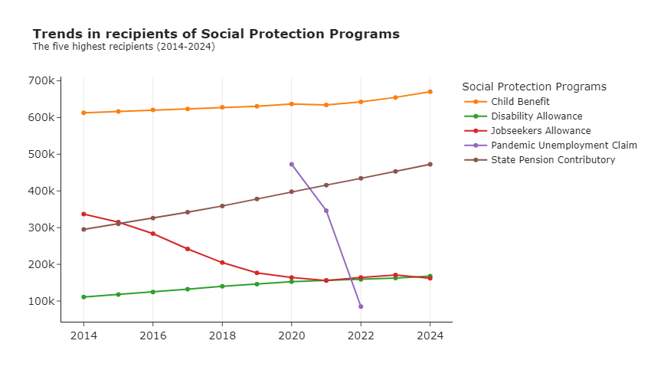

*figure 4 – Annual trend for the five social protection programs with the highest number of recipients in Ireland (2014 – 2024).*

As previously analysed in the labour force data, the slight increase in individuals not in the labour force may be caused by an ageing population. It is evident in the rise of state pension contributions, which highlight the growing number of elderly individuals and the increasing demand for pension benefits over time.

The Pandemic Unemployment Benefit emerged as the second-highest benefit, indicating the significant impact of COVID-19. However, even in its peak, it did not surpass Child Benefit, which has maintained a consistent high number of recipients over the years.

It’s possible to observe the economic resilience through the gradual decline in jobseeker’s allowance, suggesting a reduction in unemployment and improvement in economic conditions over time.

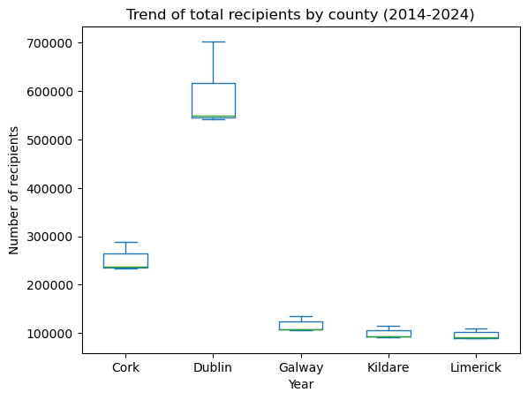

*figure 5 – Annual trend for the five counties with the highest number of recipients in Ireland (2014 – 2024).*

Dublin has the highest number of recipients compared to other counties, with a significant gap even when compared to the second highest, Cork. This shows Dublin’s dominance in Social Protection demands.

The wider interquartile range (IQR) for Dublin indicates greater variability in the number of recipients over time. In contrast, other counties show more stable recipient numbers with smaller IQRs that suggest consistent trends.

To address these disparities, focusing on managing social protection demands in Dublin could help ensure adequate funding and resource allocation for its larger and more variable recipient population.

Ultimately, a linear regression was conducted to analyse if there was a significant change in the total number of recipients over the years with and without the Pandemic Unemployment Benefit.  
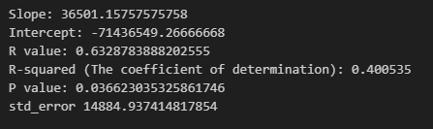

*Linear Regression with Pandemic Social Benefit results*

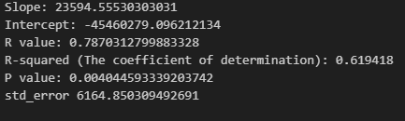

*Linear Regression without Pandemic Social Benefit results*

The hypothesis is correct, indicating a significant change in the total number of recipients over time. Even without the pandemic, the upward trend remains significant. Both analyses show a positive increase in recipients with a slope of 23,594 and 36,501. The P-value (below 0.05%) indicates a statistically significant analysis at a 95% confidence level.

**Objective 3 - Provide insights into the effectiveness of social protection programs for the labour force, examining the relationship between jobseeker allowance and benefit, and unemployment.**

Several social protection programs are linked to unemployment assistance, including training programs, short-time work support, back-to-work allowances, and part-time job incentives. However, this analysis will focus specifically on Jobseeker’s Benefit and Jobseeker's Allowance.

The main goal of these programs is to assist individuals who are actively seeking employment, to maintain strong engagement with the labour force. These programs are directly related to unemployment support and might play a significant role in reducing unemployment effectively.

This analysis will explore the correlation between these schemes and labour force trends to assess their impact.

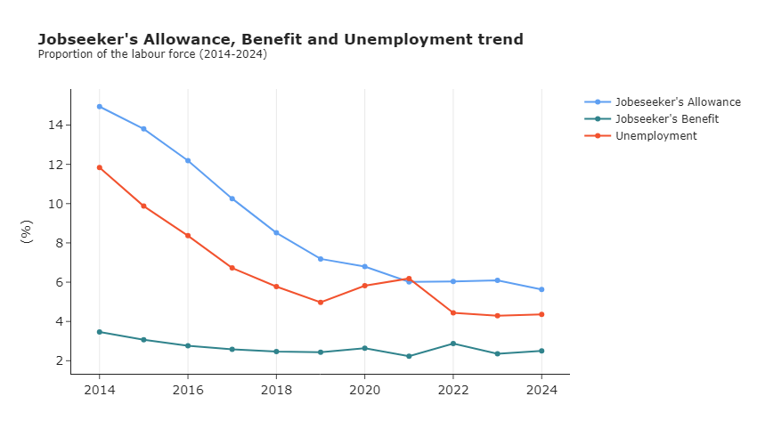

*figure 6 – Graph illustrates the proportion of Jobseeker’s Benefit, Allowance and unemployment as a percentage of the labour force (2014 – 2024).*

[Jobseeker’s Allowance](https://www.citizensinformation.ie/en/social-welfare/unemployed-people/jobseekers-allowance/) is a payment provided to individuals who are unemployed and genuinely seeking full-time work. Eligibility does not require complete unemployment; individuals working 3 days a week or less may still qualify.

[Jobseeker’s Benefit](https://www.citizensinformation.ie/en/social-welfare/unemployed-people/jobseekers-benefit/) is a weekly payment from the Department of Social Protection (DSP) for unemployed individuals who may have lost their job or meet other criteria. This benefit requires sufficient PRSI contributions in recent years.

These benefits are not limited just to unemployed individuals; They can also apply to those engaged in part-time work. This should be considered in the analysis, as it impacts how these programs support the labour force.

In Figure 6, it is possible to see a correlation between Jobseeker’s Allowance and unemployment, indicating a possible effective labour force policy and economic growth. The stability of Jobseeker’s Benefit highlights its target in supporting short-term unemployed individuals rather than long-term unemployment.

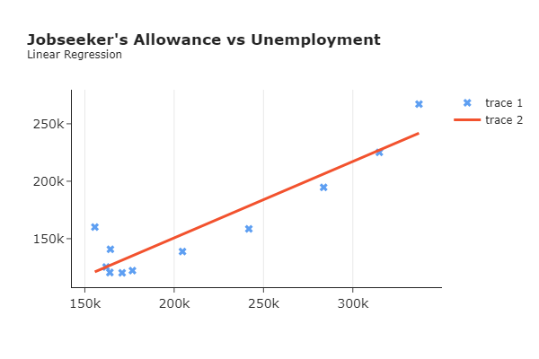

*figure 7 – Linear regression to explore the correlation between Jobseeker’s allowance and unemployment.*

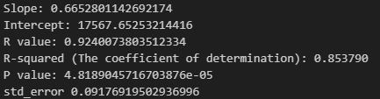  
*Linear Regression Jobseeker’s Allowance recipients and unemployed individuals*

To evaluate the relationship between the programs and unemployment, a linear regression was performed to assess their correlation.

Figure 7 highlights the Jobseeker's Allowance scheme as an essential unemployment support program, with a strong correlation with unemployment. A slope of 0.665 indicates a significant dependency in JA recipients on unemployment trends, while the P-value of 0.0917 indicates that the observed relationship is not due to random chance. JA serves as a critical support during high unemployment.

Figure 8, on the other hand, shows a weak correlation between Jobseeker’s Benefit and unemployment. The slope of 2.32 evidences the weak relationship. The analysis suggests that probably Jobseeker’s Benefit role is probably not about reducing overall unemployment, but more about temporarily supporting the groups in need.

In conclusion, both programs complement each other by addressing different needs in Ireland’s labour market.

*figure 8 – Linear regression to explore the correlation between Jobseeker’s Benefit and unemployment.*

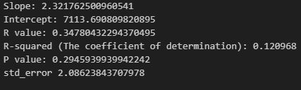  
*Linear Regression Jobseeker’s Benefit recipients and unemployed individuals*

**Objective 4 - Exploring the relationship between social protection expenditures and unemployment.**

The final analysis aims to explore the relationship between unemployment and social protection expenditures, focusing on unemployment benefits from 2000 to 2022. This analysis will investigate the effectiveness of expenditures on unemployment support.

Hypothesis formulation:

* Null hypothesis: Social protection expenditure does not affect unemployment.
* The alternative hypothesis: Social protection expenditure has a significant effect on unemployment.

A Shapiro-Wilk test was conducted to evaluate normality. The result for unemployed individuals is not normally distributed, and for unemployment benefits is normally distributed. 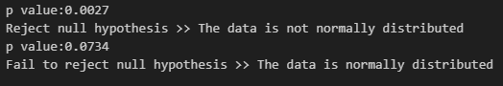

*Shapiro test for normality*

* Unemployed individuals’ data: The test indicates that it is not normally distributed.
* Unemployment benefits data: The test indicates that it is normally distributed.

To further analysis, histograms (figure 9) were created to investigate the frequency distribution of unemployed individuals and unemployment benefits expenditure.

*figure 9 – Individuals in unemployment frequency histogram and expenditure in euros (millions) frequency histogram (2000 – 2022).*

The histograms revealed that neither is normally distributed. The inconsistency between the histograms and the Shapiro-Wilk test results may be because of the sensitivity for small values of the Shapiro-Wilk test. Given the limited number of data points in unemployment expenditure data,

For this reason, we are going to choose a Kendal, which is suitable for small or non-normally distributed datasets, and a linear regression, so we can have different insights.  
  
   
*Kendal test*

The Kendal test indicates a significant relationship between social protection expenditure and unemployment. Therefore, we can reject the null hypothesis. Suggesting that unemployment levels are closely related to changes in social spending.

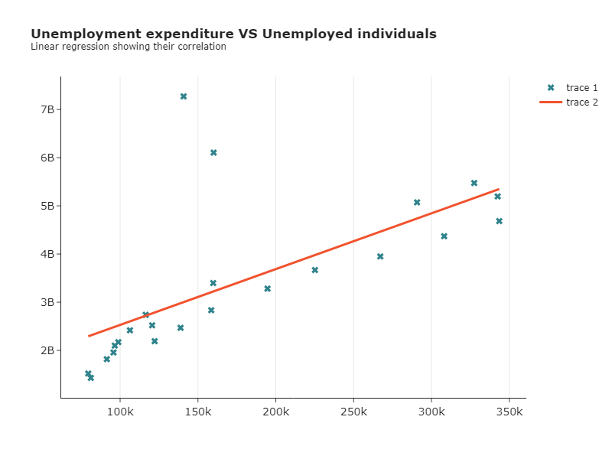  
*figure 10 – Linear regression on the relationship between unemployed individuals and unemployment expenditure (2000-2022).*

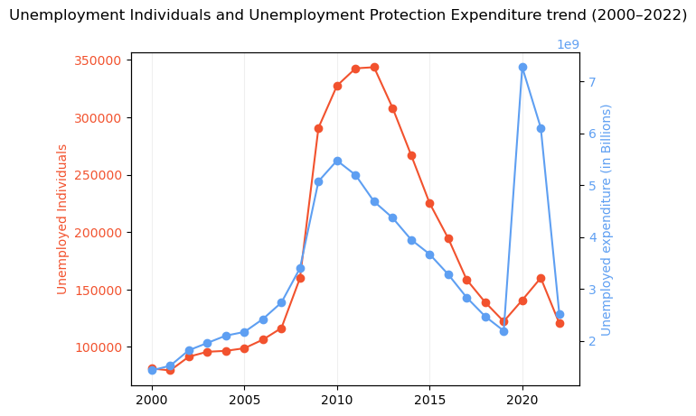  
*Figure 11 – Trend analysis exploring the relationship between them through time (2000-2022)*

Figures 10 and 11 reveal a strong correlation between unemployment and expenditure, with spikes during crises: unemployment surged during the global financial crisis, and expenditure peaked in 2020 due to COVID-19. This correlation reflects Ireland's responsive approach to rising unemployment, demonstrating resilience in stabilising the labour market. The decline in both unemployment and expenditure from 2012 indicates effective economic recovery and labour force improvement, highlighting unemployment protection schemes as vital for stabilising the market during challenges.

Project Challenges

During data preparation, analysis, and understanding dataset contexts, various challenges arose. While analysing labour force and social protection schemes, periods were aggregated with years. For social protection schemes data, accurate aggregation was critical to avoid misleading results. Referring to CSO analyses clarified when to use sums or means.

Unfamiliarity with social protection schemes required research to identify relevant programs. For example, discrepancies emerged when comparing unemployment programs with unemployed individuals, later explained by some scheme users not being unemployed.

In the social protection expenditure dataset, raw values (in billions) were scaled to thousands with a unit column, but this caused inconsistencies in visualisations and calculations. Adjustments were made during calculations to improve accuracy.

Bibliography

1. World Bank. (n.d.). *Labor force participation rate.* Retrieved from <https://databank.worldbank.org/metadataglossary/world-development-indicators/series/SL.TLF.CACT.ZS#:~:text=Labor%20force%20participation%20rate%20is,International%20Labour%20Organization>
2. United Nations. (2021). *A toolbox on social protection.* Retrieved from <https://www.un.org/sites/un2.un.org/files/2021/04/a-tb_on_social_protection.pdf>
3. Central Statistics Office. (n.d.). *Labour force survey: Survey background notes.* Retrieved from <https://www.cso.ie/en/methods/surveybackgroundnotes/labourforcesurvey/>
4. Central Statistics Office. (2022). *Social protection expenditure in Ireland 2022: Main results.* Retrieved from <https://www.cso.ie/en/releasesandpublications/ep/p-spei/socialprotectionexpenditureinireland2022/mainresults/>
5. Citizens Information. (n.d.). *Jobseeker’s Allowance.* Retrieved from <https://www.citizensinformation.ie/en/social-welfare/unemployed-people/jobseekers-allowance/>
6. Citizens Information. (n.d.). *Jobseeker’s Benefit.* Retrieved from <https://www.citizensinformation.ie/en/social-welfare/unemployed-people/jobseekers-benefit/>
7. Government of Ireland. (n.d.). *Social welfare schemes and services.* Retrieved from <https://www.gov.ie/en/collection/ff767-social-welfare-schemes-and-services/>
8. Central Statistics Office. (n.d.). QLF01 - Labour Force Dataset. Retrieved from <https://data.cso.ie/table/QLF01>
9. Department of Social Protection. (n.d.). Welfare recipients by scheme and county Dataset. Published under Creative Commons Attribution 4.0. Retrieved from <https://data.gov.ie/dataset/welfare-recipients-by-scheme-and-county>
10. Central Statistics Office. (n.d.). SPEA02 - Social Benefits Protection Expenditure by Function Dataset. Retrieved from <https://data.cso.ie/table/SPEA02>