BUSINESS INSIGHTS:
- Which departments face operational bottlenecks?
The analysis indicates that departments with the highest patient volume and longest average waiting times experience the greatest operational bottlenecks. These departments handle a large number of appointments, which increases the workload on doctors, nurses, and support staff. High patient demand also results in longer queues and delayed consultations. Departments with greater emergency case volumes are particularly affected because urgent cases often disrupt scheduled appointments. Improving staff allocation and appointment scheduling in these departments can significantly reduce bottlenecks and improve operational efficiency.

- What causes long waiting times?
Long waiting times are mainly caused by appointment delays, high patient arrivals during peak hours, and limited availability of healthcare professionals. Emergency cases often receive priority, causing scheduled consultations to be postponed. Departments with a high patient load also experience longer consultation queues, increasing overall waiting time. Inefficient appointment scheduling and uneven distribution of patients across time slots further contribute to delays. Better scheduling practices and optimized resource planning can help reduce waiting times.

- Which resources are overloaded?
The analysis suggests that doctors in high-demand departments are the most overloaded resources due to a large number of patient consultations. Hospital beds also experience high utilization when admission rates increase, reducing their availability for new patients. Nurses and supporting medical staff in busy departments face increased workloads because they must manage more patients within limited working hours. During peak periods, consultation rooms and medical equipment may also become heavily utilized. Expanding staffing levels and balancing workloads across departments can improve resource utilization.

- How does waiting time affect patient satisfaction?
The results show a negative relationship between waiting time and patient satisfaction. Patients who experience longer waiting times tend to provide lower satisfaction ratings because delays reduce their overall healthcare experience. Short waiting times generally lead to higher satisfaction scores, reflecting better service quality and operational efficiency. Appointment delays and overcrowding further reduce patient confidence in hospital services. Reducing waiting times through efficient scheduling and faster patient flow can significantly improve patient satisfaction and service quality.

- What actions should hospital management take?
Hospital management should focus on improving appointment scheduling, optimizing staff allocation, and increasing resource availability during peak hours. Departments with consistently high patient loads should receive additional doctors, nurses, and support staff to reduce waiting times. Monitoring appointment delays through dashboards can help identify operational issues before they become severe. Increasing bed capacity and improving patient flow for admitted cases will enhance operational efficiency. Continuous monitoring of key performance indicators such as waiting time, patient satisfaction, bed utilization, and department performance will support better decision-making and improve the overall quality of healthcare services.

Output:
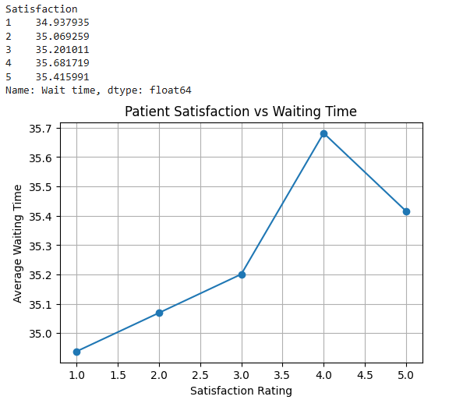
Innovation: pandas, matplotlib.pyplot, patient flow, resource utilization, operational KPIs

