EV Charging Network Planner
Strategic Questions:
- Which areas are underserved by the current charging infrastructure?
Cities such as Seoul, Beijing, Berlin, Toronto, and Sydney with low Coverage Scores, high EV populations, and limited charging station availability. These locations have insufficient charging infrastructure to meet current demand and should be prioritized for new charging station deployment. Geographic analysis also highlighted coverage gaps where charging stations are sparsely distributed, reducing accessibility for EV users.

- Where will charging demand grow over the next 3–5 years?
Cities such as Berlin, Dubai, Mexico City, and San Francisco with high EV Growth (%), increasing EV Population, and rising Charging Sessions are expected to experience the greatest increase in charging demand over the next three to five years. These areas represent emerging demand zones where additional charging infrastructure will be required to support future EV adoption and prevent network congestion.

- Which locations should be prioritized for expansion?
The machine learning model calculated an Expansion Priority Index and generated Expansion Recommendations for each charging station. Locations with High Expansion Priority, low Coverage Scores, high Station Utilization, and high EV demand should receive immediate investment for infrastructure expansion. These locations offer the highest operational and business value.

- How can charging congestion be reduced?
Charging congestion can be minimized by expanding charging capacity at stations with high Queue Lengths, high Congestion Risk, and high Station Utilization (%). Installing additional fast chargers, increasing charging points, balancing demand across nearby stations or cities such as San Francisco, Moscow, Dubai, Beijing, São Paulo, Seoul, Los Angeles, Sydney, Chicago, Toronto, Cape Town, Berlin, Bangkok, Mumbai, and Mexico City, and continuously monitoring utilization will improve service efficiency and reduce customer waiting times.

- How can investment generate maximum business impact?
Investment should focus on locations or cities including Berlin, Dubai, Mexico City, San Francisco, and Seoul with high EV Population, strong EV Growth, high Expansion Priority Index, and low charging coverage. Prioritizing these areas will maximize charging station utilization, improve customer accessibility, reduce congestion, increase revenue potential, and deliver the highest return on infrastructure investment while supporting long-term sustainable EV network growth.

Infrastructure Context:
EV Ecosystem Overview
The electric vehicle (EV) ecosystem is expanding rapidly due to increasing environmental awareness, government incentives, and advancements in EV technology. As EV adoption continues to grow, the demand for reliable, accessible, and efficient charging infrastructure has become a critical requirement. A well-planned charging network supports sustainable transportation, improves user convenience, and encourages greater adoption of electric vehicles.
Business Problem Definition
The current EV charging infrastructure faces challenges such as uneven station distribution, inadequate coverage in certain regions, high congestion at busy stations, and difficulty identifying optimal expansion locations. This project addresses these challenges by using data analytics and machine learning to identify underserved areas, forecast future charging demand, prioritize infrastructure expansion, and maximize investment efficiency.
Data Strategy
Datasets Used
The project utilizes an EV charging station dataset containing information such as station locations, charger types, charging capacity, station utilization, charging sessions, installation year, station operators, renewable energy sources, customer ratings, parking availability, and maintenance frequency. Additional analytical features, including EV Population, Coverage Score, Congestion Risk, Expansion Priority Index, Revenue, and EV Growth (%), were generated to support comprehensive business analysis.
Data Integration Approach
The dataset was integrated and prepared using Python by cleaning missing values, removing duplicates, converting data types, and creating new analytical features. SQL was used for business query analysis, machine learning models were applied to generate expansion recommendations, and Power BI was used to develop interactive dashboards that combine operational, geographical, and business performance insights.
Data Quality Findings
The dataset was assessed for missing values, duplicate records, and inconsistent data formats before analysis. Data quality issues were resolved through preprocessing techniques such as missing value imputation, feature engineering, and validation of numerical and categorical variables, resulting in a clean and reliable dataset suitable for analysis, visualization, and machine learning.

Planning Framework
Coverage Analysis
Coverage analysis evaluated the geographic distribution of charging stations and measured infrastructure adequacy using the Coverage Score. Regions with low coverage and high EV demand were identified as underserved areas, highlighting where additional charging stations are required to improve accessibility and reduce service gaps.
Opportunity Scoring
An Expansion Priority Index was developed by considering factors such as EV Population, EV Growth, Station Utilization, Charging Sessions, Revenue, Queue Length, and Coverage Score. Locations with high demand, increasing EV adoption, and limited charging infrastructure received higher scores, indicating strong opportunities for infrastructure expansion.
Expansion Methodology
Machine learning techniques, including Decision Tree, Random Forest, and Gradient Boosting, were used to classify charging stations based on their expansion priority. The methodology combined operational performance, customer demand, utilization, congestion, and coverage metrics to generate Expansion Recommendations that support strategic infrastructure planning.

Business Recommendations
Expansion Roadmap
The organization should prioritize expanding charging infrastructure in underserved cities with low Coverage Scores and rapidly growing EV populations. Existing high-utilization stations should be upgraded by increasing charging capacity and installing additional fast chargers, while future expansion should follow the recommendations generated by the Expansion Priority Index.
Investment Priorities
Investment should focus on locations with high EV demand, increasing charging sessions, high station utilization, and significant congestion risk. Prioritizing these locations will improve charging accessibility, reduce waiting times, increase infrastructure utilization, and maximize the return on investment for future expansion projects.
Expected Outcomes
Implementing the recommended expansion strategy is expected to improve charging network coverage, reduce congestion at high-demand stations, enhance customer satisfaction, optimize infrastructure utilization, support future EV adoption, and enable data-driven decision-making for long-term infrastructure planning.

Future Vision
Smart Charging Integration
Future charging infrastructure should incorporate smart charging technologies that dynamically manage charging schedules, balance electricity demand, and optimize energy usage during peak periods. Intelligent charging systems will improve operational efficiency while reducing grid stress and customer waiting times.
Renewable Energy Integration
Integrating renewable energy sources such as solar and wind power into charging stations will reduce carbon emissions, lower operating costs, and promote environmentally sustainable transportation. Combining renewable energy with battery storage systems can further improve energy reliability and charging efficiency.
Real-Time Planning Systems
Future EV charging networks should utilize IoT devices, real-time monitoring systems, and AI-driven predictive analytics to continuously track station utilization, charging demand, congestion levels, and infrastructure performance. Real-time planning systems will enable dynamic expansion decisions, proactive maintenance, and efficient management of the charging network as EV adoption continues to grow.

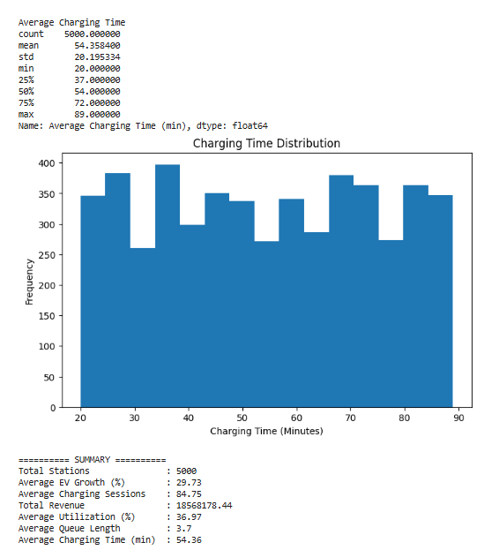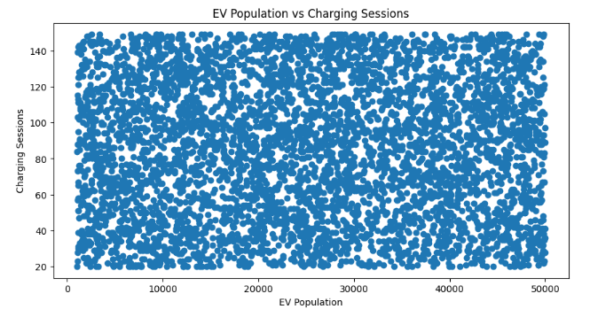

Innovation: pandas, matplotlib.pyplot, highest ROI locations, strategic expansion zones, infrastructure upgrade opportunities, Map, charger type

