1. **SampleUIFramework** Software Required:
2. java 11
3. maven 3.9.4
4. eclipse
5. Install Cucumber Eclipse Plugin in eclipse
6. Install TestNG plugin in eclipse

2)**General Flow of Any Selenium Framework with POM model and Cucumber.**[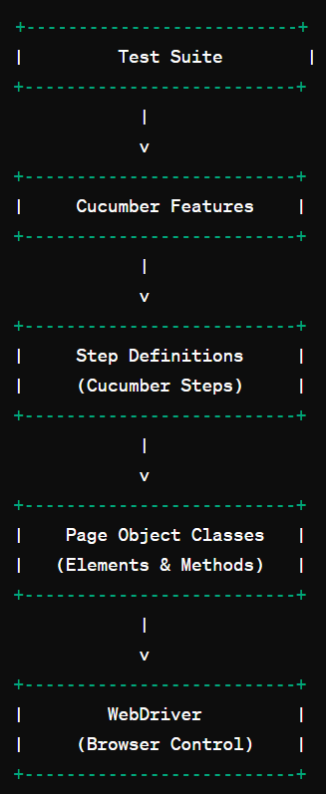](https://private-user-images.githubusercontent.com/20809464/326511632-f265766a-8c5c-4388-afa8-5956fc8b0eda.png?jwt=eyJhbGciOiJIUzI1NiIsInR5cCI6IkpXVCJ9..ncPqh_FWZIaHZ0dvlhBcEW0RiHc5NzXLZ-YqIrMiytk)

**3) Project Structure** The project structure is organized as follows:

├── src

│ ├── main

│ │ └── java

│ │ └── com

│ │ └── pages

│ │ ├── pages (All the Page Object classes)

│ │

│ │ └── driver

│ │ └── ConfigurationDriver.java (Contains browser Launch related code)

│ │ └── repo

│ │ └── Repository.java (Common Utils/Common code)

│ │ └── resources

│ │ └── features (All the Feature Files)

│ └── test

│ └── java

│ ├── run (Executor.java--Cucumber Executable code where you can pass the tags)

│ └── tests (All the test methods related with respect to cucumber step definitions)

├── pom.xml (Maven configuration)

**4) Test Results**

* Test report automatically generated on target folder after finished the test execution
* See test report from target/cucumber-reports/advanced-reports/cucumber-html-reports/overview-features.html
* You can also share your Cucumber Report with another person at [https://reports.cucumber.io](https://reports.cucumber.io/), just go to src/test/resources/cucumber.properties then change the value to be true

cucumber.publish.enabled=true

* For more information about reports cucumber you can go to <https://reports.cucumber.io/docs/cucumber-jvm>